**EX:No.8 221501012**

**15/04/25**

**IMPLEMENT PROGRAM FOR DECOMPOSING TIME SERIES DATA INTO TREND AND SEASONALITY.**

**AIM:**

To implement program for decomposing time series data into trend and seasonality.

**ALGORITHM:**

**OBJECTIVE:**

Smooth the electric production data to reduce noise, highlight trends, and prepare for forecasting.

**BACKGROUND:**

1.Time series data has short-term fluctuations.

2.Moving average reduces noise and clarifies trends.

3.Smoothed data improves forecast accuracy and interpretability.

**SCOPE OF THE PROGRAM:**

1.Load and clean dataset

2.Convert date column to datetime

3.Aggregate data monthly and yearly

4.Apply 3-month and 12-month moving averages

5.Plot original vs smoothed data

**ALGORITHM:**

1.Import libraries

2.Load dataset

3.Preprocess and set datetime index

4.Resample data (monthly, yearly)

5.Apply 3-month & 12-month smoothing

6.Visualize results

**PROCESS:**

import pandas as pd

import numpy as np

import matplotlib.pyplot as plt

from statsmodels.tsa.arima.model import ARIMA

from sklearn.metrics import mean_squared_error

**# Load the dataset (use the correct column names for the date and electric production)**

df = pd.read_csv('Electric_Production.csv', parse_dates=['DATE'], index_col='DATE')

**# Display the first few rows of the dataset**

print(df.head())

**# Use the electric production data as the time series**

time_series = df['IPG2211A2N'] # This is the column containing electric production values

**# Split the data into training and testing sets (80% training, 20% testing)**

train_size = int(len(time_series) * 0.8)

train, test = time_series[:train_size], time_series[train_size:]

**# Fit ARIMA model (you can adjust the order of ARIMA for better results)**

model = ARIMA(train, order=(5, 1, 0)) # (p, d, q) - tune for best performance

model_fit = model.fit()

**# Forecasting**

forecast = model_fit.forecast(steps=len(test))

**# Plot training data**

plt.figure(figsize=(10, 4))

plt.plot(train, label='Training Data', color='blue')

plt.title('Training Data')

plt.xlabel('Date')

plt.ylabel('Electric Production')

plt.legend()

plt.grid(True)

plt.tight_layout()

plt.show()

**# Plot actual test data**

plt.figure(figsize=(10, 4))

plt.plot(test, label='Actual Test Data', color='green')

plt.title('Actual Test Data')

plt.xlabel('Date')

plt.ylabel('Electric Production')

plt.legend()

plt.grid(True)

plt.tight_layout()

plt.show()

**# Plot forecast vs actual**

plt.figure(figsize=(10, 4))

plt.plot(test.index, forecast, label='ARIMA Forecast', color='red')

plt.plot(test, label='Actual Test Data', color='green')

plt.title('ARIMA Forecast vs Actual')

plt.xlabel('Date')

plt.ylabel('Electric Production')

plt.legend()

plt.grid(True)

plt.tight_layout()

plt.show()

**# Calculate RMSE (Root Mean Squared Error)**

rmse = np.sqrt(mean_squared_error(test, forecast))

print(f'RMSE: {rmse:.2f}')

**OUTPUT:**

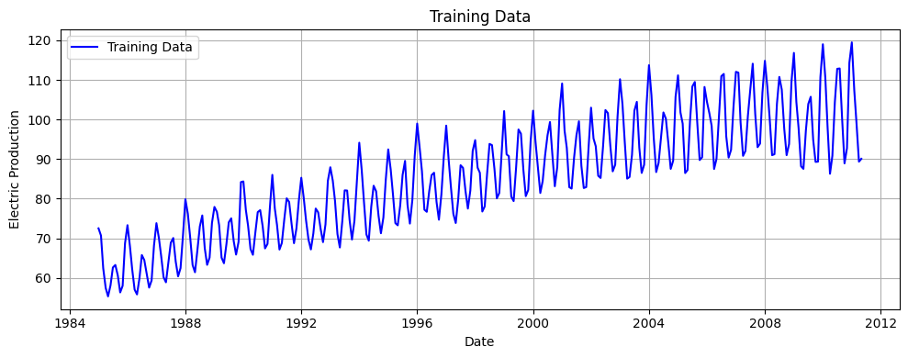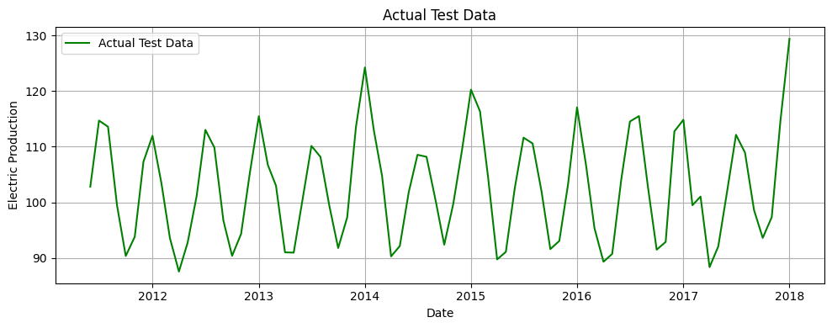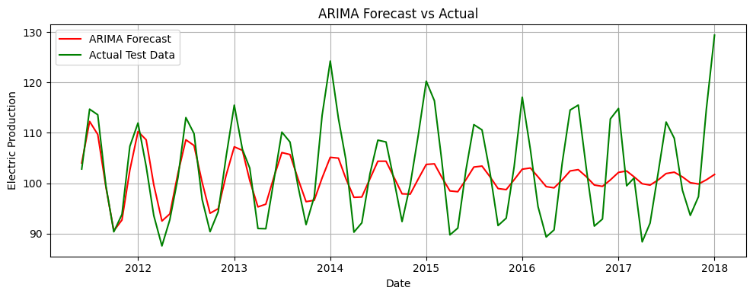

**RESULT:**

The program to implement of program to Create an ARIMA model for time series forecasting created and executed successfully.