**EX:No.9 221501012**

**15/04/25**

**DEVELOP NEURAL NETWORK-BASED TIME SERIES FORCASTING MODEL.**

**AIM:**

To implement program for Develop neural network-based time series forecasting model.

**ALGORITHM:**

**OBJECTIVE:**

Smooth the electric production data to reduce noise, highlight trends, and prepare for forecasting.

**BACKGROUND:**

1.Time series data has short-term fluctuations.

2.Moving average reduces noise and clarifies trends.

3.Smoothed data improves forecast accuracy and interpretability.

**SCOPE OF THE PROGRAM:**

1.Load and clean dataset

2.Convert date column to datetime

3.Aggregate data monthly and yearly

4.Apply 3-month and 12-month moving averages

5.Plot original vs smoothed data

**ALGORITHM:**

1.Import libraries

2.Load dataset

3.Preprocess and set datetime index

4.Resample data (monthly, yearly)

5.Apply 3-month & 12-month smoothing

6.Visualize results

**PROCESS:**

**# Install required packages (if not already available)**

**# !pip install pandas numpy matplotlib scikit-learn tensorflow**

import pandas as pd

import numpy as np

import matplotlib.pyplot as plt

from sklearn.preprocessing import MinMaxScaler

from sklearn.model_selection import train_test_split

from tensorflow.keras.models import Sequential

from tensorflow.keras.layers import Dense

**# Load dataset**

df = pd.read_csv('/content/Electric_Production.csv', parse_dates=['DATE'], index_col='DATE')

**# Use the relevant column**

data = df['IPG2211A2N'].values.reshape(-1, 1)

**# Normalize the data**

scaler = MinMaxScaler()

scaled_data = scaler.fit_transform(data)

**# Function to prepare time series data for supervised learning**

def create_dataset(dataset, window_size):

X, y = [], []

for i in range(len(dataset) - window_size):

X.append(dataset[i:i+window_size, 0])

y.append(dataset[i+window_size, 0])

return np.array(X), np.array(y)

**# Define time window**

window_size = 12

X, y = create_dataset(scaled_data, window_size)

**# Split into training and testing sets (80% training)**

X_train, X_test, y_train, y_test = train_test_split(X, y, test_size=0.2, shuffle=False)

**# Build Neural Network model**

model = Sequential([

Dense(64, activation='relu', input_shape=(window_size,)),

Dense(32, activation='relu'),

Dense(1)

])

model.compile(optimizer='adam', loss='mse')

**# Train the model**

history = model.fit(X_train, y_train, epochs=100, batch_size=16, validation_data=(X_test, y_test), verbose=0)

**# Predict on test set**

predictions = model.predict(X_test)

predictions = scaler.inverse_transform(predictions.reshape(-1, 1))

actual = scaler.inverse_transform(y_test.reshape(-1, 1))

**# Plot results**

plt.figure(figsize=(10, 5))

plt.plot(actual, label='Actual')

plt.plot(predictions, label='Predicted', color='red')

plt.title('Neural Network Forecast vs Actual')

plt.xlabel('Time Steps')

plt.ylabel('Electric Production')

plt.legend()

plt.grid(True)

plt.show()

**# Show RMSE**

from sklearn.metrics import mean_squared_error

rmse = np.sqrt(mean_squared_error(actual, predictions))

print(f'RMSE: {rmse:.4f}')

**OUTPUT:**

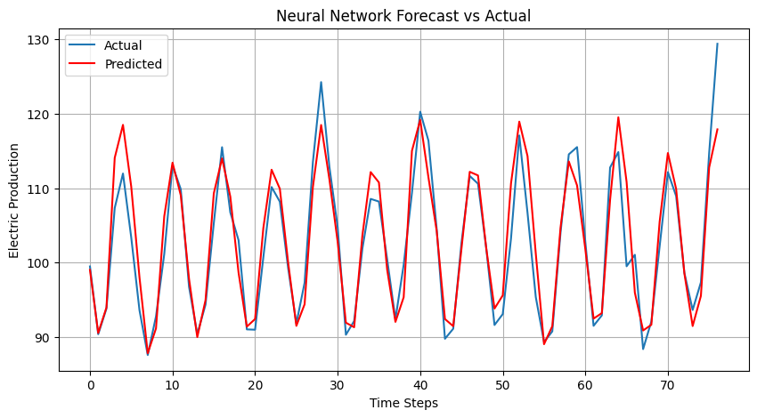

**RESULT:**

The program to Develop neural network-based time series forecasting model created and executed successfully.