**E-learning web portal on machine learning, deep learning, and artificial intelligence courses**

**Abstract**

The project ‘E-learning web portal’ is a web-based application. This software provides facility for accessing different subjects and their courses by registered students. Teachers can be registered with their topics of interest. This system allows student to sign up and book their corresponding topics. Teacher will be alerted about student registration and they can reject or accept the booking. Teacher-admin-student can message each other. Teacher can conduct exams to students on corresponding topic and do analysis. Admin has an overall control on subjects, courses, teachers, and students. This website includes trending courses such as machine learning, artificial intelligence, deep learning.

Keywords: payment, booking, course, student, teacher.

**1 Introduction**

In today’s complex world, students’ futures are determined by their ability to master the basics of subjects. Yet costs, class sizes and other issues often prevent student’s access to quality online learning that can support and reinforce these essential skills. Traditional classroom based approach to learning is limited by these constraints. E-learning has been a topic of increasing interest in recent years. It is often perceived as a group effort, where content authors, instructional designers, multimedia technicians, teachers, trainers, database administrators, and people from various other areas of expertise come together in order to serve a community of learners. Although e-Learning has grown organically without a clear picture of the components of a typical e-learning system or how they interrelate, the need for establishing architecture is critical for defining competitive arenas and standards of development. This paper proposes to establish such an integrated architecture for e-Learning.

E-Learning is as an approach to instruction and learning that utilize Information and communication technologies to communicate and collaborate in an educational milieu. This includes technological expertise that supplements traditional classroom training with web-based components and learning environments where the educational process is experienced online. This paper reflects the importance of elearning in higher education with its extent and growth among students. Some of the major initiatives and the target segments covered by the online education have also been detailed in this article. The e-learning was being considered useful only for distance learning programs. But no one can deny the fact that e-learning is the most innovative application of the Internet and it has done wonders globally and currently is achieving education classroom as well.

In a society, the student generation must be positively influenced by the imparters of education who have a higher moral, ethical and social responsibility. They have to realize the importance of technology and have to be well aware how to teach the future leaders, they need to be technology better equipped. Annually, the demand for higher education is growing globally and India is no exception to it. In fact, in India, the number of applicants is three to five times as against the number of seats in any institution of higher education. The delivery of learning or content can be over the intranet, extranet or over the Internet, via CDROM, interactive TV, or satellite broadcast (WAGNER, 2008). Over the past few years, nations have been trying to achieve the target of making education accessible to every corner of the society. Still there are many parts of the world, which are in darkness about e-learning (MALIK, 2009).

The e-learning is fast growing and seems to take control of the world because of its educational advantages (SAHA, 2010). The traditional mindsets are changing, with the corporate and business sector leading the way in embracing technology based learning networks. The major hindrance to the acceptance of e-learning can be attributed to the mindset that is more inclined to traditional classroom teaching (HANSEN, 2008). The estimated growth in the e-learning offshoring industry is at a Compound Annual Growth Rate (CAGR) of 15% through 2012 is reaching USD $603 million (it is now US$ 341 million) (BANDUNI, 2008).

While delivery costs of e-learning are significantly reduced compared to costs associated with classroom learning delivery, especially when large numbers of learners are involved. The initial development and purchase of e-learning products represents a major barrier to the adoption of e-learning training within organizations. This claim is substantiated by evidence from a survey conducted for the Office of Learning Technologies (OLT) in Canada, which found that cost was the single most important factor preventing employers from investing in e-learning. In any case, organization must weigh the initial costs of developing e-learning against savings accrued from economics of scale at delivery time. E-learning focuses on the broadest view of learning-learning solutions that go beyond the traditional paradigm of learning (ROSENBERG, 2001).

Machine learning models and algorithms are used in almost all fields to reduce manpower (SCHAPIRE, 2003).  It is an integral part of artificial intelligence, which is used to design algorithms based on the data trends and historical relationships between data. Machine learning is used in various fields such as bioinformatics, intrusion detection, Information retrieval, game playing, marketing, malware detection, image deconvolution and so on. The field of artificial intelligence (AI) has shown an upward trend of growth in the 21st century (from 2000 to 2015). The evolution in AI has advanced the development of human society in our own time, with dramatic revolutions shaped by both theories and techniques. However, the multidisciplinary and fast-growing features make AI a field in which it is difficult to be well understood (VERNON, 2007). Compared to traditional machine learning methods, deep learning has a strong learning ability and can make better use of datasets for feature extraction. Because of its practicability, deep learning becomes more and more popular for many researchers to do research works (HEBB, 1949). The above mentioned subjects are highly demanded and that is the reason to include them in our portal.

## *1.1 Aim*

The main aim of this project is to develop an e-learning web portal which provides facility for accessing different subjects and their courses by registered students where a teacher can handle all learning activities of a student online.

***1.2 Objectives***

This application is to develop a dynamic robust web-based application for analyzing and uploading subjects and courses by individual teachers that enhance an instructor to choose a subject of interest. A student can register for a course of their choice.

***1.3 Scope***

The scope of e-learning is much wider with many e-learning companies stepping forward in providing the service. Though nothing can actually outrun the popularity of traditional classroom teaching, e-learning only gives more value to the process, independent of the distance factor. E-learning scenario is still growing and at an experimental stage. The traditional mindsets are changing, with the corporate and business sector leading the way in embracing technology based learning networks. In this project, a teacher can upload content of their interest. If the content is not satisfied by admin, admin can delete it. A student can register for a course by selecting an instructor of their interest. Teacher can even conduct examinations online.

**2 Literature survey**

Despite the enormous growth of e-learning in education and its perceived benefits, the efficiency of such tools will not be fully utilized if the users inclined to not accept and use the system. Therefore, the successful implementation of e-learning tools depends on whether or not the students are willing to adopt and accept the technology. Thus, it has become imperative for practitioners and policy makers to understand the factors affecting the user acceptance of web-based learning systems in order to enhance the students’ learning experience (Tarhini et al., 2014a). However, recent studies have shown that e-learning implementation is not simply a technological solution, but also a process of many different factors such as social factors (Schepers and Wetzels, 2007; Tarhini et al., 2014b; 2015), and individual factors (Liaw and Huang, 2011), organizational such as facilitating conditions (Sun and Zhang, 2006) in addition to behavioural and cultural factors (Masoumi, 2010).Such major factors play an important role in how an information technology is developed and used (Kim and Moore, 2005). Fischer et al. (2015) studied how proceedings of scientific conferences can be used for trend studies in the field of e-learning. They examined the abstracts of 427 scientific articles of leading German-speaking e-learning conferences GesellschaftfürMedien in der Wissenschaft and E-Learning-Fachtagungen der GesellschaftfürInformatik e. V. (GMW and DeLFI) – published from 2007 to 2013. The study was conducted at German-speaking conferences and, thus, reflects the situation in Germany, Switzerland and Austria. Fischer et al. (2015) made an important contribution to the diffusion of digital media in higher education. The researchers found that the detailed analysis of the frequency distribution over the seven years reflects the intensity of scientific discussion towards e-learning trends, and conclusions about the didactical or technical potentials of innovations can be introduced.

**3. Description of the project**

The project ‘E-learning web portal’ enhances learning experience of a student. This software comes up with facility for accessing different subjects and their courses by registered students. Teachers can be registered with their topics of interest. This system allows pupil to sign up and book their corresponding topics. Teacher will be notified about student registration and they can deny or accept the booking. Teacher-admin-student can message each other. Teacher can conduct exams to students on corresponding topic and do analysis. Admin can add/update/delete subjects and courses, teachers, and students. Guests have option to contact admin. They can add blogs about the website. Every day education news can also been accessed. The news web page is designed through web scraping.

**4. User story**

Users are student and teacher. Teacher will upload the subjects and their corresponding topics in website. Then, student will register in website with a predefined fee. Students will view the registered teachers with their subjects from home page. If students need to attend a course, they must register in the website and book their subject and teacher of interest. Students can send feedbacks after the completion of course to admin which will be used to assess academic ability of teacher. The booking details will be acknowledged to teacher. Then teacher can reject or accept the booking. Teacher can mark attendance of students. Exams can be conducted to specific student in which student can see question paper only in a specific date and time interval. Based on attendance and marks obtained, a certificate will be issued to student from admin.

**5. Existing and proposed system**

***5.1.1 Existing system***

In existing system, the whole system is not user-friendly. Teachers are not allowed to add their subjects of interest which will eventually decrease the relevance of web portal. Students are unable to analyze the qualities needed for their instructor in conventional system.

Conventional system takes much time to perform different tasks and there is no data handling. Once the data were entered it is very difficult to update these records. Reports are prepared and updates are done manually. Highly demanded subjects in current scenario are rare in web portals.

***5.1.2 Proposed system***

As the existing system has lot of drawbacks hence those drawbacks are considered in the proposed system. In proposed system, records are easy to maintain, accessing the information is easy and application is user-friendly. New system can generate result immediately after getting the data. Students can book courses based on their requirements and fee of the courses will be differed based on the instructor they choose. Highly demanded subjects in current scenario are included.

***5.1.3 Feasibility study***

Feasibility study is done to see whether the system meets the proposed system with respect to the systems workability, whether the system is capable of addressing user issues and time spent on the work. Feasibility study is used to determine whether the proposed system can be implemented and should proceed. Once the proposed system has been determined that the system is feasible, then analyst can prepare and proceed with the next step.

Feasibility analysis is the procedure for identifying the system, evaluating and selecting the most feasible system. Proposed system will take only if it meets the best performing requirements. Technical, economical, and operational feasibility have been checked.

***5.1.4 Technical feasibility***

Technical feasibility should be done in order to know the outcome of the product with the availability of resources. After identifying the entire system requirements, the developer must suggest the language to be developed, method to develop and method to run the system once it is completely designed. In this project, the existing system is examined first and generated ideas about the new system. The proposed system is evaluated from the technical view point and is found to be feasible comparing to the existing system.

***5.1.5 Economic feasibility***

Economic analysis is known as cost-benefit analysis. This is to be done in order to know the outcomes and benefits from the proposed system. As the proposed system is automated, hence it reduces the manual work and thus reduces the manpower cost; also it reduces the lag in time. As the proposed system is maintained in the computer, the hardware of the present system is sufficient for the system development. Even after the development of the system any updates in the system or maintenance of the proposed system does not pose as very high-priced concern.

***5.1.6 Operational feasibility***

Operational feasibility mainly deals with the human, organization, and political aspects. The issues arise in the operational feasibility is all about the job changes that will be brought about. The operational feasibility of the proposed system is tested based on the organizational constraints, that is, whether the company has a person to develop the new system and so on.

***6 Tools and technologies used***

***6.1 HTML***

Hyper Text Markup Language is used to develop/design a structure and layout of the static web page. HTML helps in creating, formatting, and enhancing webpage by inserting graphics, colors, and fonts with the help of HTML tags.

***6.2 MySQL***

MySQL is an open-source relational database management database. Linux OS uses LAMP as a web-development platform, Apache as webserver, MySQL as a database management system. MySQL run in all the platforms like Linux, Unix and Windows. MySQL uses standard form of SQL data language.

***6.3 Hardware and software requirements***

***Software requirements:***

|  |  |  |
| --- | --- | --- |
| Operating System | : | Linux, Windows XP/7/8, Unix |
| Technology | : | Python, HTML5, CSS 3, JQuery, Bootstrap |
| IDE | : | PyCharm |
| Database | : | MySQL database |

***Hardware requirements:***

|  |  |  |
| --- | --- | --- |
| Processor | : | Intel Core i5 |
| Ram | : | 2GB or more |
| Hard disk | : | 1GB or more |

***6.4 Software requirement specifications***

Software requirement specification (SRS) is a report prepared by system analyst after collecting requirements of the application from different stockholders or users. SRS will give the complete description of functional and non-functional requirements of the application.

**7 Users**

***7.1 Admin***

* + - * Update admin’s profile.
      * Approve/reject blogs added.
      * Upload/delete certificates.
      * Add ‘About’ page content.
      * Block/allow a student/teacher from website.
      * View/delete feedbacks.
      * Approve password requests.
      * View/send/delete messages.
      * Edit/delete subjects/course contents.

***7.2 Teacher***

* + - * Update teacher’s profile.
      * View progress report of students.
      * Change password.
      * Add/edit/delete subject/chapter/chapter content.
      * Accept/reject student booked.
      * Schedule/cancel examinations.
      * View examination results.
      * View/send messages.
      * Mark attendance.

***7.3 Student***

* + - * Update student’s profile.
      * Book courses.
      * View booked courses
      * Access course contents.
      * Download course certificate upon completion.
      * Sending feedbacks on completed courses.
      * Give a rating score to instructor.
      * Change password.
      * View examination notification.
      * Attend examination.
      * View examination result.
      * View/send messages.

**8 Functional requirements**

***Course addition***

Courses are added based on teacher’s interest. Therefore, student need to select subject, courses, chapters, chapter contents uploaded by different instructors. After student has booked a course, the teacher will accept/reject student and certificates will be provided by admin after course completion.

***Course materials***

Course materials will be added to the website by instructor. Everything added by teachers will be verified by admin and students can access the contents after verification.

***Payment***

Full payment must be provided by students before accessing course contents. This can be done while booking a course.

**9 Non-functional requirements**

***Security***

The application can only be accessed by authenticated users. The students need to center their authentication details like email and password in order to continue their payments and so on.

***Reliability***

Reliability tells in which condition the application will come up short. The product is said to be dependable just when it is reliable. On the off chance that the information stream quicker than consistent stream, then it is said to be unwavering quality.

***Maintainability***

Maintainability is the non-useful necessity which is demonstrated the long haul of the system utilization from the client. The plan depends on the module and if there is any bug is corrected here. Here a future necessity ought to be satisfied by the engineer and the administration for the long haul must be given.

***Portability***

This is a web-based application; hence the system is available for the user at all time. The application can be accessed by the user without using any extra resources.

**10 System design**

***10.1 Context diagram***

Context diagram tells about the system, their components, and the relationship between them. It shows the system boundaries or the part of the system entities.

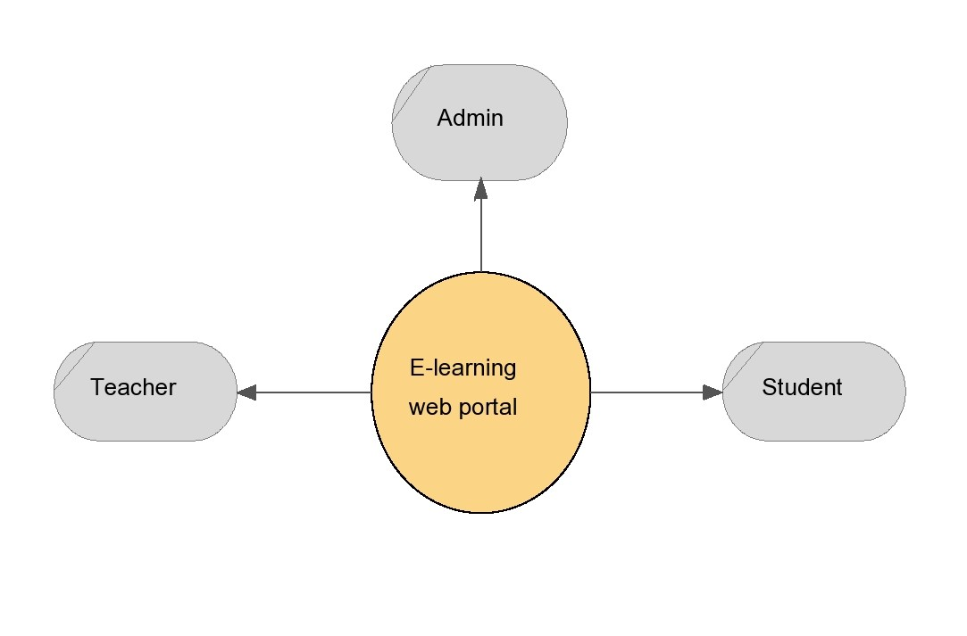

**Fig 10.1 Context Diagram**

**11 Detailed design**

***11.1 Data flow diagram***

Data flow diagram shows the relationship between the database and entities which clearly demonstrates accessing of modules and their operation.

***11.1.1 Data flow diagram of home page***

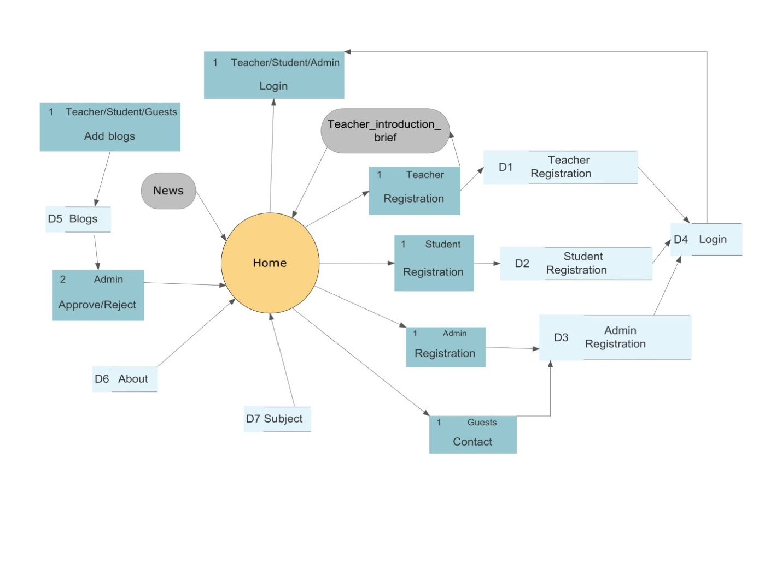

**Fig 11.1 Data Flow Diagram of Home Page**

***11.1.2 Data flow diagram of student home page***

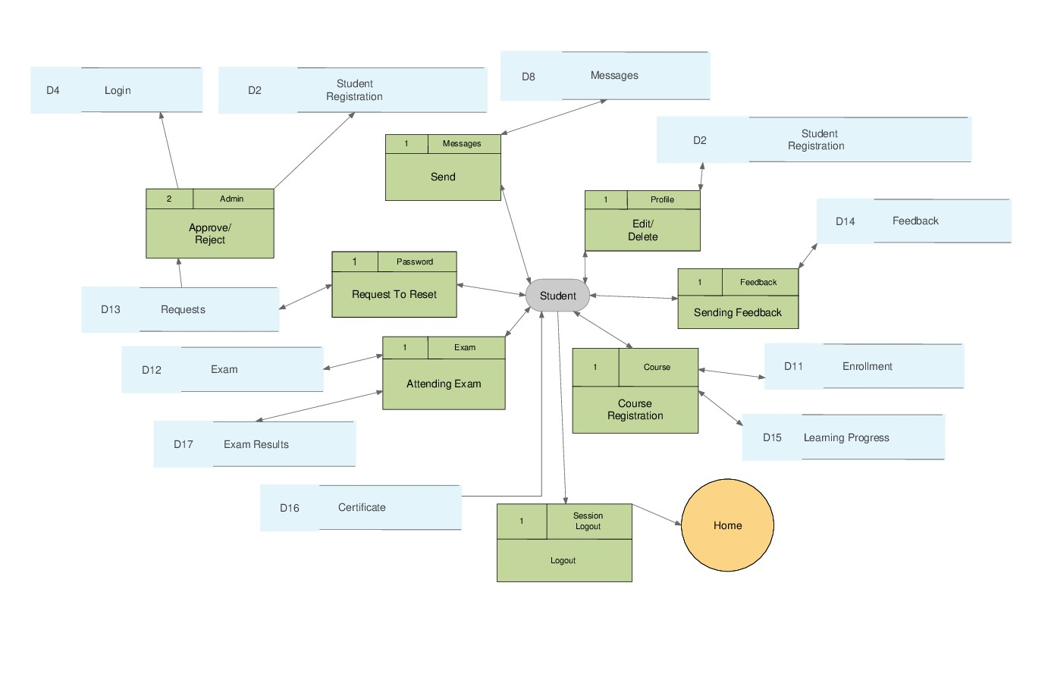

**Fig 11.2 Data Flow Diagram of Student Home Page**

***11.1.2 Data flow diagram of teacher home page***

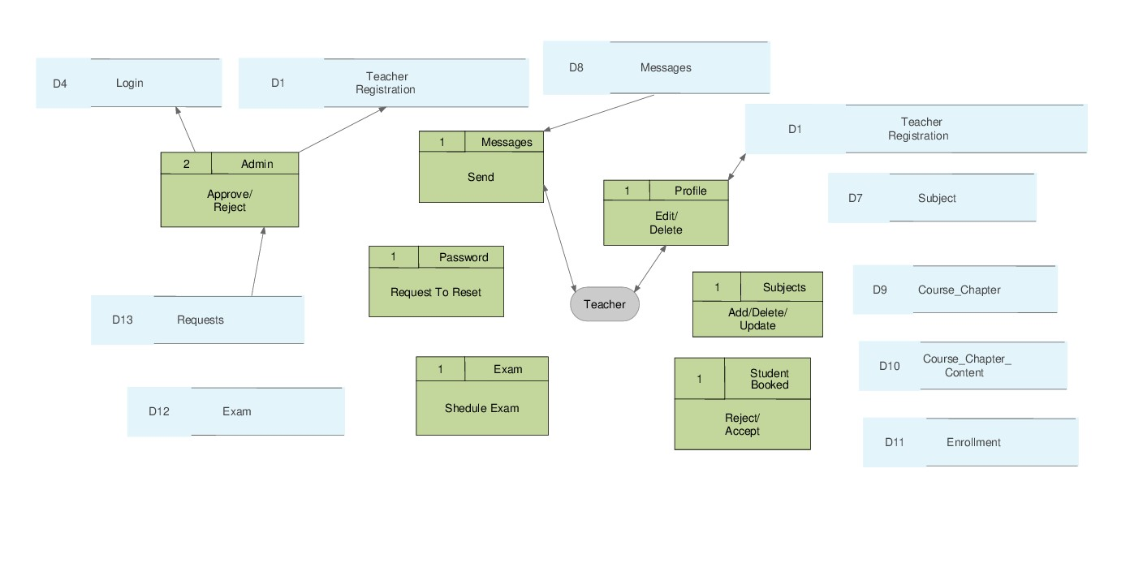

**Fig 11.3 Data Flow Diagram of Teacher Home Page**

***11.1.2 Data flow diagram of admin home page***

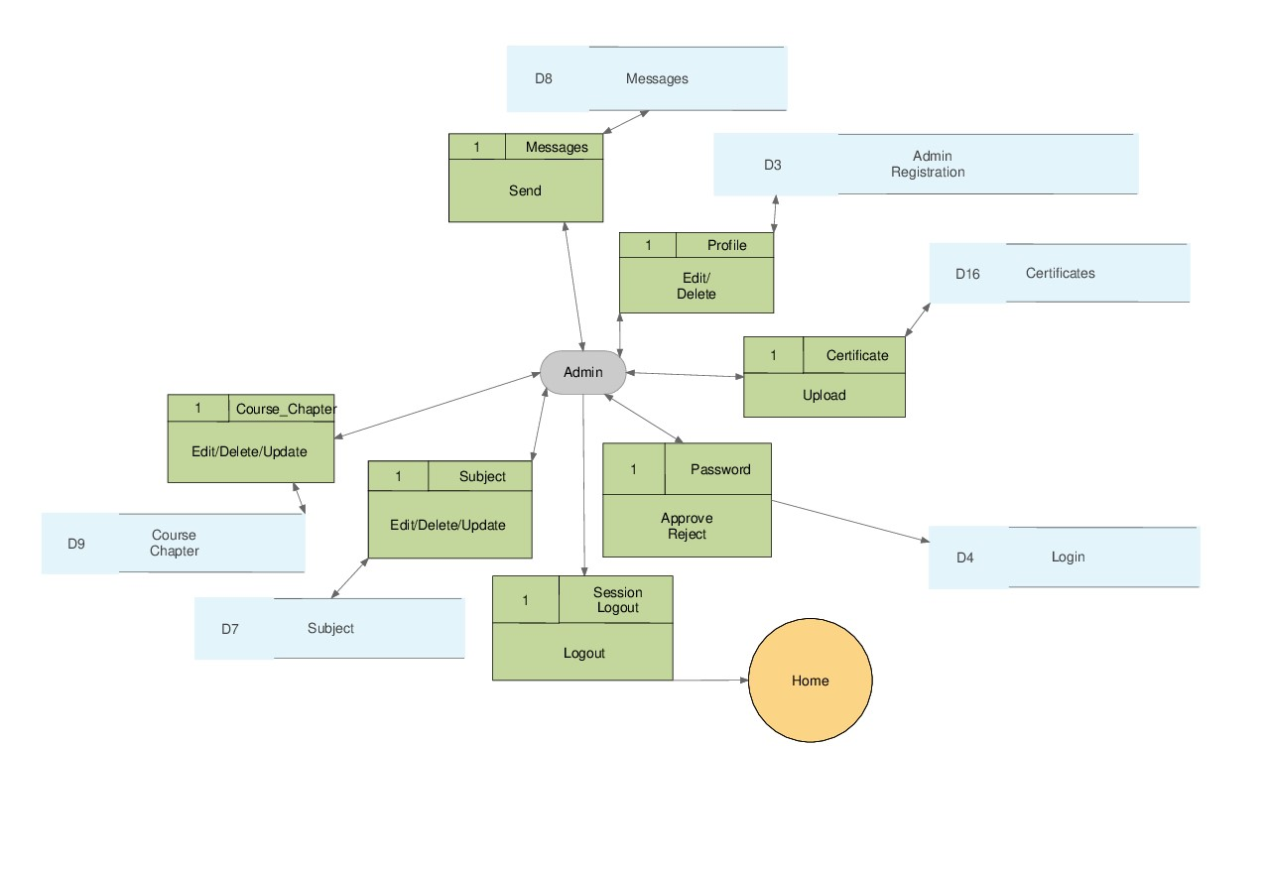

**Fig 11.4 Data Flow Diagram of Admin Home Page**

**12 Software testing**

Software testing must be done in order to know whether the system can meet client’s requirements. Testing helps us to figure out the bugs in project. Different software testing are as flows.

***12.1 Unit Testing***

Unit testing is a level of software testing where single unit/segment of software is tested. The main purpose is to test each unit of the software to check whether it performs as designed. It has one or more inputs and usually result will be a single output. Unit testing, a first level of software testing has been performed before the integrated testing is performed. While doing unit testing the length of the code can be reduced and code can be made simple. Unit testing is cost effective when compared to other software testing.

***12.2 Integrated Testing***

Integrated testing is the second level of testing where single units are combined and tested as a group. This testing is used to find out faults among the interaction between integrated units. Integrated testing has been done after completion of unit testing and before the system testing.

***12.3 Black-Box Testing***

In black-box testing the software tests only front end, it does not test the backend source code. Black-box testing is also known as behavioral testing. In black-box testing the testing is done from the user point of view. To test in black-box test method, accessing of code is not required. This testing method is well suitable for large code segments. Black-box testing is used to find out the errors like

* + - * Incorrect and missing functions
      * Interface errors
      * Errors in initialization and termination
      * Performance errors and so on.

***13 Test Cases***

### *13.1 Test cases for student module*

|  |  |  |  |  |
| --- | --- | --- | --- | --- |
| **Test case id** | **Test scenario** | **Expected output** | **Actual output** | **Result** |
| 1 | Student registration 1.Enter all the fields. 2.Click on ‘Register’  button. | Information will be stored in the database and ‘You have successfully registered’ message will be shown to student. | As expected | Pass |
| 2 | Student registration 1.Some fields left empty.  2.Click on ‘Register’  button. | “Please fill out this field” error message will be shown to student. | As expected | Fail |
| 3 | Student login  1. Enter valid email id. 2. Enter valid password.  3. Click on ‘Login’ button. | Student can successfully login and navigates the student to home page. | As expected | Pass |
| 4 | Student login   1. Enter invalid email id. 2. Enter password. 3. Click on ‘Login’ button. | “Email or password entered is incorrect” error message will be shown to student. | As expected | Fail |

|  |  |  |  |  |
| --- | --- | --- | --- | --- |
| 5 | Booking a course  1. Click on ‘Book a course’ button.  2. Select subject and click on ‘submit’ button.  3. Select course and click on ‘submit’ button.  4. Teacher details and course details will be displayed. Click on ‘Book course’ button.  5. Enter full payment and click on ‘Next’ button. | Booking information will be stored in the database and “You have successfully booked a course” message will be displayed to student. | As expected | Pass |
| 6 | Viewing booked courses  1. Click on ‘Booked courses’ button.  2. Booked courses will be displayed. If ‘Teacher response’ is not ‘To be expected’, click on ‘Acces chapters’ button  3. Select chapter and click on ‘Next’ button. | Chapter contents will be shown to student. | As expected | Pass |
| 7 | Viewing chapter content again  1. Click on ‘Booked courses’ button.  2. Booked courses will be displayed. If ‘Teacher response’ is not ‘To be expected’, click on ‘Acces chapters’ button. | ‘You have already finished this chapter’ message will be displayed to student. | As expected | Fail |
| 8 | Download certificate  1. Click on ‘Download certificate’ button.  2. Click on ‘Download’ button. | Certificate will be downloaded. | As expected | Pass |
| 9 | Update profile  1. Click on ‘My profile’ button.  2. Change registration details and click on ‘Update’ button. | Updated information will be stored in the database and “Profile updated” message will be displayed to student. | As expected | Pass |
| 10 | Feedback  1. Click on ‘Feedback’ button.  2. Select subject, course, rating score. Add text feedback also.  3. Click on ‘Submit’ button | Feedback will be stored in the database and “Thank you for your valuable feedback” message will be shown to student. | As expected | Pass |
| 11 | Give rating score for teachers  1. Click on ‘Value teacher’ button.  2. Select teacher and score and click on ‘Submit’ button | Rating score will be stored in the database and “Thank you for your valuable rating” message will be shown to student. | As expected | Pass |
| 12 | Change password  1. Click on ‘Change password’ button.  2. Enter new password and click on ‘Submit’ button. | “Please wait for your password approval.. Continue to use old password” message will be shown to student. | As expected | Pass |
| 13 | Examination notification  1. Click on ‘Exam’ button  2. Click on ‘Exam notification’ button. | Scheduled exam details to the student will be displayed. | As expected | Pass |
| 14 | Attending examination  1. Click on ‘Exam’ button.  2. Click on ‘Start test’ button. | Examination stop time, questions, and options will be shown to student when the start time is reached. | As expected | Pass |
| 15 | Attending examination  1. Click on ‘Exam’ button.  2. Click on ‘Start test’ button. | ‘No exam is scheduled on today’ message will be shown to student when the start time is not reached. | As expected | Fail |
| 16 | Exam results  1. Click on ‘Exam’ button.  2. Click on ‘Exam result’ button. | Exam results will be displayed to student. | As expected | Pass |
| 17 | Message  1. Click on ‘Messages’ button.  2. Inbox messages will be displayed if any. Click on ‘Send message’ button.  3. Enter email address of recipient.  4. Enter message content and click on ‘Send’ button. | ‘Message sent successfully’ message will be shown to student. | As expected | Pass |

### *13.2 Test cases for teacher module*

|  |  |  |  |  |
| --- | --- | --- | --- | --- |
| **Test case id** | **Test scenario** | **Expected output** | **Actual output** | **Result** |
| 1 | Teacher registration  1. Enter all the fields. 2. Click on ‘Register’  button. | Information will be stored in the database and ‘You have successfully registered’ message will be shown to student. | As expected | Pass |
| 2 | Teacher registration 1.Some fields left empty.  2.Click on ‘register’  button. | “Please fill out this field” error message will be shown to teacher. | As expected | Fail |
| 3 | Teacher login  1. Enter valid email id. 2. Enter valid password.  3. Click on ‘Login’ button. | Teacher can successfully login and navigates the teacher to home page. | As expected | Pass |
| 4 | Student login   1. Enter invalid email id. 2. Enter password. 3. Click on ‘Login’ button. | “Email or password entered is incorrect” error message will be shown to teacher. | As expected | Fail |

|  |  |  |  |  |
| --- | --- | --- | --- | --- |
| 5 | Update profile  1. Click on ‘Update profile’ button.  2. Change registration details and click on ‘Update’ button. | Updated information will be stored in the database and “Updated successfully” message will be displayed to teacher. | As expected | Pass |
| 6 | Viewing student progress  1. Click on ‘Student progress’ button. | Booked student details and status of completion will be displayed. | As expected | Pass |
| 7 | Change password  1. Click on ‘Change password’ button.  2. Enter new password and click on ‘Submit’ button. | “Please wait for your password approval.. Continue to use old password” message will be shown to teacher. | As expected | Pass |
| 8 | Add/edit/delete subject  1. Click on ‘Topics’ button.  2. Click on ‘Subject’ button. | Teacher’s registered course details will be displayed where instructor can add/edit/delete courses. | As expected | Pass |
| 9 | Add/edit/delete chapter  1. Click on ‘Topics’ button.  2. Click on ‘Chapter’ button. | Chapter details will be displayed where instructor can add/edit/delete chapters. | As expected | Pass |
| 10 | Add/edit/delete course content  1. Click on ‘Topics’ button.  2. Click on ‘Chapter content’ button. | Chapter content details will be displayed where instructor can add/edit/delete chapter content. | As expected | Pass |
| 11 | Student booked details  1. Click on ‘Student booked details’ button | Student booked details will be displayed where instructor can accept/reject/delete booked students. | As expected | Pass |
| 12 | Scheduling examination  1. Click on ‘Schedule a test’ button.  2. Select candidates for the examination.  3. Enter number of questions, examination start and stop time.  4. Click on ‘Submit’ button.  5. Enter questions, options, and correct answers.  6. Click on ‘Add next question/options’. | After predefined number of questions and answers were entered, ‘Exam scheduled successfully’ message will be shown to teacher. | As expected | Pass |
| 13 | Deleting exam schedule  1. Click on ‘Exam’ button.  2. Click on ‘Delete scheduled test’ button.  3. Scheduled test details will be displayed. Click on ‘Delete’ button. | Examination information will be permanently deleted from the database. | As expected | Pass |
| 14 | Exam results  1. Click on ‘Exam’ button.  2. Click on ‘Exam results’ button. | Exam results will be displayed to teacher. | As expected | Pass |
| 15 | Message  1. Click on ‘Messages’ button.  2. Inbox messages will be displayed if any. Click on ‘Send message’ button.  3. Enter email address of recipient.  4. Enter message content and click on ‘Send’ button. | ‘Message sent successfully’ message will be shown to teacher. | As expected | Pass |
| 16 | Attendance  1. Click on ‘Give attendance’ button.  2. Select student.  3. Enter attendance in number of days.  4. Click on ‘Submit’ button. | ‘Attendance given’ message will be shown to teacher. | As expected | Pass |

### *13.3 Test cases for admin module*

|  |  |  |  |  |
| --- | --- | --- | --- | --- |
| **Test case id** | **Test scenario** | **Expected output** | **Actual output** | **Result** |
| 1 | Admin registration 1.Enter all the fields. 2.Click on ‘register’  button. | Information will be stored in the database and registration successful message will be shown to admin. | As expected | Pass |
| 2 | Admin registration  1. Enter all the fields.  2. Click on ‘register’  button. | If an admin already exists for website, “You are not allowed to be registered as admin” message will be shown to the user. | As expected | Fail |
| 3 | Admin login  1. Enter valid email id. 2. Enter valid password.  3. Click on ‘Login’ button. | Admin can successfully login and navigates to admin home page. | As expected | Pass |
| 4 | Admin login   1. Enter invalid email id. 2. Enter password. 3. Click on ‘Login’ button. | “Email or password entered is incorrect” error message will be shown to admin. | As expected | Fail |
| 5 | Update profile  1. Click on ‘Update profile’ button.  1. Click on ‘Edit my profile’ button.  2. Click on ‘Submit’ button. | Updated information will be stored in the database and “You have successfully updated your profile” message will be displayed to admin. | As expected | Pass |
| 6 | Update profile  1. Click on ‘Resign from administration’ button. | Admin registered information will be permanently deleted from the database and new admin can be registered. | As expected | Pass |
| 7 | Blogs  1. Click on ‘Blogs’ button. | Admin can approve/reject/delete blogs added by guests. | As expected | Pass |
| 8 | Upload certificate  1. Click on ‘Certificate’ button.  2. Click on ‘Upload certificate’ button.  3. Select student.  4. Upload certificate.  5. Click on ‘Submit’ button. | ‘Certificate uploaded successfully’ message will be displayed to admin. | As expected | Pass |
| 9 | Delete certificate  1. Click on ‘Certificate’ button.  2. Click on ‘Delete certificate’ button.  3. Click on ‘Delete’ button. | Certificate will be permanently deleted from the database. | As expected | Pass |
| 10 | About website  1. Click on ‘About website’ button.  2. Enter content.  3. Click on ‘Add’ button. | ‘Content added successfully’ message will be displayed to admin. | As expected | Pass |
| 11 | Block members  1. Click on ‘Block a member’ button.  2. Click on Block/Allow button. | Member will be blocked/allowed from login to website. | As expected | Pass |
| 12 | Feedbacks  1. Click on ‘Feedbacks’ button.  2. Feedbacks, rating score of courses, and student details will be displayed.  3. Click on ‘Delete’ button. | Selected feedback will be permanently deleted from the database. | As expected | Pass |
| 13 | Password requests  1. Click on ‘Password requests’ button.  2. Click on ‘Approve’ button. | Password of corresponding user will be changed permanently. | As expected | Pass |
| 14 | Member messages  1. Click on ‘Messages’ button.  2. Click on ‘Member messages’ button.  3. Click on ‘Delete’ button for read messages.  4. Click on ‘Reply’ button to reply back.  5. Click on ‘Send message’ to send message.  6. Select email-id  7. Enter message content.  8. Click on ‘Send’ button. | ‘Message sent successfully’ message will be shown to admin. | As expected | Pass |
| 15 | Guest messages  1. Click on ‘Messages’ button.  2. Click on ‘Guest messages’ button.  3. Messages send by guests will be displayed  4. Click on ‘Delete’ button. | ‘Message deleted successfully’ message will be shown to admin. | As expected | Pass |
| 16 | Edit/delete subject  1. Click on ‘Topics’ button.  2. Click on ‘Subject’ button. | Teacher’s registered course details will be displayed and admin can edit/delete courses. | As expected | Pass |
| 17 | Edit/delete chapter  1. Click on ‘Topics’ button.  2. Click on ‘Chapter’ button. | Chapter details will be displayed and admin can edit/delete chapters. | As expected | Pass |
| 18 | Edit/delete chapter content  1. Click on ‘Topics’ button.  2. Click on ‘Chapter content’ button. | Chapter content details will be displayed and admin can edit/delete chapters. | As expected | Pass |

**Conclusion**

The e-learning is emerging as the future trend of learning that would be dominant in the times ahead. E-Learning has created new dimensions in education, both within and beyond the curriculum and is still looking at further opportunities of becoming more practical. A word of concern at this juncture would serve good, though, the e-learning seems to be a solution for an absent teacher, deploying such an atmosphere would be requiring much thought. Both the instructor and the learner need to shift their methods of teaching and learning. Educational Institutions need to have suitable strategies in place for successful deployment of the e-learning process. But, call it Web-based Training (WBT) or Border-less Education; e-learning is here to stay. We can strongly believe that e-learning will soon substitute classroom learning. This project clearly uplifts the fact that user-friendly e-learning web portal may replace conventional class room tutoring in near future. Courses included in this web portal are highly appreciated by students and instructors of all streams.

References:

WAGNER, N.; HASSANEIN, K.; HEAD, M. Who is responsible for e-learning success in higher education?: A stakeholders' analysis. Educational Technology & Society, v.11, n.3, p.26-36, 2008. Available: <http://www.ifets.info/journals/11_3/3.pdf>.

MALIK, S. E-learning in India: The electronic way of learning. Merinews, Apr. 2, 2009. Available: <http://www.merinews.com/article/e-learning-in-india-the-electronicway-to learning/15764276.shtml>.

SAHA, S. E-learning in India. GoArticles, 2010. Available: <http://www.goarticles.com/cgi-bin/showa.cgi?C=2741690>.

HANSEN, H. B. India: E-Learning has potential to manage teacher shortage. OWL Institute, 2008. Available: <http://owli.org/oer/node/2469>.

BANDUNI, M. The future of e-learning in India: Weekly insights for technology professionals. Weekly Insights for Technology Professionals, Mumbai, 2005. Available: <http://www.expresscomputeronline.com/20051114/market03.shtml>.

ROSENBERG, M. E-Learning: strategies for delivering knowledge in the digital age, McGraw-Hill, New York, 2001.

SCHAPIRE, R.E. The boosting approach to machine learning: An overview. In nonlinear estimation and classification. Springer New York, 2003.

VERNON, D.; METTA, G; SANDINI. “A survey of artificial cognitive systems: Implications for the autonomous development of mental capabilities in computational agents”. IEEE Trans. Evol. Comput, 2007.

HEBB, D.O. “The organization of behavior”. J.Appl.Behav.Anal, 1949.