**Healthcare Chatbot**

This is a Python-based project for dealing with human symptoms and predicting their possible outcomes.

**Project Goal**

The primary goal of this project is to forecast the disease so that patients can get the desired output according to their primary symptoms.

**Technology used**

We used [**TKinter**](https://docs.python.org/3/library/tkinter.html) to create a desktop-based application and [**Spacy**](https://spacy.io/) for NLP-based processes like ***text sentence tokenization and lemmatization***, and we used a [**Huggingface**](https://huggingface.co/) pretrained model to extrat disease names from a given sentence ***( or ner processing)***.

**Huggingface**

Downloading pre-trained model from [Huggingface Model](https://huggingface.co/raynardj/ner-disease-ncbi-bionlp-bc5cdr-pubmed)

from transformers import pipeline

PRETRAINED = "raynardj/ner-disease-ncbi-bionlp-bc5cdr-pubmed"

ners = pipeline(task="ner",model=PRETRAINED, tokenizer=PRETRAINED)

**Spacy**

Download [spacy](https://spacy.io/usage) For window, Linux, MacOS

pip install -U pip setuptools wheel

pip install -U spacy

python -m spacy download en_core_web_sm

**Installation**

Use the package manager [pip](https://pip.pypa.io/en/stable/) to install the requirements.txt file package.

pip install -r requirements.txt

**Output Image**

**First opening window**

[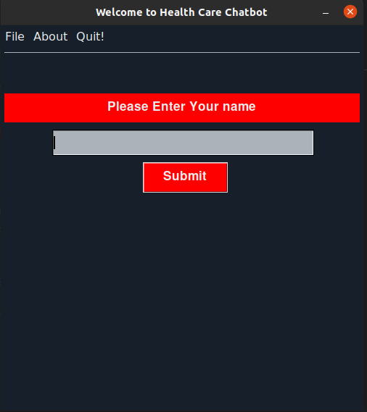](https://github.com/Durgesh63/HealthCare_ChatBot/blob/master/firstwindow.png?raw=true)

**Main Opening Window**

[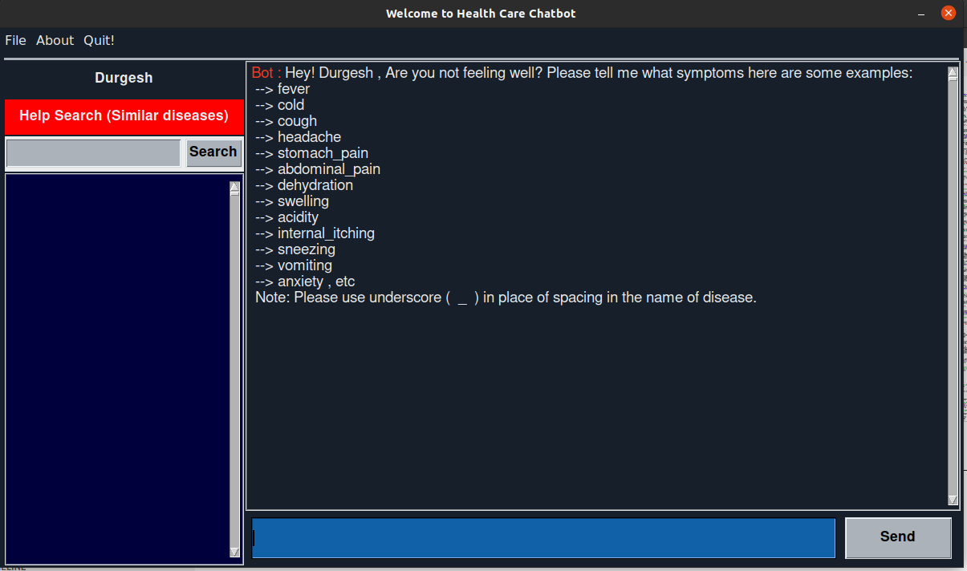](https://github.com/Durgesh63/HealthCare_ChatBot/blob/master/main_window.png?raw=true)