**Navbar**

[Navbar](https://camo.githubusercontent.com/501f126000dd1fe5a17e9c8970ab526f3112c75ad5c7bf0f5ebffa737fe72119/68747470733a2f2f6d69726f2e6d656469756d2e636f6d2f6d61782f3730302f312a37614d4b49506e7a6e6e382d4846643555796d6263512e706e67)

**Car tempo**

[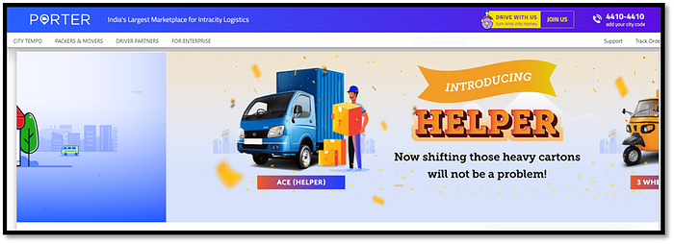](https://camo.githubusercontent.com/1c92c2c3139f0963137f6d9c958673b5d4731845bc401f2ca12c7aab06daf5c5/68747470733a2f2f6d69726f2e6d656469756d2e636f6d2f6d61782f3730302f312a675a334747576a70344c7a54746f34356654716a39512e706e67)

[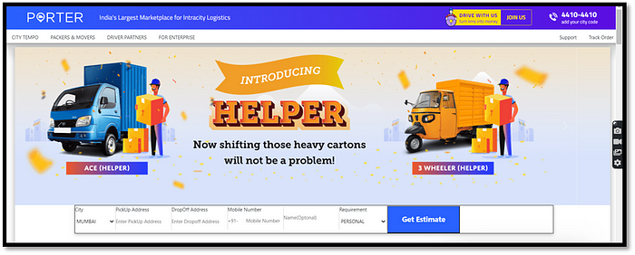](https://camo.githubusercontent.com/aa6caa6e518cbc59b1a7410066cfe8c9d41f436e7108fa1826676f7b554bce41/68747470733a2f2f6d69726f2e6d656469756d2e636f6d2f6d61782f3730302f312a74702d64504553656947426c427a71454e4a68496f412e706e67)

**Packers & Movers**

**Here you can see this is Porter’s Packers and Movers Page**

[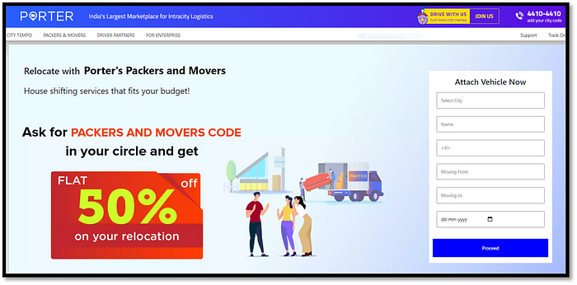](https://camo.githubusercontent.com/e0392d0b1fd0cd30326d59d1dbdee8b39a7b79c4b856c92b63d6a15f39a5d09d/68747470733a2f2f6d69726f2e6d656469756d2e636f6d2f6d61782f3730302f312a6130515f33543337726b4c486277426e6952337774412e706e67) [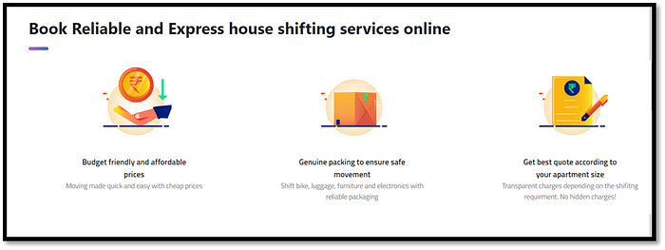](https://camo.githubusercontent.com/18f13e406bac05b60c11cb42dc49d169a468ec636d8e65703c071ef8bf52cad7/68747470733a2f2f6d69726f2e6d656469756d2e636f6d2f6d61782f3730302f312a4e58746c6d416a54454a696d526b77694732726235672e706e67) [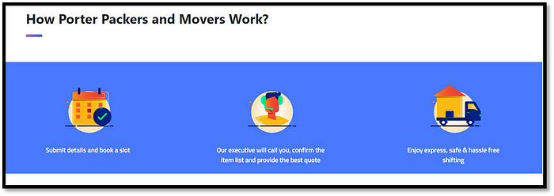](https://camo.githubusercontent.com/cbf6917c88a7cb2b23b26094797819f88b6bd9de6684b58056f7206b0efa2da9/68747470733a2f2f6d69726f2e6d656469756d2e636f6d2f6d61782f3730302f312a6263685730444d4d4c474473496173786e7833334f672e706e67) [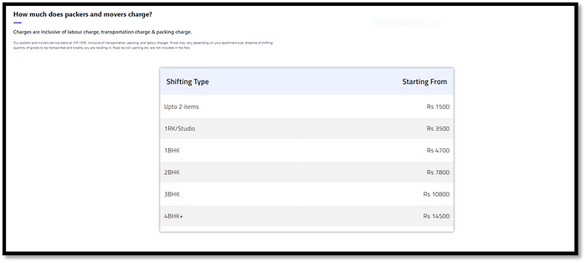](https://camo.githubusercontent.com/f5a0391f1cbafcf411586cbe50d7a1bf2da3babdb76f18add1ff2356314b34d4/68747470733a2f2f6d69726f2e6d656469756d2e636f6d2f6d61782f3730302f312a444d7a6e4136416e322d5031595577417630523130512e706e67) [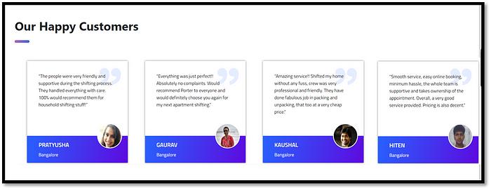](https://camo.githubusercontent.com/b3b39ddcc0edb420d79b11880a25f2b28899f3d9321bf577059719cab3309840/68747470733a2f2f6d69726f2e6d656469756d2e636f6d2f6d61782f3730302f312a3252377a786c486f6d574356336f456b553443652d672e706e67)

**Driver Partners**

[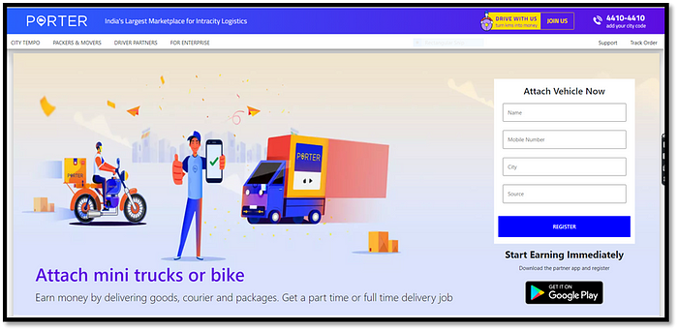](https://camo.githubusercontent.com/e74ba8276495a1ee6b7f05e63c9bf96b1cced7a659f0442c6cc141987a5d74f9/68747470733a2f2f6d69726f2e6d656469756d2e636f6d2f6d61782f3730302f312a457038444b4958463665424f594b4169444e6a7144512e706e67)

[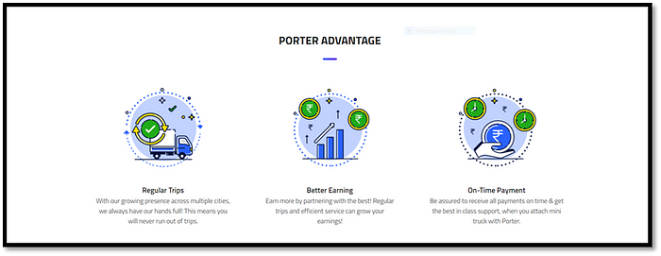](https://camo.githubusercontent.com/9aa6d6f3fbd36a8ce88fd8d419f35e19a077bdd01af4ef200aef91fb217c8c19/68747470733a2f2f6d69726f2e6d656469756d2e636f6d2f6d61782f3730302f312a54337a5431534f4e384f6f54734f79514b766f7232512e706e67)

[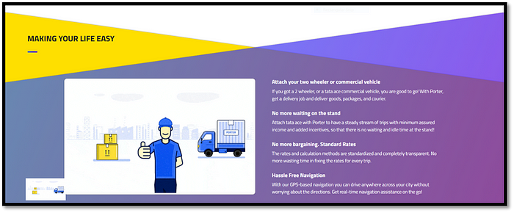](https://camo.githubusercontent.com/54af867c7cee5f7f6b0e7cd1cec49f7a6ba9961bcf0ffd79bcd01deae01e3d81/68747470733a2f2f6d69726f2e6d656469756d2e636f6d2f6d61782f3730302f312a494e69615977394b5132487171673967516a64716a412e706e67)

**Enterprise page**

[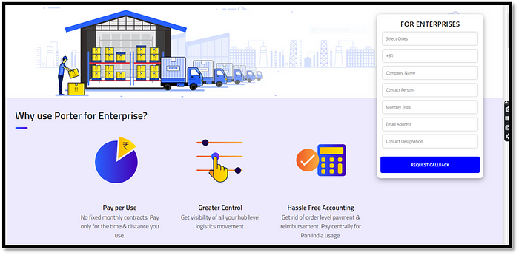](https://camo.githubusercontent.com/d12dfd1c0f28cb3ffd1b32921f185ac3c5e43cef7710d2728cc0c139f7ddfa2a/68747470733a2f2f6d69726f2e6d656469756d2e636f6d2f6d61782f3730302f312a714d725431646a5a476654456b5958566f67384b6e512e706e67)

**support**

[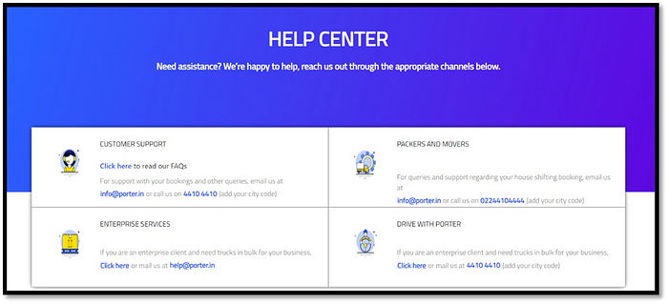](https://camo.githubusercontent.com/b859ae555d554afaa77915dde9ce8dd81cb36a5c1006c33d307bb318a0e072e4/68747470733a2f2f6d69726f2e6d656469756d2e636f6d2f6d61782f3730302f312a7a6652466f62646c387872755538737a5770424572412e706e67)

**track order**

here you can track your order. [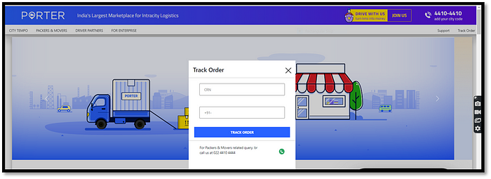](https://camo.githubusercontent.com/609522c33e5fa6bbae4d4e858964bca094669867d44df81a63a798e0ef04eca5/68747470733a2f2f6d69726f2e6d656469756d2e636f6d2f6d61782f3730302f312a495459373758343461464f752d4242646674476868772e706e67)

**Footer**

This footer is coming on all pages making it easy to check other pages in an easy fashion. Whenever you have a problem like booking tempo, a two-wheeler whatever you have to problem. We are here to help you. [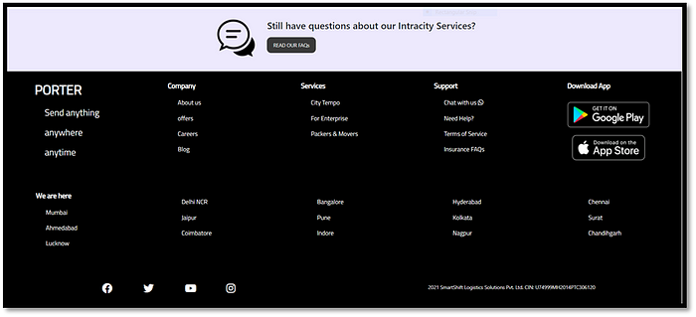](https://camo.githubusercontent.com/5102a539b16733f7bfe22bc7166ddc6e541d625bc300f4868b3dd1f1b25c13ad/68747470733a2f2f6d69726f2e6d656469756d2e636f6d2f6d61782f3730302f312a64737831324f53597a4953374a3174756374755747772e706e67)