Assignment – 2

• Connect to the Store Sales Data and do the following: -

− Remove all the blank rows. − Update the column header if they are not updated − Create a text table and show the sales in terms of o Customers o Product Category o Regions

1. − Remove all the blank rows

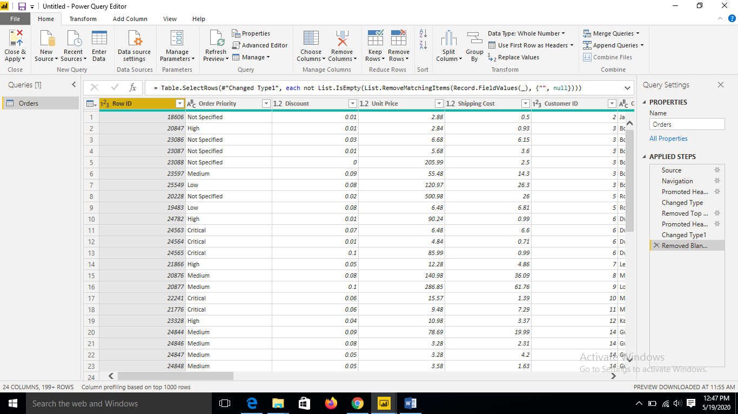

2. Update the column header if they are not updated

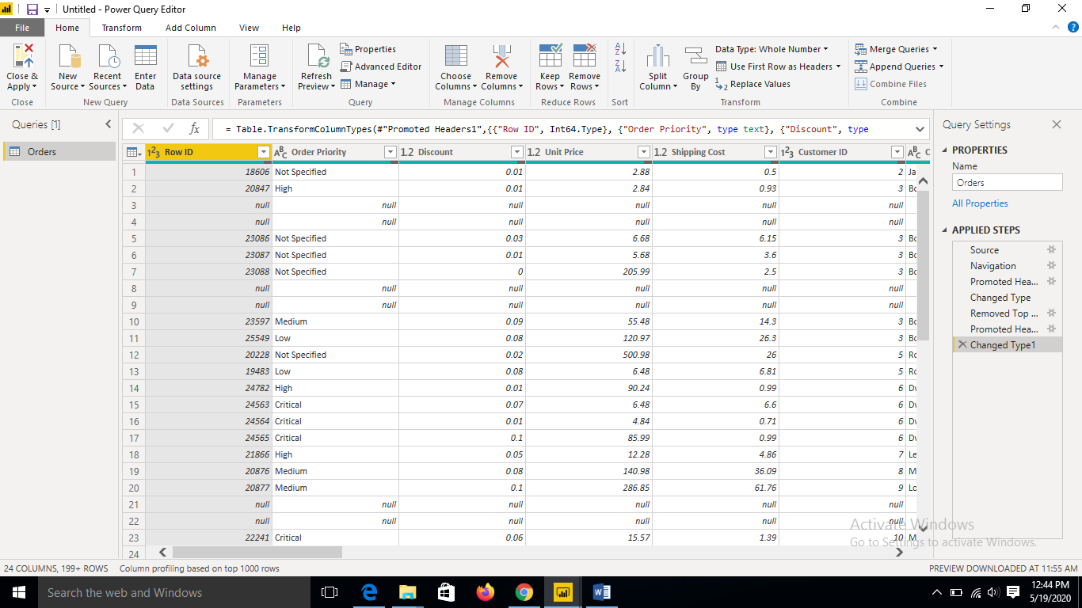

Create a text table and show the sales in terms of o Customers o Product Category o Regions

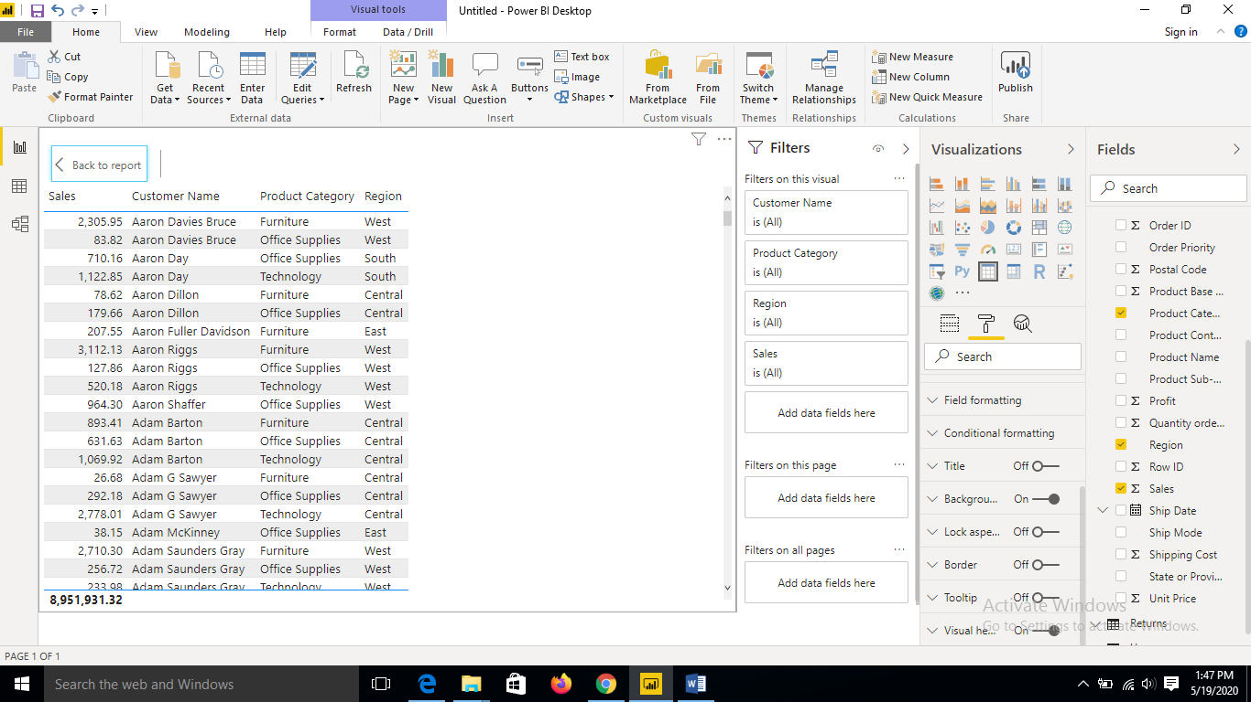

• Create a line and Clustered Column Chart showing the Sales and Discount as per the State or Province

− Format the bars and line with different colors − Which state has the highest sales in terms Technology

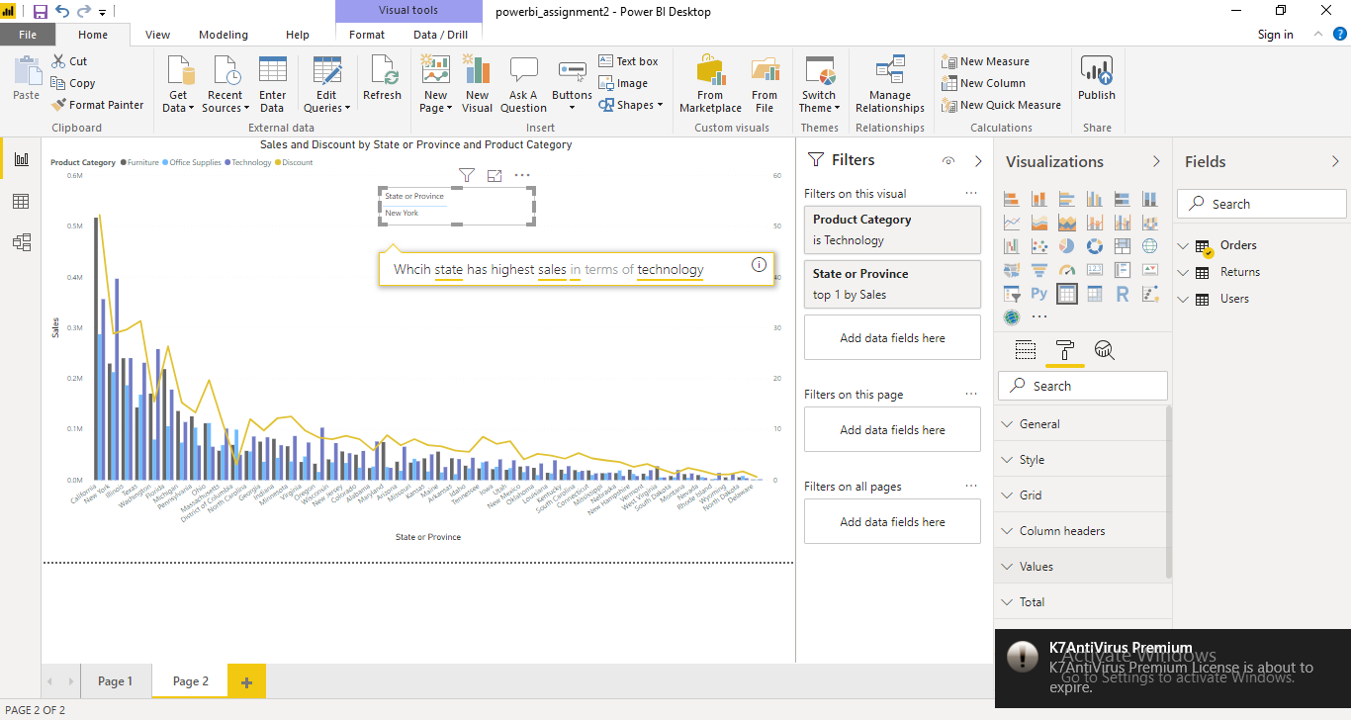

• Create a Donut Chart showing sales in terms of Product category

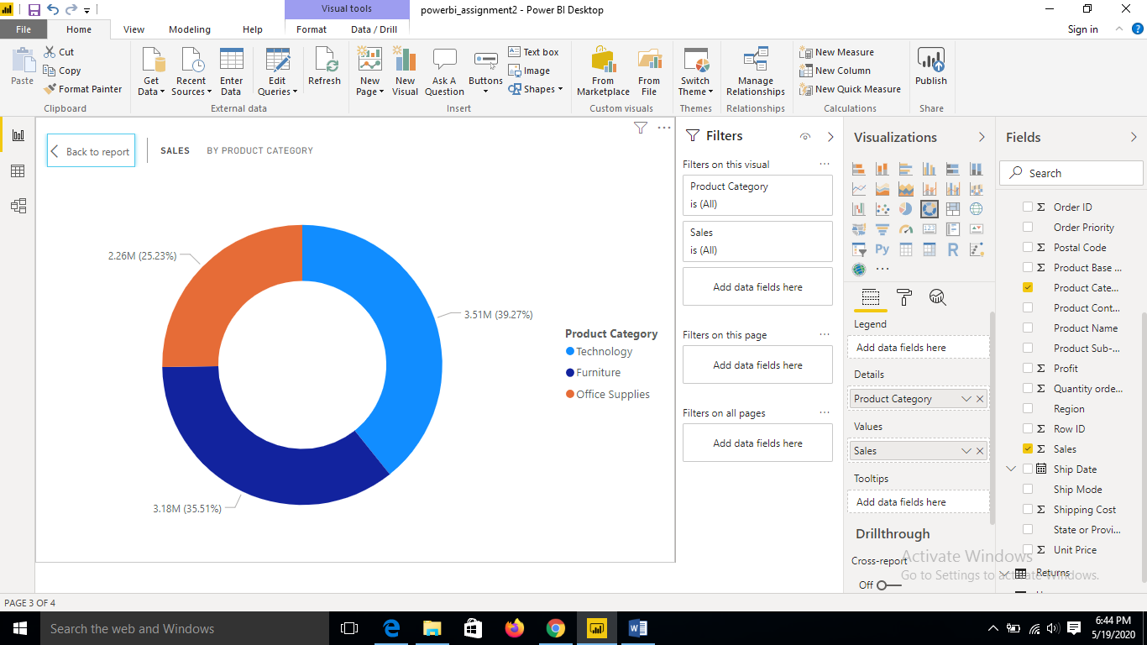

Create a Slicer and show the regions in dropdown. See how all the visuals mentioned above behaving when a particular region is selected.

