Install Power BI Desktop and share the final screenshot of the report view page which appears when power desktop starts.

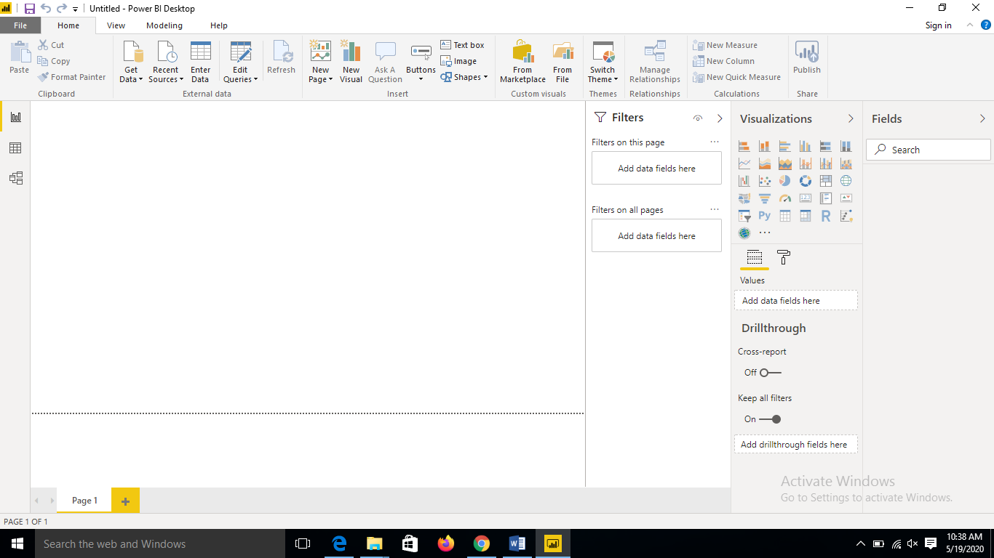

• Prepare a document and with the following screenshot − Report View − Data View − Model View − Power Query Editor − Advance Editor

Report View

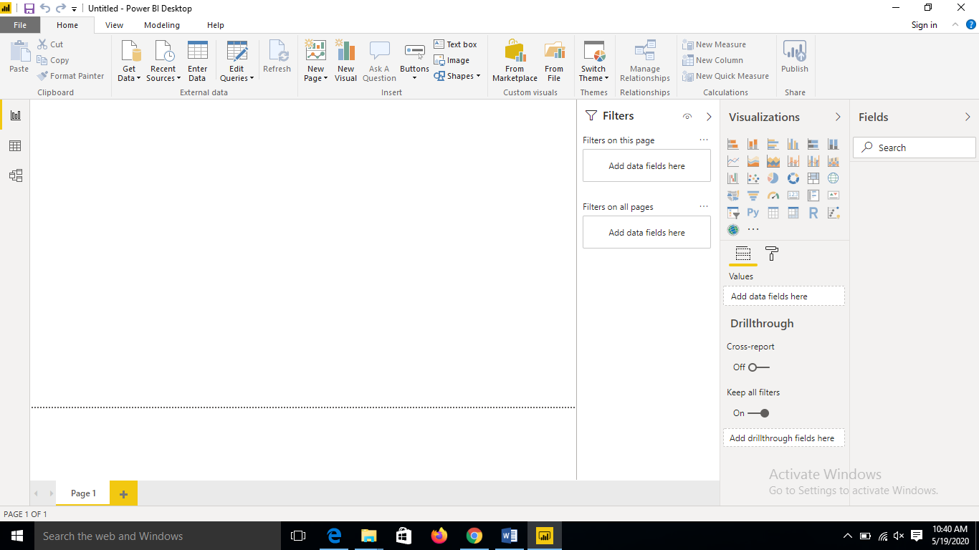

Data view

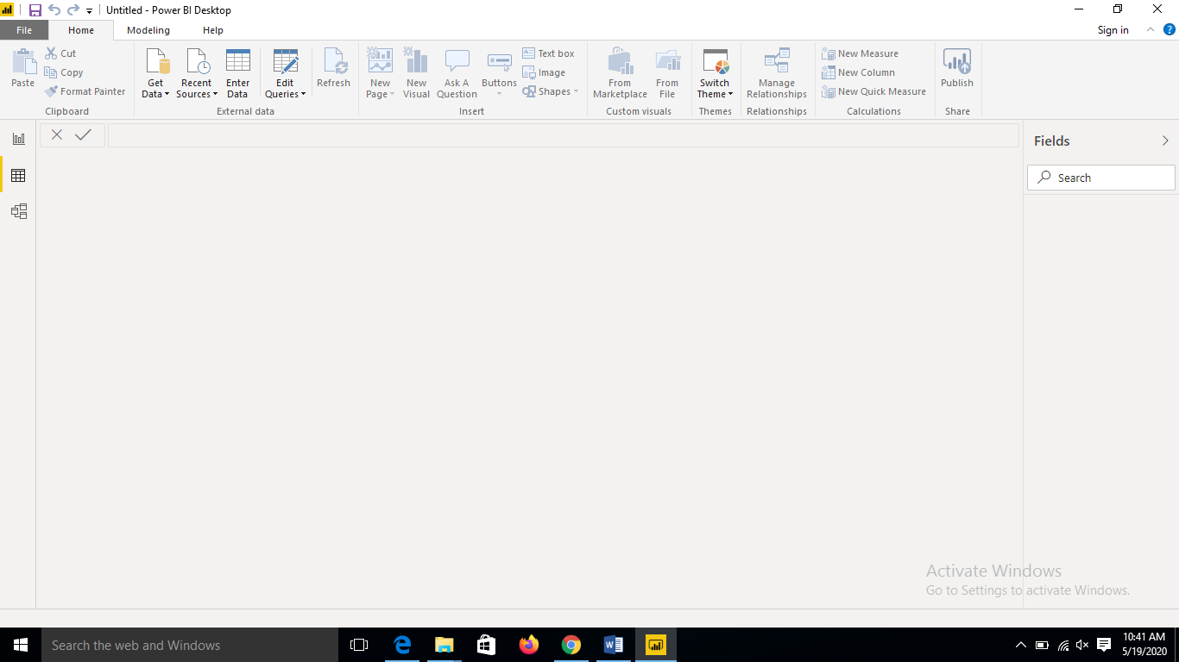

Model View

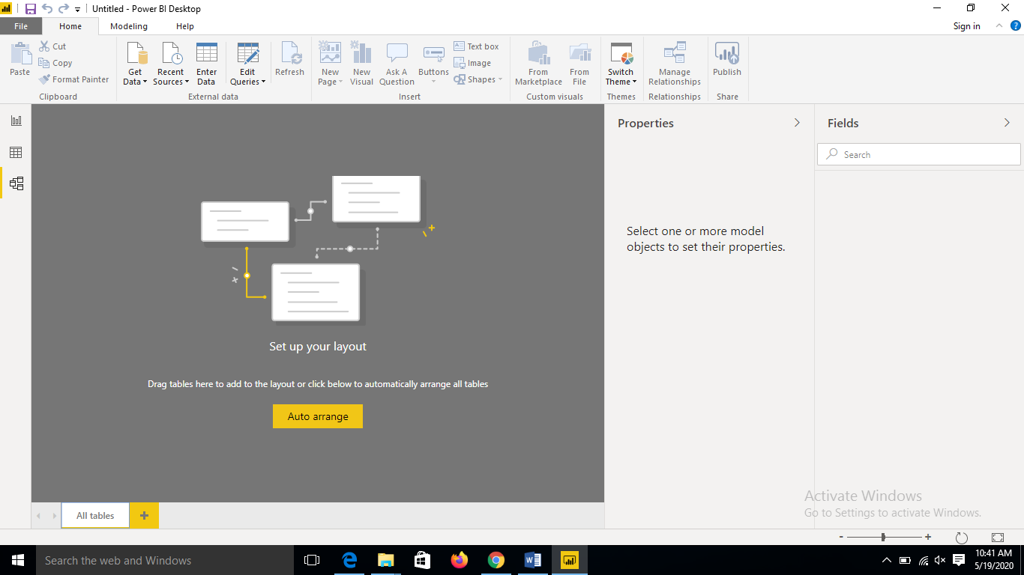

Power query editor

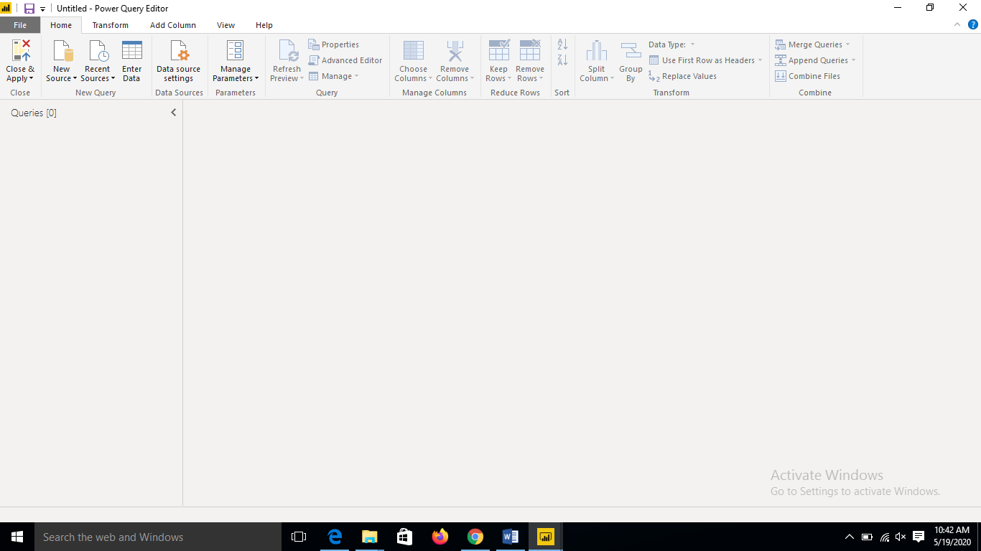

Advanced editor

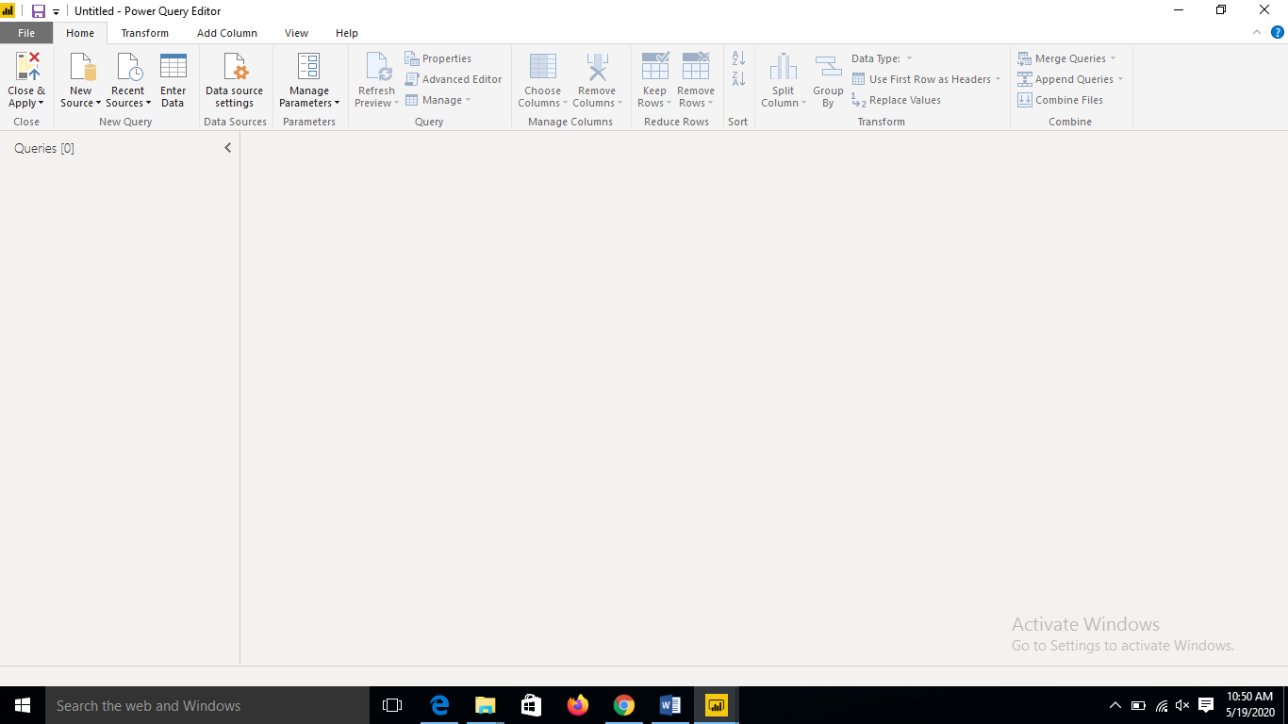

**• Prepare a document with details of the following along with their price**

**− Power BI Desktop − Power BI Pro − Power BI Premium**

**Power BI Desktop** is a free application you install on your local computer that lets you connect to, transform, and visualize your data. With **Power BI Desktop**, you can connect to multiple different sources of data, and combine them (often called modeling) into a data model

**Power BI Pro** is an individual user license that lets users read and interact with reports and dashboards that others have published to the **Power BI** service. Users with this license type can share content and collaborate with other **Power BI Pro** users.

**Power BI Premium** is a tenant-level Office 365 subscription available in two SKU (Stock-Keeping Unit) families: P SKUs (P1-P5) for embedding and enterprise features, requiring a monthly or yearly commitment, billed monthly, and includes a license to install **Power BI** Report Server on-premises.

Power BI Desktop – Free

PowerBI Pro - $9.99 - Monthly price per user

Power BI Premium - $4995 - Monthly price per dedicated cloud compute and storage resource with annual subscription