**PART 1**

**1.Design and model Two classes**

**2)ALGORITHM**

Step1: Start

Step2:Define ticket class

Step 3 : Define checkout class

Step 4: Define the variables

Step 5:Import ticket & checkout class into main function

Step 6:Print Welcome message

Step 7:The customer can choose Child, Adult, Senior/Concession

Step 8:Enter Number of tickets in child,Adult,Senior/concession

Step 9:Enter yes/no if more number of tickets is necessary

Step 10:Print total amount to pay

Step 11:call the checkout function

Step 12:Enter card details to pay

Step 13:Display ticket confirmed with number of tickets in each category

Step 14:Open a text file & write into it , transactions.txt

Step 15: Close the text file

Step 16: End

**3) CLASS DIGRAM FOR TICKET & CHECKOUT**

**TICKET CLASS DIAGRAM CHECKOUT CLASS DIGRAM**

setChildTicketPrice(integer)

getChildTicketPrice():integer

setAdultTicketPrice(integer)

getAdultTicketPrice():integer

setSeniorTicketPrice(integer)

getSeniorTicketPrice():integer

setTotal(integer)

getTotal():integer

setCardNumber(integer)

getCardNumber():integer

setName(string)

getName():string

setExpirydate(integer)

getExpirydate():integer

setCVV(integer)

getCVV():integer

**PART 2**

**ACTIVITY FLOW CHART :**

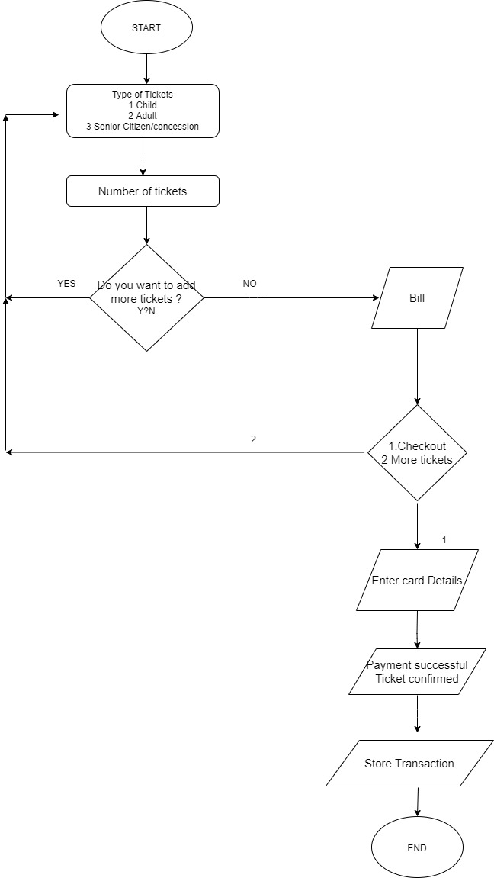

**3. Computer Program**

**ticket.py**

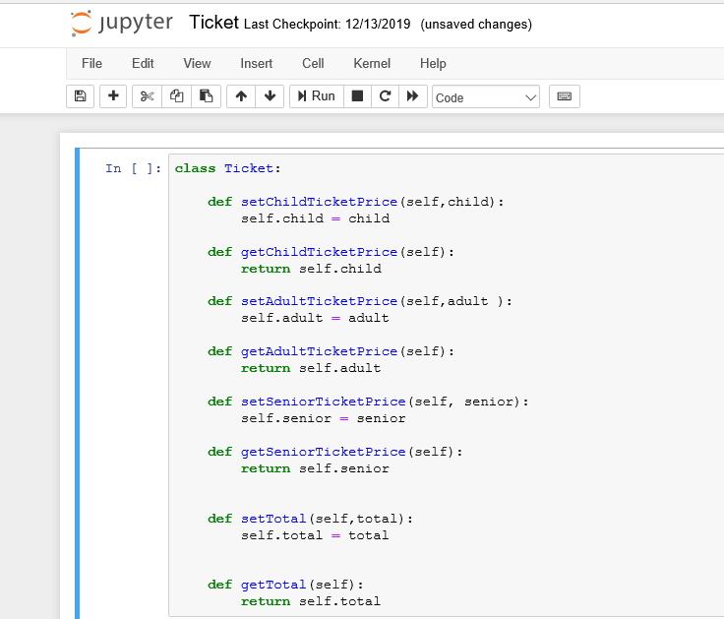

**checkout.py**

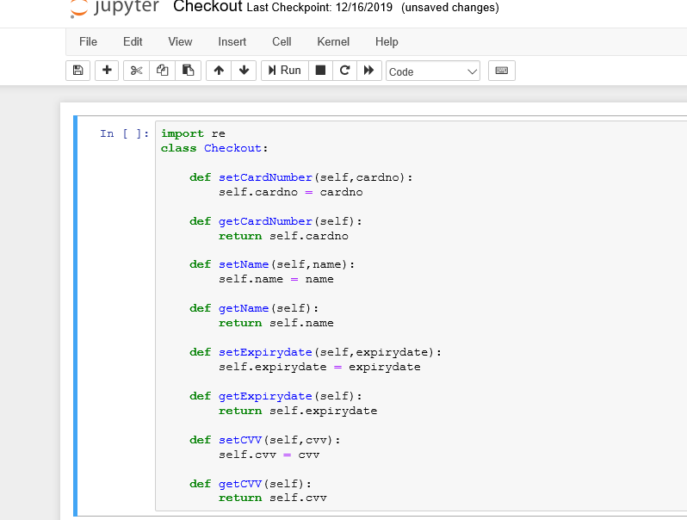

**Main.py**

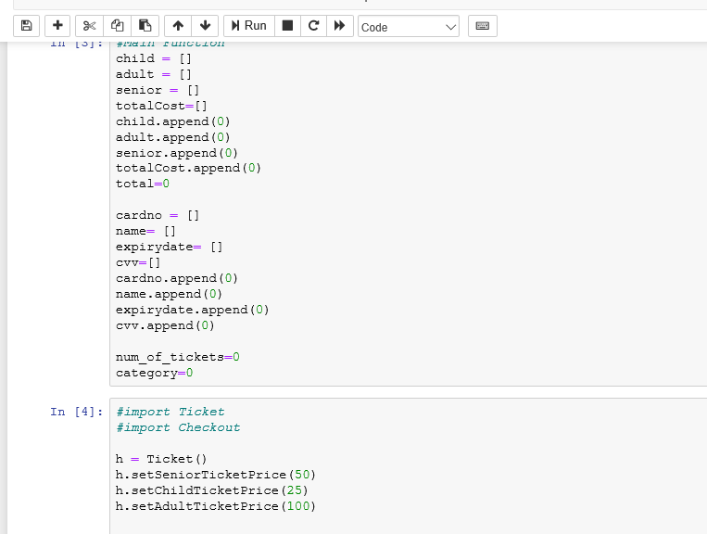

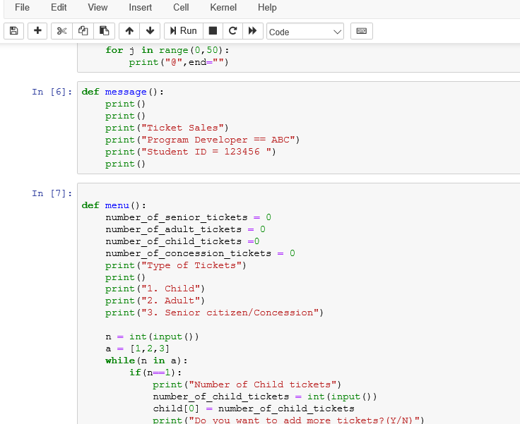

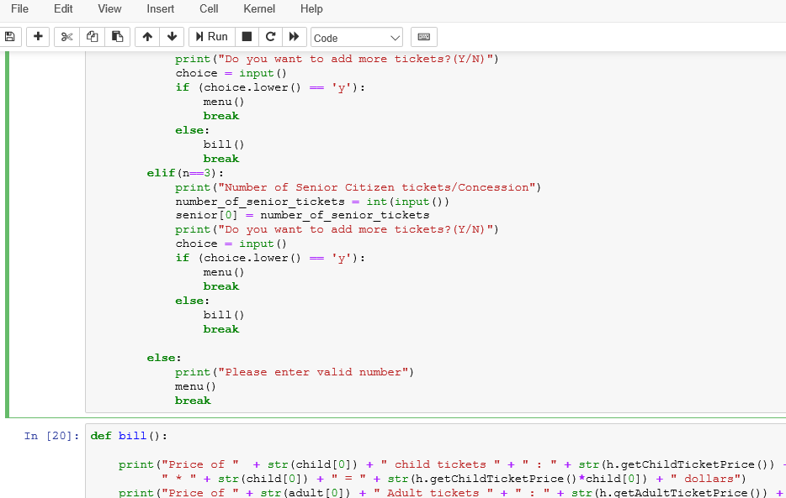

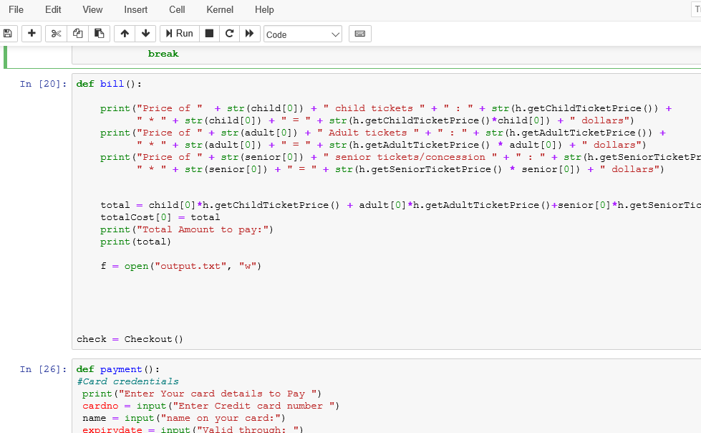

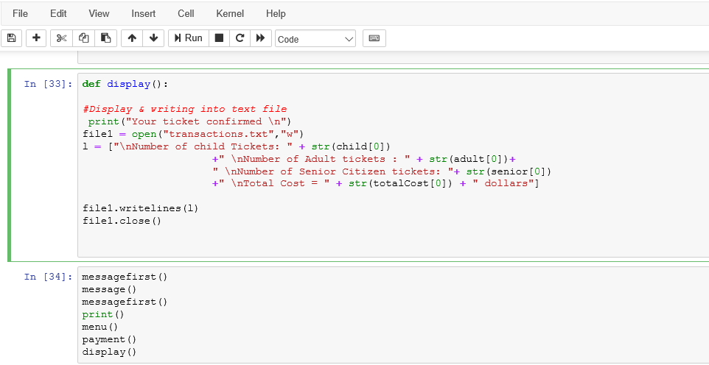

**Sample Result:**

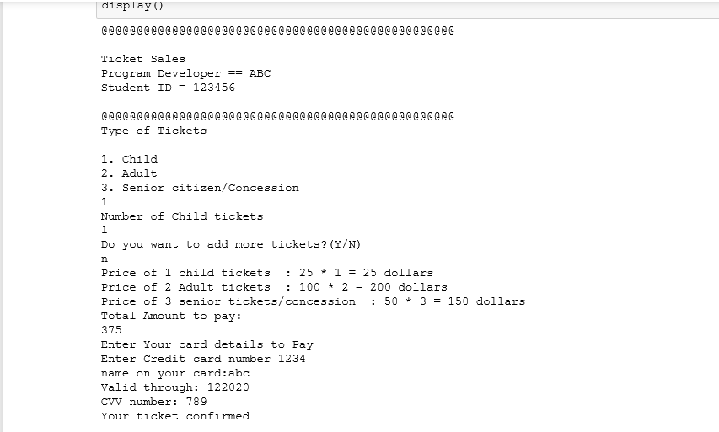

**References:**

1. <https://www.python.org/>
2. .<https://www.geeksforgeeks.org/python-programming-examples/>
3. <https://www.w3schools.com/python/python_intro.asp>
4. <https://www.draw.io/>