Following is the security group of the Bastian Host:

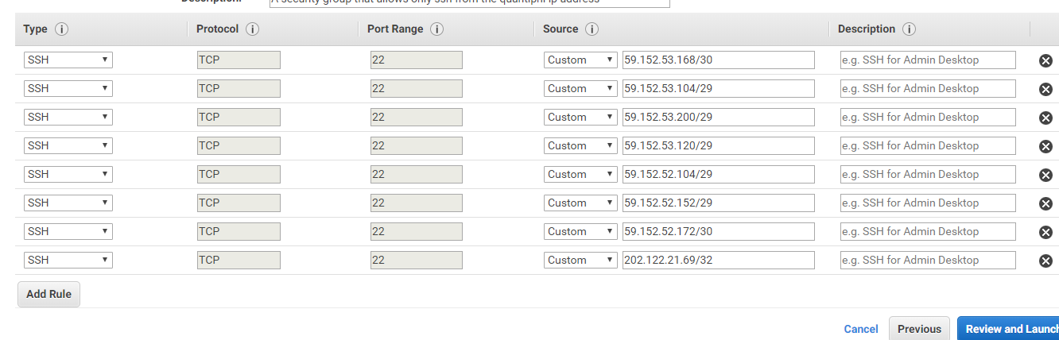

Following is the inbound security group of the instances

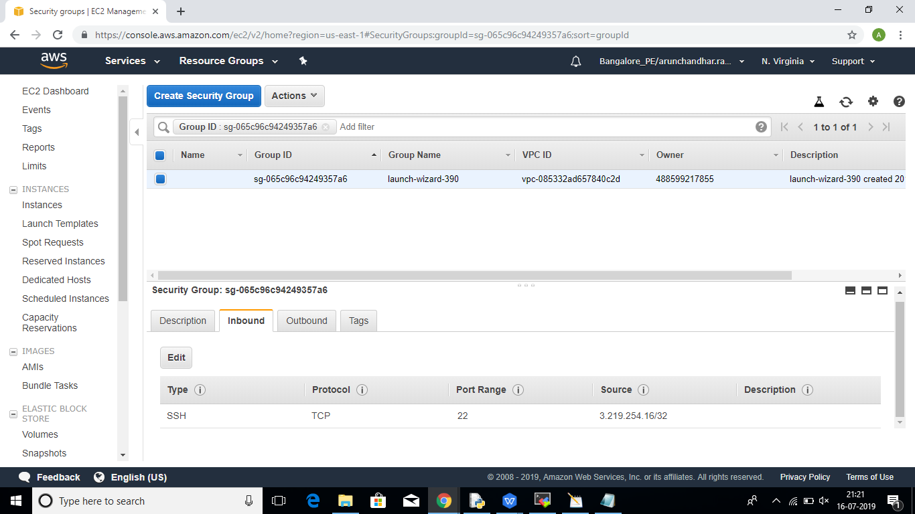

Following is the outbound security group of the instances:

