Step1: Create an EC2 instance and SSH into it.

Step2: Install Python3 in the instance. Verify if it is installed by entering the command

“python3 --version”

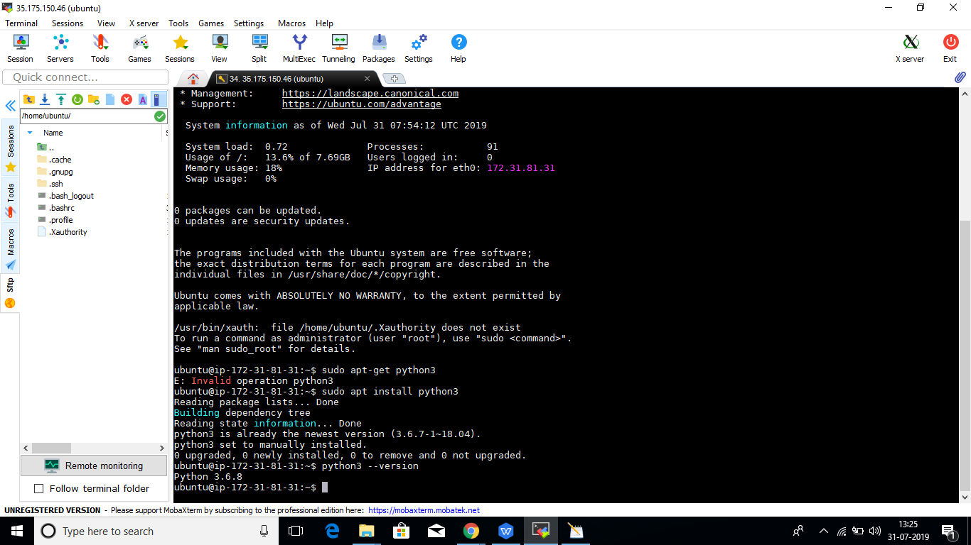

Step3: Enter the command “ sudo apt-get update -y “

Step4: Now install Docker, by entering the command “ sudo apt install docker.io 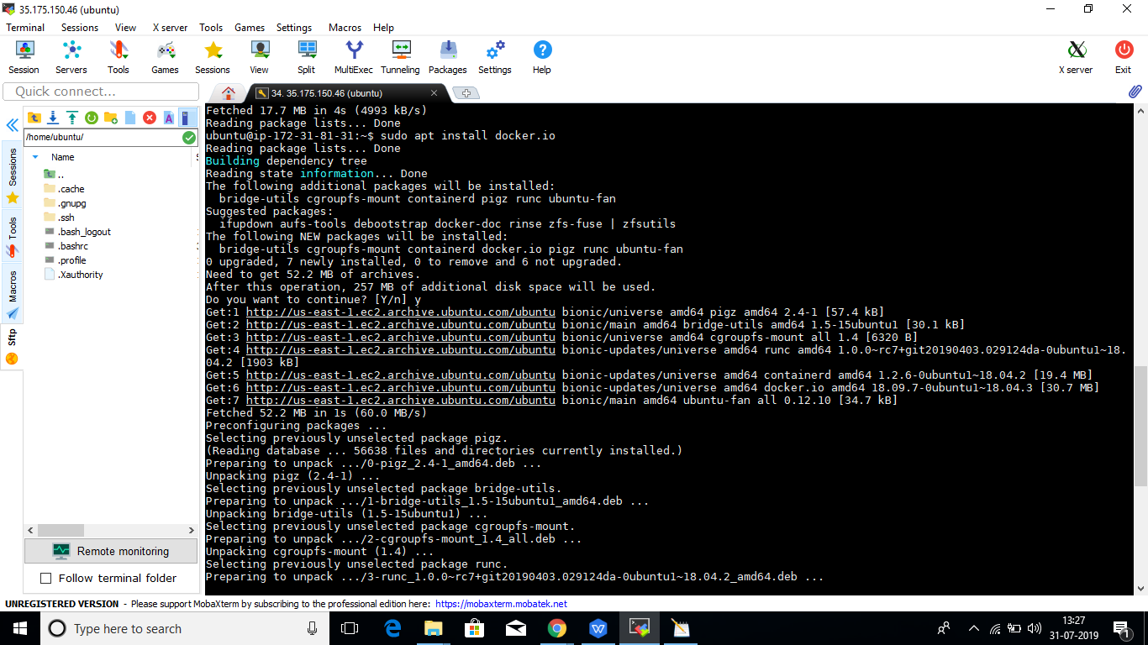

Step5: In the present directory, create a file “app.py”, and enter the following

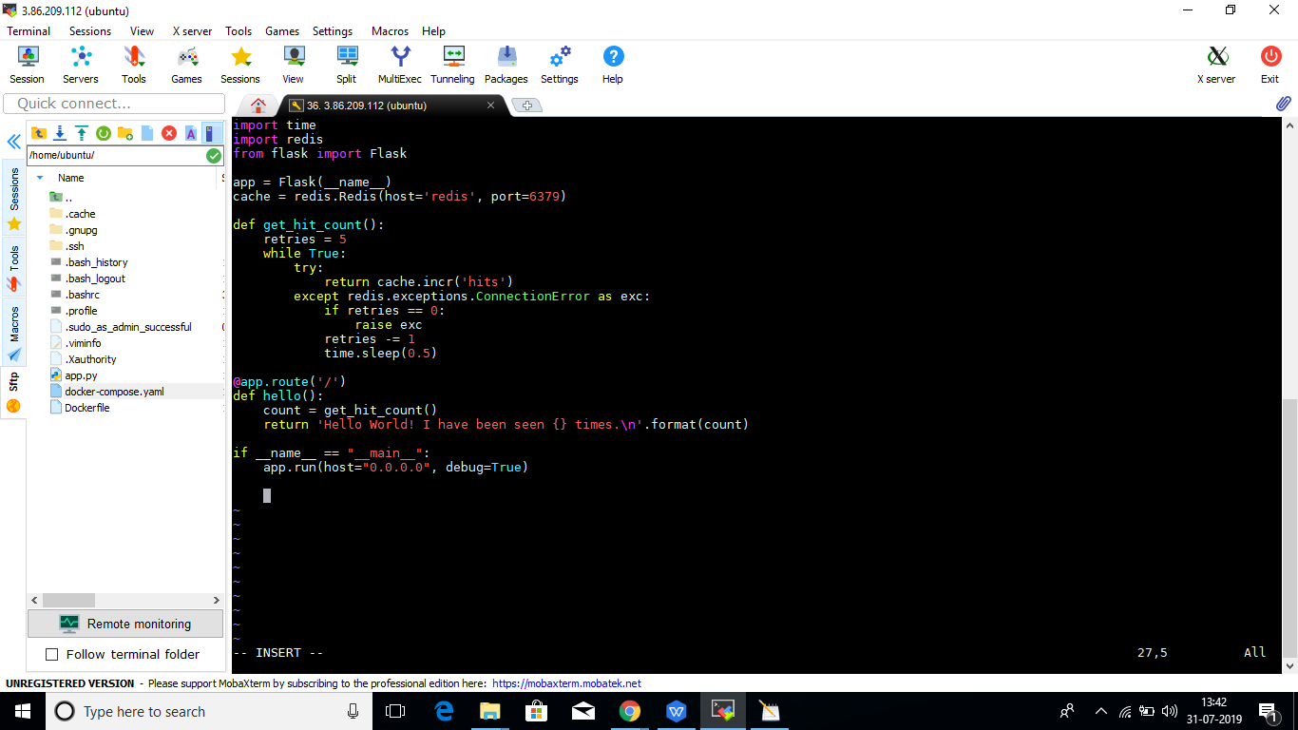

Step 6: Now create another file “Dockerfile” and enter the following

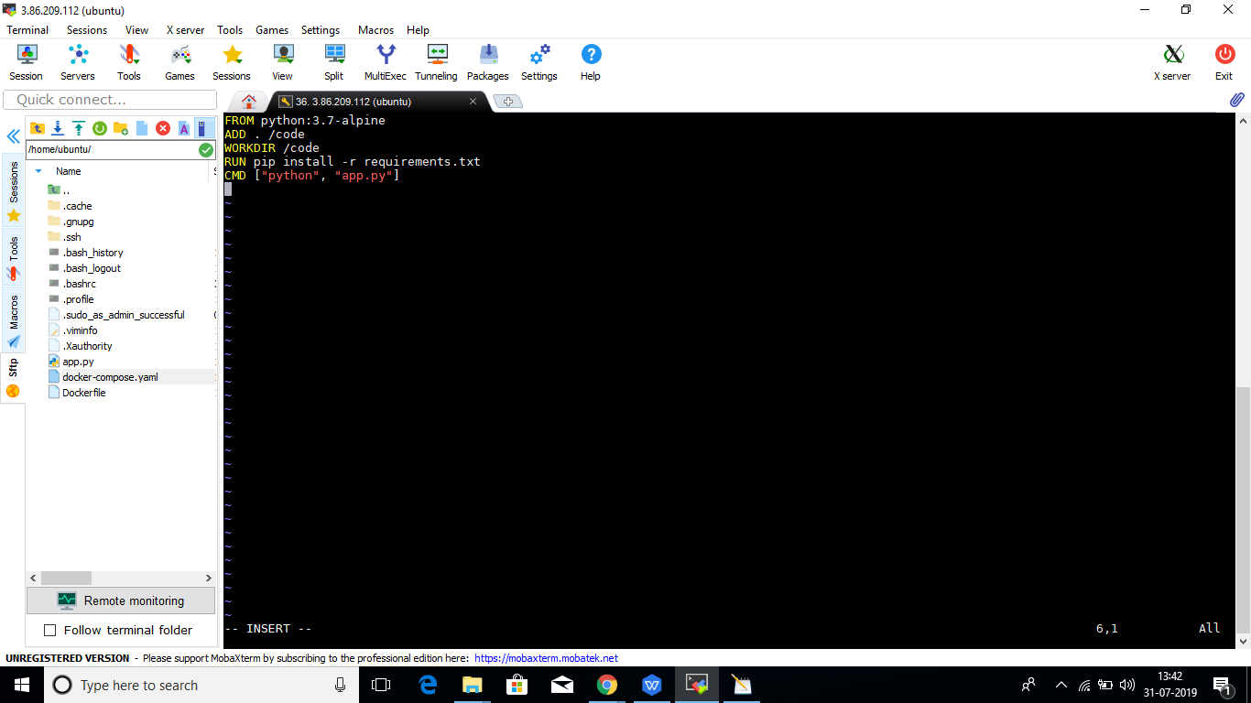

Step 7: Create a file named “docker-compose.yaml”, and enter the following

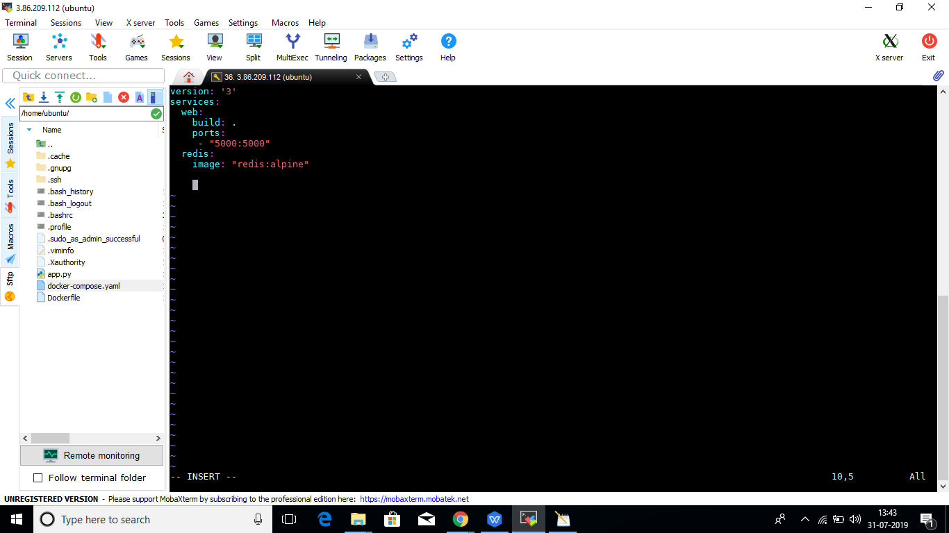

Step 8: Create a file “requirements.txt” and enter the following

redis

flask

Step 9: Now go to root by entering the command : sudo su

Step 10: Now enter the command “docker-compose up” . These files get run in the background.

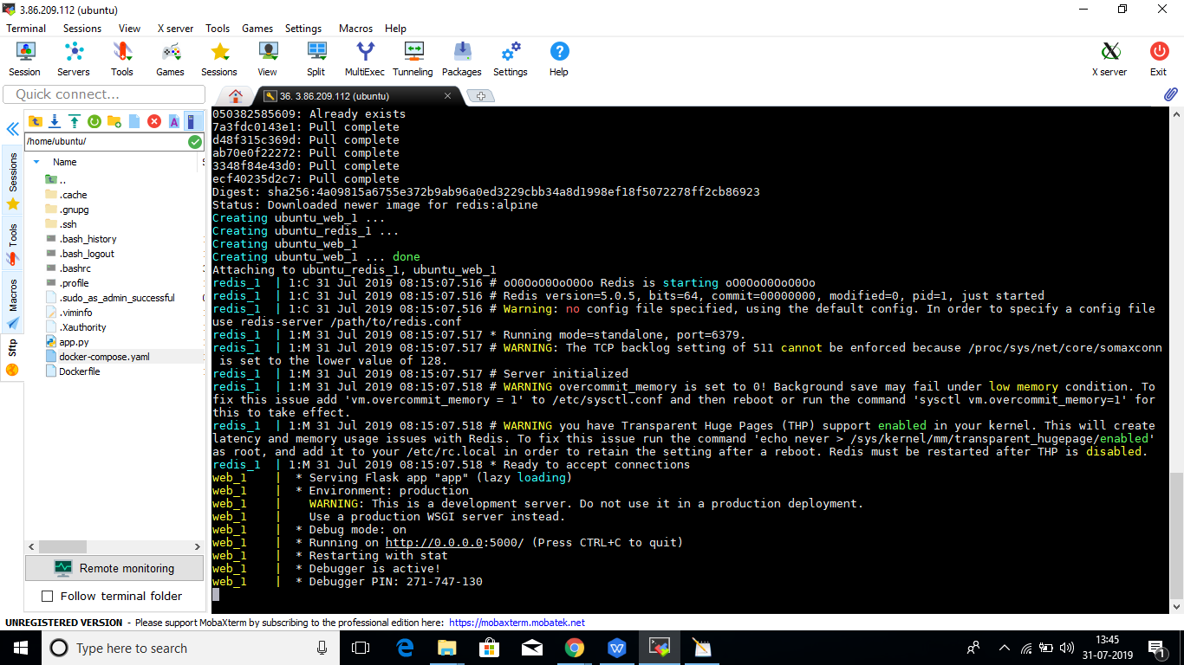

Step 11: Enter the public IP in the browser along with the port

3.86.209.112:5000



Step 12: Now refresh the page.



**2B**

Step 1: Open the file “docker-compose.yaml”, and make the following changes

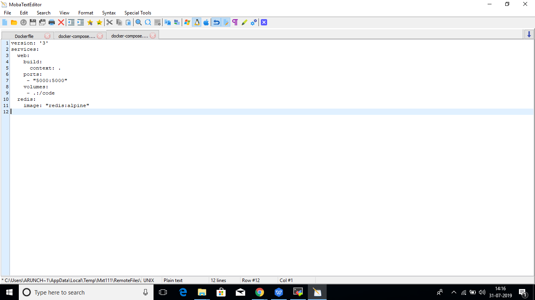

Step 2: Now enter the following command “ docker-compose up “. The files will run in the background.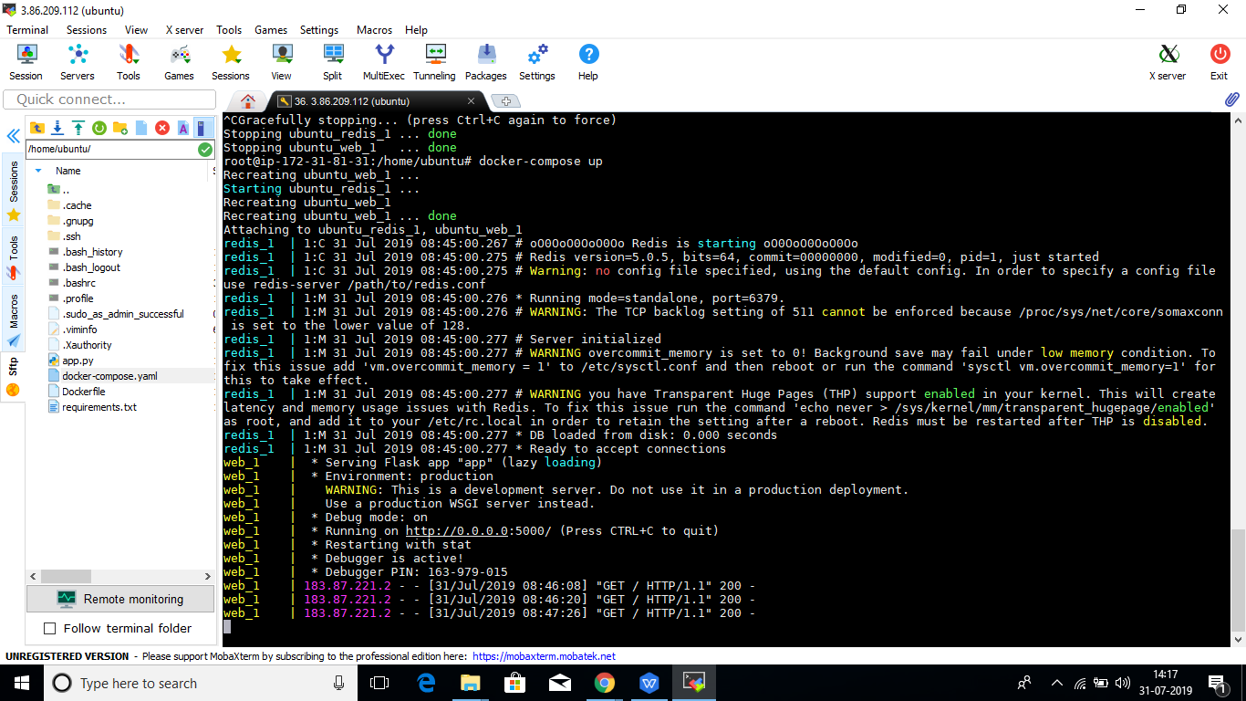

Step 3: Now enter in the web browser:-

3.86.209.112:5000

You will get the following output.

