Step 1: Create an instance without an external IP (arun-gcp2-q1a)

Step 2: Create an instance with an external IP (arun-gcp2-q1b)

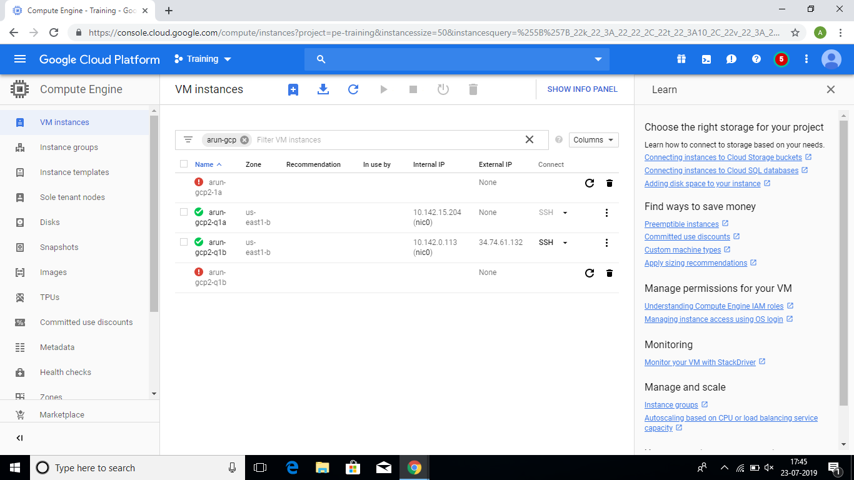

Step 3: Now create a NAT Gateway, so that the private instance (arun-gcp2-q1a) can access the internet.

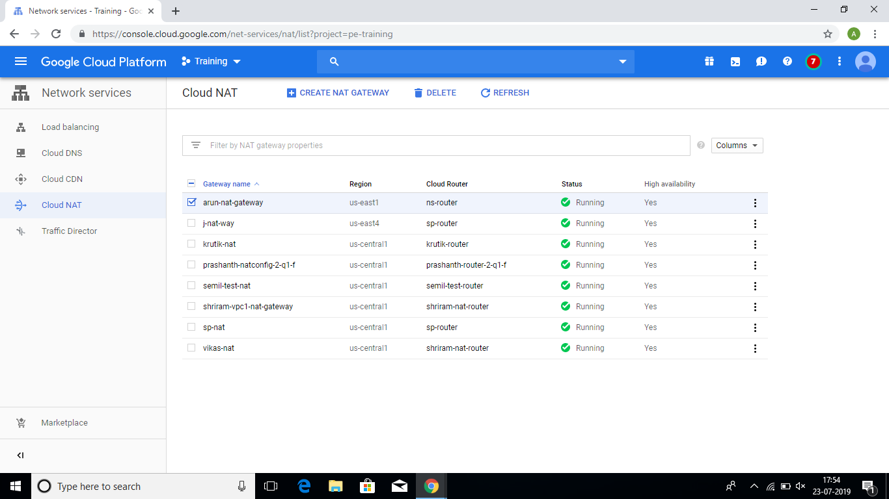

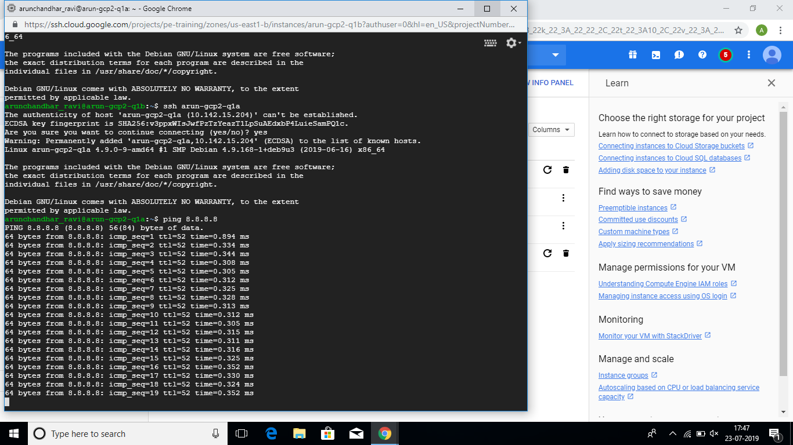Step 4: Now access the public instance (arun-gcp2-q1b) through SSH

Step 5: Enter the name of your private instance here

Step 6: It will ask “Are you sure?”, enter “Yes”

Step 7: Now enter the command “ping 8.8.8.8”

Step 8: We get the required output