Step 1: Create a cloud storage bucket (object-detection-bucket-01)

Step 2: Create a cloud function (object-detecting function)

Step 3: Set the trigger for the function as the bucket

Step 4: Enter the code in the cloud function with Python3.7 for the run-time

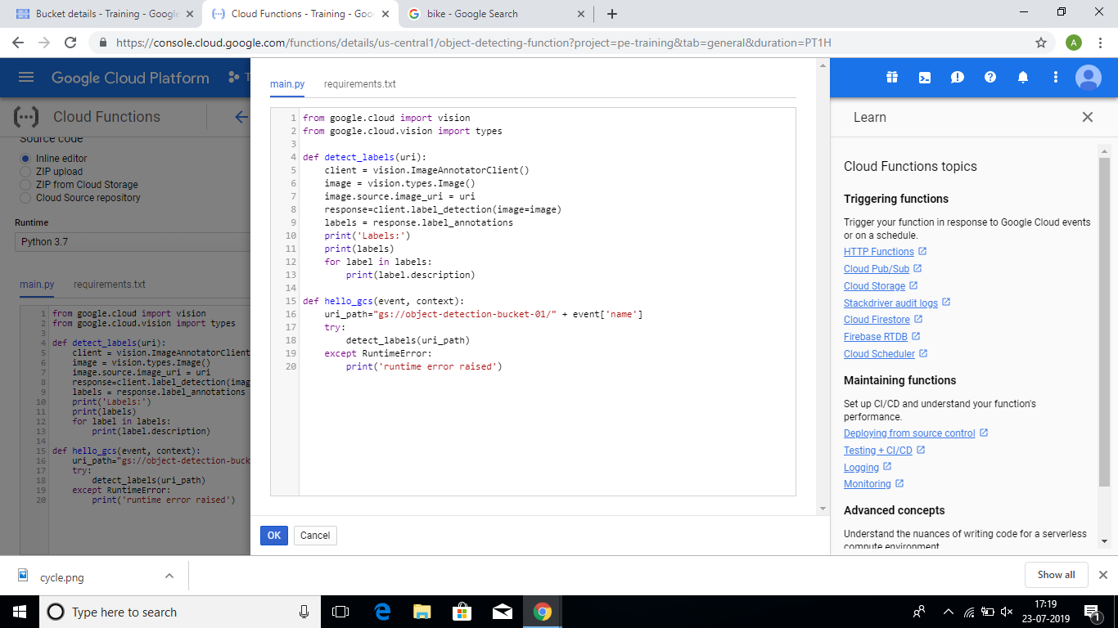

Step 5: Save the code.

Step 6: Now upload an image into the bucket.

Step 7: Let the cloud function run.

Step 8: After 2-3 mins go to the cloud function’s logs.

Step 9: You can see the required output

