1. Create a Pub/Sub topic (every-friday-send-mail)

1. Create a cloud function with Pub/Sub as its trigger with a http trigger (every-friday-send-mail)

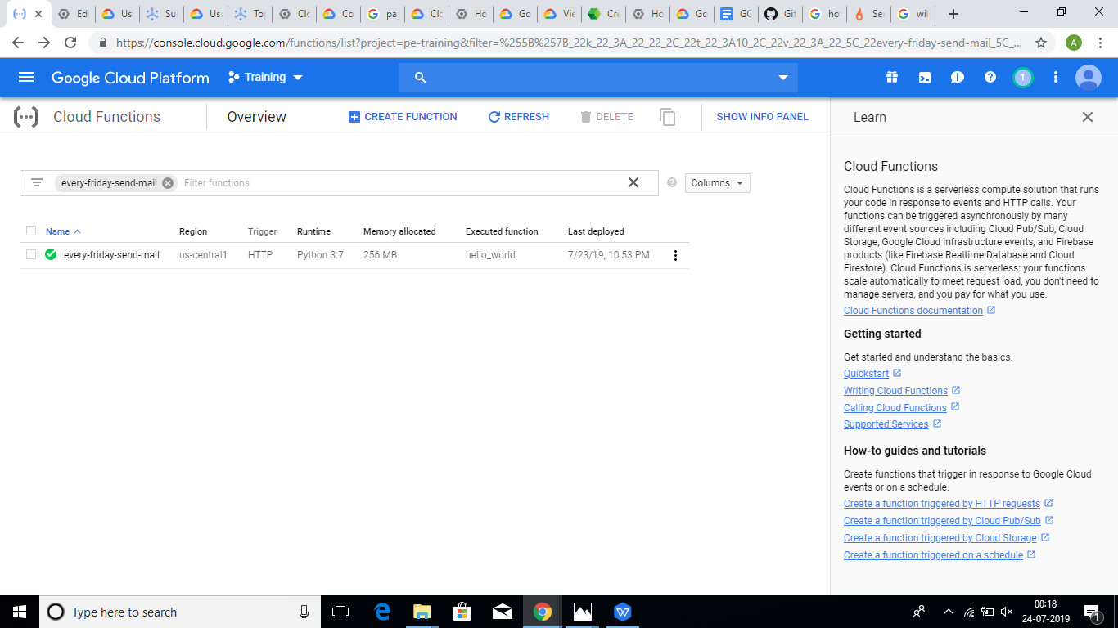

1. Create a job in cloud scheduler with following configurations

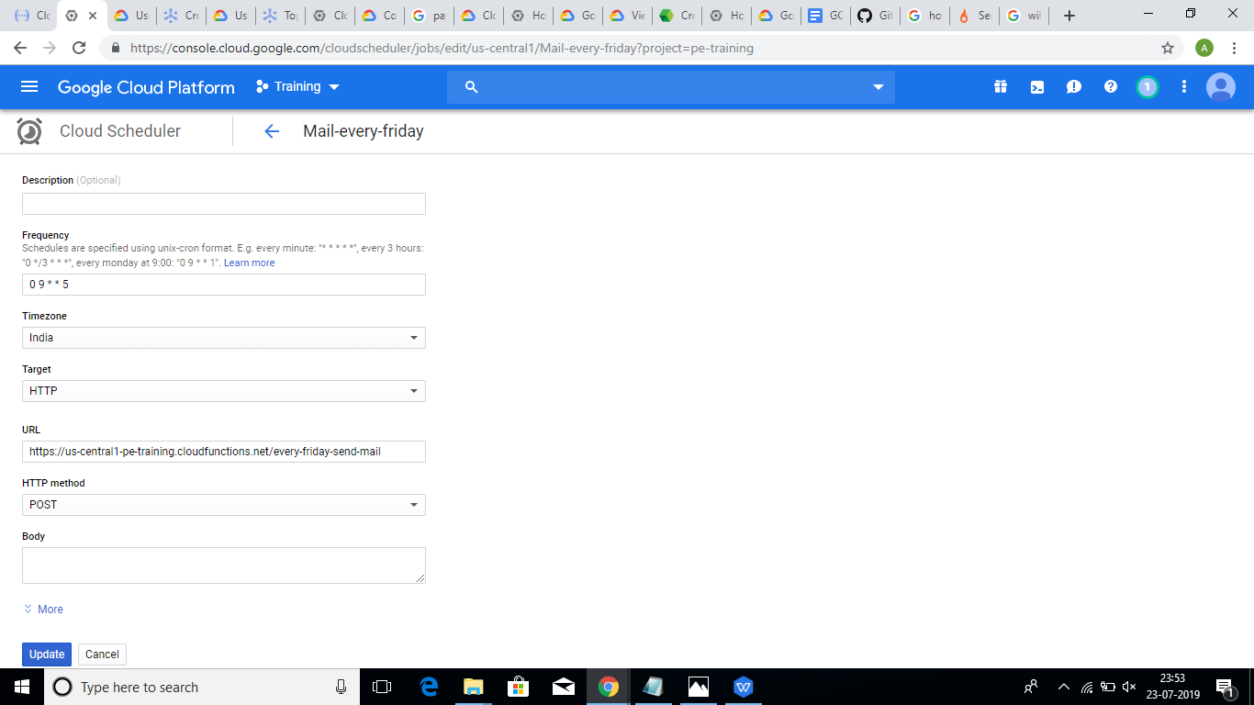

1. Now the cloud scheduler is set in such a way it invokes Pub/Sub every Friday at 9am which in turn triggers the cloud function.
2. To receive email, a subscription must be created to the topic.
3. An endpoint URL must be assigned to the push type pub/sub
4. The cloud function creates a sync and exports logs of CPU utilization of all instances and user information to pub/sub.
5. A subscription is to be made to the pub/sub topic by DevOps team to receive the message published from the topic.