SOFTWARE REQUIREMENTS
SPECIFICATION
for
PlaySphere
Sports Discovery, Booking and Community Platform

Version 1.1
Prepared by PlaySphere Project Team
Name | PRN
Arun Solanki | 260240320027
Janhavi Sutar | 260240320051
Radha Mali | 260240320126
Riya Mourya | 260240320135
Vivek Patil | 260240320208
Vivek Tiwari | 260240320209
Centre for Development of Advanced Computing
Raintree Marg, Near Bharati Vidyapeeth, Opp. Kharghar Railway Station,
Sector 7, CBD Belapur, Navi Mumbai - 400 614, Maharashtra (India)

Table of Contents
Section | Page
Revision History | 3
1. Introduction | 4
1.1 Purpose | 4
1.2 Intended Audience and Reading Suggestions | 4
1.3 Project Scope | 4
1.4 References | 4
2. Overall Description | 4
2.1 Product Perspective | 4
2.2 Product Features | 5
2.3 User Classes and Characteristics | 5
2.4 Operating Environment | 5
2.5 Design and Implementation Constraints | 5
2.6 User Documentation | 5
2.7 Assumptions and Dependencies | 5
2.8 Mandatory Technical Architecture | 6
3. System Features | 6
3.1 Registration, Login and Email Verification | 6
3.2 Discover Dashboard | 7
3.3 Turf Discovery and Booking | 7
3.4 Teams and Clans | 7
3.5 Matches, Events and Scores | 7
3.6 Find Players | 8
3.7 Real-time Chat | 8
3.8 Reviews and Ratings | 8
3.9 Payments | 9
3.10 Administration | 9
4. External Interface Requirements | 9
4.1 User Interfaces | 9
4.2 Hardware Interfaces | 9
4.3 Software Interfaces | 9
4.4 Communication Interfaces | 10
5. Other Nonfunctional Requirements | 10
5.1 Performance Requirement | 10
5.2 Reliability and Recovery Requirements | 10
5.3 Security Requirements | 10
5.4 Privacy Requirements | 10
5.5 Software Quality Attributes | 11
5.6 Logging, Testing and Deployment Requirements | 11
Appendix A: Glossary | 11

Table of Contents (continued)
Section | Page
Appendix B: Analysis Models | 12
B.1 System Context | 12
B.2 Logical Component Model | 12
B.3 Data Model Overview | 12
B.4 Software Development Approach | 12
Appendix C: Required Analysis Diagrams | 13
C.1 Use Case Diagram | 13
C.2 Class Diagram | 14
C.3 ER Diagram - Chen Notation | 15
C.4 Sequence Diagram - Registration and Email Verification | 16
C.5 Sequence Diagram - Turf Booking and Payment | 17
C.6 Activity Diagram - Turf Booking Workflow | 18
C.7 Data Flow Diagram - Level 0 | 19
C.8 Data Flow Diagram - Level 1 | 20
C.9 Microservices and AWS Messaging Deployment Diagram | 21
Appendix D: Requirements Traceability Matrix | 22
Appendix E: Delivery and Compliance Checklist | 23

Revision History
Version | Date | Author | Reason for Changes
1.0 | 20 July 2026 | PlaySphere Project Team | Initial approved SRS baseline

1. Introduction

1.1 Purpose
This Software Requirements Specification defines the functional and nonfunctional requirements for PlaySphere, a responsive full-stack web application that connects sports enthusiasts, turf owners, teams, clans and event organizers. It provides a shared baseline for implementation, testing, deployment and acceptance of the system.

1.2 Intended Audience and Reading Suggestions
This document is intended for developers, testers, project mentors, administrators, turf owners and prospective users. Developers should read Sections 2 through 5 before implementation. Testers should derive acceptance cases from Section 3 and quality targets from Section 5. Product stakeholders should review scope, roles and constraints.

1.3 Project Scope
PlaySphere centralizes the discovery and coordination of recreational sports. The system allows users to create verified accounts, discover turfs and events, reserve available time slots, create or join teams and clans, find nearby players, participate in matches, exchange real-time messages, record scores and submit reviews. Turf owners manage venues, availability and bookings. Administrators oversee platform data and user safety.
- Responsive React user interface for desktop, tablet and mobile browsers.
- Java Spring Boot REST API with role-based access control and JWT authentication.
- Email verification and password-reset delivery through Brevo.
- Optional payment initiation and verification for bookings.
- Docker Compose deployment of frontend, backend and database services.
- Real-time chat and event updates using WebSocket/STOMP.

1.4 References
- Spring Boot documentation - https://spring.io/projects/spring-boot
- React documentation - https://react.dev/
- MySQL documentation - https://dev.mysql.com/doc/
- MongoDB documentation - https://www.mongodb.com/docs/
- Amazon SNS documentation - https://docs.aws.amazon.com/sns/
- Amazon SQS documentation - https://docs.aws.amazon.com/sqs/
- Docker Compose documentation - https://docs.docker.com/compose/
- Brevo API documentation - https://developers.brevo.com/
- Stripe developer documentation - https://docs.stripe.com/
- OpenAPI specification - https://spec.openapis.org/oas/latest.html

2. Overall Description

2.1 Product Perspective
PlaySphere is a web-based platform organized around independently deployable Spring Boot microservices. The React client communicates through an API Gateway over HTTPS and WebSocket connections. The Core Service owns identity, sports, turf, booking and payment transactions in MySQL; the Communication Service owns chat and notification documents in MongoDB. Amazon SNS and Amazon SQS provide asynchronous domain-event delivery, Brevo provides transactional email, Stripe provides optional payment processing, and AWS hosts the production runtime.

2.2 Product Features
- Secure account registration, verification, login, logout and password recovery.
- Personal profiles containing location, skill level, sports preferences and playing role.
- Turf search, detail views, time-slot availability and booking lifecycle.
- Team and clan creation, membership management and invitations.
- Sports match and event discovery, joining, scheduling and score tracking.
- Player discovery filtered by city, locality, sport, game, skill and availability.
- Direct and group communication through real-time chat.
- Ratings and reviews for turfs and sports experiences.
- Owner and administrator dashboards for operational management.

2.3 User Classes and Characteristics
User Class | Characteristics and Capabilities
Player / Captain | Registers, discovers venues and players, books turfs, joins activities and coordinates teams.
Turf Owner | Manages owned turfs, schedules, prices, availability and booking requests.
Organizer | Creates teams, clans, events and matches; manages membership and results.
Administrator | Moderates users and content, audits activity and manages platform records.

2.4 Operating Environment
- Client: current Chrome, Edge, Firefox or Safari with JavaScript enabled.
- Server: Java 21 runtime and Spring Boot 4.0.
- Frontend build: Node.js/Vite/React; production delivery through AWS.
- Database: MySQL for transactional data and MongoDB for communication documents.
- Container runtime: Docker Desktop or Docker Engine with Compose.
- Minimum development workstation: dual-core CPU, 8 GB RAM and 5 GB free storage.

2.5 Design and Implementation Constraints
- The interface language is English.
- Passwords must never be stored in plaintext or reversibly encrypted form; BCrypt hashes shall be used.
- Authenticated API operations require a valid JWT.
- Email delivery depends on Brevo API service , template and API credentials.
- Payments require valid Stripe API credentials and verified server-side webhooks.
- Docker service ports shall be configurable through environment variables and documented in the README.

2.6 User Documentation
The release shall include a README with prerequisites, environment-variable definitions, Docker startup and shutdown commands, demo credentials, troubleshooting guidance and API health-check instructions. OpenAPI/Swagger documentation shall describe available REST operations.

2.7 Assumptions and Dependencies
- Users provide accurate contact and profile information.
- Turf owners maintain correct venue availability and pricing.
- An internet connection is available for Brevo and Stripe integrations.
- The host operating system can run Docker containers.
- Email recipients may need to check spam folders during development.
- Production deployment provides HTTPS, secure secrets and persistent database backups.

2.8 Mandatory Technical Architecture
The target architecture shall use React.js and a minimum of two independently deployable Spring Boot microservices. The Core Service shall own identity, profiles, turfs, bookings, teams, clans, matches, events, scores and payments in MySQL. The Communication Service shall own notifications and chat history in MongoDB. Amazon SNS topics and service-owned Amazon SQS queues shall carry asynchronous domain events. Each service shall expose RESTful APIs and implement Spring Security, JWT validation, input validation, global exception handling, structured logging, Swagger/OpenAPI and JUnit 5/Mockito tests.
- API Gateway shall provide a single frontend entry point.
- Each service shall own its database and shall not directly access another service database.
- The React application shall use protected routes and role-based navigation.
- Deployment shall target AWS using EC2/ECS/Elastic Beanstalk or another approved AWS service.
Amazon SNS topics, Amazon SQS queues, retry policies and dead-letter queues shall be documented; consumers shall be idempotent.
- Git and GitHub shall be used for branch-based team collaboration and code review.

3. System Features

3.1 Registration, Login and Email Verification

3.1.1 Description and Priority
Description: Creates secure user identities and prevents unverified accounts from accessing protected functions. Priority: High

3.1.2 Stimulus/Response Sequence
A visitor submits registration details. The system validates uniqueness, hashes the password, creates a verification token and sends an email link. The user opens the link and may then log in.

3.1.3 Functional Requirements
- Validate name, email and minimum password strength.
- Store normalized email addresses and BCrypt password hashes.
- Issue expiring, single-use verification and reset tokens.
- Reject login for inactive or unverified accounts.
- Issue a signed JWT after successful authentication.
- Support resend verification and forgot/reset password workflows.

3.2 Discover Dashboard

3.2.1 Description and Priority
Description: Presents relevant turfs, events, teams, clans and platform activity. Priority: High

3.2.2 Stimulus/Response Sequence
The user opens Discover. The client requests available content and displays responsive cards, search controls and navigation actions.

3.2.3 Functional Requirements
- Load public content without exposing protected personal data.
- Provide loading, empty and error states.
- Preserve navigation across desktop and mobile layouts.

3.3 Turf Discovery and Booking

3.3.1 Description and Priority
Description: Allows players to locate venues, select available slots and reserve them. Priority: High

3.3.2 Stimulus/Response Sequence
A user filters turfs, opens a venue, selects a date and slot, reviews price and confirms. The system validates availability and creates a booking.

3.3.3 Functional Requirements
- Search by city, locality .
- Display address, amenities, images, ratings and owner details.
- Prevent overlapping confirmed bookings for the same turf and slot.
- Track booking states such as pending, confirmed, completed and cancelled.
- Allow owners to publish and update turf schedules and prices.
- Restrict booking management to the booking user, owner or administrator.

3.4 Teams and Clans

3.4.1 Description and Priority
Description: Supports persistent sports groups and membership coordination. Priority: Medium

3.4.2 Stimulus/Response Sequence
An authenticated user creates a team or clan, adds descriptive information and invites or approves members.

3.4.3 Functional Requirements
- Create, view, update and archive groups.
- Assign creator/captain ownership.
- Allow users to request membership and captains to approve or reject.
- Prevent duplicate active memberships.
- Expose member rosters subject to privacy rules.

3.5 Matches, Events and Scores

3.5.1 Description and Priority
Description: Coordinates scheduled sports activities and captures results. Priority: High

3.5.2 Stimulus/Response Sequence
An organizer creates a match or event with venue, sport, date, capacity and rules. Users discover and join it; authorized organizers record results.

3.5.3 Functional Requirements
- Validate start time, capacity and required fields.
- Allow eligible users to join or leave before cutoff.
- Prevent participant counts from exceeding capacity.
- Store score entries and publish final status.
- Provide event and match lists sortable by date and location.

3.6 Find Players

3.6.1 Description and Priority
Description: Helps users discover compatible nearby sports partners. Priority: High

3.6.2 Stimulus/Response Sequence
The user supplies preferred sport and location filters. The system ranks profiles that match and excludes the requesting user.

3.6.3 Functional Requirements
- Filter by city, locality, sports.
- Display only active, discoverable profiles.
- Provide a clear path to view a profile or initiate contact.
- Avoid exposing passwords, tokens, private keys or internal security fields.

3.7 Real-time Chat

3.7.1 Description and Priority
Description: Enables contextual communication among players and groups. Priority: Medium

3.7.2 Stimulus/Response Sequence
A logged-in user opens a conversation, establishes a WebSocket/STOMP session and sends a message. Subscribed participants receive it in near real time.

3.7.3 Functional Requirements
- Authenticate access to conversations.
- Persist message sender, conversation, content and timestamp.
- Reject empty or oversized content.
- Deliver updates through broker topics and allow history retrieval.
- Prevent users from reading conversations they do not belong to.

3.8 Reviews and Ratings

3.8.1 Description and Priority
Description: Collects structured user feedback for turfs and experiences. Priority: Medium

3.8.2 Stimulus/Response Sequence
After an eligible interaction, the user selects a rating and optionally adds a comment. The platform updates the aggregate rating.

3.8.3 Functional Requirements
- Accept ratings only within the configured scale.
- Associate each review with its author and target.
- Allow moderation of abusive content.
- Calculate aggregate rating without trusting client-supplied averages.

3.9 Payments

3.9.1 Description and Priority
Description: Supports optional online payment for confirmed booking transactions. Priority: Medium

3.9.2 Stimulus/Response Sequence
The backend creates a Stripe Checkout Session or Payment Intent, the client completes checkout, and the backend validates the webhook signature and payment status before marking payment successful.

3.9.3 Functional Requirements
- Keep secret keys on the backend only.
- Verify payment signatures server-side.
- Record provider order/payment references and status.
- Do not mark a booking paid when verification fails.
- Allow local booking flows when payment integration is deliberately disabled.

3.10 Administration

3.10.1 Description and Priority
Description: Provides controlled moderation and operational oversight. Priority: High

3.10.2 Stimulus/Response Sequence
An administrator authenticates and opens protected management views to review users, turfs, bookings, events and reports.

3.10.3 Functional Requirements
- Enforce administrator authorization at API level.
- Enable account activation/deactivation and content moderation.
- Prevent ordinary users from invoking administration operations.

4. External Interface Requirements

4.1 User Interfaces
The user interface shall use a consistent dark PlaySphere visual identity, clear navigation, responsive cards and accessible form controls. Validation errors shall appear near the affected action and asynchronous operations shall provide loading and success/error feedback. Keyboard navigation and sufficient color contrast should be supported.

4.2 Hardware Interfaces
- Client display, keyboard, mouse or touch screen through a standards-compliant browser.
- Server storage for MySQL data and uploaded/public media references.
- No specialized sports hardware is required.

4.3 Software Interfaces
Interface | Purpose | Protocol / Format
React Frontend | Responsive presentation and browser interaction | HTTPS, JSON, WebSocket
API Gateway | Single entry point, routing, TLS and CORS | HTTPS
Core Service | Identity, sports, turf, booking and payment workflows | REST JSON, JWT
Communication Service | Notifications and chat | REST, STOMP, AWS SDK
MySQL | Normalized transactional data | JDBC, JPA, Hibernate
MongoDB | Chat and notification documents | MongoDB driver
Amazon SNS/SQS | Asynchronous domain events, queues and DLQ | AWS SDK / HTTPS
Brevo | Verification and password-reset email | HTTPS REST/JSON
Stripe | Payment session and webhook verification | HTTPS REST/JSON

4.4 Communications Interfaces
- All production browser traffic shall use HTTPS.
- REST payloads shall use UTF-8 JSON.
- WebSocket/STOMP shall carry real-time message events.
- Amazon SNS and Amazon SQS shall carry asynchronous domain events between microservices through AWS SDK/HTTPS APIs.
- Messages shall be durable where business recovery requires it and consumers shall be idempotent.
- CORS shall allow only configured frontend origins.
- API errors shall use consistent status codes and structured response bodies.

5. Other Nonfunctional Requirements

5.1 Performance Requirements
- The Microservices shall communicate through lightweight REST APIs, and service failures shall be isolated to prevent one service from degrading the performance of the entire application
- Frequently accessed data shall be cached, and database queries shall use proper indexing, pagination, and optimized execution plans to minimize response time.
- Long-running tasks such as email delivery, notifications, and report generation shall be processed asynchronously so that user requests remain responsive.

5.2 Reliability and Recovery Requirements
- MySQL data shall be stored in a persistent Docker volume or managed database.
- Failed transactions shall roll back without leaving partial booking or payment state.
- Restarting application containers shall not delete persistent data.
- Production operators shall schedule backups and test restoration.
- The application shall return controlled error responses rather than expose stack traces.

5.3 Security Requirements
- Passwords shall be hashed with a modern adaptive algorithm such as BCrypt.
- JWT secrets shall contain at least 32/64 unpredictable characters and remain outside source control.
- Brevo private keys, database credentials and Stripe secrets shall be injected through environment variables.
- Verification/reset tokens shall be random, hashed at rest, expiring and single-use.
- Authorization shall be enforced on the server for owner, member and administrator operations.
- Inputs shall be validated to reduce injection, malformed payload and stored-content risks.

5.4 Privacy Requirements
- The application shall collect only information necessary for platform functions.
- Private security attributes shall never appear in public API responses.
- Profile discovery shall expose only approved profile fields.
- Logs shall avoid passwords, authentication tokens and private API keys.

5.5 Software Quality Attributes
Attribute | Requirement
Usability | Primary tasks shall be understandable without formal training and work on mobile layouts.
Reliability | Core identity, booking and payment state transitions shall be transactional and deterministic.
Maintainability | Frontend and microservices shall remain modular with documented configuration and API contracts.
Scalability | Stateless services, SNS/SQS and service-owned databases shall permit independent scaling.
Testability | JUnit 5 and Mockito shall cover service logic; integration tests shall cover APIs and messaging.
Portability | Docker shall provide repeatable startup across developer and AWS environments.
Accessibility | Controls should provide labels, focus states, keyboard operation and readable contrast.

5.6 Logging, Testing and Deployment Requirements
- Each microservice shall use structured application logging with timestamp, level, service name and correlation identifier.
- Global exception handlers shall convert validation, authorization and business failures into consistent API responses.
- JUnit 5 and Mockito shall test services, security rules, validators and event publishers/consumers.
- Coverage reports shall be produced during the build and critical business paths shall receive priority coverage.
- Swagger/OpenAPI shall document each public REST API.
- GitHub shall contain the source, branch history, pull requests, README and release instructions.
- The production target shall be AWS with Docker-based service deployment, managed secrets, HTTPS, health checks and persistent databases.

Appendix A: Glossary
Term | Meaning
API | Application Programming Interface
Brevo | External transactional email delivery service
CORS | Cross-Origin Resource Sharing
CRUD | Create, Read, Update and Delete
JWT | JSON Web Token
MongoDB | Document database for communication-owned data
MySQL | Relational database for transactional domain data
REST | Representational State Transfer
SRS | Software Requirements Specification
STOMP | Simple Text Oriented Messaging Protocol
Stripe | Online payment platform
Turf | Bookable sports venue or playing surface
WebSocket | Full-duplex persistent browser/server communication

Appendix B: Analysis Models

B.1 System Context
External Actor / System | Interaction with PlaySphere
Player / Captain | Registration, discovery, booking, groups, matches, chat and reviews
Turf Owner | Venue, availability, pricing and booking management
Administrator | Moderation, account control and operational oversight
Brevo | Delivers verification and password-reset emails
Stripe | Creates payment sessions and returns verifiable webhook events
MySQL | Stores normalized transactional domain records
MongoDB | Stores chat and notification documents

B.2 Logical Component Model
Layer | Primary Components | Responsibility
Presentation | React, Vite, API Gateway | Responsive views, forms, navigation, API and WebSocket clients
Application | Spring Boot microservices | Validation, authorization and service-owned workflows
Security | Spring Security, JWT, BCrypt | Authentication, token validation and access control
Persistence | JPA/Hibernate/MySQL; MongoDB | Transactions, documents and service-owned data
Integration | Brevo, Stripe, STOMP | Email, payment and real-time communications

B.3 Core Data Model
Entity / Document | Key Relationships
User | Owns bookings, reviews, groups, messages and participation records
Turf | Owned by a user; has availability, bookings and reviews
Booking | Links user and turf with date, slot, amount, payment and status
Team / Clan | Created by a user and contains membership records
Match / Event | Created by an organizer and contains participants and scores
Conversation / Message | Stored in MongoDB and connects authorized participants
Notification | Stored in MongoDB and produced from SNS/SQS domain events
Auth Token | Links a user to a hashed verification or reset token

B.4 Software Development Approach
PlaySphere follows an iterative and incremental development approach. Each iteration delivers a vertical feature slice across the React interface, Spring Boot microservices, MySQL schema, MongoDB documents and Amazon SNS/SQS event flows. Requirements are prioritized, designed, implemented, reviewed and verified before integration into the Docker and AWS environments.
- Requirements and acceptance criteria are maintained before coding begins.
- API contracts and database changes are reviewed together.
- Automated builds verify Java compilation and frontend bundling.
- Docker Compose provides a consistent integration environment.
- User feedback informs the next iteration.

Appendix C: Required Analysis Diagrams
C.1 Use Case Diagram
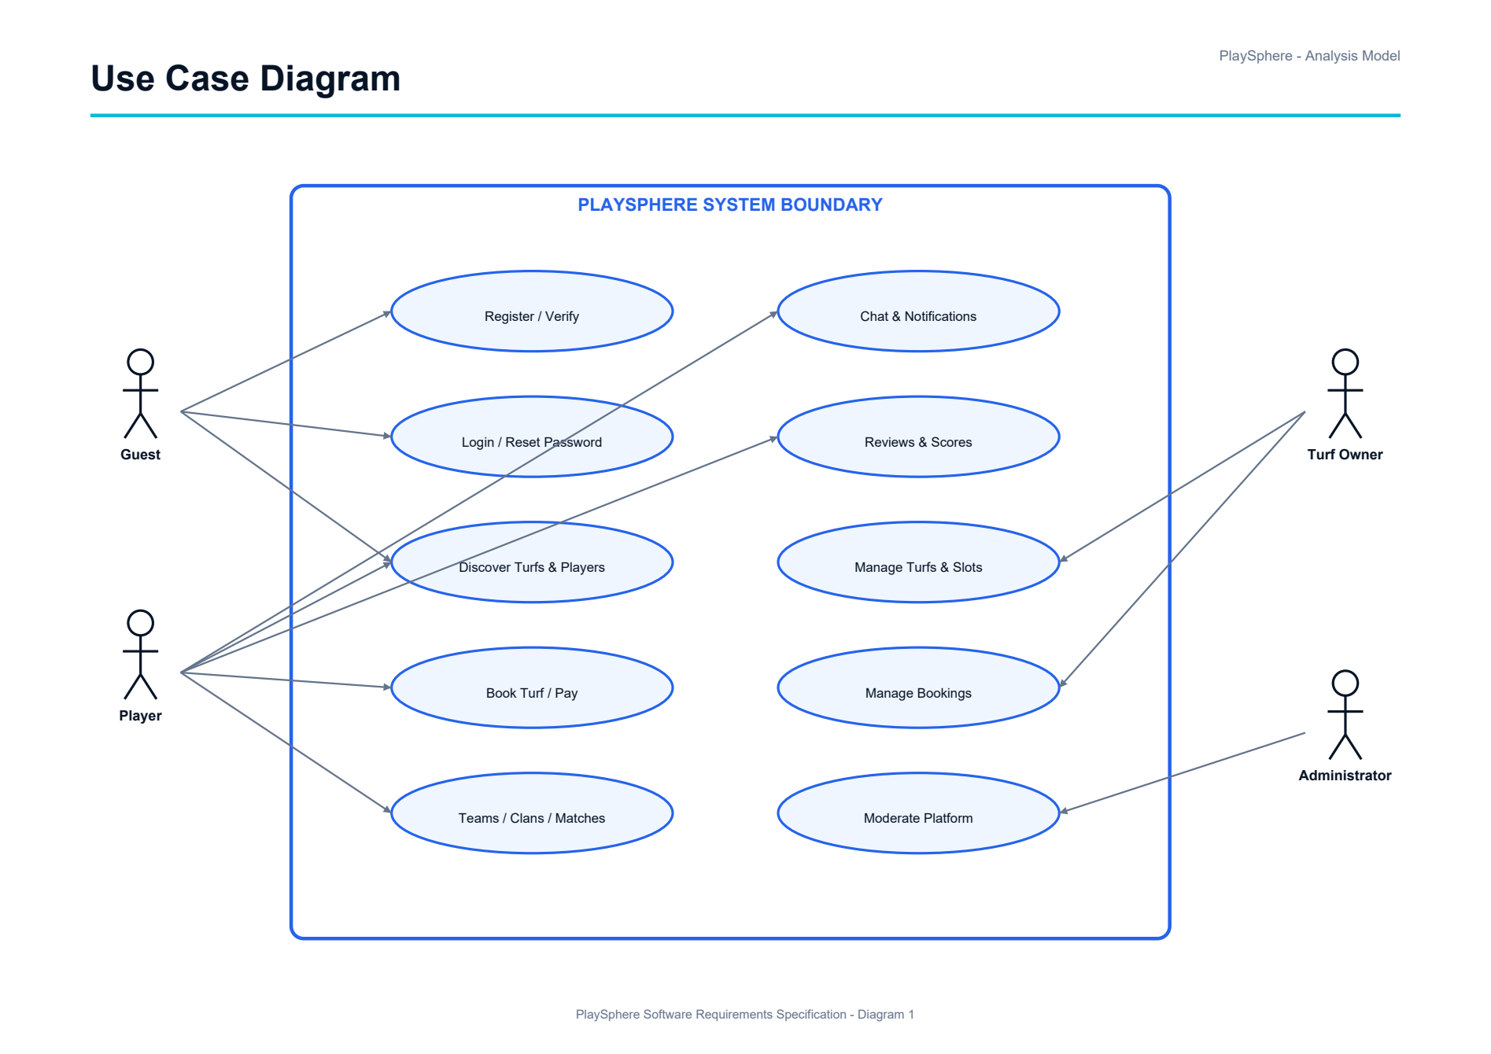

C.2 Class Diagram
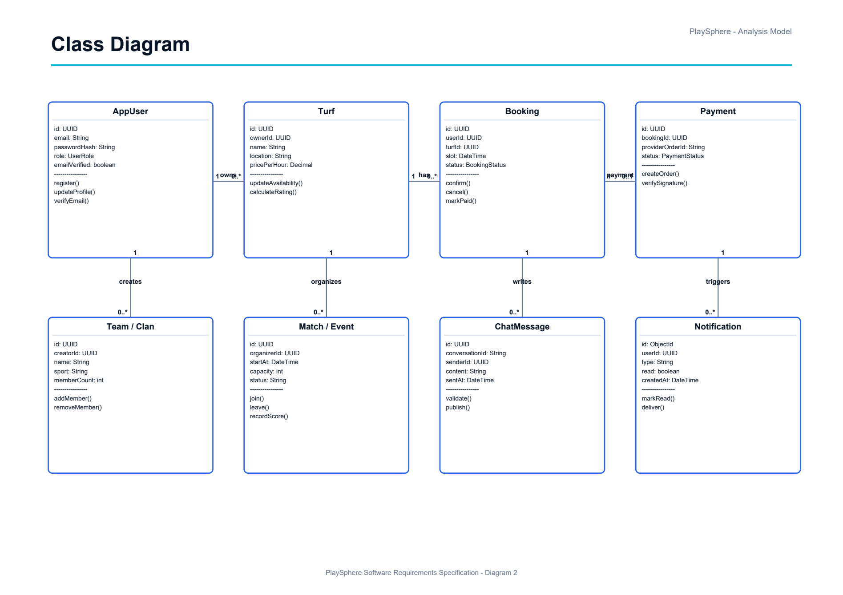

C.3 ER Diagram — Chen Notation
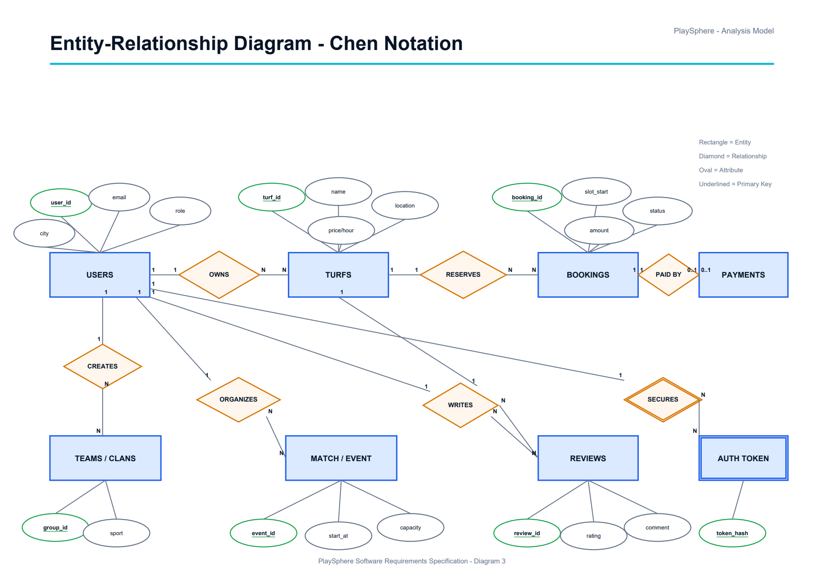

C.4 Sequence Diagram — Registration and Email Verification
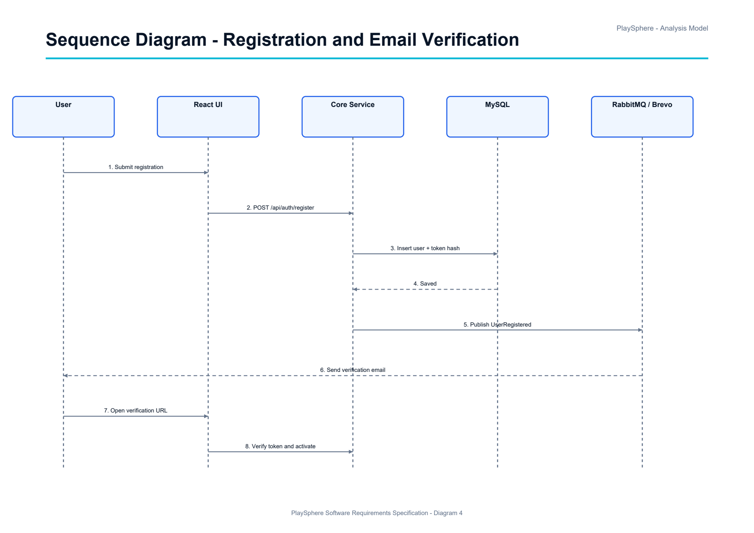

C.5 Sequence Diagram — Turf Booking and Payment
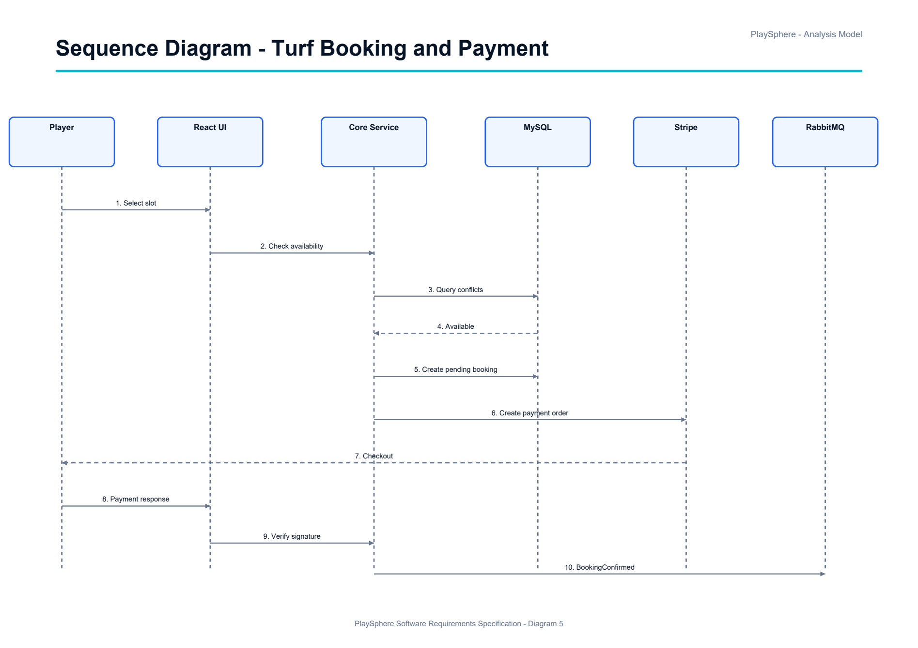

C.6 Activity Diagram — Turf Booking Workflow
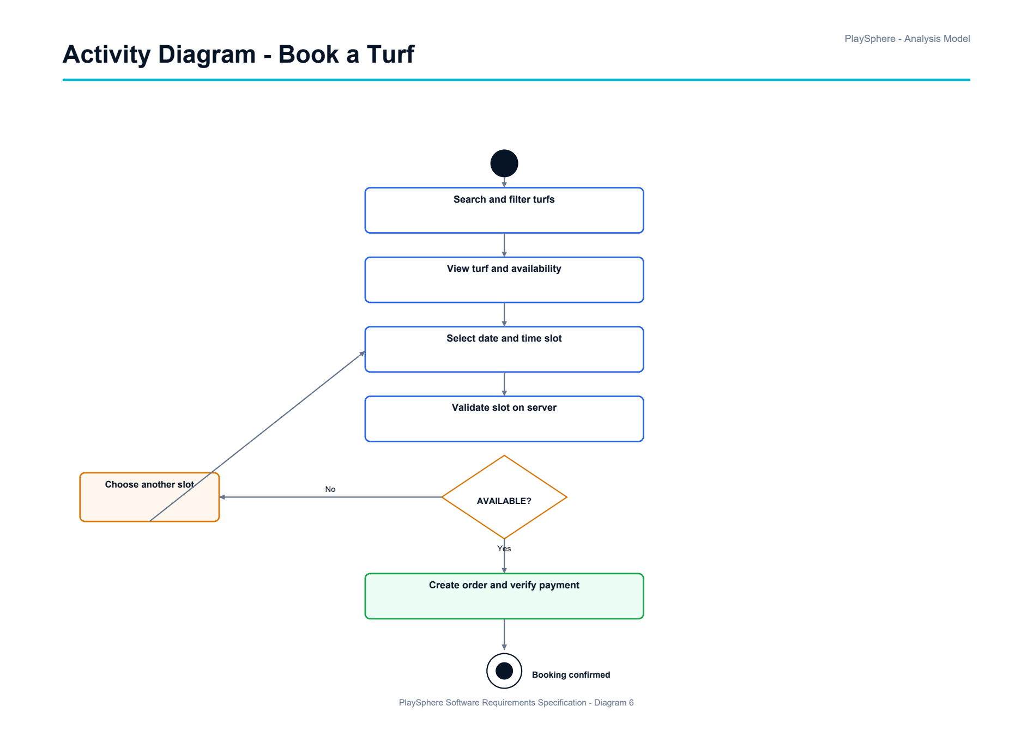

C.7 Data Flow Diagram — Level 0
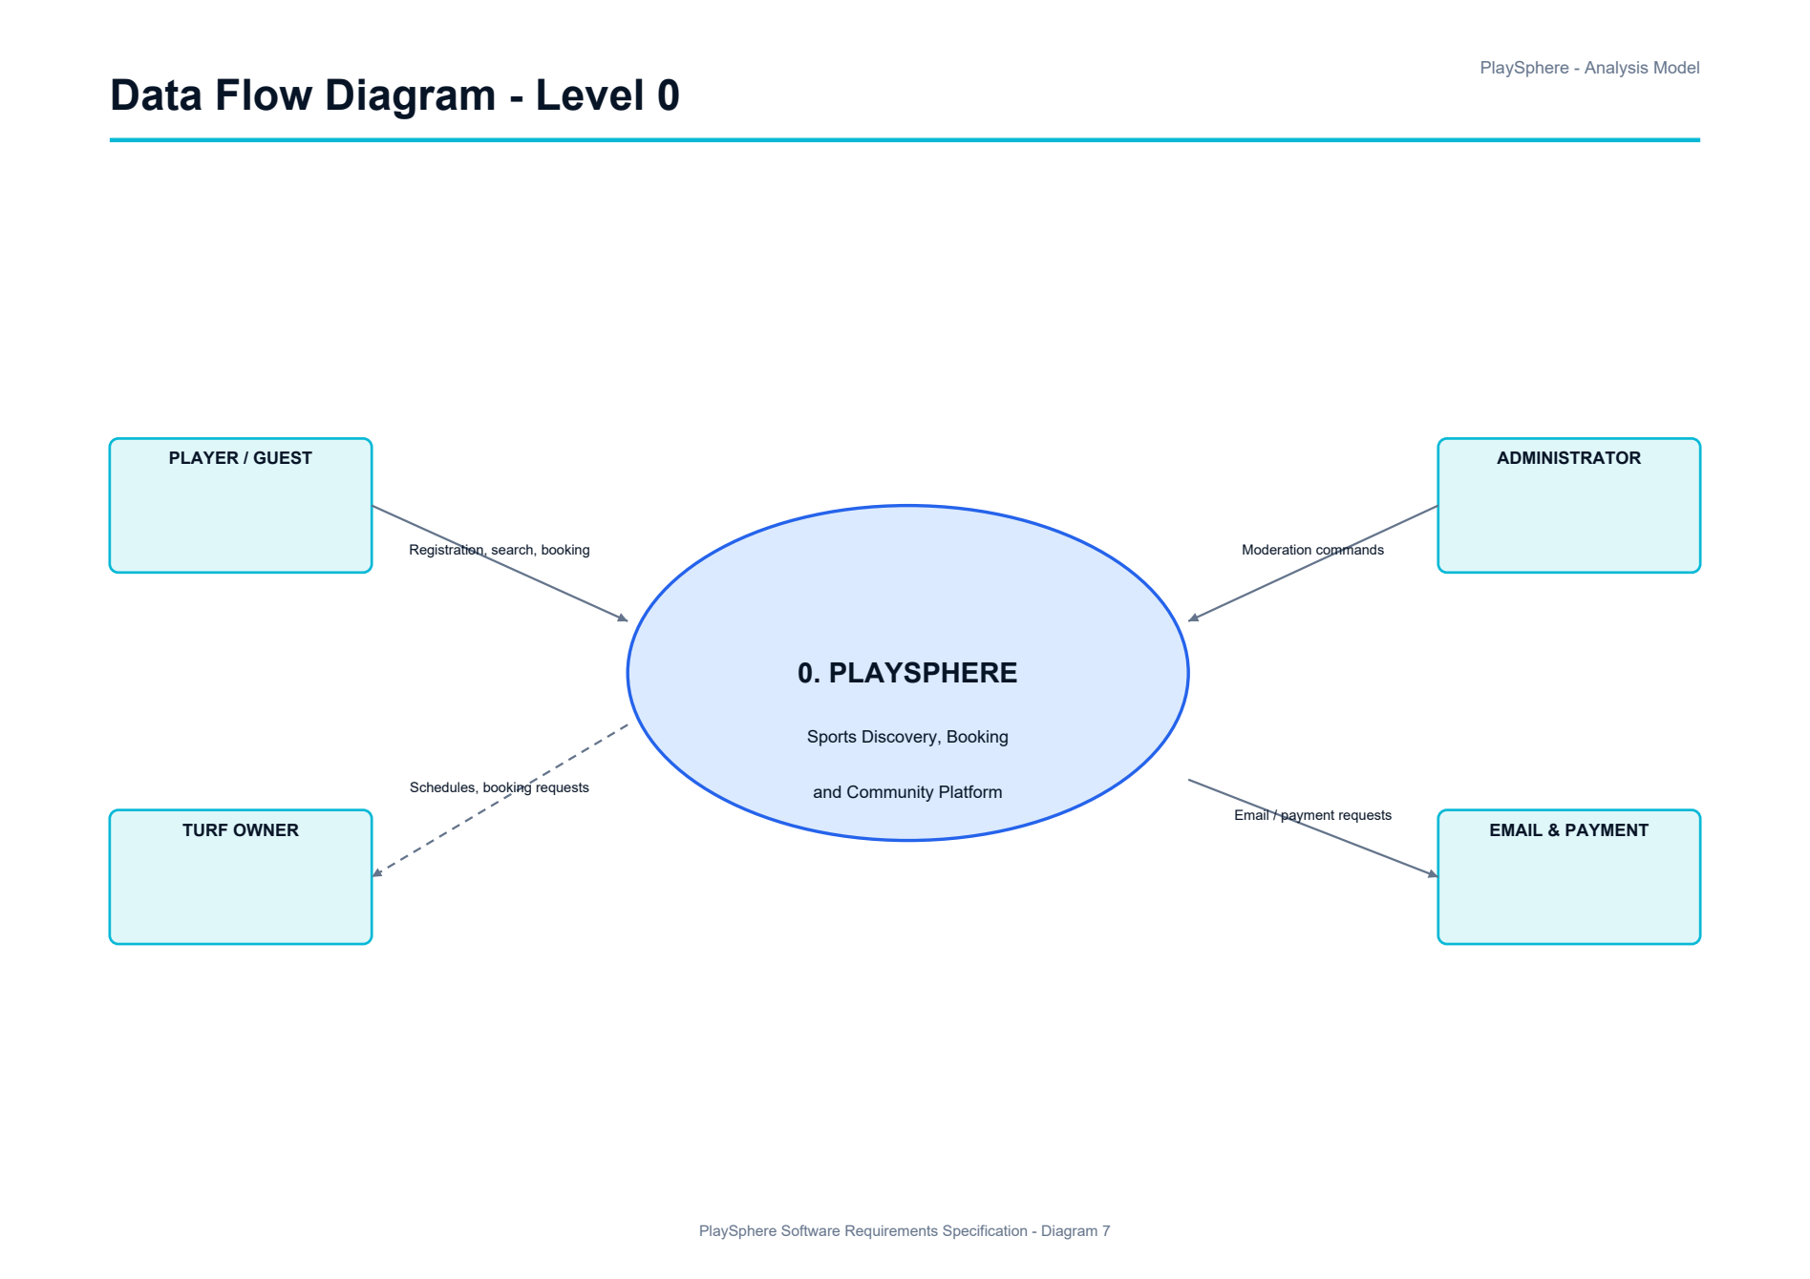
C.8 Data Flow Diagram — Level 1
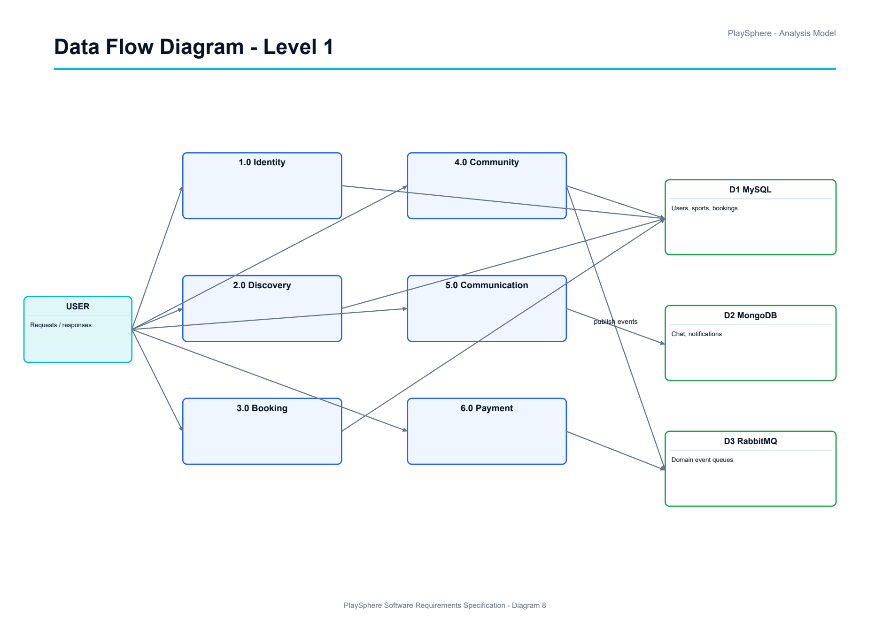

C.9 Microservices and AWS Messaging Deployment Diagram
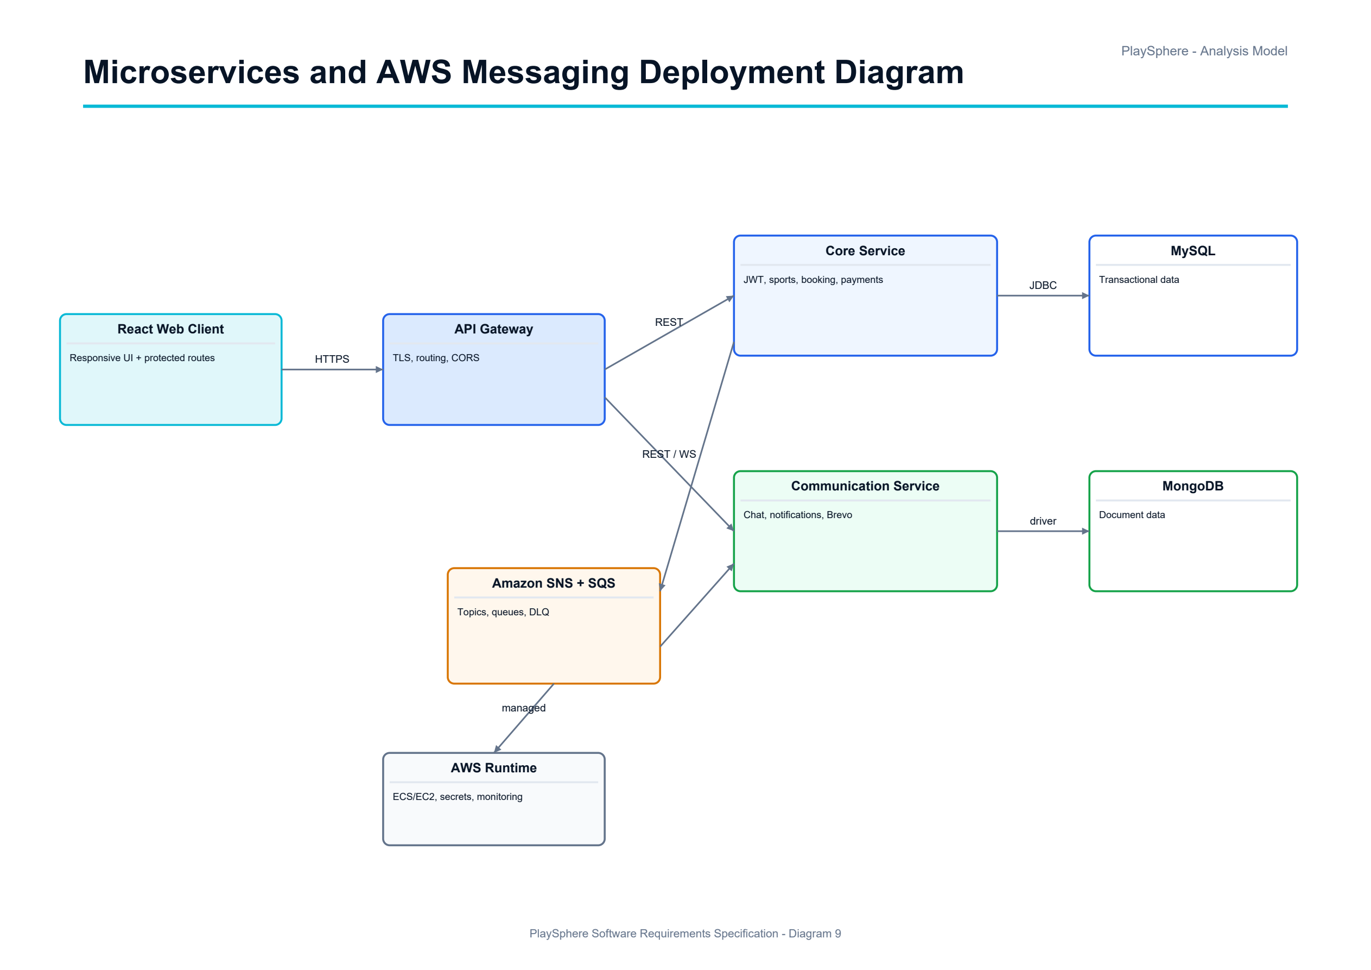

Appendix D: Requirements Traceability Matrix
This matrix links the principal functional, architectural, data and quality requirements to their source sections and objective verification evidence.
ID | Requirement | Source | Verification Evidence
FR-01 | Register, verify and authenticate accounts | 3.1 | Auth API and negative-path integration tests
FR-02 | Enforce JWT authentication and role authorization | 3.1, 5.3 | Spring Security authorization tests
FR-03 | Discover turfs and create conflict-free bookings | 3.3 | Search, availability and concurrent-slot tests
FR-04 | Manage teams and clans | 3.4 | Membership, ownership and duplicate tests
FR-05 | Create and join matches/events; record scores | 3.5 | Capacity, schedule and result tests
FR-06 | Find compatible players | 3.6 | Filter, privacy and self-exclusion tests
FR-07 | Exchange authorized persisted real-time messages | 3.7 | WebSocket, MongoDB and access tests
FR-08 | Submit and moderate reviews | 3.8 | Rating range, ownership and moderation tests
FR-09 | Create and verify Stripe payments | 3.9 | Webhook signature and status tests
FR-10 | Perform protected administration operations | 3.10 | Role-denial and audit tests
AR-01 | Deploy at least two Spring Boot microservices | 2.8 | Independent service build and health checks
AR-02 | Use SNS/SQS asynchronous messaging with DLQ | 2.8, 4.4 | Publish, consume, retry and DLQ tests
DR-01 | Store transactional data in MySQL | 2.8, 4.3 | Migration and persistence tests
DR-02 | Store chat/notification documents in MongoDB | 2.8, 4.3 | Document persistence tests
NFR-01 | Validate inputs and handle exceptions globally | 5.3, 5.6 | Validator and error-contract tests
NFR-02 | Provide logging and correlation identifiers | 5.6 | Log-format and trace review
NFR-03 | Provide JUnit 5/Mockito coverage | 5.6 | Generated coverage report
DEP-01 | Document APIs and deploy with Docker on AWS | 2.6, 5.6 | Swagger, README, GitHub and deployed URL

Appendix E: Delivery and Compliance Checklist
The team shall update the status/evidence column before submission. An item is complete only when the listed artifact or demonstration is available.
Area | Required Evidence | Status / Evidence Location
React frontend | Responsive UI, validation, API integration and role-protected routes | To be completed by team
Spring Boot backend | REST APIs, Spring Security, JWT/RBAC, validation and exception handling | To be completed by team
Microservices | Core and Communication services build and deploy independently | To be completed by team
Databases | Normalized MySQL schema and MongoDB collections with ownership boundaries | To be completed by team
Testing | JUnit 5/Mockito tests and coverage report for critical workflows | To be completed by team
API documentation | Swagger/OpenAPI available for public REST endpoints | To be completed by team
Setup documentation | README includes prerequisites, environment variables, startup and troubleshooting | To be completed by team
Deployment | Docker images and working AWS application URL with HTTPS/health checks | To be completed by team
Version control | GitHub repository with branches, commits, pull requests and release tag | To be completed by team
SRS and diagrams | Final SRS contains use case, ER, class, sequence, activity, DFD and deployment diagrams | Included in this document
Presentation | Final project PPT covers problem, architecture, demo, testing and deployment | To be completed by team
Viva readiness | Team and individual ownership, guide remarks and known limitations documented | To be completed by team

