AI Assisted Coding

ASSIGNMENT 7.4

Name: Arun
HT No: 2303A52064
Batch: 32

Question 1: Mutable Default Argument – Function Bug

Task:
Analyze given code where a mutable default argument causes unexpected behavior. Use AI to fix it.
# Bug: Mutable default argument
def add_item(item, items=[]):
items.append(item)
return items
print(add_item(1))
print(add_item(2))
Expected Output: Corrected function avoids shared list bug.

Prompt:
Fix the mutable default argument issue in the function so that each call gets a fresh list.

Code:
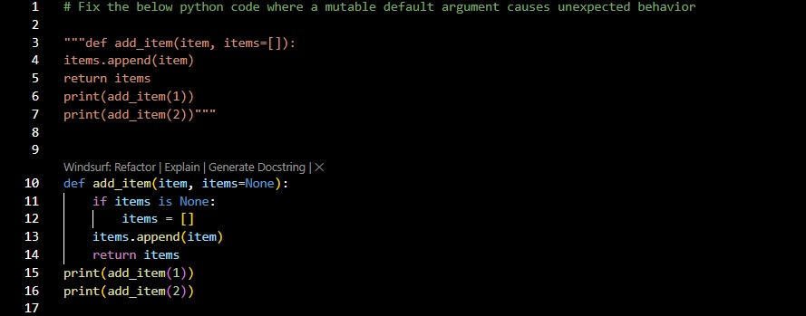

Output(O/P)



Explanation:
The default list [] was shared between calls.
Default arguments are created only once.
Using None ensures a new list is created each time.

Question 2: Floating-Point Precision Error

Task:
Analyze given code where floating-point comparison fails. Use AI to correct with tolerance.
# Bug: Floating point precision issue
def check_sum():
return (0.1 + 0.2) == 0.3
print(check_sum())
Expected Output: Corrected function

Prompt:
Fix floating point comparison using tolerance.

Code:
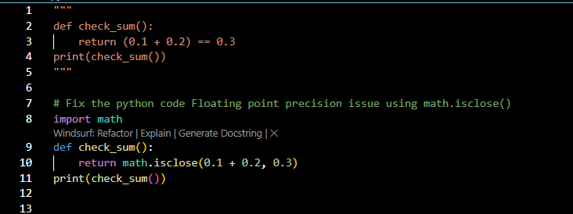

Output(O/P)

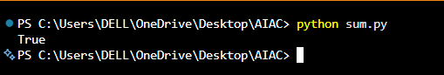

Explanation:
Floating numbers are not exact in binary.
Instead of ==, we compare the difference with a small tolerance.

Question 3: Recursion Error – Missing Base Case

Task:
Analyze given code where recursion runs infinitely due to missing base case. Use AI to fix it.
# Bug: No base case
def countdown(n):
print(n)
return countdown(n-1)
countdown(5)
Expected Output : Correct recursion with stopping condition.

Prompt:
Add a stopping condition to prevent infinite recursion.

Code:
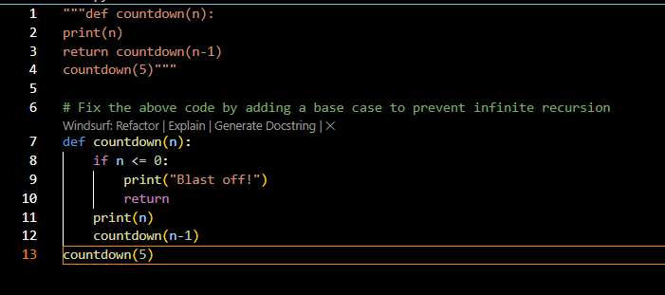

Output(O/P)

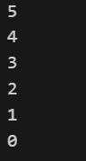

Explanation:
Without a base case, recursion never stops.
The base case stops when n becomes 0.

Question 4: Dictionary Key Error

Task:
Analyze given code where a missing dictionary key causes error. Use AI to fix it.
# Bug: Accessing non-existing key
def get_value():
data = {"a": 1, "b": 2}
return data["c"]
print(get_value())
Expected Output: Corrected with .get() or error handling.

Prompt:
Fix missing key access safely.

Code:
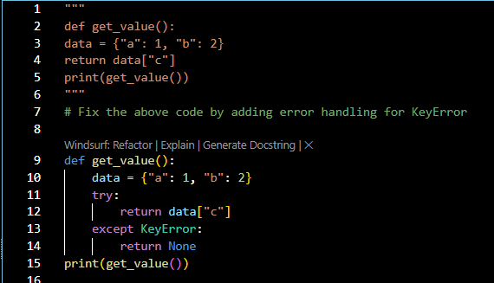

Output(O/P)

Explanation:
Accessing data["c"] causes KeyError.
.get() prevents crashes and allows default value.

Question 5: Infinite Loop – Wrong Condition

Task:
Analyze given code where the loop never ends. Use AI to detect and fix it.
# Bug: Infinite loop
def loop_example():
i = 0
while i < 5:
print(i)
Expected Output: Corrected loop increments i.

Prompt:
Fix the infinite loop by incrementing the counter.

Code:
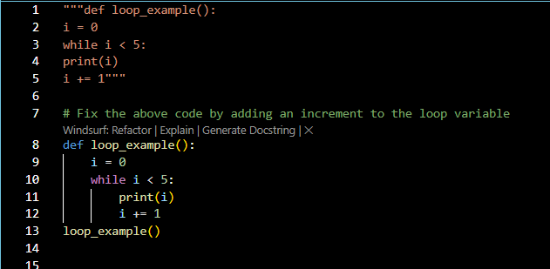

Output(O/P)

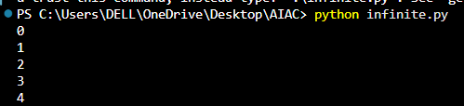

Explanation:
‘i’ was never incremented.
The loop condition stayed True forever.

Question 6: Unpacking Error – Wrong Variables

Task:
Analyze given code where tuple unpacking fails. Use AI to fix it.
# Bug: Wrong unpacking
a, b = (1, 2, 3)
Expected Output: Correct unpacking or using _ for extra values.

Prompt:
Fix tuple unpacking.

Code:
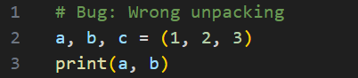

Output(O/P)

Explanation:
Tuple had three values but only two variables.
Added c to Fix.

Question 7: Mixed Indentation – Tabs vs Spaces

Task:
Analyze given code where mixed indentation breaks execution. Use AI to fix it.
# Bug: Mixed indentation
def func():
x = 5
y = 10
return x+y
Expected Output : Consistent indentation applied.

Prompt:
Fix inconsistent indentation.

Code:
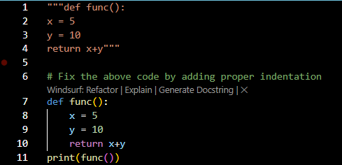

Output(O/P)

Explanation:
Python requires consistent indentation.
Using spaces consistently fixes execution.

Question 8: Import Error – Wrong Module Usage

Task:
Analyze given code with incorrect import. Use AI to fix it.
# Bug: Wrong import
import maths
print(maths.sqrt(16))
Expected Output: Corrected to import math

Prompt:
Fix incorrect module import.

Code:
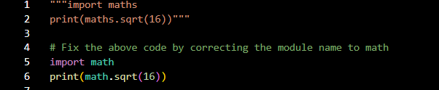

Output(O/P)

Explanation:
Corrected Typo of Import of math module

Question 9: Unreachable Code – Return Inside Loop

Task:
Analyze given code where a return inside a loop prevents full iteration. Use AI to fix it.
# Bug: Early return inside loop
def total(numbers):
for n in numbers:
return n
print(total([1,2,3]))
Expected Output: Corrected code accumulates sum and returns after loop

Prompt:
Fix early return inside loop.

Code:
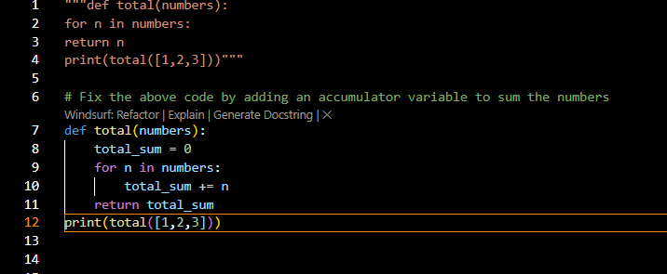

Output(O/P)

Explanation:
Return statement inside the loop stops after the first iteration.
Now it sums all elements before returning.

Question 10: Name Error – Undefined Variable

Task:
Task: Analyze given code where a variable is used before being defined. Let AI detect and fix the error.
# Bug: Using undefined variable
def calculate_area():
return length * width
print(calculate_area())
Requirements:
• Run the code to observe the error.
• Ask AI to identify the missing variable definition.
• Fix the bug by defining length and width as parameters.
• Add 3 assert test cases for correctness.
Expected Output :
• Corrected code with parameters.
• AI explanation of the bug.
Successful execution of assertions.

Prompt:
Fix undefined variables by using parameters. Add 3 assert test cases to test correctness.

Code:
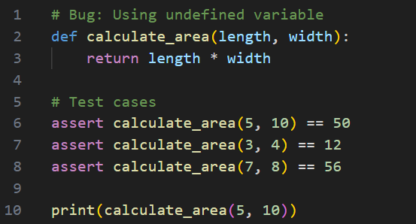

Output(O/P)

Explanation:
length and width were undefined.
Making them parameters fixes NameError.

Question 11: Type Error – Mixing Data Types Incorrectly

Task:
Analyze given code where integers and strings are added incorrectly. Let AI detect and fix the error.
# Bug: Adding integer and string
def add_values():
return 5 + "10"
print(add_values())
Requirements:
• Run the code to observe the error.
• AI should explain why int + str is invalid.
• Fix the code by type conversion (e.g., int("10") or str(5)).
• Verify with 3 assert cases.
Expected Output #6:
• Corrected code with type handling.
• AI explanation of the fix. Successful test validation.

Prompt:
Fix int adding string error using conversion. Add 3 assert test cases to test correctness, explain in a docstring why int + str is invalid.

Code:
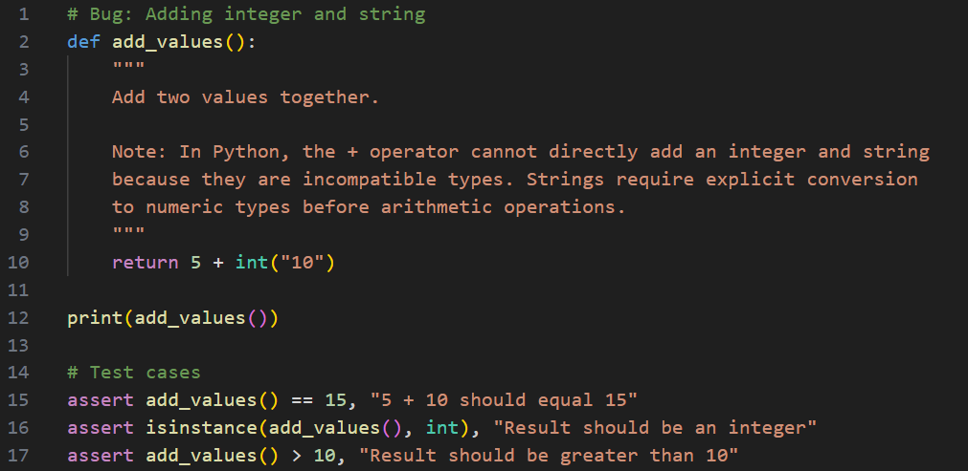

Output(O/P)



Explanation:
Python cannot add int and str directly.
Type conversion solves the issue.

Question 12: Type Error – String + List Concatenation

Task:
Analyze code where a string is incorrectly added to a list.
# Bug: Adding string and list
def combine():
return "Numbers: " + [1, 2, 3]
print(combine())
Requirements:
• Run the code to observe the error.
• Explain why str + list is invalid.
• Fix using conversion (str([1,2,3]) or " ".join()).
• Verify with 3 assert cases.
Expected Output:
• Corrected code
• Explanation
• Successful test validation

Prompt:
Fix string + list concatenation using conversion, Add 3 assert test cases to test correctness, explain in a docstring why str + list is invalid.

Code:
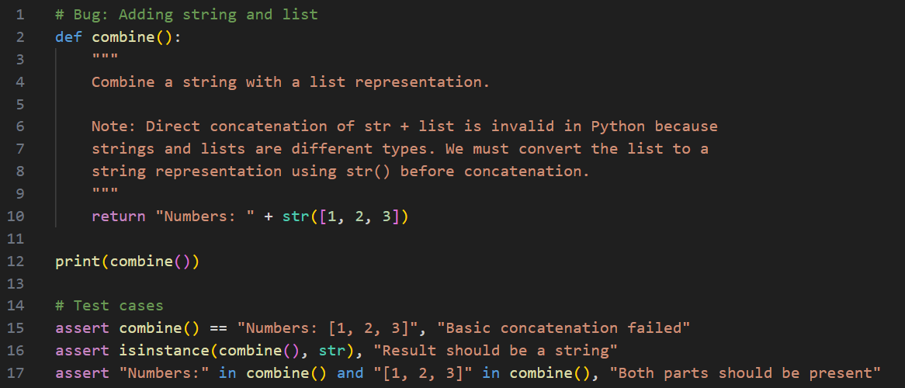

Output(O/P)

Explanation:
String cannot be directly added to the list.
Convert list to string first.

Question 13: Type Error – Multiplying String by Float

Task:
Detect and fix code where a string is multiplied by a float.
# Bug: Multiplying string by float
def repeat_text():
return "Hello" * 2.5
print(repeat_text())
Requirements:
• Observe the error.
• Explain why float multiplication is invalid for strings.
• Fix by converting float to int.
• Add 3 assert test cases.

Prompt:
Fix string multiplied by float using conversion, Explain in a docstring why float multiplication is invalid for strings, Add 3 assert test cases.

Code:
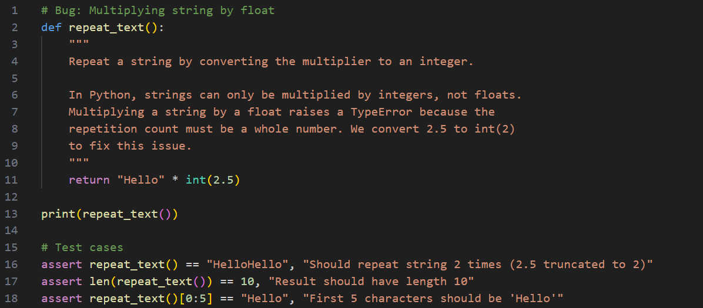

Output(O/P)



Explanation:
Strings can only be multiplied by integers.
Convert float to int before multiplication.

Question 14: Type Error – Adding None to Integer

Task:
Analyze code where None is added to an integer.
# Bug: Adding None and integer
def compute():
value = None
return value + 10
print(compute())
Requirements:
• Run and identify the error.
• Explain why NoneType cannot be added.
• Fix by assigning a default value.
• Validate using asserts.

Prompt:
Fix None addition issue, Explain in a docstring why NoneType cannot be added, Validate using asserts.

Code:
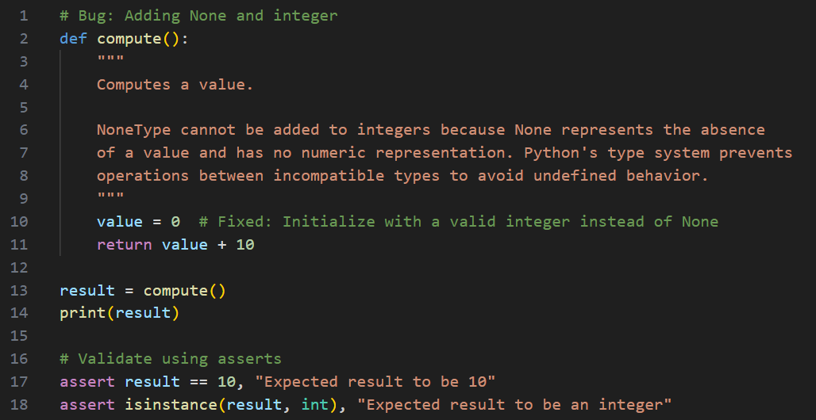

Output(O/P)

Explanation:
NoneType cannot be added to int.
Assign default numeric value before operation.

Question 15: Type Error – Input Treated as String Instead of Number

Task:
Fix code where user input is not converted properly.
# Bug: Input remains string
def sum_two_numbers():
a = input("Enter first number: ")
b = input("Enter second number: ")
return a + b
print(sum_two_numbers())
Requirements:
• Explain why input is always string.
• Fix using int() conversion.
• Verify with assert test cases.

Prompt:
Fix input conversion issue using type conversion, Explain in docstring why input is always string, Verify with assert test cases.

Code:
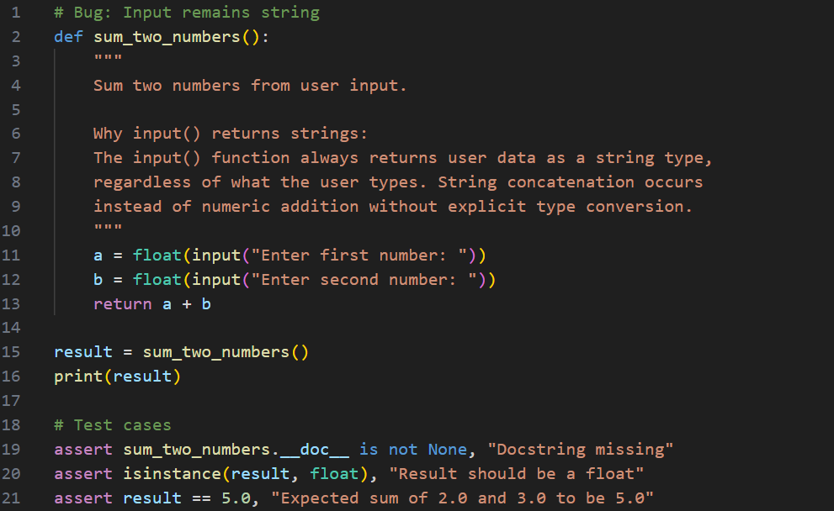

Output(O/P)

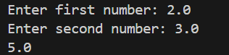

Explanation:
input() always returns string.
Convert to float or int before addition.

