Overview:

**WEB 3.0**

**What is web 3.0?**

As we speak web3.0 is more of an ideology rather than a technology, of having the ownership rights of our data.

In other words, web3 is basically an idea of making any individual to take a ownership across everything with the help of blockchain.

**What is blockchain?**

It is a common language across business. A technology which enables moving digital assets across individuals.

It connects everybody with everybody. The data in a blockchain network is called a block. These blocks have a secured key called “hash value”.

Every block has its own hash value and holds the hash value of the previous block. It is a 64-digit alpha numeric value. To sum it up, blockchain is a database with a different method of storing.

Now that we have an idea of what is a web3 and blockchain is,

WEB3 has many kinds of applications in the real world, to name a few, in Crypto, in pharma industries, in data management and so on, as it all depends on the programmer’s area of expertise. Let us quickly go through a lab environment where we catalog team had built the few go-to things which are the basics needs to build a web3 platform.

Basically, to build any application or website on a web3 platform we need,

* A frontend- React
* Compiler- Hardhat
* Programming language package- Solidity
* Programming tool-VS code
* An e-wallet- Metamask

Here we have built an environment where a user can transfer his Ethereum from one account to another account.

After logging in the lab:

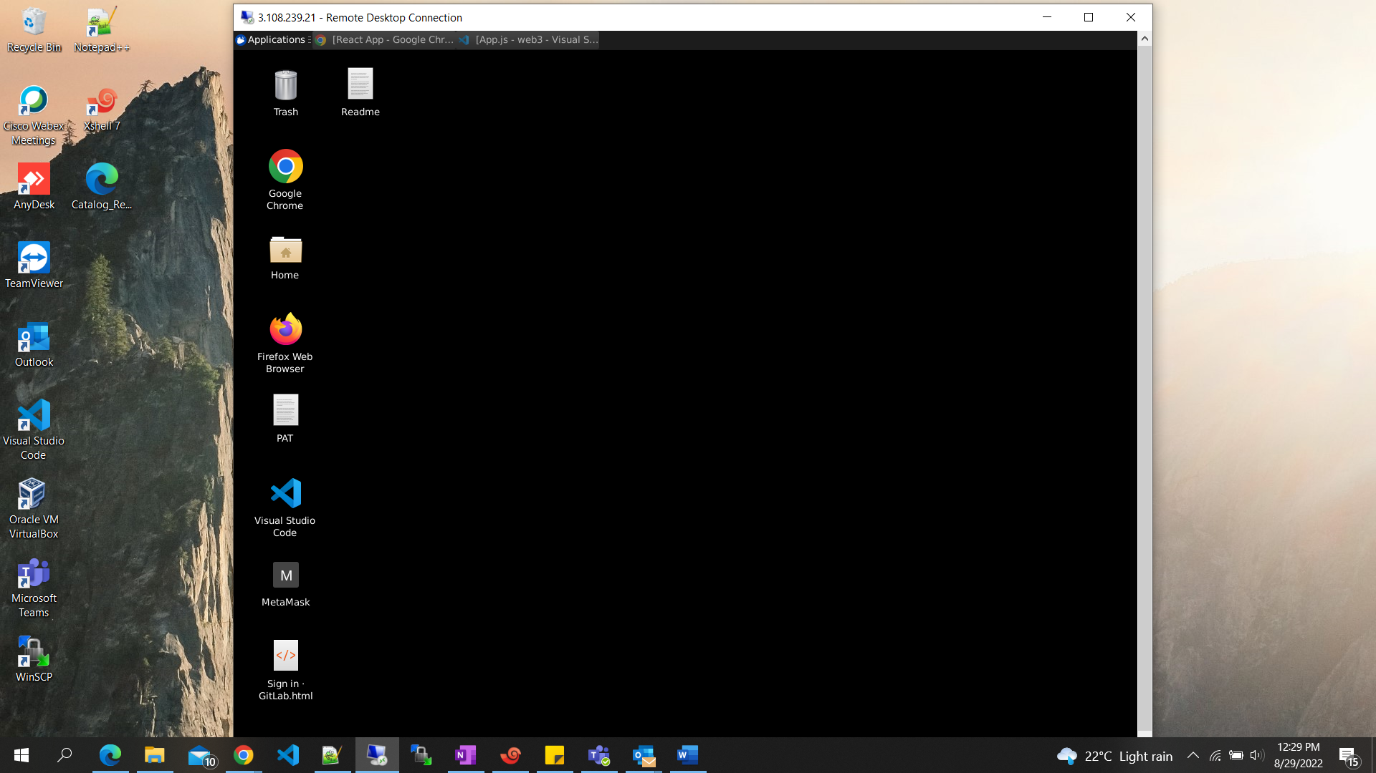

**Step 1:**

Triggering the hardhat node and react app:

* + Open the VS-code and set the directory to the created react app i.e web3 in this demo case.
  + Get to the terminal in that location and run two commands to get the step done

NOTE: commands to be executed in different terminal in the same location to avoid the conflicts.

1. npx hardhat node- which starts the local node
2. npm run start- which starts the react app

The responding images have been attached below. You should get a response like this.

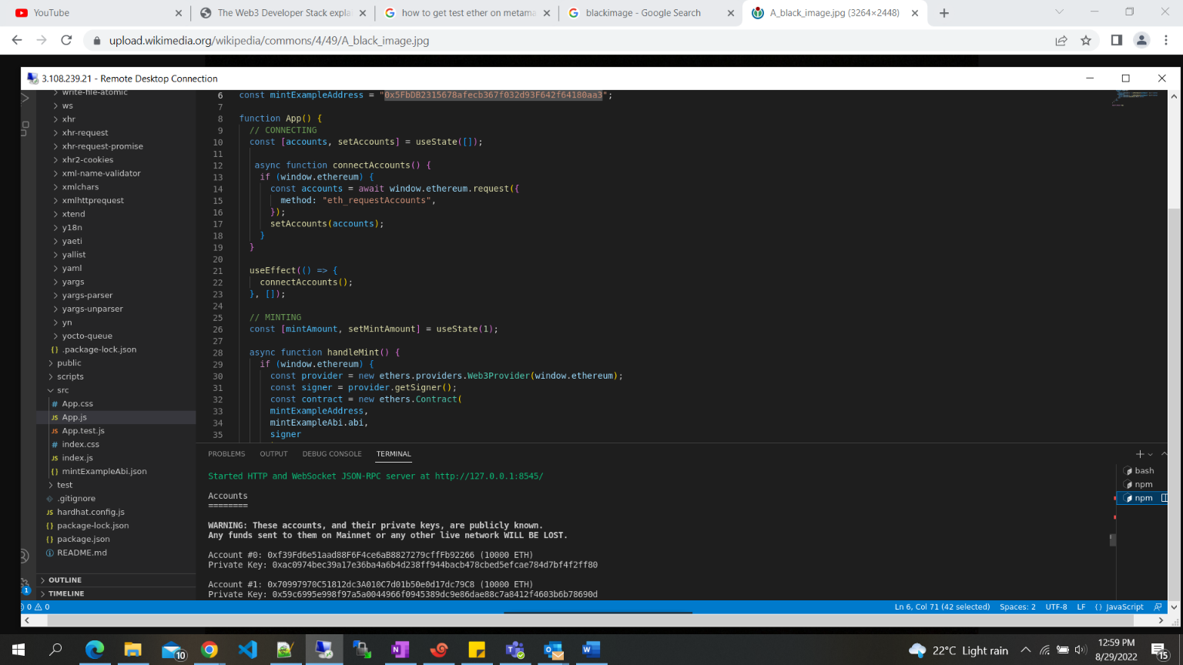

This is when u run hardhat node

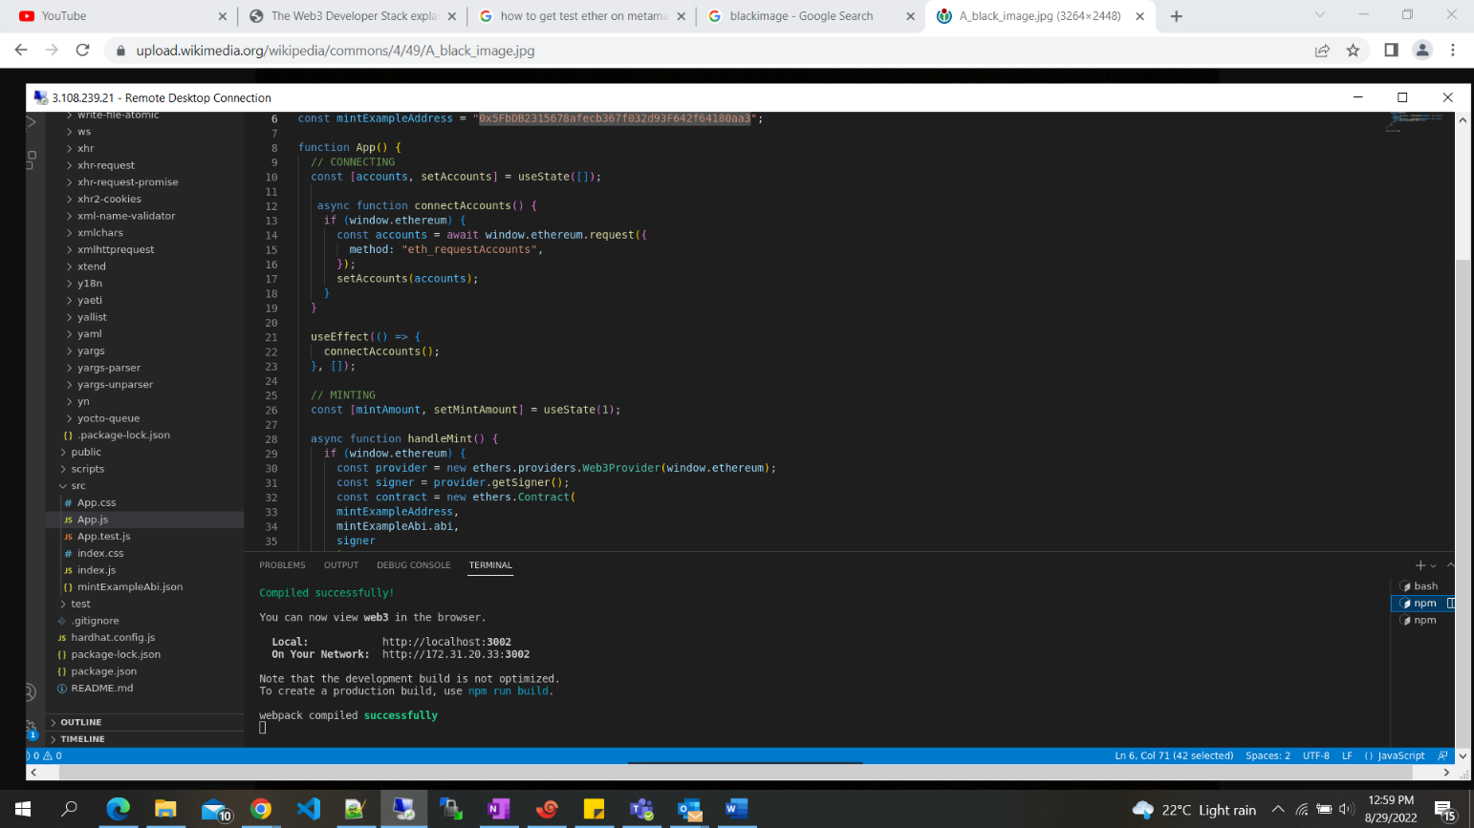

This is when you run react app, this directly triggers the browser and opens the react app

**Step 2:**

Linking the metamask account:

The opened window will look like this. It may ask you to connect your metamask wallet for the first time, after the linking, you will notice the Mint button or else need to connect the wallet.

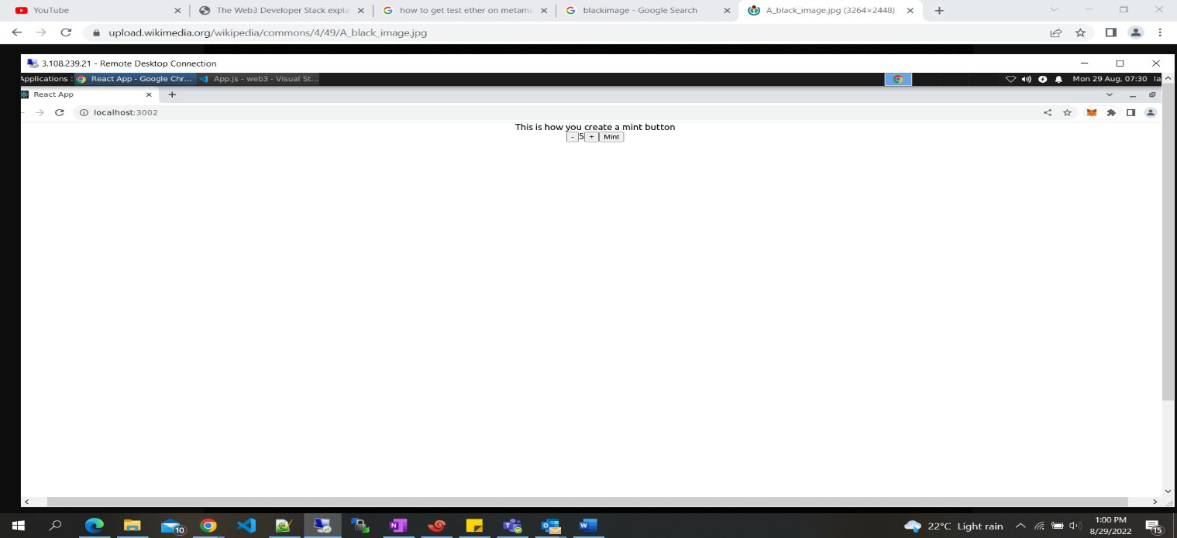

**Step 3:**

* After the successful completion of linking wallet, you’ll get the mint buttons.
* Now select the amount to be transferred and click mint.

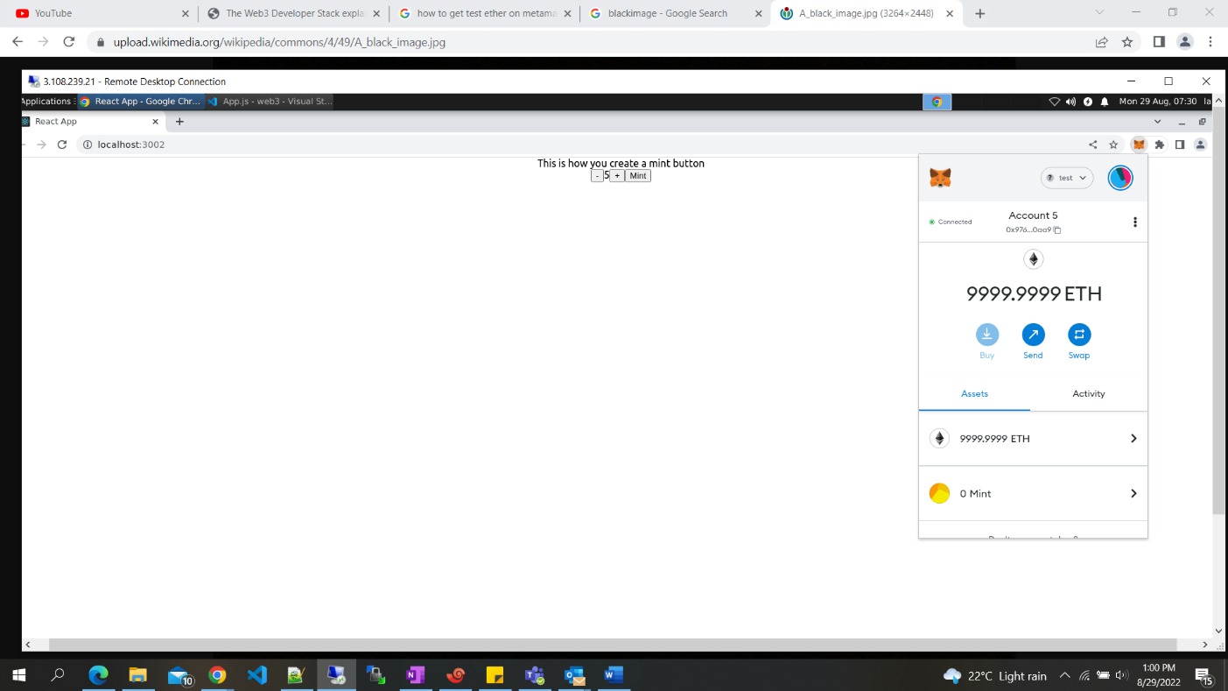

**Step 4:**

Now that will trigger the metamask and ask you to confirm once its loaded, now click confirm.

**Step 5:**

After confirming, wait for the transaction to be completed, and you’ll get a notification for that after successful completion.

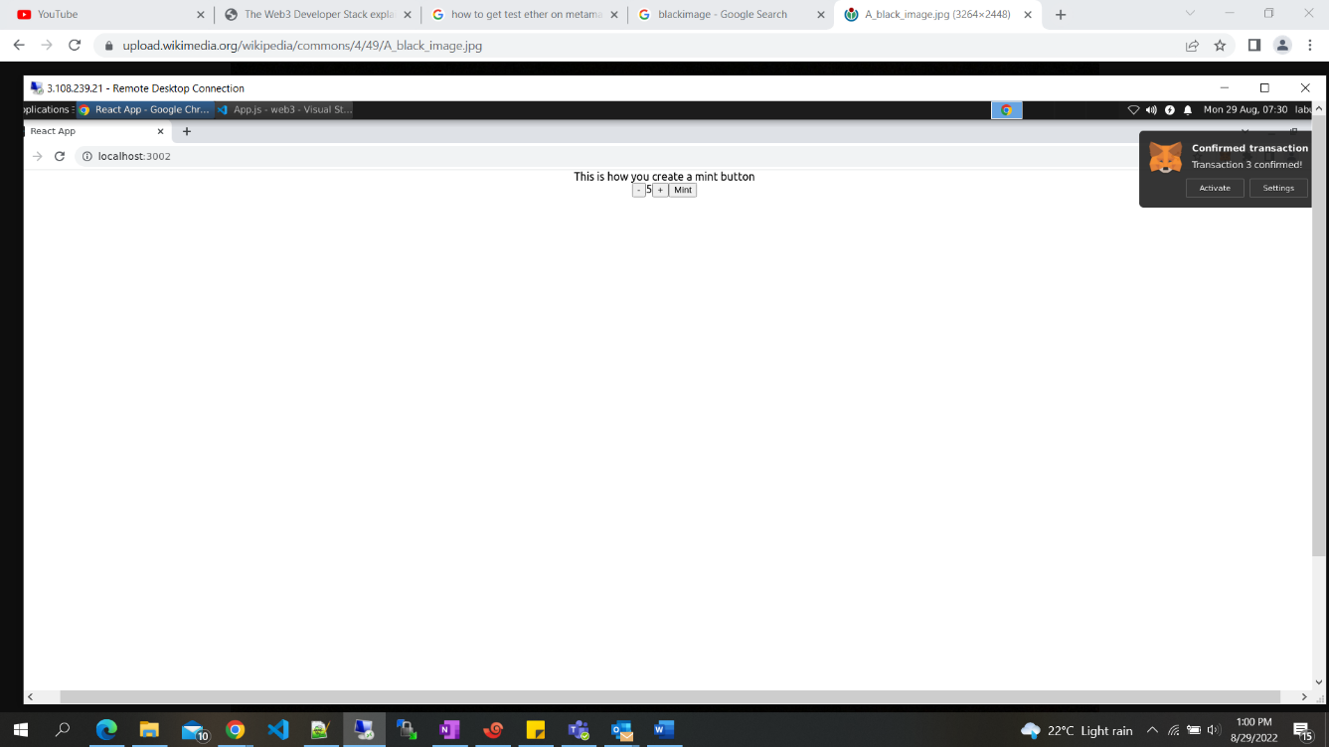

**Step 6:**

You can view the transaction history by checking the activity column

**Step 7:**

And finally, the transferred amount should be reflected in the received account

