- Now after having hands of experience
you have options to lead as a full stack developer, app developer, data analytics, data science, salesforce, AI & ML.
full stack developer – since you know have an experience on windows then you have a slight idea about the full stack which includes both frontend and backend so here you choose MERN full stack or python or java full stack
App developer – since you are from the computer science you know about the programming languages and you prefer java then here you have an advantage for this it use flutter, Kotlin.
Data Analytics— here you work with data since you have experience in handling data on excel and Power BI and have knowledge on python you prefer this
Data science – here you work with on data
Salesforce – salesforce is used in company example just like handling the details of the company in import and export, handling all the data and Provide analytics on which items are needed most, giving the percentage of which item is should we need most and all stuff like Automates workflows (e.g., sending shipping alerts).Improves customer service (e.g., tracking complaints).Connects with other tools (e.g., ERP, logistics software).
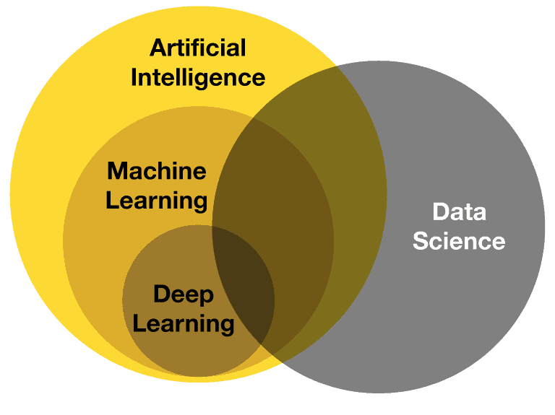
AI & ML – I think we all know about this thing now a days this has impact on every sector.

