

SR UNIVERSITY
Assignment-12.1

Name : Eldi Arun Kumar
Enrollment No : 2503A51L27
Batch No : 19

Task Description :1
Use AI to generate a Python program that implements the Merge Sort algorithm.
• Instructions:
o Prompt AI to create a function merge_sort(arr) that sorts alist in ascending order.
o Ask AI to include time complexity and space complexity in the function docstring.
o Verify the generated code with test cases.
PROMPT:
Generate a Python program that implements the Merge Sort algorithm using ascending order and descending order.

CODE:
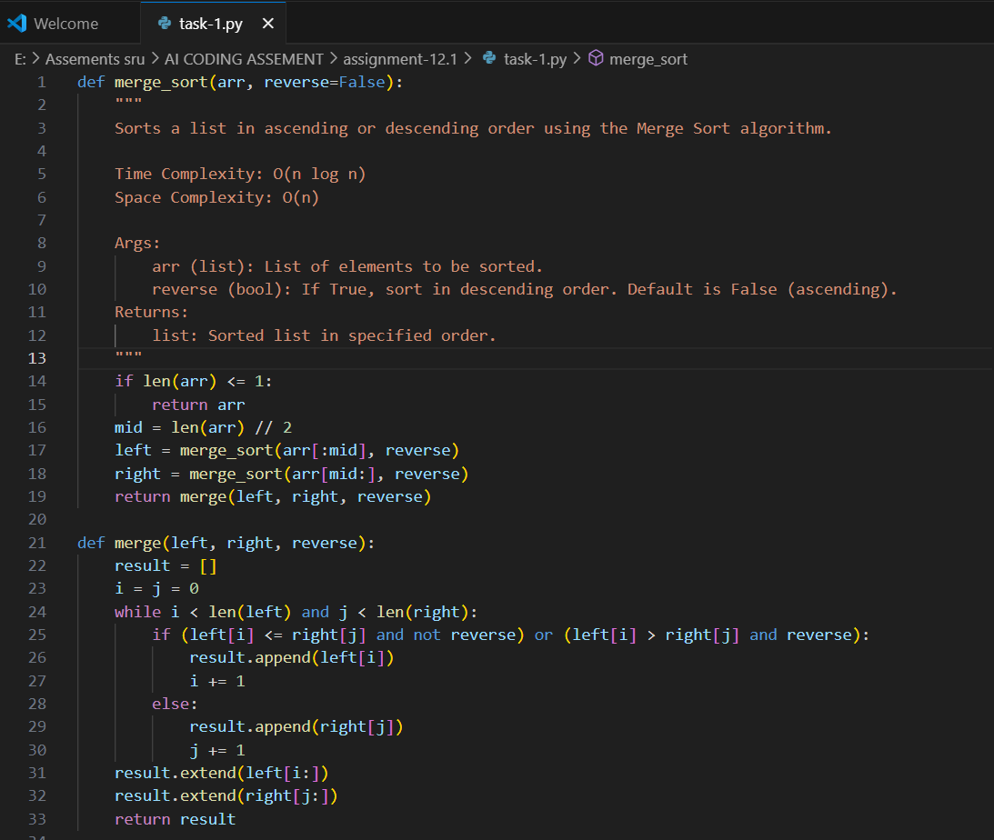
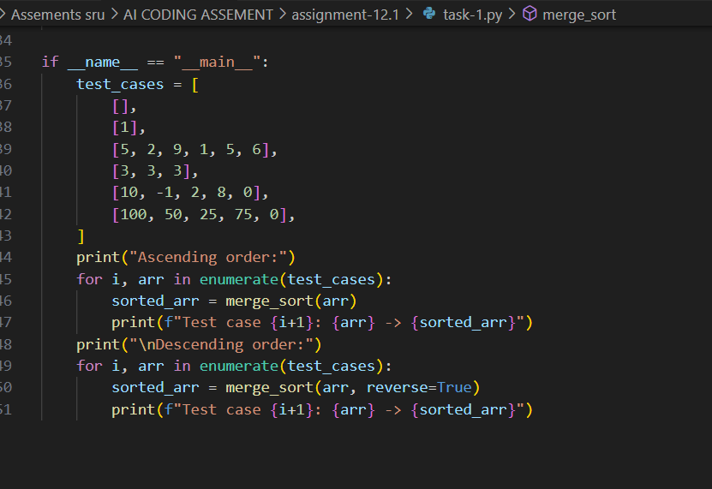

OUTPUT:
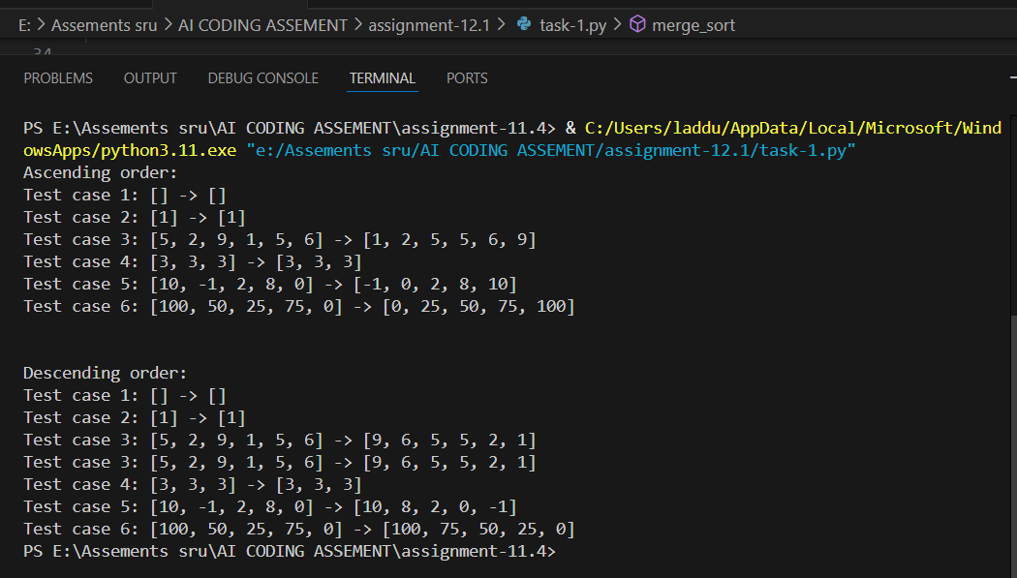

OBSERVATION:
I observed that the code correctly implements merge sort using recursion with a separate merge function, and the reverse flag properly switches between ascending and descending order. It also handles edge cases like empty lists, single elements, duplicates, and negatives effectively, while returning a new sorted list without altering the original input.

Task Description :2
Use AI to create a binary search function that finds a target element in a sorted list.
• Instructions:
o Prompt AI to create a function binary_search(arr, target) returning the index of the target or -1 if not found.
o Include docstrings explaining best, average, and worst- case complexities.
o Test with various inputs.

PROMPT:
Generate a Python function binary_search(arr, target) that returns the index of target in a sorted list or -1 if not found. Add a docstring explaining best, average, and worst-case time complexities. Include test cases with various inputs to show it works.
CODE: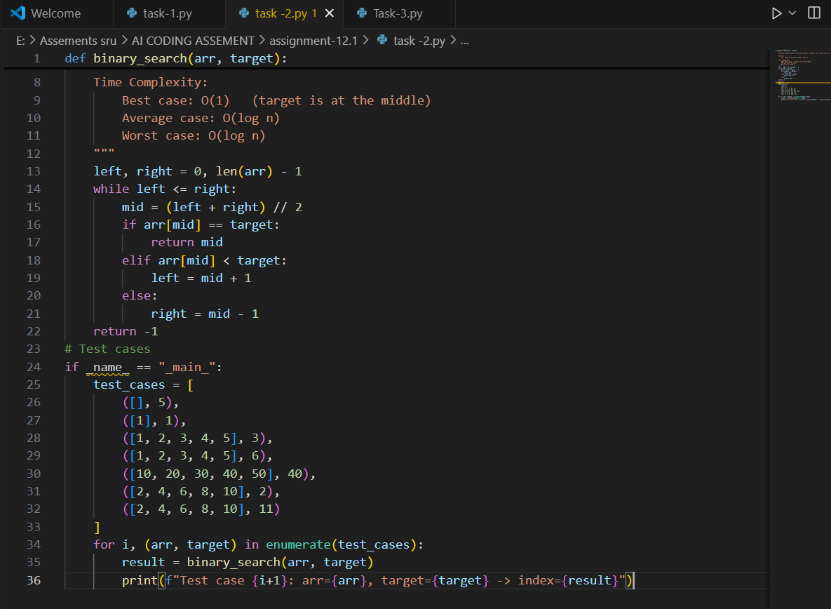

OUTPUT:
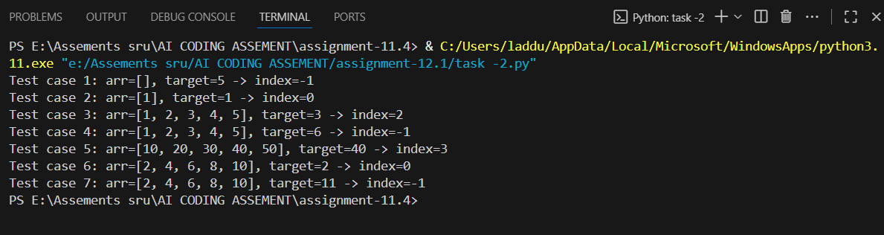

OBSERVATION:
I observed that the function correctly implements an iterative binary search on a sorted list and returns the index of the target or -1 if not found.
Its docstring clearly states best, average, and worst-case complexities.
The provided test cases cover empty lists, single elements, present and absent targets, and edge positions, showing the function works as expected.

Task Description :3
Scenario: A retail store’s inventory system contains thousands of
products, each with attributes like product ID, name, price, and
stock quantity. Store staff need to:
1. Quickly search for a product by ID or name.
2. Sort products by price or quantity for stock analysis.
• Task:
o Use AI to suggest the most efficient search and sort
algorithms for this use case.
o Implement the recommended algorithms in Python.
o Justify the choice based on dataset size, update frequency,
and performance requirements.
PROMPT:
Generate a Python function binary_search(arr, target) that returns the index of target in a sorted list or -1 if not found. Include a docstring explaining best, average, and worst-case time complexities.

CODE: 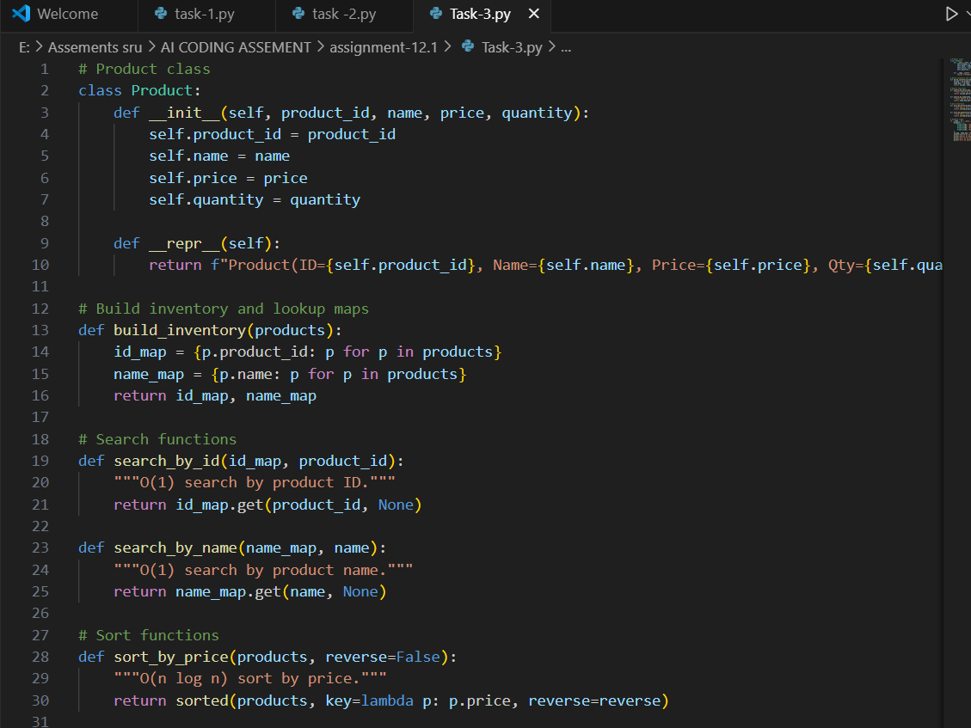

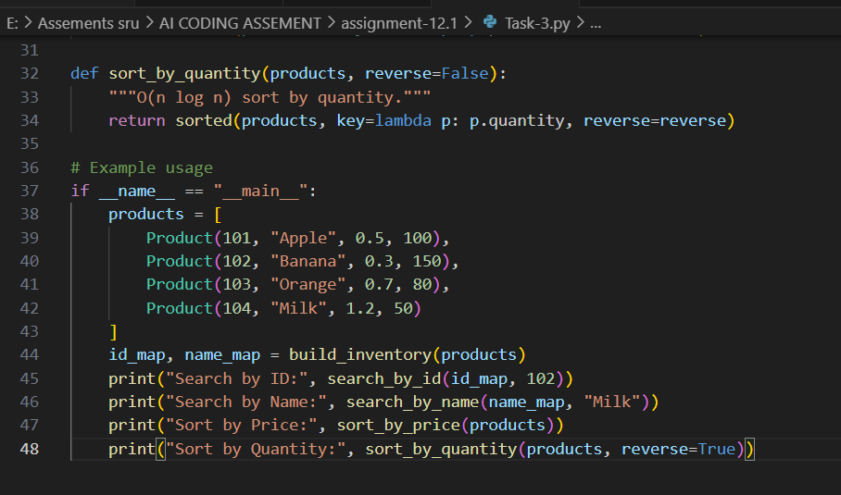
OUTPUT:
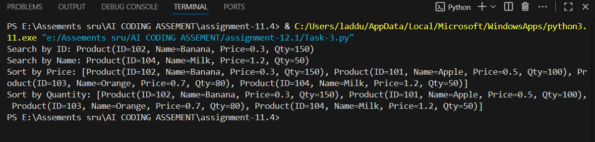

OBSERVATION:
I observed that the code cleanly defines a Product class and uses dictionaries for fast O(1) lookups by ID or name.
Sorting by price or quantity is correctly implemented with O(n log n) complexity and supports ascending or descending order.
Overall, it’s an efficient and well-structured inventory management example

