

SR UNIVERSITY
Assignment-12.1

Name : Eldi Arun Kumar
Enrollment No : 2503A51L27
Batch No : 19

Task Description 1:
Provide AI with the following redundant code and ask it to
refactor
Python Code
def calculate_area(shape, x, y=0):
if shape == "rectangle":
return x * y
elif shape == "square":
return x * x
elif shape == "circle":
return 3.14 * x * x

Prompt: Generate a Python program to calculate the area of a rectangle, square, or circle based on the shape name and its parameters.

Code:
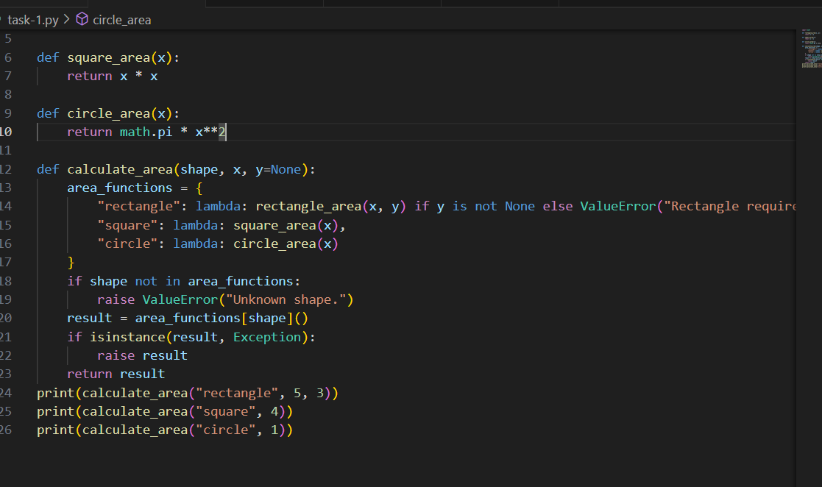
Output:
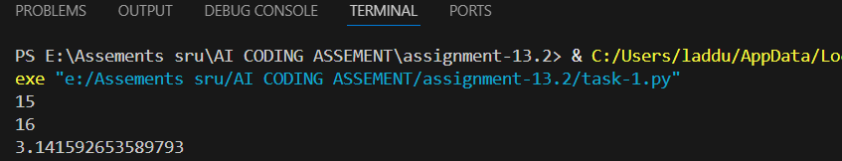

Observation:
- The code is missing a rectangle_area function. In area_functions, "rectangle" calls rectangle_area(x, y), but that function isn’t defined anywhere, which will raise a NameError.
- The calculate_area function uses lambdas correctly for square and circle but not for rectangle (it should call a defined rectangle_area). Also, checking isinstance(result, Exception) after computing is unusual; exceptions should normally be raised directly.

Task Description 2:
Legacy function without proper error handling
Python Code
def read_file(filename):
f = open(filename, "r")
data = f.read()
f.close()
return data

Prompt: Generate a Python function to read the contents of a text file and handle cases where the file is missing or any error occurs.

Code:
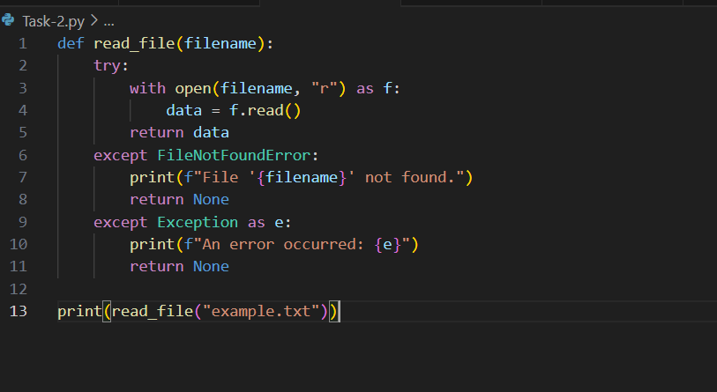

Output:
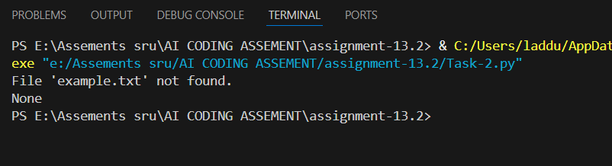

Observation:
- The function read_file(filename) correctly opens the file in read mode and returns its content; if the file does not exist, it prints a custom “not found” message and returns None.
- The except Exception as e: block ensures other errors (like permission issues) are caught and logged. This makes the code robust.
- When example.txt does not exist, it will print File 'example.txt' not found. and return None

Task Description 3:
Provide this legacy class to AI for readability and modularity
improvements:
Python Code
class Student:
def __init__(self, n, a, m1, m2, m3):
self.n = n
self.a = a
self.m1 = m1
self.m2 = m2
self.m3 = m3
def details(self):
print("Name:", self.n, "Age:", self.a)
def total(self):
return self.m1+self.m2+self.m3

Prompt: Generate a Python class Student that stores a student's name, age, and marks, provides a method to display details, and another method to return the total marks.

Code:
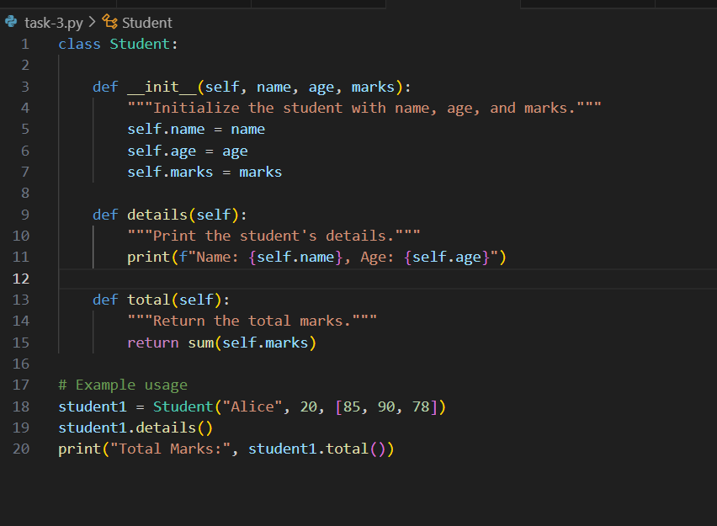

Output:
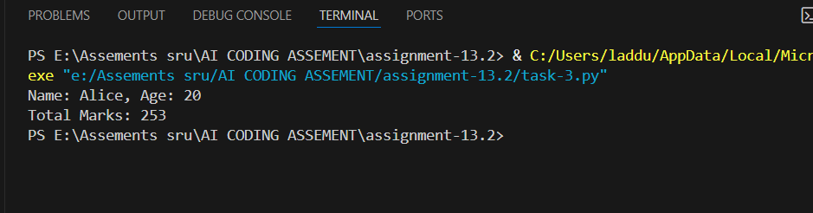

Observation:
- The class Student correctly initializes name, age, and marks using the __init__ constructor.
- The details() method prints the student’s name and age in a formatted string.
- The total() method calculates the sum of marks in the marks list using Python’s built-in sum() function.
- The example usage creates a Student object, prints its details, and outputs the total marks successfully.

Task Description 4:
Refactor this inefficient loop with AI help
Python Code
nums = [1,2,3,4,5,6,7,8,9,10]
squares = []
for i in nums:
squares.append(i * i)

Prompt: Generate a Python loop that calculates the square of each number in a list into a concise, efficient one-liner using list comprehension.
Code:
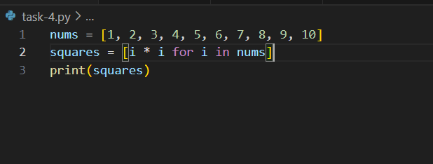

Output:
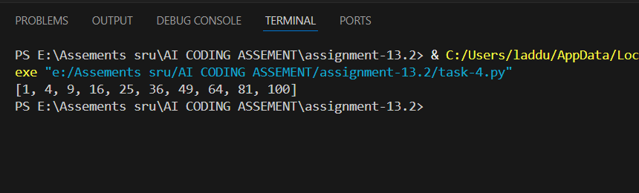

Observation:
- The given code uses an explicit for loop and .append() to build the squares list, which is correct but not Pythonic.
- It can be rewritten more efficiently as:
- squares = [i * i for i in nums]
- This is shorter, cleaner, and usually faster because list comprehensions are optimized in Python.

