# PUBLIC TRANSPORT OPTIMIZATION

# COMPONENTS:

The proposed system utilizes the following hardware and software components

Hardware Specifications:

The bus’s hardware is the most crucial Component. The hardware utilized for prototype Development is described in this section.

IR Sensor:

The proposed system uses an IR sensor as The first step in verifying the student’s entry into the bus. With a pair of infrared transmitters and a receiver tube, An IR Sensor module has an adaptable potentiality of Atmospheric light. Infrared technology is used in a Variety of wireless applications.

RFID Reader RC522:

The RFID RC522 Card Reader Module, based on the MFRC522 controller, is a low-cost 13.56 MHz RFID Reader module. The module necessitates a 3.3V power Supply. It can communicate with any CPU board directly Using the SPI protocol, and it also supports I2C and UART. It is utilized for attendance analysis and person Identification in the proposed system.

Raspberry Pi 3 B+ Micro-controller:

The Raspberry Pi foundation microcomputer that was created to promote programming and computing principles. It has a 64-bit quad-core processor with a clock speed of 1.4GHz and dual-band 2.4GHz. It has 5GHz wireless LAN and Bluetooth connectivity, making it an ideal alternative for highly networked designs. Its high processing power and on-board connectivity make it ideal for IOT applications.

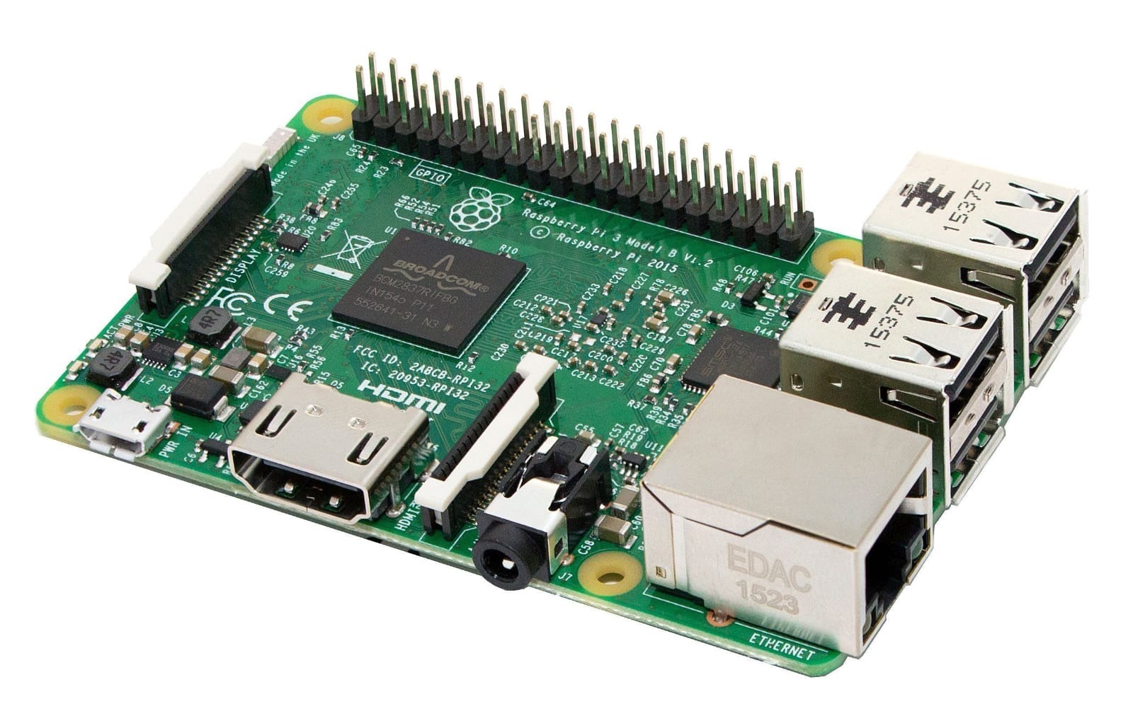

Camera Module:

The 5-megapixel Camera Module Rev 1.3 is a specially developed Raspberry Pi add-on. A unique CSI interface is utilised for camera interaction. The CSI bus provides extremely high data speeds and consistently transports pixel data. It is used to capture a snapshot of the intruder in the proposed system.

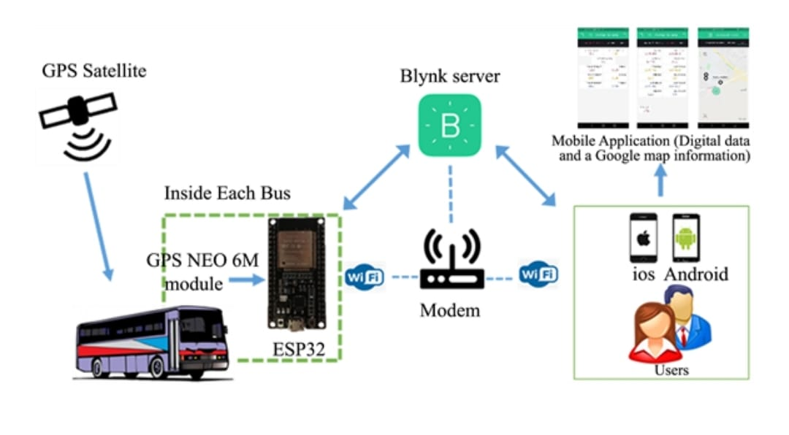

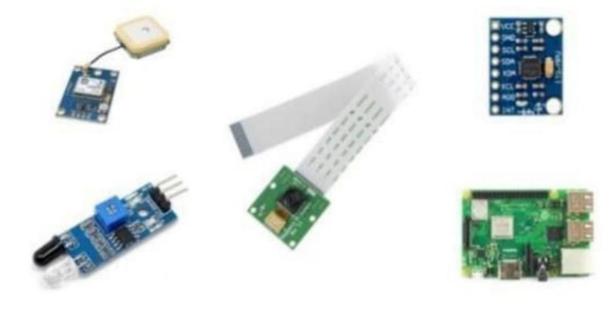

GPS Module –Neo 6M: The Neo-6M GPS module is a reliable GPS receiver with a 25 x 25 x 4mm ceramic antenna built in. It has a good satellite search capacity. The power and signal indicators can be used to check on the module’s status. It is used to gather information about geographical parameters.

# MPU6050 Accelerometer:

The MPU6050 is a single-chip 3-axis accelerometer and gyroscope. It is also known as a six-axis motion tracking or six Degrees of Freedom (DOF) device because of the three accelerometer and three gyroscope outputs. Hardware components used in the prototype development

# Specifications for Software

HTML, JS, CSS, jQuery, and Bootstrap were used to create The android application. In order to view the current location, the Google Maps API has been integrated into the programmer. Using Firebase fire-store, we were able to get real-time changes Firebase:

The Firebase database is a cloud-based database that allows for real-time data syncing and storage across users around the world. It promotes user participation and server less application development. JSON is the format in which the NoSQL database is stored. When developing cross-platform programmer, a real time database instance can be shared among all clients. Even If the app goes down, the data is still accessible.

API for Google Maps:

Google has created application programming interfaces (APIs) that allow users to communicate with Google services and integrate them with other services. Analytics, machine learning as a service, and user data access are among the features. Google Maps can also be iIntegrated into a website or application. It is used in the suggested model to add a map to the Android app to detect bus routes and deliver the best way to destination with real-time traffic update

# PROPOSED SYSTEM ARCHITECTURE:

The suggested system seeks to provide effective services through the integration of various technologies and the Internet of Things. The suggested system’s diagrammatic representation.

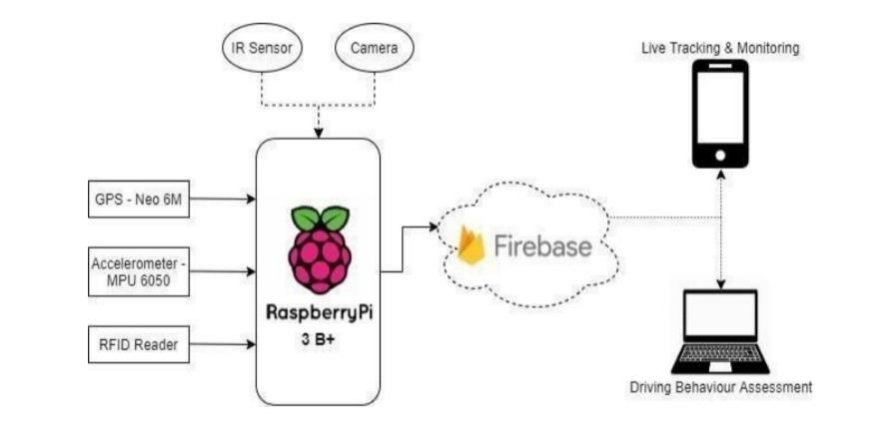

The various hardware prototype components that were used to construct the prototype. The Raspberry Pi serves as the system's brain, connecting to several sensors like as GPS, Accelerometer, RFID, IR, and Camera. For database management, it's also linked to Google Firebase. The Raspberry Pi and the Firebase have most of the data in sync.

# DATA FLOW DIAGRAM

# ROUTE DIAGRAM:

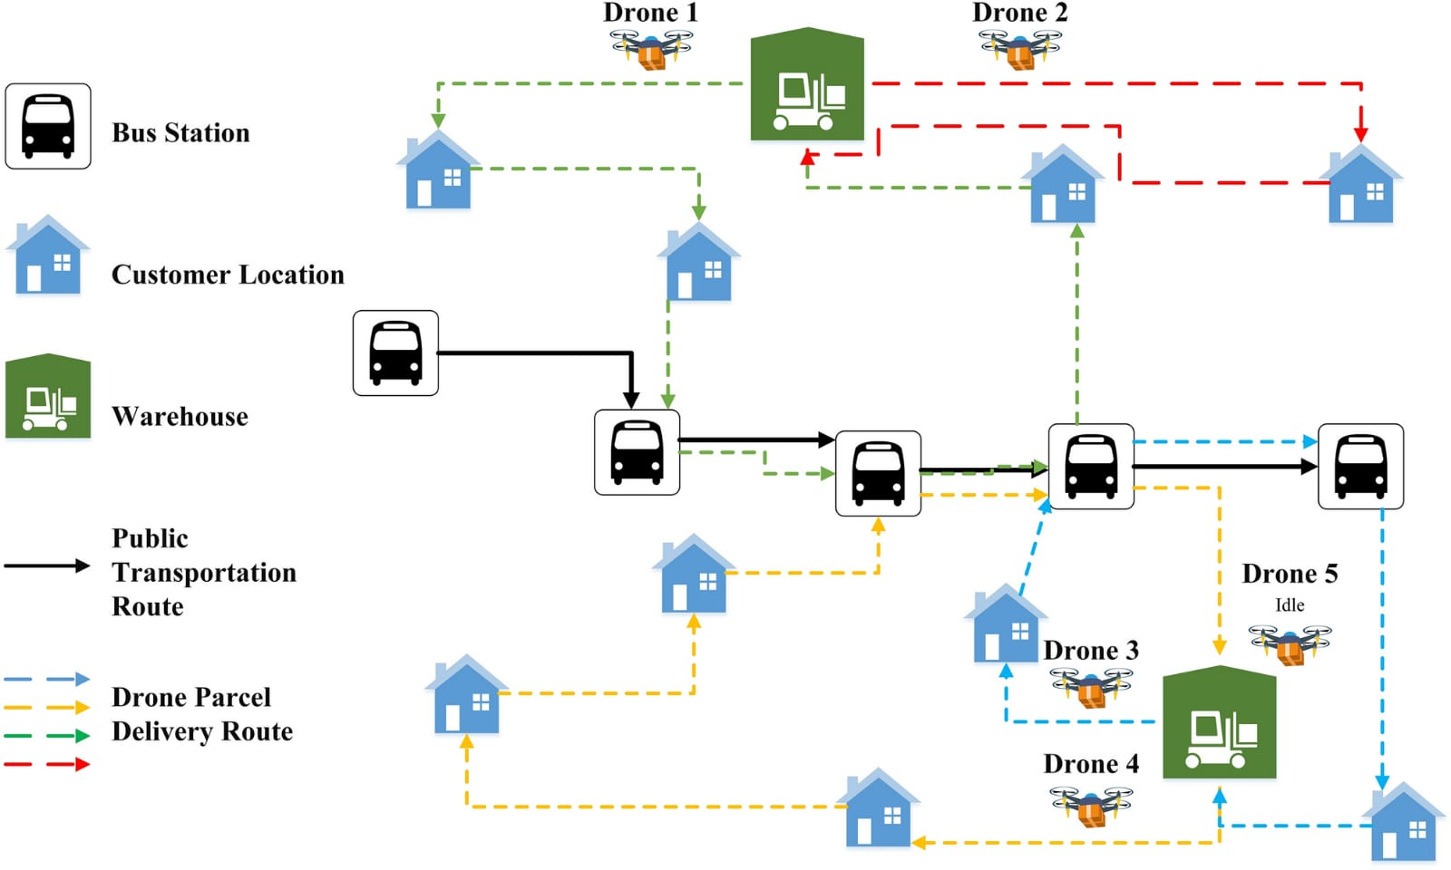

# SECURITY SYSTEM DIAGRAM

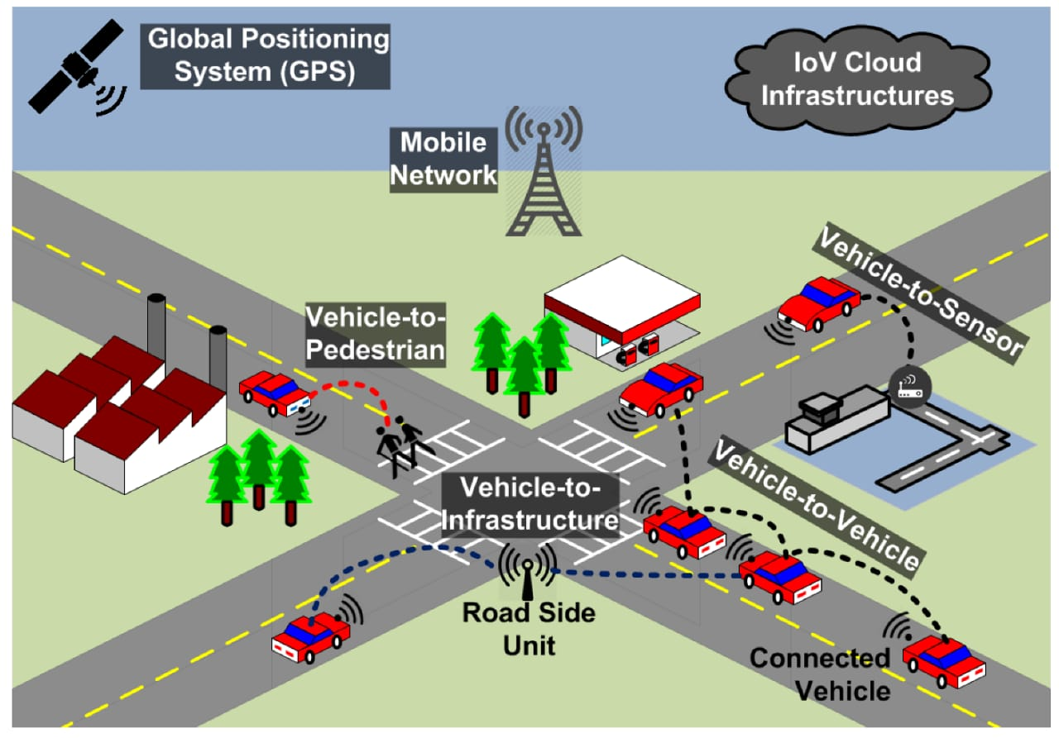

# PROGRAM

import numpy as np, json, random, solver, operator, pandas as pd from flask import * import pandas as pd import numpy as np import matplotlib.pyplot as plt from sklearn.cluster import KMeans import csv app = Flask(__name__)

city_name_data = pd.read_csv('namelist.csv',header=None) city_dist_data = pd.read_csv('distlist.csv',header=None) city_weight_data = pd.read_csv('poplist.csv',header=None) city_coord_data = pd.read_csv('Latlong.csv',header=None) print(city_name_data) print(city_dist_data) print(city_coord_data) class City:

def __init__(self,name,population,coord):

self.name=name self.population=population self.coord=coord

def distance(self, city): distance=city_dist_data.iloc[self.name,city.name] return distance def CityName(self):

return str(city_name_data.iloc[self.name,0]) def CityCoord(self): return self.coord def __repr__(self): return "\""+str(city_name_data.iloc[self.name,0]) + " "+str(self.coord[0])+", "+str(self.coord[1])+"" +"\"" class Fitness: def __init__(self, route): self.chromosome = route self.distance = 0 self.fitness= 0.0 self.total_population= 0

def routeDistance(self): pathDistance = 0 for i in range(0, len(self.chromosome)): for j in range(0,len(self.chromosome[0])):

fromCity = self.chromosome[i][j] toCity = None if j + 1 < len(self.chromosome[0]):

toCity = self.chromosome[i][j +1] #doubtfull else: break

if(type(toCity) == list): break pathDistance += fromCity.distance(toCity) self.distance = pathDistance return self.distance

def routePopulation(self): path_population = 0 for i in range(0, len(self.chromosome)): for j in range(0,len(self.chromosome[0])): City = self.chromosome[i][j] if type(City) != list: path_population += int(City.population.replace(',', '')) else:

path_population = 0 self.total_population = path_population return self.total_population

def routeFitness(self): if self.fitness == 0: if(self.routeDistance()==0): return self.routePopulation() self.fitness = self.routePopulation() / float(self.routeDistance()) return self.fitness def Diff(l1, l2): li_dif = [i for i in l1 if i not in l2] return li_dif

def GenerateTiming():

res = []

res.append( str(random.randint(6,9)) + ":"+str(random.randint(0,11)*5) ) res.append( str(random.randint(9,12)) +":"+ str(random.randint(0,12)*5) ) res.append( str(random.randint(12,15)) +

":"+str(random.randint(0,12)*5) )

res.append( str(random.randint(15,18)) +

":"+str(random.randint(0,12)*5) )

res.append( str(random.randint(18,21)) +

":"+str(random.randint(0,12)*5) )

res.append( str(random.randint(21,23)) +

":"+str(random.randint(0,12)*5) ) return res cityRoute = solver.solve() def createRoute(cityList): tempcityList = cityList.copy() chromosome = [] for i in range(5):

route = random.sample(tempcityList, 7) chromosome.append(route)

tempcityList = Diff(tempcityList,route) return chromosome

def initialPopulation(popSize, cityList): population = [] for i in range(0, popSize):

population.append(createRoute(cityList)) return population def rankRoutes(population): fitnessResults = {}

for i in range(0,len(population)): fitnessResults[i] = Fitness(population[i]).routeFitness() return sorted(fitnessResults.items(), key = operator.itemgetter(1), reverse = True) def selection(popRanked, eliteSize): selectionResults = []

df = pd.DataFrame(np.array(popRanked), columns=["Index","Fitness"]) df['cum_sum'] = df.Fitness.cumsum()

df['cum_perc'] = 100*df.cum_sum/df.Fitness.sum()

for i in range(0, eliteSize):

selectionResults.append(popRanked[i][0]) for i in range(0, len(popRanked) - eliteSize): pick = 100*random.random() for i in range(0, len(popRanked)): if pick <= df.iat[i,3]:

selectionResults.append(popRanked[i][0]) break return selectionResults def matingPool(population, selectionResults):

matingpool = [] for i in range(0, len(selectionResults)): index = selectionResults[i] matingpool.append(population[index]) return matingpool def breed(parent1, parent2): copyParent1 = parent1.copy()

copyParent1 = [ j for i in parent1 for j in i ] copyParent2 = parent2.copy()

copyParent2 = [ j for i in parent2 for j in i ] child = [] childP1 = [] childP2 = []

geneA = int(random.random() * len(copyParent1)) geneB = int(random.random() * len(copyParent1))

startGene = min(geneA, geneB) endGene = max(geneA, geneB) for i in range(startGene, endGene): childP1.append(copyParent1[i]) for item in copyParent2: if item not in childP1 and len(childP1)<35:

childP1.append(item) child = childP1 offspring = [] temp=[] for i in range(len(child)): temp.append(child[i]) if(len(temp)==7):

offspring.append(temp) temp=[] return offspring def breedPopulation(matingpool, eliteSize): children = []

length = len(matingpool) - eliteSize

By pool = random.sample(matingpool, len(matingpool)) for i in range(0,eliteSize):

children.append(matingpool[i])

for i in range(0, length): child = breed(pool[i], pool[len(matingpool)-i-1]) children.append(child) return children

def mutate(individual, mutationRate): # this can be improved for swapped in range(len(individual)): if(random.random() < mutationRate): swapWith = int(random.random() * len(individual))

city1 = individual[swapped] city2 = individual[swapWith]

individual[swapped] = city2 individual[swapWith] = city1 return individual

def mutatePopulation(population, mutationRate):

mutatedPop = []

for ind in range(0, len(population)): mutatedInd = mutate(population[ind], mutationRate) mutatedPop.append(mutatedInd) return mutatedPop def nextGeneration(currentGen, eliteSize, mutationRate): popRanked = rankRoutes(currentGen)

selectionResults = selection(popRanked, eliteSize) matingpool = matingPool(currentGen, selectionResults) children = breedPopulation(matingpool, eliteSize) nextGeneration = mutatePopulation(children, mutationRate) return nextGeneration

def geneticAlgorithm(population, popSize, eliteSize, mutationRate, generations):

pop = initialPopulation(popSize, population) print("Initial distance: " +

str(Fitness(pop[rankRoutes(pop)[0][0]]).routeDistance())) print("Initial population: " + str(Fitness(pop[rankRoutes(pop)[0][0]]).routePopulation())) for i in range(0, generations):

pop = nextGeneration(pop, eliteSize, mutationRate) total_distance=0 total_population = 0 for i in range (0,1): bestRouteIndex = rankRoutes(pop)[i][0] bestRoute = pop[bestRouteIndex] fitness = Fitness(bestRoute) fitness.routeFitness() for route in bestRoute: print(route,"\n")

total_distance += fitness.distance total_population += fitness.total_population print("Total distance= "+ str(total_distance))

FirstbestRouteIndex = rankRoutes(pop)[0][0]

FirstbestRoute = pop[FirstbestRouteIndex]

return FirstbestRoute def toCity(city):

ind = 0 for i in range(len(city_name_data)): if city == city_name_data[0][i]:

ind = i break

return City( name=ind,population=city_weight_data.iloc[ind,0],coord =

LatLongDict[ city_name_data.iloc[ind,0] ]) LatLongDict = {} for i in range(len(city_coord_data)):

LatLongDict[city_coord_data.iloc[i,0]] = [ city_coord_data.iloc[i,1]

, city_coord_data.iloc[i,2]] cityList = [] cities=[] for i in range(0,len(city_name_data)): cityList.append(City(name=i,population=city_weight_data.iloc[i,0], coord = LatLongDict[ city_name_data.iloc[i,0] ] )) cities.append(city_name_data.iloc[i,0])

X=city_coord_data

X.columns =["Name","latitude","longitude","demand"] kmeans = KMeans(n_clusters = 5, init ='k-means++') kmeans.fit(np.array(X.iloc[:,1:3]))

X['cluster_label'] = kmeans.fit_predict(np.array(X.iloc[:,1:3])) centers = kmeans.cluster_centers_

labels = kmeans.predict(np.array(X.iloc[:,1:3]))

X.plot.scatter(x = 'latitude', y = 'longitude', c=labels, s=50, cmap='viridis')

plt.scatter(centers[:, 0], centers[:, 1], c='black', s=200, alpha=0.5)

# plt.show() # uncomment for graph

FirstbestRoute = geneticAlgorithm(population=cityList, popSize=60, eliteSize=20, mutationRate=0.15, generations=10) for i in cityRoute: for j in range(len(i)):

i[j] = toCity(str(i[j])) AllRoutes = FirstbestRoute + cityRoute

index = 0 MapRouteToCity={} for route in AllRoutes: if route[0].CityName() not in MapRouteToCity: MapRouteToCity[ route[0].CityName() ] = []

MapRouteToCity[ route[0].CityName() ].append(route) TotalRoute = [] for FromCity in MapRouteToCity.keys():

timing = GenerateTiming() itr = 0 for route in MapRouteToCity[ FromCity ]: TotalRoute.append( [ timing[itr] , route] ) itr+=1 if(itr==5) : itr =0 @app.route('/getAllCities') def CityList():

d = {} for i in range(len(cityList)):

d[i] = [cityList[i].CityName() , cityList[i].CityCoord()] return json.dumps(d) @app.route('/getBusRouteByID') def getBusRouteByID():

ID = request.args.get('ID', default = 0, type = int) if(ID<0 or ID>int(len(TotalRoute))):

return "Invalid ID" else:

res = {} for i in range(len(TotalRoute[ID][1])):

res[i] = [ TotalRoute[ID][1][i].CityName() , TotalRoute[ID][1][i].CityCoord() ] res[-1] = TotalRoute[ID][0] return json.dumps(res)

@app.route('/getBusesBySrcDest') def getBusesBySrcDest():

src = request.args.get('src', default = 0, type = str).lower() dest = request.args.get('dest', default = 0, type = str).lower() res = {} for routeInd in range(len(TotalRoute)): l = [i.CityName().lower() for i in TotalRoute[routeInd][1]] if src in l and dest in l: if(l.index(src) < l.index(dest)):

res[routeInd] = [TotalRoute[routeInd][0]]+[ [i.CityName()

, i.CityCoord()] for i in TotalRoute[routeInd][1] ] if res == {}:

return "Invalid" return json.dumps(res)

if __name__ == '__main__': app.run(host="0.0.0.0",port=4000).

**Output:**

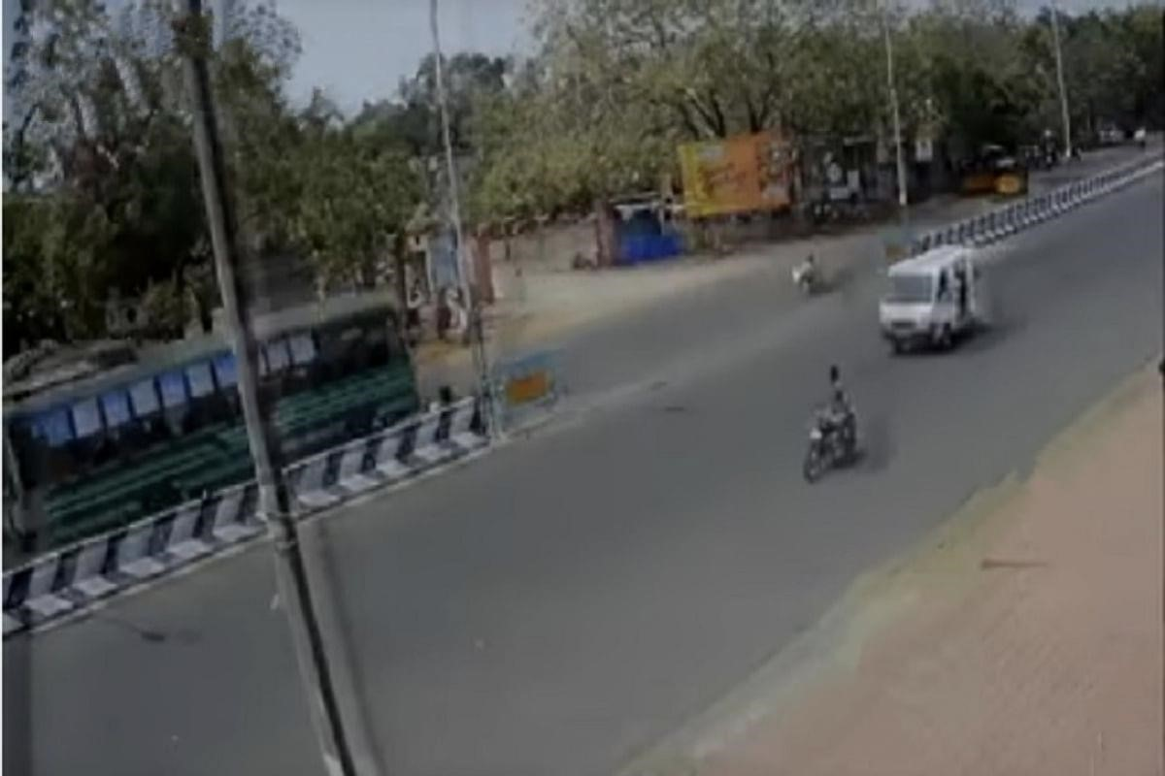

First , the user must determine his location by activating the location feature in a smartphone. To get the information entered the application will provide the details about buses, bus location, bus speed, bus arrival time, nearest bus from a user by offering the distance between user location and bus. This information will assist the passenger to select their suitable bus. In the flowchart that describes the proposed system.

Second A GPS is connected to an ESP32 Microcontroller with a built-in Wi-Fi is placed inside each bus. When the power supply is on, the GPS is communicates continuously with the satellite to get coordinates.

Once the GPS obtains the coordinates, it sends the data, including latitude and longitude, and speed to the IOT Blynk server through the ESP32. At the Blynk server, the latitude and longitude are extracted and used on the visual map in the Blynk application. The live location of the bus can be seen on the Google map. Continuous data digital updates such as speed, distance, and the arrival time of the bus are displayed on the mobile application.

Finally the prototype has been installed (GPS unit and ESP32) inside a vehicle with supplied internet to use the possibilities offered by the Internet of Things. This information will be transmitted via