TASK-12

Q1:

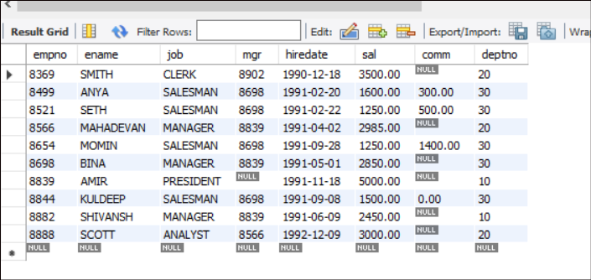

A. Write a query to display EName and Sal of employees whose salary are greater than or equal to 2200?

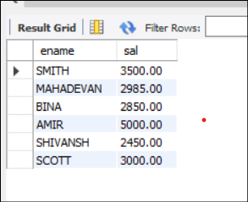

B. Write a query to display details of employees who are not getting commission?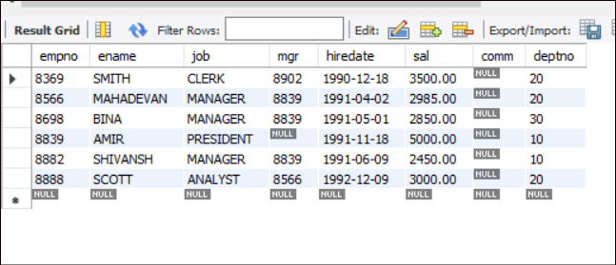

C. Write a query to display employee name and salary of those employees who don't have their salary in the range of 2500 to 4000?

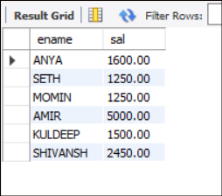

D. Write a query to display the name, job title and salary of employees who don't have a manager?

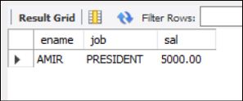

E. Write a query to display the name of an employee whose name contains "A" as third alphabet

Note: there is no name with “A” as third alphabet

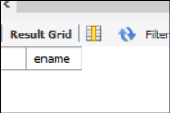

F. Write a query to display the name of an employee whose name contains "T" as last Alphabet

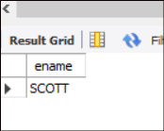

Q2:

