Preparatory session- 1

## Internet:

The Internet (or internet) [a] is the global system of interconnected computer networks that uses the Internet protocol suite (TCP/IP)[b] to communicate between networks and devices.

## Packet switching:

Packet switching is the transfer of small pieces of data across various networks. These data chunks or “packets” allow for faster, more efficient data transfer. Often, when a user sends a file across a network, it gets transferred in smaller data packets, not in one piece.

## Galactic Network:

The concept of the Galactic Network was created by J.C.R. Licklidfer, a Massachusetts Institute of Technology (MIT) researcher and professor. Licklider's vision of a Galactic Network—**a network of computers that allows users to gather data and access programs anywhere in the world.**

## Internet Service Provider:

The term Internet service provider (ISP) refers to a company that provides access to the Internet to both personal and business customers.

## Telenet:

When first ISP was born, Introduction of commercial version of Arpanet called as telenet.

## TCP:

**Transmission Control Protocol** a communications standard that enables application programs and computing devices to exchange messages over a network. It is designed to send packets across the internet and ensure the successful delivery of data and messages over networks.

## IP:

An Internet Protocol address is **a unique numerical name that every electronic device connected to a computer network has**. You can think of an IP address as being similar to your home address. It is specific to that particular device and serves as a way to identify and locate these devices.

## DNS:

The Domain Name System (DNS) is the phonebook of the Internet. Humans access information online through [domain names](https://www.cloudflare.com/learning/dns/glossary/what-is-a-domain-name/), like nytimes.com or espn.com. Web browsers interact through [Internet Protocol (IP)](https://www.cloudflare.com/learning/network-layer/internet-protocol/) addresses. DNS translates domain names to [IP addresses](https://www.cloudflare.com/learning/dns/glossary/what-is-my-ip-address/) so browsers can load Internet resources.

## Cyberspace:

Cyberspace refers to the **virtual computer world**, and more specifically, an electronic medium that is used to facilitate online communication.

## First router name:

First router name is Cisco ships.

## HTML:

HTML (Hypertext Markup Language) is **the most basic building block of the Web**. It defines the meaning and structure of web content.

Other technologies besides HTML are generally used to describe a web page's appearance/presentation (CSS) or functionality/behaviour (JavaScript).

## Name of the first browser:

**Mosaic** is the first browser to display images in line with text instead of in a separate window.

## First dating site:

Match.com is first dating website.

## First viral video:

The dancing baby is a first 3D animation dubbed video.

## Netflix:

Netflix is founded in 1997.

## Google search engine:

Google search engine is born in 1998.

## YouTube:

You tube is born in 2005.

## Submarine cable:

A **submarine communications cable** is a cable laid on the [sea bed](https://en.wikipedia.org/wiki/Seabed) between land-based stations to carry [telecommunication](https://en.wikipedia.org/wiki/Telecommunication) signals across stretches of ocean and sea.

## Optical fiber cable:

Fiber optics, or optical fiber, refers to **the technology that transmits information as light pulses along a glass or plastic fiber**. A fiber optic cable can contain a varying number of these glass fibers -- from a few up to a couple hundred.

## Type of optical fiber cable:

There are two types of fibre optic cables – **multimode and single-mode**.

## Tier1:

## Tier2

## Tier3:

## Router:

It is like a minicomputer which will help to transfer message in the right direction to right device.

## Modem:

It converts telephone analog single into digital signal.

Preparatory session- 2

## Internet protocol (IP):

IP is the method or protocol by which data is sent from one computer to another computer on the internet. Each computer known as host on the internet has at least one IP address that uniquely identifies it from all other computers on the internet.

Internet protocols are set of rules that governs the communication and exchange of data over the internet. Both sender and receiver should follow the same protocols in order to communicate the data.

## OSI VS TCP/IP model:

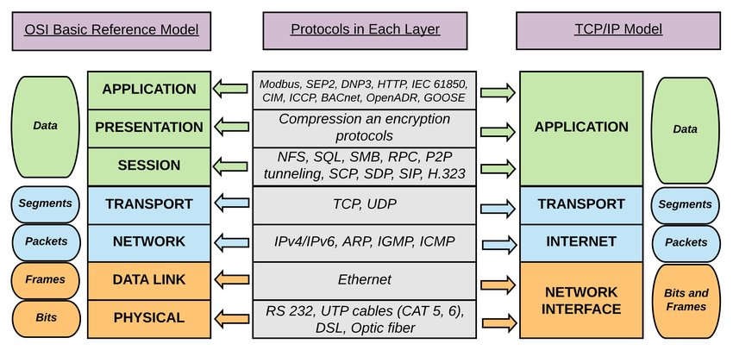

## IP VS Physical Address:

The IP address of a device mainly helps in identifying the connection of a network (using which the device is connecting to the network). The MAC Address, on the other hand, ensures the computer device's physical location. It helps us to identify a given device on the available network uniquely.

**Know all IP and physical address with the help of arp command.**

## Application Layer:

The application layer makes sure that the data from the sending end is received in the format that is acceptable and supported at the receiving end.

## Transport Layer:

The transport layer is responsible for the smooth transmission of the data from one end to the other. It is also responsible for reliable connectivity, error recovery and flow control of the data.

## Internet Layer:

The internet layer moves packets from source to destination by connecting independent networks.

## Network Access Layer:

The network access layer sees how a computer connects to a network.

## Father of Git:

Git was originally authored by Linus Torvalds in 2005 for development of the Linux kernel.

## Git Commands:

1. Git command list: git config --list
2. Register name on git profile: git config --global user.name “Arun Kumar”
3. Register email on git profile: git config --global user. email “arun36531@gmail.com”
4. Check git username: git config user.name
5. Check git email: git config user.email
6. Initialize the folder as git repository: git init
7. Check files available in folder: ls -lart
8. Check the status of folder: git status
9. Restore the file and previous data: git checkout or git restore
10. Go to the previous version of data in all files at same time: git checkout -f
11. Check what data modified in file: git diff (run this command after git status when file is modified)
12. To discard the changes first run git diff --staged and then git checkout -f
13. Check the commits message: git log (give all commits message)
14. Check last 2 commits message: git log -2
15. Check last 2 commits message with data modified: git log -p -2
16. Make the file, not the part of git (untracked file): git rm --cached filename with extension
17. Delete file from folder: git rm filename

<https://www.cloudways.com/blog/git-cheat-sheet/?id=290872&gclid=CjwKCAjwu5yYBhAjEiwAKXk_eBLPbBXwJbUXO40be00T4TnW9-XFU9mXzR8vDX6H30S_ZjUnUppqChoCOBoQAvD_BwE>