YAHYA YAQUBI
yahya.yaqubi@gmail.com
+93786665757

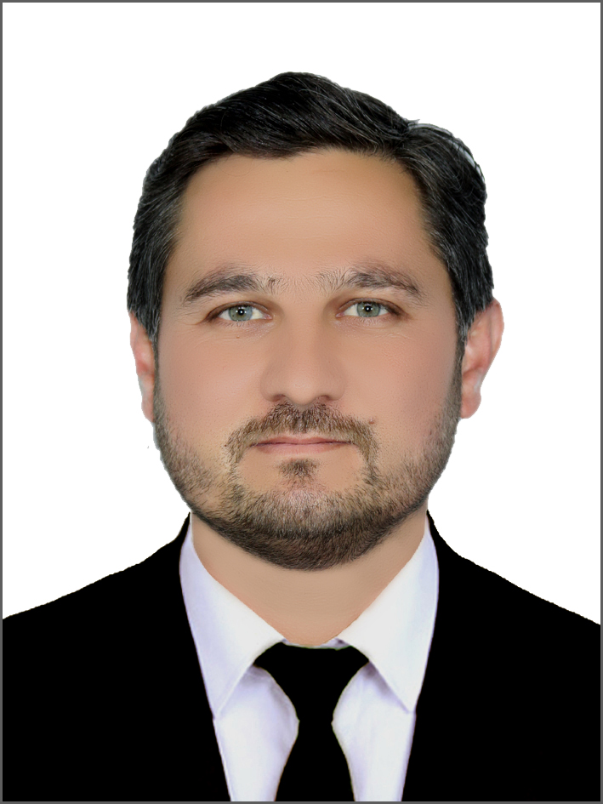

Profile:
Ph.D. scholar, M.A in Political Science, B.A in Journalism and certificates in management, leadership, Peacebuilding and Conflict Resolution, research, communication, with 17 years of diverse working experience in Media, Program implementation, Management, Supervision and field visits with/at several International and national organizations and social institutions.
Beside a sincere, motivated, decision maker and hardworking employee who strongly believes in teamwork and achieving professional excellence.

Work Experience:

Media Trainer: July 2023 up to Now, BBC Media Action, Kabul
- Developing training material, including handouts and presentations on lifeline programming, editorial, technical and studio gears.
- Providing training, advice, support, resources, ideas, and help with, through a mixture of email and phone contact, in person and online training to each partner station and local journalists.
- Train the partner FM radio stations and build their skill to produce relevant radio outputs.
- Review the script, comment, and guide the local FM station partners for any recommended changes.
- Manage relationships with the local FM stations.
- Support the design of training workshops, and managing logistics and arrangements for training and mentoring sessions.
- Support local FM stations and local journalists understand and use online learning resources that the project will provide.
- Advise local FM stations and local journalists to help them maintain strong production and editorial values.
- Use project contacts and link local FM stations to civil society contributors, interviewees and aid workers for their content on lifeline programming, where appropriate.
- Supportting other project teams in the production of other project media outputs where necessary.
Copy Editor: March 2022 to June 2023, Pajhwok News Agency, Kabul
- Editing daily reports and News for Pajhwok website
- Review story ideas and decide what material will appeal most to readers
- Offering comments to improve the product and suggest titles and headlines
- Reading content and correct spelling, punctuation, and grammatical errors
- Verify facts cited in material for posting
- Developing story and content ideas according to the website style and editorial policy

University Associate Professor: 2012 – Present, Laghman University
- Aug 2012 to now, Journalism Faculty, Laghman University.
- Sep 2018 to Sep 2019, Journalism Department, Khurasan University, Nangarhar
- Nov 2018 to 2021, Political Science Faculty, Rokhan University, Laghman
- Sep 2013 to July 2014, Journalism Faculty, Alfalah University, Nangarhar
I am preparing teaching materials, presenting lectures to the students using different teaching methodologies, performing research studies, evaluating students’ performance, taking exams, keeping related documents, preparing handouts, participating at admin and professional meetings and active attendance at the cultural committee at university level.

Coordinator: Jan- 2020 up to Mar-2021, USIP (United States Institute for Peace), Laghman University.
Working for peacebuilding and Conflict resolution programs to motivate and encourage youths for working as young peacebuilders in their society.
Establishing peace studies programs.
Empowering young leaders to address small conflicts in their societies.

Manager: March-2011 to 2016, Killid Radio, Nangarhar Branch.
Over all managing the radio office and broadcasting, keeping eye on day to day administrative, logistic and procurement issue as well as the financial. In addition, I was responsible for implementation of the program activities and monitoring if the tasks are achieved as per the already set objectives. I was responsible to conducting coordination among the branch and head quarter programs and participating at management and coordination meetings and zone and head quarter level.
I represented Radio Killid at zonal and provincial level at media meetings and events. More ever, staff capacity building and programs promotion as well advocating of the radio programs were my other responsibilities. Task division and encouraging team work among the employees and strengthening the programs were my other work related concern areas.

News Presenter: 12 Sep 2008 to 05 March 2009, Tehran Radio-Iran.
I was presenting news and translating different news stories from several credible news agencies as per the radio policy and program requirements, meanwhile I was selecting the best articles from different websites for daily radio programs. As well, I was participating at daily technical and program meetings.

Reporter and Producer: Feb 2005 to July 2008, BBC. World Radio, Kabul-Afghanistan.
I was managing and organizing Phone Chatting, Producing entertainment cultural programs and was editing the productions by Vox Pop Program. I was performing interview with Youths regarding Youth’s Social and Educational issues and was editing the recorded radio programs.
In addition I was producing Malghalarai Amel special cultural program broadcasted by Radio BBC.

Coordinator: Feb 2008 to Aug 2008, AFSG, Nangarhar-Afghanistan.
I was performing interviews and focus group discussion for writing social and financial stories and reports on the social and economic status of the community people. In addition I was editing the stories and managing broadcasting and publication of the products.

Reporter: Aug 2005 to Nov 2005, Kabul weekly, Kabul-Afghanistan.
I was conducting interviews with sport athletes and National Olympic Committee authorities meanwhile was responsible to produce social and political reports and was responsible to participate at weekly and daily staff and technical meeting. In addition was doing liaison with other media and magazine associations.

Education & qualifications:
Ph.D. Scholar: 2021- Continue
Department of Political Science and Public Administration, Andhra University, Vishakhapatnam, India.
M.A Political Science: 2016 to 2018
Himachal Pradesh University, Shimla India.
B.A: In Mass Communication and Journalism: 2002 to 2006,
Journalism Faculty, Kabul University.
Baccalaureate: Rahmaan Baba High School, 1997 to 2002.

Certificates:
- International Trainings: Qualitative Research Methodology India.
- Peacebuilding and Conflict Resolution, Leadership, Public Speaking, Gender Equality, Anti-Corruption, Human Rights by Counterpart International, Kabul, Afghanistan.
- Peacebuilding and Conflict Resolution by USIP (United State Institute for Peace), Afghanistan.
- Research Methodology by MOHE, Afghanistan,
- Micro-Finance Operation Management Course by BRAC-Kabul,
- Qurack Express and Photo Shop in Faculty of Journalism/Kabul,
- How to Operate Answering Machine by BBC World/Kabul,
- Colledit Pro by Nai/Kabul arranged by BBC World Radio,
- MS-Office
- English language Intensive levels-IRC/ELP.

Publications:
- Writings-Books:
- Journalism
- Afghan Scholars and Politicians
- Challenges to Democracy in Afghanistan as my Thesis for M.A
- Journalism and Politics

- Translations-Books:
- Ethics of journalism,
- Magazine Journalism,
- Zaland-a-Hendara
- And Khazana.

Volunteer Service:
Participating in several media campaigns as a civil society activist, translating and writing several social and political articles in different social and political websites and magazines like: Melli Magazine, Gaheez Magazine, Mina Magazine, www.tolafghan.com, www.taand.com, www.benawa.com, www.baheer.com and Etc.

Skills:
- Leadership Skills: Decisive, Creative, Attention to details, Motivation, and Stakeholder engagement
- Managerial Skills: Project Management, Time and stress Management, Task and Deadline Management,
- Computer Skills: Excellent Computer Knowledge( Ms. Office, Adobe Audition), Printing, Scanning, Internet

Languages:
English - Excellent
Pashto and Dari - Native
Urdu – Fluent.

Travels:
- Turkey, Bosnia & Herzegovina: a study tour by Counterpart International,
- Uzbekistan: a study tour by Counterpart International,
- Iran: job tour with Tehran Radio ,
- UAE: a formal mission for broadcasting cricket match by Killid Radio,
- India: For Master Degree through ICCR Scholarship,
- and Pakistan:

References:

Sadaqat Yaqubi: HIV Program Associate, GF-UNDP Country Office-Kabul, Afghanistan, +93786212204, sadaqat.yaqubi@undp.org

Said Ziaurahman Banouri: Dean of Faculty, Laghman University, Afghanistan,
+93787146547

Hari Babu: University Lecturer, Andhra University, India,
+919440031413, haribabuvundrakonda@gmail.com

Sharif Shaheen: Protection Field Officer, ICRC, Kabul- Afghanistan.
+93730666955, sharif.shaheen2014@gmail.com

Website references:
https://www.theavicenna.org/search-record

https://www.linkedin.com/feed/
https://www.facebook.com/qalamwal.qalamwal
https://www.facebook.com/
https://www.facebook.com/yahya.yaqubi
https://nai.org.af/wp-content/uploads/2018/11/Media-Watch_Monthly-Report_125_English.pdf
https://www.tolafghan.com/articles/7419
https://www.samsoor.com/article/5749
https://taand.com/main/?p=132013
http://www.sapand.blogfa.com/post/292
https://rohi.af/news/29591
https://www.facebook.com/106392791113389/posts/164907705261897/
https://www.facebook.com/gaam.laghman.af/posts/966490277022896/
https://journalismku.blogspot.com/2019/08/blog-post_38.html
https://tolafghan.com/posts/21362
http://www.benawa.com/details.php?id=23076
https://www.facebook.com/gaam.laghman.af/photos/a.186903358314929/1366844603654126/?type=3&_rdr

https://nu.edu.af/ps/%D9%84%D8%BA%D9%85%D8%A7%D9%86-%D9%BE%D9%88%D9%87%D9%86%D8%AA%D9%88%D9%86-%DA%A9%DB%90-%D8%AF-%D8%B3%D9%88%D9%84%DB%90-%D9%85%D8%B1%DA%A9%D8%B2-%D9%BE%D8%B1%D8%A7%D9%86%DB%8C%D8%B3%D8%AA%D9%87-%D9%88%D8%B4%D9%88%D9%87

https://www.gaheez.af/%DA%86%D8%A7%D8%B1%D9%88%D8%A7%DA%A9%D9%8A-%D9%84%D9%87-%D8%B1%D8%B3%D9%86%DB%8C%D9%88-%DA%85%D9%87-%D8%BA%D9%88%D8%A7%DA%93%D9%8A%D8%9F/

https://www.youtube.com/watch?v=FG1Lb0NvNz8

