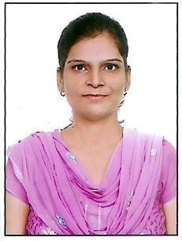

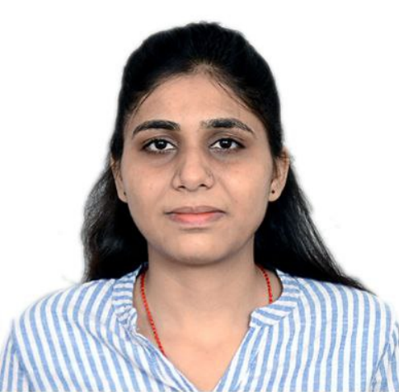

**SWEETY RANI**

**E-mail**: [Sweetykotyan61@gmail.com](mailto:Sweetykotyan61@gmail.com)

**Contact No**. :

+91-9654273309

**Current Address:**

Flat No. 1185, A-Block, Maruti Kunj Gurugram, (122102).

**Personal Data**:

**Date of Birth**: 05/01/1995

**Gender**: Female

**Nationality**: Indian

**Marital Status**: Unmarried **Languages**: English, Hindi.

**CURRICULUM - VITAE**

**Career Objective:**

To enhance the organization's competitiveness by applying the cutting-edge knowledge, skills, and attitude I have gained in my career to see myself grow along with the organization.

**Educational Qualifications:**

* **M.Sc.** in **Mathematics** with **55%** marks from **Acharya Narendra Dev College, University of Delhi**
* **B.Sc.** in **Mathematics (Hons.)** with **77.8%** marks from **Gargi College, University of Delhi**
* **Senior Secondary** (PCM) from **Delhi Public School** with

**78.6 %**

* **Secondary** from **Delhi Public School** with **7.8 CGPA**

**Achievements:**

.

* **Joint CSIR-UGC NET** qualified for **JRF and Assistand Professor**in **Computer Science and Application** (December2020&June2021, June 2019).
* **15th Rank** Joint CSIR-UGC NET qualified for JRF and Assistant Professor in Mathematics (December-2022/June-2023) in **M.D.U.** in M.Sc. first semester.
* **1st Prize** in Intra College **Math Quiz** (National Science Day) during B.Sc.
* **3rd Position** in Intra College **Math Quiz** during B.Sc.

**Work Experience:**

* Worked as **Trained Graduate Teacher in Computer**, Hemnani Public School, Lajpat Nagar (Delhi) from 31st March 2018 to 1st April 2019.
* Worked as **Laboratory Assistant in Physics** Dept., Maharani Kishori Kanya Mahavidhalaya Hodal Faridabad affiliated to MDU Rohtak under the scheme of **“Earn while Learn”** from 1st August 2015 to 30th September 2017.

**Paper Published in Journals/Conferences:**

1. Bharti B., Gill N.S. and Gulia P. (June, 2023), “Exploring machine learning techniques for fake profile detection in online social networks”, International Journal of Electrical and Computer Engineering (IJECE) [Scopus, SCImago Journal Rank (SJR)] <https://ijece.iaescore.com/index.php/IJECE/article/view/28634/16543>.
2. Goyal B., Gill N.S. and Gulia P. (21 March, 2023), “Detection of Fake Profiles on Online Social Media: A Strategy”, National Conference on Computational Intelligence and Data Science (NCCIDS-23), Maharshi Dayanand University Rohtak, India [Conference Proceedings ISBN: 978-93-80544-50-2] <https://www.researchgate.net/publication/369643807_Detection_of_Fake_Profiles_on_Online_Social_Media_A_Strategy>.

**Workshop/Symposium/Conference Attended:**

* Attended “**One Week faculty Development Programme**”, held in Dr B R Ambedkar National Institute of Technology Jalandhar on February 2023.
* Attended "**IEEE Authorship and OA Symposium**" held on 26 August 2021.
* Attended National Workshop on "**Writing Research Proposal**" held in MDU on 30 April 2021.
* Attended IEEE Authorship Workshop-India about “**How to Publish a Technical Paper with IEEE**” (September 2019).

**Declaration:**

I now declare that the above information is accurate to my knowledge.

**Place:**  **(BHARTI)**

**Date:**