**Curriculum Vitae**

**Miss Deepshikha Kushwaha**  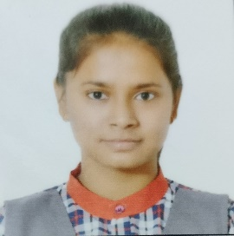

**Address:** C/O Tara Devi W/o Late Khazan Singh

H.No. 280 Plot No. 3 G-2 G/F

Village Bagdola sector 8 Dwarka New Delhi-45

**D.O.B :** 28/12/2006

**Phone**: 7011913502 Or 8287583223 **e mail:** [gu010628date@gmail.com](mailto:gu010628date@gmail.com)

**Citizenship**: India

**Education Qualification:**

10th CBSE 2022 85% KV SPG DWARKA N/DELHI

12TH CBSE 2024 Appearing KV SPG DWARKA N/DELHI

**Language Known:** English (Read, Write and spoken)

Hindi (Read, Write and spoken)

**Extra Curriculum Activities:**

1. Taken part in visit of HPM Shri Narendra Modi in SPECIAL PROTECTION GROUP ( SPG ) Raising day celebration and presented bouquet to him in year 2015.

2. Taken part in visit of HPM Shri Narendra Modi in the inauguration of new SPG Complex and attended his speech.   
  
3. Attended Road Safety awareness Programme 2024 in which chief guest was Cabinet Minister Shri Nithin Gadkari and it was telecasted on CNN-News 18.   
  
**Skills:** Have knowledge of computer coding.