

|  |  |
| --- | --- |
| **Student Name** | **Arun Adhikari** |
| **SRN No** | 202100406 |
| **Roll No** | 31 |
| **Program** | **Department of Computer Engineering** |
| **Year** | 2024-2025 |
| **Division** | G |
| **Subject** | AI LAB |
| **Assignment No** | 1 |

**Experiment No : 1**

# Title /Problem Statement:

Implement Non-AI Techniques for the following problems:

1. Tic Tac Toe
2. N Queens
3. Magic square

# Description:

A non-AI technique employs traditional algorithms or rule-based logic, leveraging predefined conditions and deterministic operations to solve problems systematically, ensuring transparency, predictability, and minimal computational overhead without machine learning.

# Code:

1. Tic Tac Toe:

import tkinter as tk

from tkinter import messagebox

root = tk.Tk()

root.title("Tic Tac Toe")

current_player = "X"

board = ["" for _ in range(9)]

def check_winner():

win_combinations = [

(0, 1, 2), (3, 4, 5), (6, 7, 8),

(0, 3, 6), (1, 4, 7), (2, 5, 8),

(0, 4, 8), (2, 4, 6)

]

for combo in win_combinations:

if board[combo[0]] == board[combo[1]] == board[combo[2]] != "":

return board[combo[0]]

if "" not in board:

return "Draw"

return None

def on_click(index):

global current_player

if board[index] == "":

board[index] = current_player

buttons[index]["text"] = current_player

winner = check_winner()

if winner:

if winner == "Draw":

messagebox.showinfo("Game Over", "It's a Draw!")

else:

messagebox.showinfo("Game Over", f"Player {winner} wins!")

reset_game()

else:

current_player = "O" if current_player == "X" else "X"

def reset_game():

global current_player, board

current_player = "X"

board = ["" for _ in range(9)]

for button in buttons:

button["text"] = ""

buttons = []

for i in range(9):

btn = tk.Button(root, text="", font=("Arial", 24), height=2, width=5,

command=lambda idx=i: on_click(idx))

btn.grid(row=i//3, column=i%3)

buttons.append(btn)

root.mainloop()

**Output :**

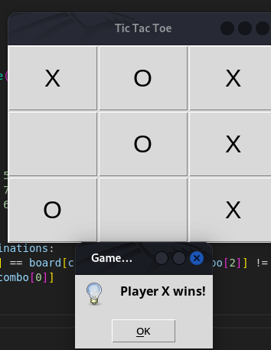

1. **N Queens**

import tkinter as tk

from tkinter import messagebox

class NQueensGUI:

def __init__(self, n):

self.n = n

self.root = tk.Tk()

self.root.title(f"{n}-Queens Problem")

self.board = [[0] * n for _ in range(n)]

self.buttons = [[None for _ in range(n)] for _ in range(n)]

self.setup_board()

def setup_board(self):

for row in range(self.n):

for col in range(self.n):

btn = tk.Button(self.root, width=4, height=2, bg="white",

command=lambda r=row, c=col: self.toggle_queen(r, c))

btn.grid(row=row, column=col)

self.buttons[row][col] = btn

def toggle_queen(self, row, col):

if self.board[row][col] == 1:

self.board[row][col] = 0

self.buttons[row][col].config(text="", bg="white")

else:

if self.is_safe(row, col):

self.board[row][col] = 1

self.buttons[row][col].config(text="Q", bg="lightblue")

if self.check_solution():

messagebox.showinfo("Success", "All queens are placed safely!")

else:

messagebox.showwarning("Invalid Move", "This position is not safe!")

def is_safe(self, row, col):

for i in range(self.n):

if self.board[row][i] == 1 or self.board[i][col] == 1:

return False

for i, j in zip(range(row, -1, -1), range(col, -1, -1)):

if self.board[i][j] == 1:

return False

for i, j in zip(range(row, -1, -1), range(col, self.n)):

if self.board[i][j] == 1:

return False

return True

def check_solution(self):

queens = sum(row.count(1) for row in self.board)

return queens == self.n

def run(self):

self.root.mainloop()

if __name__ == "__main__":

n = 4

app = NQueensGUI(n)

app.run()

a

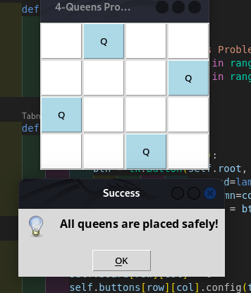

1. **Magic square:**

import tkinter as tk

from tkinter import messagebox, simpledialog

class MagicSquareGUI:

def __init__(self, n, magic_sum):

if n < 3 or n % 2 == 0:

raise ValueError("Magic squares are only defined for odd numbers greater than or equal to 3.")

self.n = n

self.magic_sum = magic_sum

self.square = [[0] * n for _ in range(n)]

self.root = tk.Tk()

self.root.title(f"{n}x{n} Magic Square with Sum {magic_sum}")

self.create_magic_square()

self.adjust_to_magic_sum()

self.setup_gui()

def create_magic_square(self):

n = self.n

num = 1

i, j = 0, n // 2

while num <= n ** 2:

self.square[i][j] = num

num += 1

new_i = (i - 1) % n

new_j = (j + 1) % n

if self.square[new_i][new_j]:

i += 1

else:

i, j = new_i, new_j

def adjust_to_magic_sum(self):

"""Scales the base magic square to match the user-specified magic sum."""

base_sum = self.n * (self.n ** 2 + 1) // 2 # Standard magic sum formula

factor = self.magic_sum / base_sum

for i in range(self.n):

for j in range(self.n):

self.square[i][j] = int(self.square[i][j] * factor)

def setup_gui(self):

for i in range(self.n):

for j in range(self.n):

tk.Label(self.root, text=self.square[i][j], font=("Arial", 18),

borderwidth=2, relief="solid", width=4, height=2).grid(row=i, column=j)

def run(self):

self.root.mainloop()

if __name__ == "__main__":

n = 3 # You can change this value for larger magic squares

try:

magic_sum = simpledialog.askinteger("Input", f"Enter the desired sum for {n}x{n} magic square:")

if magic_sum is None:

raise ValueError("No sum provided.")

app = MagicSquareGUI(n, magic_sum)

app.run()

except ValueError as e:

messagebox.showerror("Error", str(e))

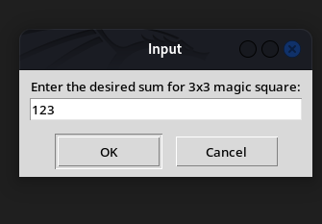

# 

# Conclusion:

The implementation of non-AI techniques for Tic Tac Toe, N Queens, and Magic Square demonstrates how traditional algorithmic approaches effectively solve well-defined problems.

* 1. Tic Tac Toe: A rule-based approach ensures efficient gameplay, validating moves and determining game outcomes without requiring advanced computational models. This illustrates how deterministic logic can manage simple strategy games.
  2. N Queens: The backtracking algorithm efficiently finds all possible arrangements of queens on the board, ensuring no two queens threaten each other. This highlights the power of recursion and constraint satisfaction for combinatorial problems.
  3. Magic Square: A mathematical formula or iterative construction method generates magic squares systematically, emphasizing the importance of analytical problem-solving in constrained number arrangements.

These solutions underscore the strength of non-AI techniques in providing precise, predictable, and computationally efficient solutions to structured problems without the complexity of machine learning or AI-driven methods.