

|  |  |
| --- | --- |
| **Student Name** | **Arun adhikari** |
| **SRN No** | 202100406 |
| **Roll No** | 31 |
| **Program** | **Department of Computer Engineering** |
| **Year** | 2024-2025 |
| **Division** | G |
| **Subject** | Artificial Intelligence lab |
| **Assignment No** | 8 |



**Experiment Number - 08**

**Title /Problem Statement: Design and implement an Expert System.**

# Description: An expert system is a computer program that simulates the decision-making ability of a human expert. It uses a knowledge base of human expertise and an inference engine to solve complex problems by reasoning through bodies of knowledge, represented mainly as if-then rules. In this experiment, we design a simple expert system for diagnosing common diseases based on a patient's symptoms.

### **1. Introduction**

An **Expert System** is a type of computer program designed to simulate the decision-making ability of a human expert.  
In this project, we build an **Expert System for Library Management** that helps:

* Students, Faculty, and Librarians
* Borrow, Return, Search, and Recommend Books
* Manage users and books efficiently

### **Features**

**Add New Users:** Librarians can add new students or faculty members.  
 **Add New Books:** Librarians can insert new books into the library.  
 **Search Books:** Any user can search for books by title, author, or genre.✅ **Borrow/Return Books:** Users can borrow books (within their borrow limit) and return them.  
 **Recommendations:** The system recommends books based on the user's interests.  
 **Role-based Access:** Librarians can manage the library, while normal users can only borrow/return books.

### **. Expert System Rules Applied**

* **Rule 1:** If a book’s copies > 0 → it is Available, otherwise Unavailable.
* **Rule 2:** A user can borrow books only up to their allowed limit (students: 5, faculty: 10).
* **Rule 3:** Recommend books based on the user's preferred genre.
* **Rule 4:** Only librarians are allowed to add users or books.

These rules make decisions automatically without manual human supervision — the core idea behind **expert systems**!

**Output Screenshot:**

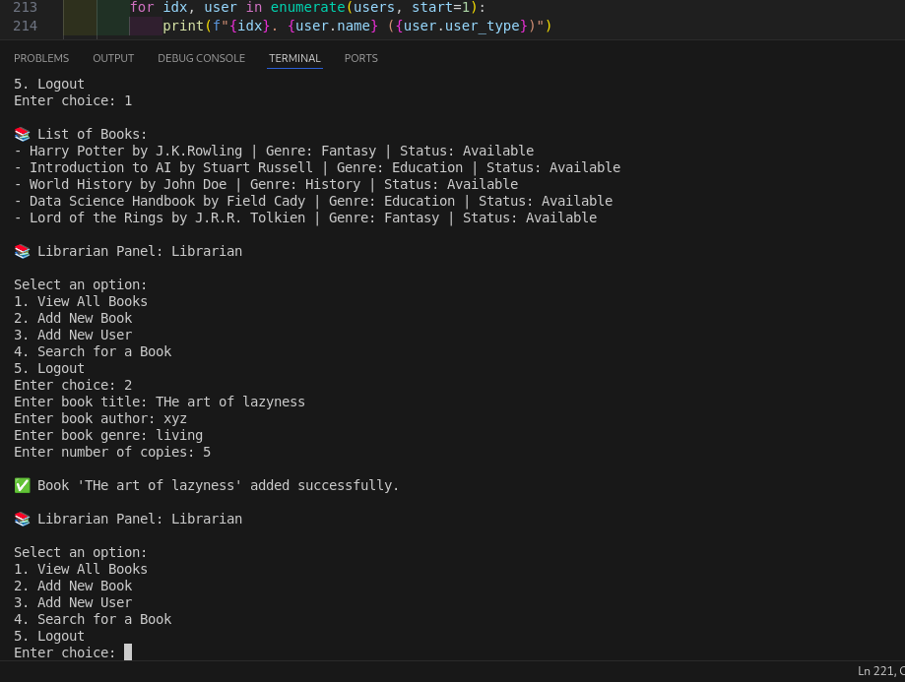

**Conclusion:**

An expert system mimics the decision-making ability of a human expert by applying a predefined set of logical rules on the knowledge base. In this experiment, we developed a basic medical expert system that diagnoses diseases based on symptoms provided by the user. The system utilizes forward chaining where symptoms are input and matched with predefined rules to determine a diagnosis. This highlights how expert systems can offer quick, consistent, and reliable assistance in specialized domains such as medical diagnosis, and emphasizes the significance of knowledge representation and reasoning in Artificial Intelligence applications.