|  |  |
| --- | --- |
| **Student Name** | **Arun Adhikari** |
| **SRN No** | 202100406 |
| **Roll No** | 38 |
| **Program** | Computer Engineering |
| **Year** | Third Year |
| **Division** | G |
| **Subject** | Computer Network Laboratory (BTECCE21506) |
| **Assignment No** | Four |

**Title :** Configuration of router for implementation of RIP protocol

**Problem Statement :** Using a Network Simulator (e.g. packet tracer) Configure RIP protocol.

**Theory :**

* **Routing Information Protocol (RIP) :**
* **Overview :**

The Routing Information Protocol (RIP) is one of the oldest distance-vector routing protocols, designed to facilitate the exchange of routing information within an autonomous system. RIP employs hop count as its primary metric for path selection, where each hop represents a router traversed by the data packet. The protocol periodically broadcasts the entire routing table to its immediate neighbors, ensuring that all routers maintain an up-to-date view of the network topology.

RIP operates at the Network Layer (Layer 3) of the OSI model and is defined in several RFCs, with RFC 1058 outlining RIP version 1 and RFC 2453 detailing RIP version 2. Its simplicity makes it suitable for small to medium-sized networks, although it has limitations in scalability and convergence speed compared to more advanced routing protocols.

* **RIP Version :**

**RIP has evolved through two primary versions:**

1. **RIP Version 1 (RIPv1):**

* **Classful Routing :** RIPv1 does not support variable-length subnet masking (VLSM), making it incapable of efficiently handling networks with multiple subnets.
* **Broadcast Updates :** RIPv1 sends routing updates via broadcast, which can lead to unnecessary traffic on the network.
* **Authentication :** Lacks support for routing information authentication, posing potential security risks.

1. **RIP Version 2 (RIPv2):**

* **Classless Routing :** Supports VLSM and Classless Inter-Domain Routing (CIDR), allowing for more efficient IP address utilization.
* **Multicast Updates :** Utilizes multicast (224.0.0.9) instead of broadcast for routing updates, reducing unnecessary network traffic.
* **Authentication :** Introduces support for routing information authentication, enhancing security.
* **Route Tagging :** Allows for the inclusion of additional route information, facilitating more complex network designs.

**5.**

**7. Use Cases:**

RIP is often used in small to medium-sized networks where ease of use and simplicity are priorities. It can be found in environments like branch offices, educational institutions, and small business networks.

**Case Study :**

**1. Overview:**

This network design utilizes Cisco Packet Tracer to create a small to medium-sized local area network (LAN) comprising two routers, switches, and multiple PCs. The purpose of this network is to facilitate communication among devices within different subnets while ensuring efficient routing through the use of the Routing Information Protocol (RIP).

**2. Network Topology:**

**The network consists of:**

**Two Routers (Router0 and Router1) :** These devices are responsible for routing traffic between different subnets and enabling inter-network communication.

**Two Switches :** Each router connects to a switch, which allows for multiple devices (PCs) to connect within each subnet.

**Multiple PCs :** There are several PCs (PC0, PC1, PC2, PC3) connected to the switches, assigned unique IP addresses for communication within their respective subnets.

**5. Objectives:**

The main objectives of this network implementation are:

Enable communication between devices across different subnets.

Implement dynamic routing using RIP to ensure efficient route management.

Provide a scalable solution that can accommodate future growth by adding more devices or subnets as needed.

**6. Network Functionality:**

With the implemented network:

PCs within the same subnet can communicate directly through the connected switch.

PCs across different subnets can communicate through the routers, utilizing RIP to manage the routing paths effectively.

The configuration allows for the simulation of real-world networking scenarios, providing insights into routing behavior and network management.

**7**

**Solution :**

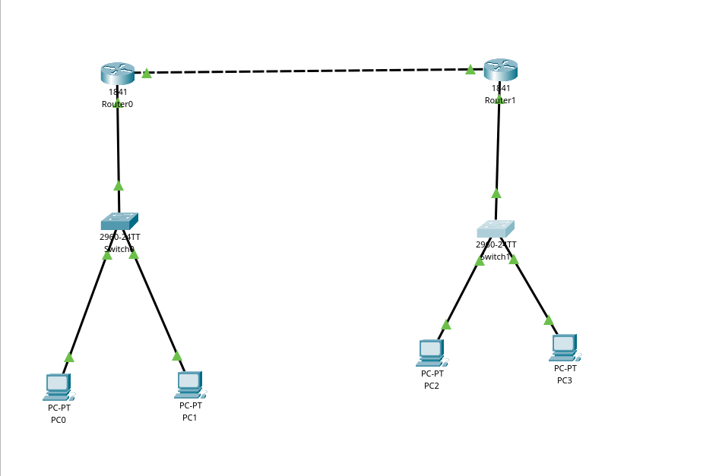

**Conclusion :**

This network topology demonstrates the implementation of a simple three-subnet setup using a /24 subnet mask (255.255.255.0) for each subnet, allowing for efficient IP address allocation and communication between devices. By assigning appropriate IP addresses and using routers for inter-subnet communication, the network ensures proper isolation and connectivity. The setup provides a scalable solution for a small to medium-sized network, with room for future expansion and the potential for incorporating routing protocols like RIP for dynamic route management. This configuration highlights effective subnetting, ensuring the network is organized, manageable, and ready for growth.