Three-Router Static Routing Configuration
Topology, IP addressing, Cisco configuration, verification and ping testing

1. Win-1 Configuration
IP Address: 10.0.0.10
Subnet Mask: 255.0.0.0
Default Gateway: 10.0.0.1

2. R1 Configuration
enable
configure terminal
interface e0/0
ip address 10.0.0.1 255.0.0.0
no shutdown
exit
interface e0/1
ip address 20.0.0.1 255.0.0.0
no shutdown
exit
ip route 30.0.0.0 255.0.0.0 20.0.0.2
ip route 40.0.0.0 255.0.0.0 20.0.0.2
end
show ip route
R1 reaches 30.0.0.0/8 and 40.0.0.0/8 through next-hop 20.0.0.2.

3. R2 Configuration
enable
configure terminal
interface e0/0
ip address 20.0.0.2 255.0.0.0
no shutdown
exit
interface e0/1
ip address 30.0.0.1 255.0.0.0
no shutdown
exit
ip route 10.0.0.0 255.0.0.0 20.0.0.1
ip route 40.0.0.0 255.0.0.0 30.0.0.2
end
show ip route
R2 reaches 10.0.0.0/8 through 20.0.0.1 and 40.0.0.0/8 through 30.0.0.2.

4. R3 Configuration
enable
configure terminal
interface e0/1
ip address 30.0.0.2 255.0.0.0
no shutdown
exit
interface e0/0
ip address 40.0.0.1 255.0.0.0
no shutdown
exit
ip route 10.0.0.0 255.0.0.0 30.0.0.1
ip route 20.0.0.0 255.0.0.0 30.0.0.1
end
show ip route
R3 reaches 10.0.0.0/8 and 20.0.0.0/8 through next-hop 30.0.0.1.

5. Win-2 Configuration
IP Address: 40.0.0.10
Subnet Mask: 255.0.0.0
Default Gateway: 40.0.0.1

6. Expected Routing Entries
R1:
C 10.0.0.0/24 → e0/0
C 20.0.0.0/24 → e0/1
S 30.0.0.0/24 [1/0] via 20.0.0.2
S 40.0.0.0/24 [1/0] via 20.0.0.2
R2:
C 20.0.0.0/24 → e0/0
C 30.0.0.0/24 → e0/1
S 10.0.0.0/24 [1/0] via 20.0.0.1
S 40.0.0.0/24 [1/0] via 30.0.0.2
R3:
C 30.0.0.0/24 → e0/1
C 40.0.0.0/24 → e0/0
S 10.0.0.0/24 [1/0] via 30.0.0.1
S 20.0.0.0/24 [1/0] via 30.0.0.1

7. Routing Codes
C = Connected route — network directly connected to the router.
L = Local route — router's own interface IP address.
S = Static route — manually configured route to a remote network.
[1/0] = Administrative Distance 1 / metric 0.

8. Verification and Ping Testing
- show ip interface brief
- show ip route
- show ip route static
- show running-config | include ip route
- Win-1: ping 10.0.0.1
- Win-1: ping 40.0.0.10
- Win-2: ping 40.0.0.1
- Win-2: ping 10.0.0.10

9. Packet Flow
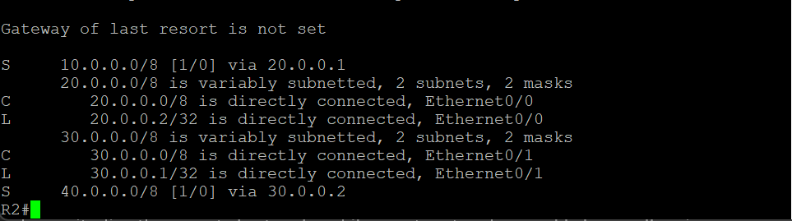
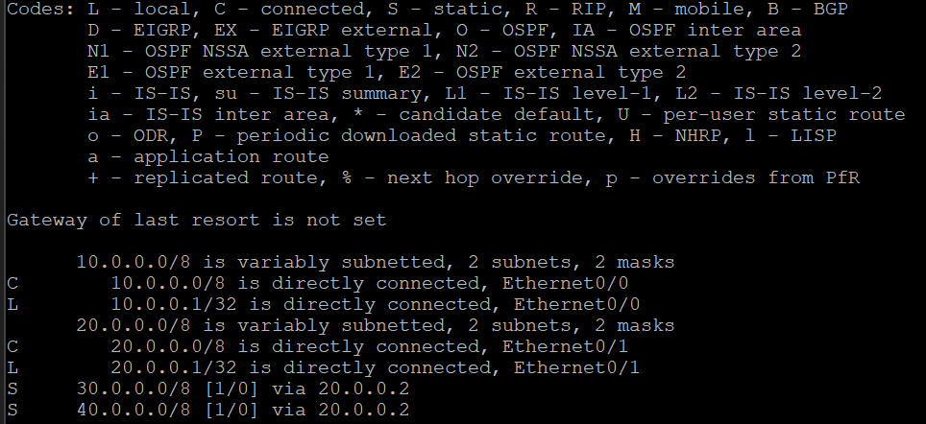
For example, if PC1 wants to communicate with PC2, the application first generates the data. The data passes through Layers 7 to 5. At Layer 4, TCP or UDP information is added. At Layer 3, source and destination IP addresses are used. At Layer 2, MAC addresses are used and a frame is created. At Layer 1, it is converted into bits and sent through the cable. At the receiver side, the reverse process happens.
10. Interview Explanation
Static routing is manually configured routing. In this topology, each router automatically knows its directly connected networks, while remote networks are added manually using next-hop IP addresses. R1 sends traffic for 30.0.0.0/8 and 40.0.0.0/8 to 20.0.0.2. R2 sends traffic for 10.0.0.0/8 to 20.0.0.1 and 40.0.0.0/8 to 30.0.0.2. R3 sends traffic for 10.0.0.0/24 and 20.0.0.0/24 to 30.0.0.1.
Output : Router 1: Output : Router 2:
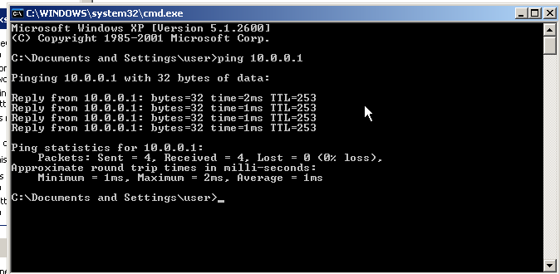
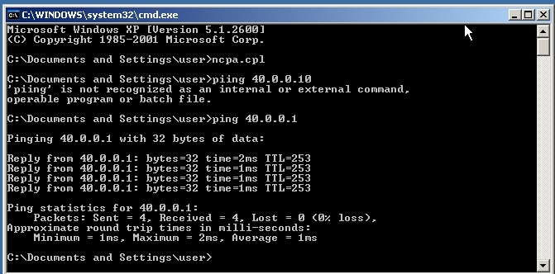
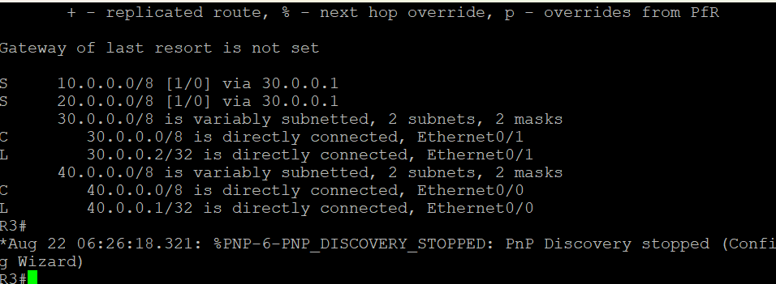
Output :Router 3:
Output : PC 1:
Output : PC 2:

