DVP Week 01 – Assignment

Files & Directories
- Create directory /home/devops_project
Output:
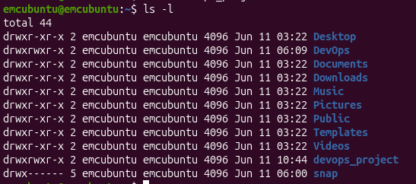
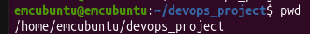
- Inside it, create 2 files: plan.txt and network_report.txt
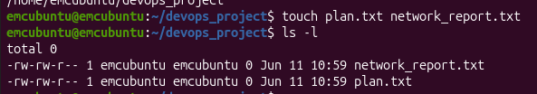
- Copy plan.txt to /tmp and delete the original
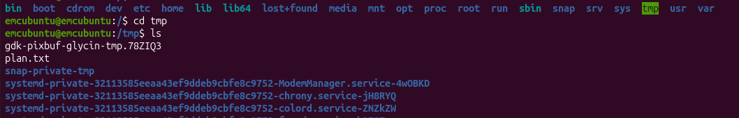
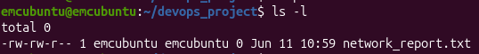

Users & Permissions
- Create a user devstudent
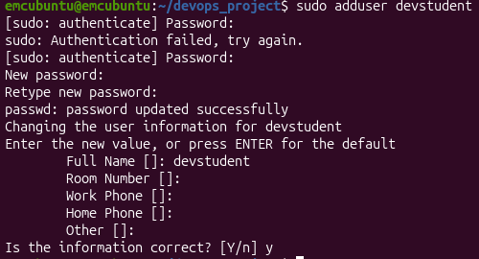
- Create a group devops_team
- Add devstudent to devops_team
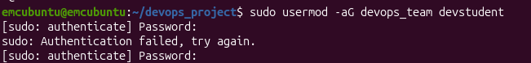
- Create a file secrets.txt, and:
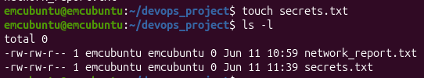
- Change its owner to devstudent
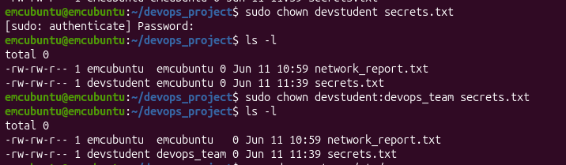
- Set permissions so only owner can read/write
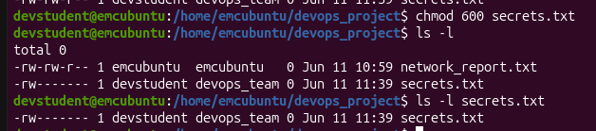

File Compression
- Download a sample .log file from internet or create dummy one using echo
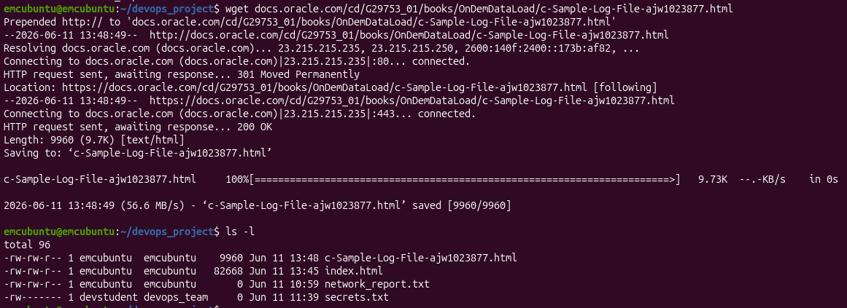
- Compress it using gzip and tar
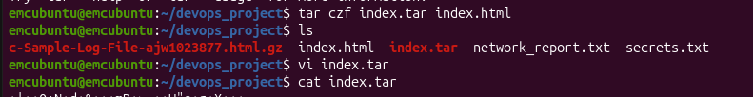

Package Management
- Install curl, htop, and net-tools using apt
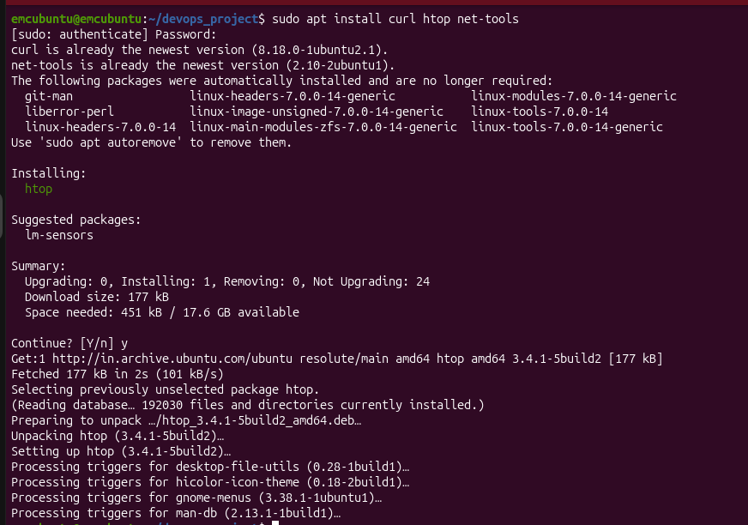
- Show which and --version outputs
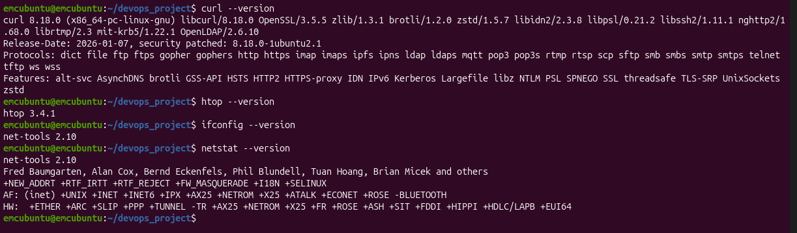

Networking Commands
Run and briefly explain outputs of the following commands:
- ifconfig
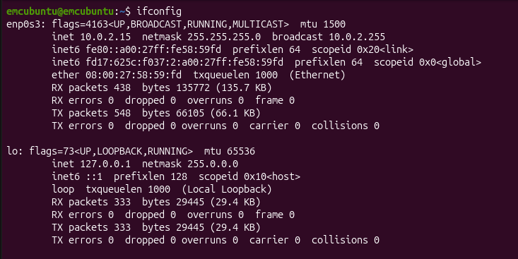
- ping google.com -c 4
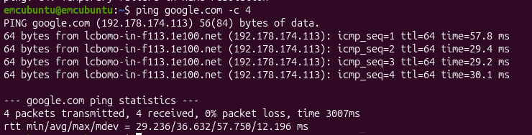
- traceroute google.com
Shows the route (path) that packets take from your computer to the destination server.
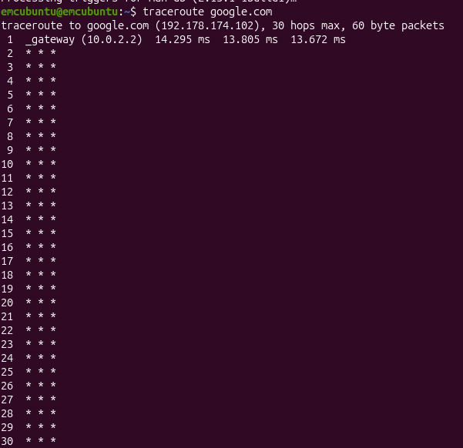
- nslookup google.com
Used to find the IP addresses of a domain.
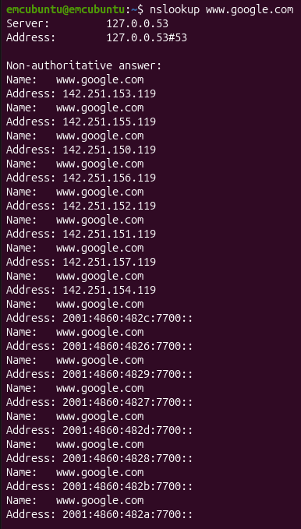
- netstat -tuln
Displays active listening ports.
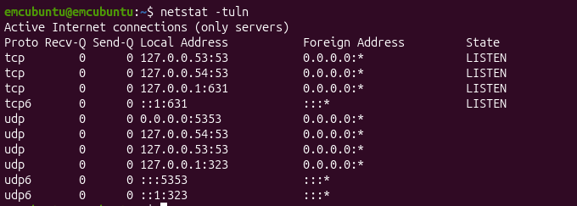
- curl ifconfig.me

