**DVA_LAB_Practical**

**Team Details:**

Arun Bhangdiya(26)

Anuj Pophali(24)

**Title:** Call Center with Dashboard

**Dataset Used:** Call Center.csv

**Link:** <https://drive.google.com/drive/folders/1BX24VrH44Ve2kQ48xAwtkA22MNblz9ib?usp=sharing>

**Tool Used:** Power BI

**Screenshot:**

Dataset consist of 32941 unique rows and 12 columns

12 attributes are there in our dataset. They are Id, Customer Name, Call Timestamp, Call-Centres, Channel, State, Reason, Response Time, City, Sentiment, Call Duration in Minutes, Csat Score.

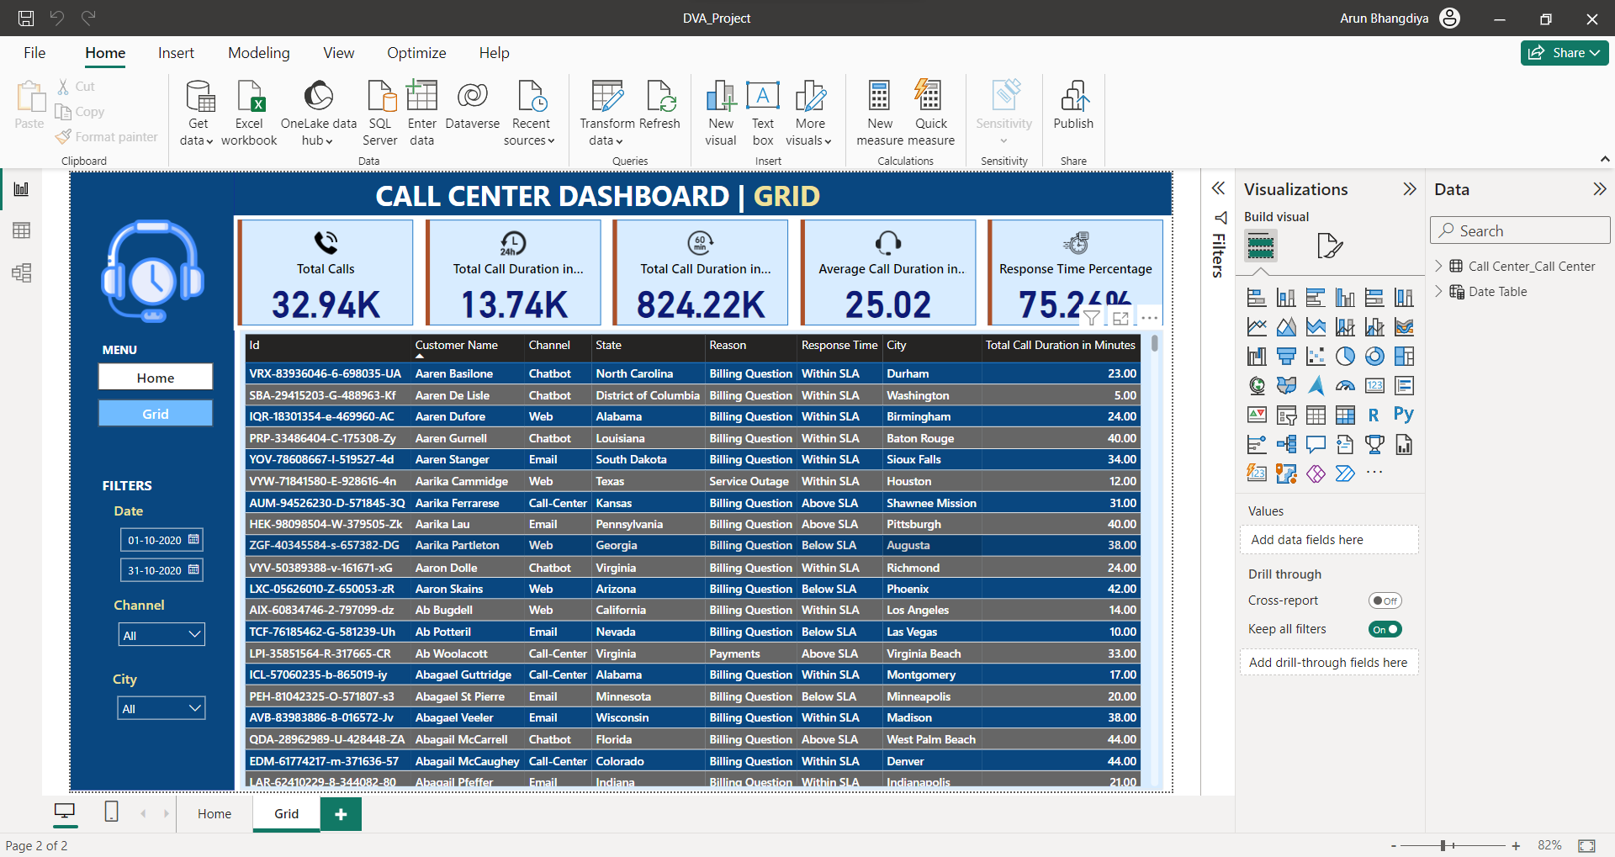

Above image shows the dataset of our project in grid view.

Used data cleaning methodologies to remove redundant data entries.

Steps to remove redundant data :

* After loading the data, we see the "Data" view where we can preview the dataset.
* To remove duplicate rows, select the table in which you want to remove duplicates.
* Go to the "Modeling" tab and click on "Remove duplicates" from the "Table tools" group.
* Specify the columns you want to use to identify duplicates and click "OK."
* We can filter the data to remove rows that are not needed.
* Use the "Filter" icon (funnel symbol) next to column names to apply filters.

To make calculations easy we have further created a Date Table whose attributes are Date, Day and Day No. and we have established many to one relationship between Call Center table and Date Table.

We further inserted various views using various filters and visulaizations:

**Card**

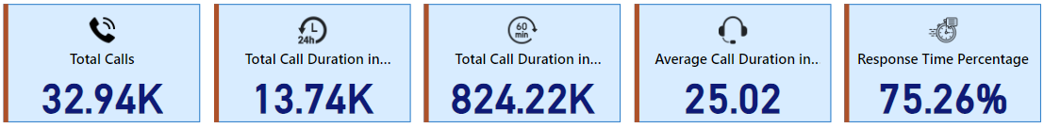

After data cleaning, the total calls are 32941 , total call duration in hours is 13737, total call duration in minutes is 824222, Average call duration in minutes is 25.02, Response time percentage is 75.26%

All these were calculated by selecting various options in fields.

**Total Calls by Day: Stacked Column Chart**

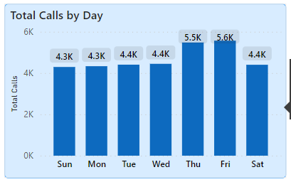

Through data visualization, a clear trend emerges, indicating that on Friday we get most calls i.e. almost 5.6K whereas on Sunday and Monday we get less calls i.e. 4.3K and on remaining days we get almost same number of calls i.e. 4.4K.

**Total Calls by States: Shape Map**

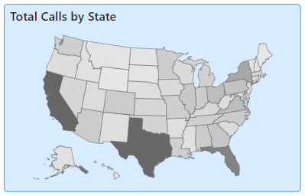

We can conclude from shape map that Texas, California, Florida are the regions in United States from where most calls are made whereas Wyoming, Vermont, Maine has the less number of calls. So, we can say that most of the calls are made from southern part of states.

**Total Calls by Reason: Treemap**

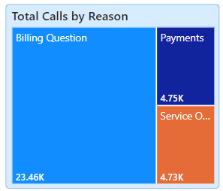

We can say that the reason for calls is higher for Billing related questions as compared to payment and services outage questions.

**Total Calls by Channels: Pie chart**

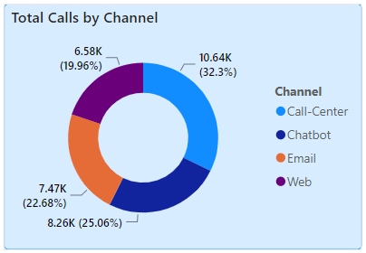

Here we have four channels for connecting to the call centres which are call-Center(calls), Chatbot, Email and Web of which Call-Centers(32.3%) holds maximum percentage for call by channel whereas Web(19.96%) holds minimum percentage for call by channels.

**Total Calls by Sentiments: Stacked Column Chart**

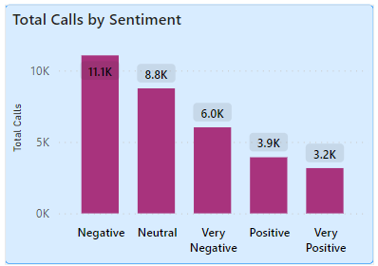

We have five categories of sentiments: Negative, Neutral, Very Negative, Positive and Very Positive.

We can clearly state that the number of negative sentiments are the highest and number of very positive sentiments are lowest compared to other sentiments.

**Total Calls by Call-Centers: Stacked Bar Chart**

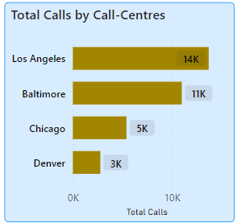

Here we can see that Los Angeles call center receives maximum nuber of calls i.e. 13734 whereas Denver receives minimum number of calls i.e. 2776

**Overall Dashboard View:**

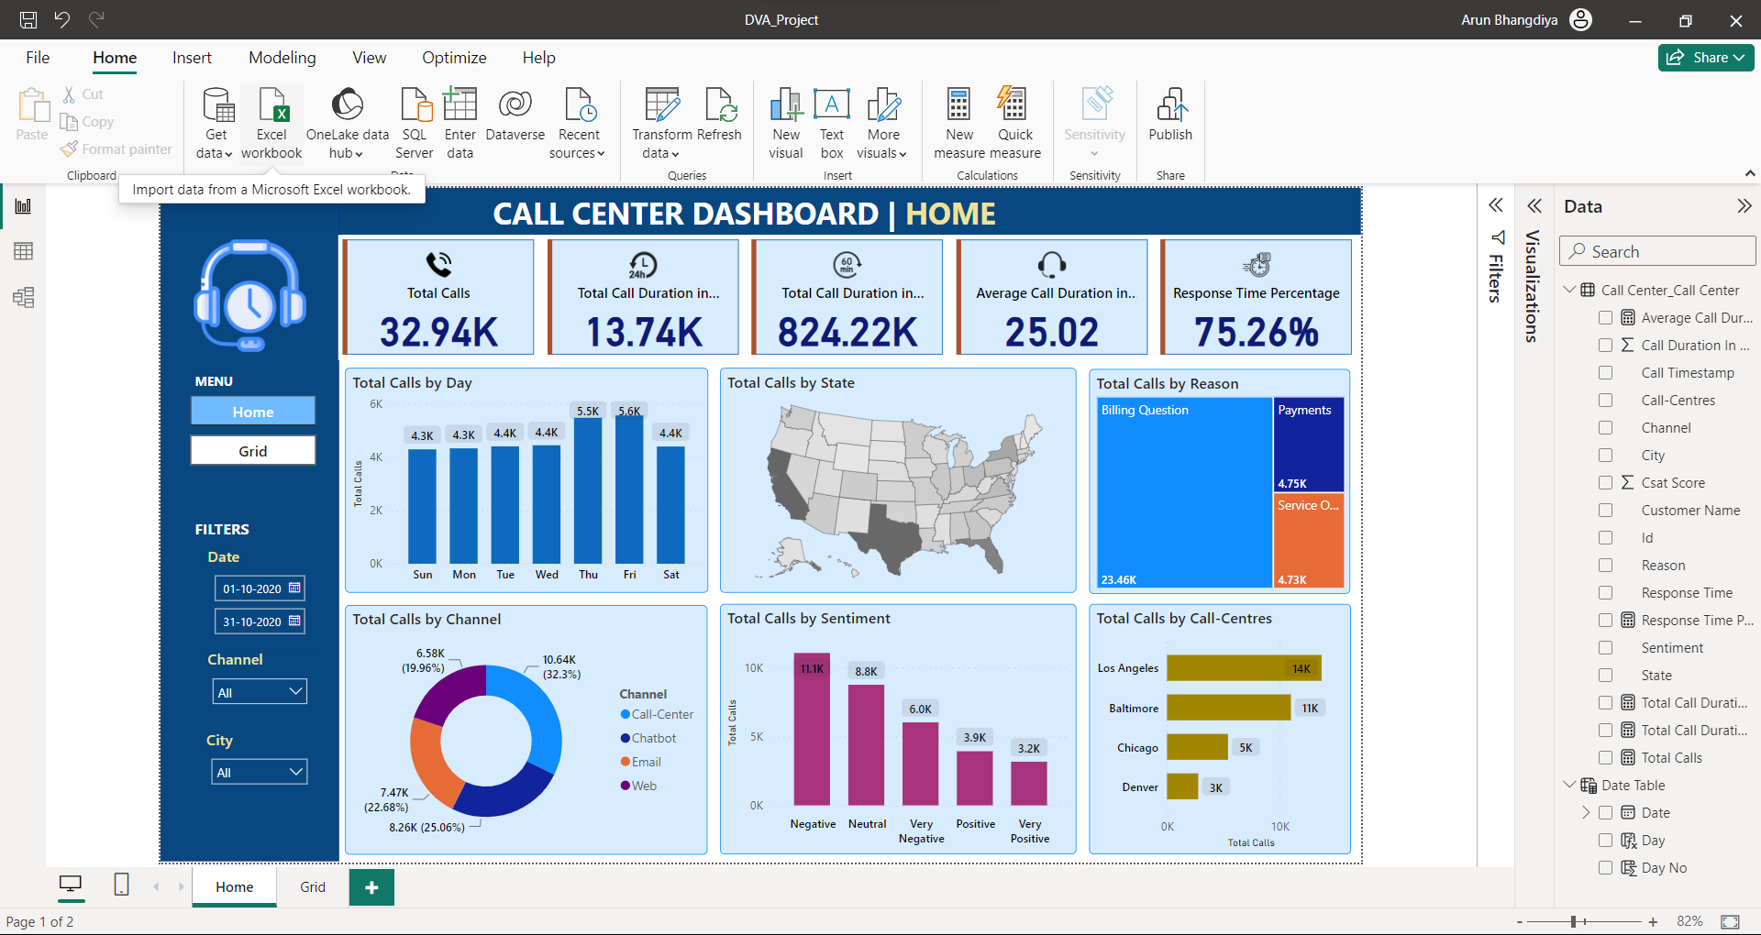

This dashboard serves as a comprehensive tool for gaining insights into the multitude of factors contributing to employee turnover. It incorporates various types of visualizations, including pie charts, histograms, and line graphs, each tailored to shed light on different aspects of the departure phenomenon.

The data is meticulously dissected, considering an array of variables such as Id, Customer Name, Call Timestamp, Call-Centres, Channel, State, Reason, Response Time, City, Sentiment, Call Duration in Minutes, Csat Score. By delving into these dimensions, the dashboard allows customer to get a analysis of call centers in the United States.