TRACEFLOW: AN ARTIFICIAL INTELLIGENCE DRIVEN SUPPLY CHAIN LEDGER AND TRANSACTION SECURITY VERIFICATION SYSTEM
A PROJECT REPORT
Submitted by
ARUN BHARATHI M B - 2116231901007
JAYGANESH KANNAN - 2116231901015
in partial fulfillment for the award of the degree
of
BACHELOR OF ENGINEERING
in
COMPUTER SCIENCE AND ENGINEERING (CYBER SECURITY)

RAJALAKSHMI ENGINEERING COLLEGE, CHENNAI - 602 105
An Autonomous Institution
OCTOBER 2026
BONAFIDE CERTIFICATE
This is to certify that the project report entitled "TraceFlow: An Artificial Intelligence Driven Supply Chain Ledger and Transaction Security Verification System" is the bonafide work of Arun Bharathi M B (2116231901007) and Jayganesh Kannan (2116231901015), submitted in partial fulfillment of the requirements for the award of the degree of Bachelor of Engineering in Computer Science and Engineering (Cyber Security) at Rajalakshmi Engineering College during the academic year 2026.

SIGNATURE  Dr. P. Tamilselvi, Ph.D.,  PROFESSOR AND HEAD OF THE DEPARTMENT  Department of Computer Science and Engineering (Cyber Security)  Rajalakshmi Engineering College  Chennai - 602 105 | SIGNATURE  Dr. Bhuvana S  ASSISTANT PROFESSOR  Department of Computer Science and Engineering (Cyber Security)  Rajalakshmi Engineering College  Chennai - 602 105
Submitted to Project Viva-Voce Examination held on ________________

Internal Examiner External Examiner

DECLARATION
We declare that this project report is an original account of the work carried out for the project. The design, implementation details, testing observations, limitations and future enhancements described in this report are based on the TraceFlow project software and its accompanying documentation.

ARUN BHARATHI M B - 2116231901007
JAYGANESH KANNAN - 2116231901015

ACKNOWLEDGEMENT
First, we thank the Almighty God for the successful completion of this project. We express our sincere thanks to our Chairman, Mr. S. Meganathan, B.E., F.I.E., for his sincere efforts in educating us in his premier institution. We would like to express our deep gratitude to our beloved Chairperson, Dr. Thangam Meganathan, Ph.D., for her enthusiastic motivation and encouragement, and to our Vice Chairman, Mr. Abhay Shankar Meganathan, B.E., M.S., for providing the necessary infrastructure and facilities.
We also express our sincere gratitude to our college Principal, Dr. S. N. Murugesan, M.E., Ph.D., and Dr. P. Tamilselvi, Ph.D., Professor and Head, Department of Computer Science and Engineering (Cyber Security), for their support and encouragement. We extend our heartfelt thanks to our project guide, Dr. Bhuvana S, AP, for her valuable guidance and continuous support throughout the development of this project.
We would also like to thank our project coordinator, Mr. Benedict J.N., M.E., Assistant Professor (SG), for his encouragement and guidance towards the successful completion of this project. We are grateful to our parents, friends, faculty members and supporting staff for their direct and indirect contributions, encouragement and support throughout the project.
Finally, we acknowledge the open-source communities and developers behind Python, Streamlit, Pandas and the other technologies used in the development of TraceFlow.
ARUN BHARATHI M B - 2116231901007
JAYGANESH KANNAN - 2116231901015

ABSTRACT
Modern manufacturing depends on supply networks that stretch across many companies and many countries. High value physical parts such as electric vehicle battery cells, aircraft fasteners, turbine blades and automotive control modules pass through several hands before they reach the assembly line. Most of these networks still keep their records in central databases. Such databases can be changed by a single person, they cannot prove that a sender is genuine, they do not ask several parties to agree before a record is saved, and they cannot warn about a suspicious batch before it is recorded.
To address these weaknesses, this thesis presents TraceFlow, a software platform that joins artificial intelligence style risk checking with a simulated shared ledger. Every material transfer request is examined for authenticity and safety first, and only a request that passes is allowed to become a permanent ledger block.
The platform is built in Python as three small, separate program modules. The Risk Engine creates a short hash fingerprint for each transaction, reads JSON and CSV data files and applies the safety rules. The UI Components library loads a clean visual style, prepares the sidebar and draws a five stage coloured progress timeline. The Application Orchestrator, built on the Streamlit framework, controls the page and runs the animation.
Each transaction is judged on three strict checks: whether its digital signature is valid, whether the sending vendor is a registered and verified origin, and whether the artificial intelligence anomaly flag is clear. A compliant transaction receives an AI Trust Score of ninety seven percent, wins the agreement of all twelve network nodes and is minted as a block on the ledger. A non compliant transaction, for example one with a missing signature, an unverified vendor or a tampered batch, receives a trust score of twenty two percent, is refused by the network and is held in a quarantined local record.
Tests with safe and unsafe datasets showed one hundred percent correct classification, file processing in under twelve milliseconds, and a memory use of about thirty two megabytes. By removing complicated server requirements and by explaining each result through a simple visual timeline, TraceFlow offers an accessible and dependable way to verify industrial supply chain transactions.
Keywords: supply chain, blockchain ledger, artificial intelligence, anomaly detection, digital signature, transaction security, Streamlit, Python

TABLE OF CONTENTS
CHAPTER AND TITLE PAGE
BONAFIDE CERTIFICATE i
DECLARATION ii
ACKNOWLEDGEMENT iii
ABSTRACT iv
LIST OF TABLES vii
LIST OF FIGURES viii
CHAPTER 1 INTRODUCTION 1
1.1 General Overview 1
1.2 Supply Chain Challenges in Modern Manufacturing 2
1.3 Problem Statement 3
1.4 Need for the Study 3
1.5 Objectives of the Research 4
1.6 Scope of the Project 4
1.7 Methodology in Brief 4
1.8 Expected Benefits 5
1.9 Organization of the Thesis 5
CHAPTER 2 LITERATURE REVIEW 6
2.1 Introduction 6
2.2 Evolution of Supply Chain Traceability Technologies 6
2.3 Blockchain Systems in Logistics 7
2.4 Artificial Intelligence in Anomaly Detection 8
2.5 Multi Criteria Decision Making and Rule Engines 8
2.6 Comparative Analysis of Existing Frameworks 9
2.7 Identified Research Gaps 9
2.8 Key Ideas Explained in Simple Words 10
2.9 Summary of the Review 11
CHAPTER 3 METHODOLOGY AND SYSTEM ARCHITECTURE 12
3.1 Overall System Architecture 12
3.2 Three Tier Modular Software Architecture 13
3.3 Security Verification Rules 14
3.4 Human Friendly Network Animation Design 16
3.5 Data Flow and Process Workflow 17
3.6 Hash Fingerprint of a Transaction 19
3.7 Input Handling: Presets and File Upload 20
3.8 Design Decisions and Their Reasons 20
3.9 Consensus Simulation and Trust Score Design 20
3.10 Reliability and Error Handling 21
3.11 Summary of the Design 21
CHAPTER 4 IMPLEMENTATION, TESTING AND RESULTS 22
4.1 Software Implementation Details 22
4.2 Component Interaction Walkthrough 22
4.3 Experimental Test Setup and Datasets 24
4.4 Scenario A: Compliant Safe Transaction 24
4.5 Scenario B: Compromised Unsafe Transaction 25
4.6 Performance and Execution Latency 26
4.7 Discussion of Results 27
4.8 Practical Use Case Walkthrough 28
4.9 Limitations of the Present Work 28
4.10 Summary 28
CHAPTER 5 CONCLUSION AND SCOPE FOR FUTURE WORK 30
5.1 Summary of Research Accomplishments 30
5.2 Key Takeaways and Practical Contributions 30
5.3 Scope for Future Work and Enhancements 31
5.4 Concluding Remarks 31
PROJECT OUTCOMES 32
APPENDIX I : DESCRIPTION OF THE PROGRAM MODULES 33
APPENDIX II : STANDARDIZED DATASET FIELDS 35
REFERENCES 36

LIST OF TABLES
TABLE NUMBER AND CAPTION PAGE
Table 1.1 Supply Chain Challenges and the Matching TraceFlow Response 2
Table 2.1 Comparison of Supply Chain Verification Approaches 9
Table 3.1 Responsibilities of the Three Program Modules 13
Table 3.2 Multi Criteria Security Rule Matrix 15
Table 3.3 All Eight Combinations of Rule Results and the Resulting Verdict 15
Table 3.4 Network Stage Definitions for Secure and Unsecure Flows 16
Table 4.1 Software Environment Used for the Project 22
Table 4.2 Comparison of System Inputs for the Safe and Unsafe Test Runs 24
Table 4.3 Evaluation Results and Diagnostic Metrics Comparison 26
Table 4.4 Execution Latency and Memory Utilization 26
Table A1 Functions of the Risk and Data Engine 33
Table A2 Functions of the UI Component Library 33
Table A3 Fields of a Transaction Dataset 35

LIST OF FIGURES
FIGURE NUMBER AND CAPTION PAGE
Figure 1.1 Centralized Tracking compared with the TraceFlow Approach 3
Figure 2.1 Evolution of Supply Chain Traceability 7
Figure 3.1 Three Tier Architecture Diagram of TraceFlow 12
Figure 3.2 Interaction between the Three Program Modules 13
Figure 3.3 Decision Logic of the Three Safety Rules 14
Figure 3.4 Five Stage Timeline Design for a Secure Flow 16
Figure 3.5 Five Stage Timeline Design for an Unsecure Flow 17
Figure 3.6 Data Flow Diagram for Transaction Processing 18
Figure 3.7 Complete End to End Workflow of TraceFlow 19
Figure 4.1 Dashboard Layout with Sidebar, Control Panel, Criteria Cards and Visualizer 23
Figure 4.2 Visual Network Progress Timeline for SECURE Execution 25
Figure 4.3 Visual Network Progress Timeline for UNSECURE Execution 25
Figure 4.4 AI Trust Score for the Safe and Unsafe Scenarios 26
Figure 4.5 Execution Latency of the TraceFlow Operations 27
Figure 5.1 Future Enhancement Roadmap for TraceFlow 31

CHAPTER 1
INTRODUCTION

1.1 GENERAL OVERVIEW
Modern manufacturing no longer happens under one roof. A single product, whether it is an electric car, an aircraft, a wind turbine or a medical device, is put together from parts that were made in many different factories, in many different countries, by many different companies. A raw material may be mined in one country, refined in another, shaped into a component in a third, and finally assembled into a finished machine in a fourth. Each step in this journey is handled by a different organisation, and each organisation keeps its own records of what it received, what it made and what it sent onward.
When everything goes well, this arrangement is efficient and cheap. When something goes wrong, it can be dangerous. In high precision industries the quality of every single physical component matters. A battery pack in an electric vehicle contains thousands of lithium cells collected from several suppliers. If one batch of poor quality or counterfeit cells slips past inspection and enters the assembly line, the finished battery may overheat, lose capacity far too early, or in the worst case catch fire. The same kind of risk exists with aircraft fasteners, structural steel, turbine blades and the electronic control units that run modern vehicles.
Most companies today track these parts using Enterprise Resource Planning software that stores everything in a central database. A central database is easy to manage, but it has a weakness that matters a great deal in a supply chain: whoever controls the database can change it. A record can be edited by a dishonest employee, altered by an outside attacker who gains access, or simply entered wrongly and never corrected. Other companies in the chain have no independent way to check whether the record they are shown is the true one.
To deal with this weakness, engineers and researchers have turned to two ideas. The first is the blockchain, a shared ledger that is copied across many computers and is built so that old entries cannot be changed without everyone noticing. The second is artificial intelligence, which can study the details of a transfer and spot patterns that look suspicious before the transfer is accepted. Each idea is useful on its own, but each also has a gap. A blockchain will faithfully preserve a false record if a false record is submitted. An artificial intelligence check that runs separately, long after the record was saved, can warn people only after the damage is done.
This project, named TraceFlow, brings the two ideas together in a simple and practical way. TraceFlow is a software platform that checks every material transfer request for authenticity and safety before it is allowed to become a permanent ledger entry. If the transfer passes the checks, the platform shows that the whole network of nodes agrees and a new block is created. If the transfer fails, the platform shows that agreement was refused and keeps the suspicious request in a separate quarantine record. The whole process is shown to the user as a clear five step coloured timeline, so that a factory manager or a logistics coordinator can understand the outcome at a glance without reading technical hash codes.
The platform is written in the Python programming language and uses the Streamlit framework to provide a web page that runs on an ordinary computer. It is deliberately lightweight. It does not need a cluster of servers or any special hardware, and it uses only about thirty two megabytes of memory. This makes it suitable for classroom demonstration, for early prototyping by industry teams, and for small edge devices placed near a warehouse or a loading dock.

1.2 SUPPLY CHAIN CHALLENGES IN MODERN MANUFACTURING
Even with the growth of automation, barcodes and digital inventory software, physical material supply chains still face a number of deep structural problems. Four of them are particularly important for this project.
Counterfeit component injection. Dishonest suppliers and fraudulent middlemen sometimes try to introduce parts of lower quality into a trusted stream of goods. They do this by producing paperwork that looks genuine. Because the receiving company often sees only the paperwork and not the true origin of the part, the substitution can go unnoticed until a failure happens in the field.
Identity spoofing at handover points. When goods pass from a transport company to a receiving warehouse, the identity of the sender is often checked by eye or by a paper signature. A person who is not a registered supplier can pretend to be one, use the name of a trusted company, and have the delivery accepted. Manual identity checks are slow, and they are easy to deceive.
No shared agreement between parties. In an ordinary ERP system each company writes its own record on its own. No automatic process asks several independent parties to examine a transfer and agree that it is valid before it is recorded. As a result, every company holds its own version of the truth and disagreements are discovered late.
Records that ordinary people cannot read. Many of the blockchain demonstrations built so far show long strings of letters and numbers, raw data files and lines of technical logs. These are meaningful to a specialist but confusing to a floor manager, a purchasing officer or an auditor. A system that nobody outside the technical team can read does not build trust.
Table 1.1 Supply Chain Challenges and the Matching TraceFlow Response
Challenge | What goes wrong today | How TraceFlow responds
Counterfeit components | Fake parts enter with forged paperwork | Digital signature check and anomaly flag check before any record is made
Identity spoofing | Unregistered sender poses as a trusted supplier | Origin vendor must be verified and must not be marked Unknown or Unregistered
No shared agreement | Each company keeps its own version of events | Network consensus of twelve nodes is shown before a block is minted
Hard to read records | Raw hash codes and technical logs | Five stage coloured timeline and simple pass or fail cards

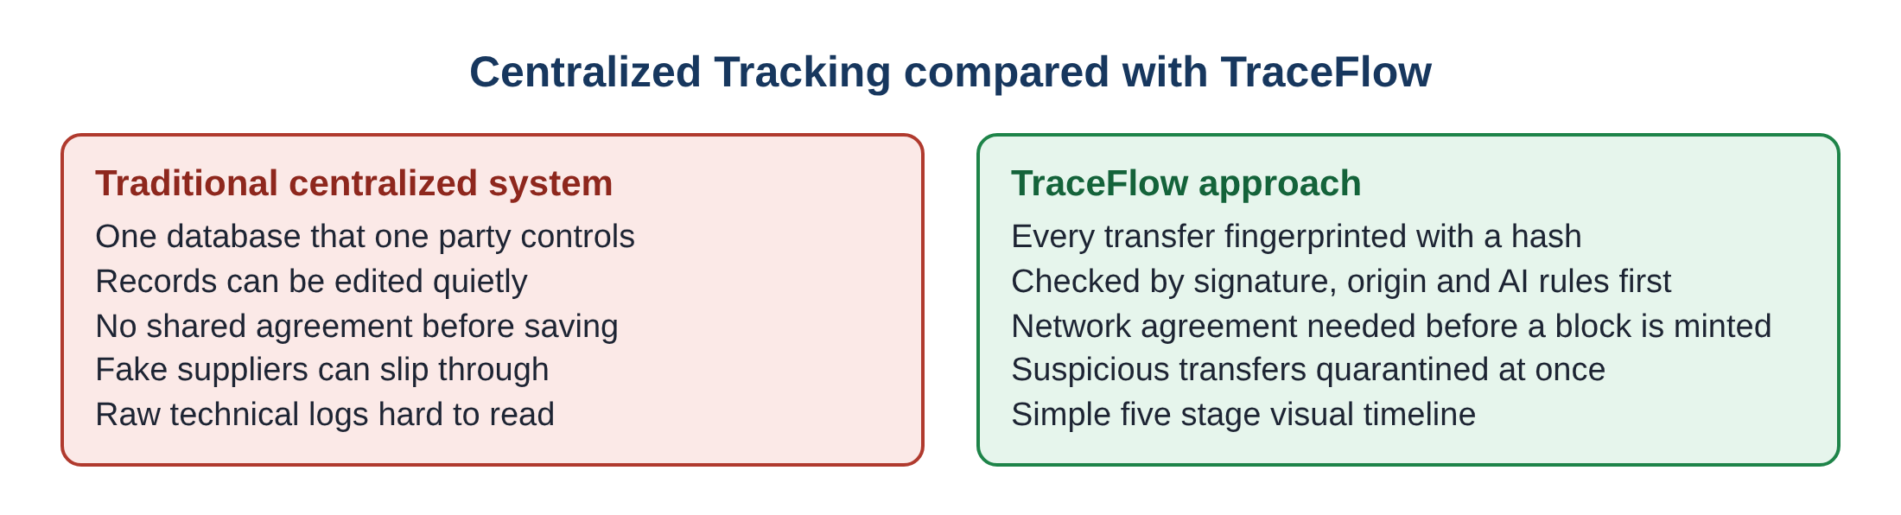
Figure 1.1 Centralized Tracking compared with the TraceFlow Approach

1.3 PROBLEM STATEMENT
Centralized supply chain systems used in manufacturing logistics are open to unauthorised data tampering, identity spoofing and the injection of counterfeit components. Existing blockchain solutions give a permanent record, but they do not include a built in artificial intelligence step that judges whether a transaction is genuine before it is written into the ledger. In addition, the tracking tools that are currently available are complicated to install and display their results in a form that ordinary users cannot follow in real time.
The problem that this project addresses can therefore be put in one sentence. How can a supply chain transfer be verified for signature, vendor identity and abnormal behaviour at the moment it is submitted, in a lightweight system that anybody can run, and with a result that anybody can understand?

1.4 NEED FOR THE STUDY
There is a clear and urgent industrial need for a simple, human friendly software platform that achieves three goals at once.
First, the platform must have a clear and predictable security framework. It should look at the digital signature, the trust level of the sending vendor and the anomaly warnings, all at the same time, and it should do so while the transfer request is being made rather than afterwards.
Second, the platform must be easy to run. Many research prototypes need container software, several virtual machines and long configuration files before a single transaction can be tested. A lightweight design that runs from a few program files on a normal laptop makes experimentation much faster and allows universities, small suppliers and training centres to study the subject without any special budget.
Third, the platform must explain itself. Progress should be visible as a short story with a beginning, a middle and an end: the sender is checked, the artificial intelligence studies the request, the network agrees or refuses, the goods travel, and the delivery is confirmed or doubted. When a person can watch this story unfold in colour, they trust the result and understand the reason for it.

1.5 OBJECTIVES OF THE RESEARCH
The specific aims of the project are listed below.
- To design and build a modular Python software framework, named TraceFlow, for real time security verification of supply chain transactions.
- To create a clear rule based risk engine that checks the digital signature, the origin vendor registry and the artificial intelligence anomaly flag together.
- To build a friendly web interface with a five stage animated progress timeline that shows how a transaction moves through the network.
- To allow two ways of giving input to the system: uploading a JSON or CSV file, and choosing a ready made preset scenario for demonstration.
- To test the platform on safe and unsafe examples and to measure its accuracy, speed and memory use.

1.6 SCOPE OF THE PROJECT
The work covers the complete journey from idea to tested software. This includes the design of the three tier architecture, the writing of the program modules, the definition of the safety rules, the preparation of test data files, the design of the user interface, the implementation of the animated timeline and the measurement of performance. The platform simulates industrial batch transfers between supply chain nodes, for example a lithium cell batch moving from a component maker in Pune to an assembly plant in Berlin.
The project is a simulation and demonstration platform. It reproduces the behaviour of an artificial intelligence guarded ledger network inside one application so that the logic can be studied, shown and measured. It does not connect to a live public blockchain, and it does not yet read live sensors. These extensions are discussed as future work in Chapter 5.

1.7 METHODOLOGY IN BRIEF
The project followed a simple engineering path. The first step was to study existing literature and find the gaps. The second step was to define what a safe transaction looks like and what an unsafe one looks like, and to turn those definitions into three clear checks. The third step was to divide the software into three small and separate program files so that the calculation, the display and the control of the application would each have one clear owner. The fourth step was to create sample data files for a safe and an unsafe transaction in both JSON and CSV form. The fifth step was to run both samples through the platform many times and record the results. The last step was to analyse these results and write up the findings.

1.8 EXPECTED BENEFITS
- Early detection: suspicious transfers are stopped before they enter the permanent record.
- Easy understanding: the colour coded timeline and simple pass or fail cards can be read by non technical staff.
- Low cost: the platform runs on an ordinary computer using free software.
- Fast response: files are checked in a few milliseconds, so the check does not slow the business process.
- Easy teaching: students and trainees can see for themselves how signature checks, vendor registries and consensus work together.

1.9 ORGANIZATION OF THE THESIS
The thesis is arranged in five chapters.
Chapter 1 gives the background of industrial supply chains, explains the main problems, states the problem, shows why the study is needed and lists the objectives and scope.
Chapter 2 reviews earlier work on traceability, blockchain in logistics, artificial intelligence for anomaly detection and rule based decision systems, and points out the gaps that TraceFlow fills.
Chapter 3 explains the method and the design of the system. It describes the architecture, the three program modules, the safety rules, the animated timeline and the flow of data through the system.
Chapter 4 describes how the software was built, how it was tested, what happened in the safe and unsafe scenarios and how fast the platform runs.
Chapter 5 summarises the achievements, lists the main contributions and suggests how the platform can be improved in the future.

CHAPTER 2
LITERATURE REVIEW

2.1 INTRODUCTION
Supply chain management has changed a great deal over the last three decades. It began with hand written ledgers and paper delivery notes. It moved to computer based inventory records, then to electronic tracking with scanners and tags, and more recently to sensor networks and shared digital ledgers. At each stage the aim has been the same: to know exactly what is moving, where it came from, who handled it and whether it can be trusted.
This chapter reviews the knowledge that lies behind TraceFlow. It first looks at how traceability technology has developed. It then explains how blockchain systems work in logistics, how artificial intelligence is used to find abnormal behaviour, and how rule based engines combine several checks into one decision. Finally the chapter compares the main approaches and identifies the gaps that the present project was designed to fill.

2.2 EVOLUTION OF SUPPLY CHAIN TRACEABILITY TECHNOLOGIES
In the early days of industrial manufacturing, tracking depended on serial numbers stamped on parts, paper bills of lading carried with the goods, and handwritten stock registers. Early work such as that of Ariponnammal and Natarajan (1994) drew attention to the importance of dependable signals and standard measuring conditions when materials move through an industrial process. The lesson that carries over to logistics is that any tracking method is only as good as the reliability of the information that it captures.
As factories spread across the world, paper records became hard to manage. They could be lost in transit, damaged by weather, copied or replaced. Barcodes brought speed, because a scanner could read a label in a fraction of a second. Two dimensional matrix codes carried more information in less space. Radio frequency identification tags went a step further and allowed a whole pallet to be read without opening it. These technologies greatly improved how fast information could be captured at a warehouse door.
However, capturing data quickly does not make the data true. Tsychiya (1980) discussed automated inspection and verification and showed that automation alone cannot guarantee integrity if the database that receives the data remains in one place and remains editable. A perfectly scanned label is of little use if the record it is linked to can be quietly changed afterwards.
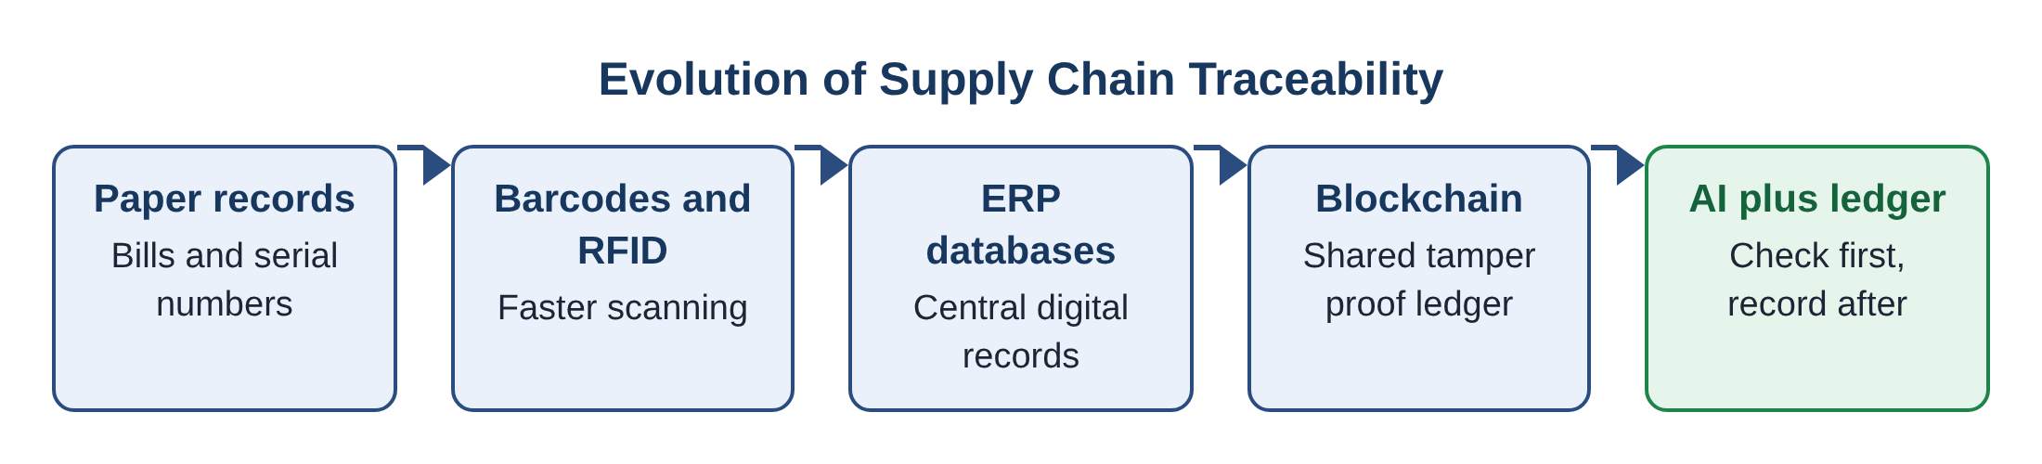
Figure 2.1 Evolution of Supply Chain Traceability
The figure above shows the path of development. Each stage solved a problem of the earlier stage and then exposed a new one. Paper was slow, barcodes were fast but local, central databases were convenient but trusted a single owner, and blockchains spread the trust but could not judge the quality of what was written into them. The final stage, which combines intelligent checking with a shared ledger, is where TraceFlow is placed.

2.3 BLOCKCHAIN SYSTEMS IN LOGISTICS
2.3.1 What a blockchain does
A blockchain is a list of records, called blocks, that are linked together in order. Each block carries a fingerprint, called a hash, which is produced from the contents of the block and from the fingerprint of the block before it. Because of this chaining, changing even one letter in an old block changes its fingerprint, which no longer matches the next block, and the tampering becomes obvious. The ledger is also copied across many computers, called nodes, so that no single party can rewrite history without the others noticing.
Jankins and Walts (1968) studied the analysis of signals and patterns, a body of thinking that underlies the modern use of mathematical fingerprints for checking data. In the present day, a widely used fingerprinting method is the Secure Hash Algorithm with a length of two hundred and fifty six bits. It always produces a fixed length output, it is practically impossible to reverse, and any small change to the input produces a completely different output. TraceFlow uses this method to create a short fingerprint for each transaction.
2.3.2 Public and permissioned networks
Public blockchains such as Ethereum allow anybody to join. They are open and highly resistant to tampering, but they can be slow and costly for industrial use, and they expose business information to outsiders. Permissioned networks such as Hyperledger Fabric allow only approved members to join. They are faster, they keep business data private among the members, and they use agreement methods like Practical Byzantine Fault Tolerance or Proof of Authority, in which a group of known participants vote on whether a new block is valid.
Shin and McKay (1984) studied control of manipulators and showed how coordinated, automated decision making can reduce unwanted interference in a system. In a supply chain the same idea appears as the smart contract, a small program stored on the ledger which runs automatically when agreed conditions are met, for example when a valid digital signature is presented at the time goods are received.
2.3.3 What blockchain cannot do alone
A blockchain guarantees that a record, once written, cannot be changed. It does not guarantee that the record was true when it was written. If an unregistered supplier sends false details in a correct format, the blockchain will store those false details permanently and faithfully. In computing this is summed up by the saying that if rubbish goes in, rubbish comes out. This limitation is the main reason why an additional checking layer is needed before data is accepted.

2.4 ARTIFICIAL INTELLIGENCE IN ANOMALY DETECTION
An anomaly is something that does not fit the normal pattern. In a supply chain, an anomaly might be a shipment that follows an unusual route, a batch number that has been altered, a vendor whose name has never been seen before, a temperature that goes beyond the safe range, or a signature that is missing. Artificial intelligence and machine learning methods are used to learn what normal looks like and to raise a warning when something falls outside it.
There are several families of methods. Statistical methods flag values that are far from the average. Clustering methods group similar items and treat items that fit no group as suspicious. Tree based methods such as Isolation Forest separate unusual items very quickly because unusual items need fewer splits to be isolated. Sequence models such as Long Short Term Memory networks study time series data like temperature or location readings and learn what a healthy journey looks like.
Most existing systems run these methods as a separate offline job. Data is collected, saved, and later analysed in a batch, perhaps once a day. This means a fraudulent transaction may already be on the ledger before anyone is warned. The more useful approach is to make the check part of the submission step itself, so that a suspicious request is held back at the door. TraceFlow follows this approach. The anomaly flag attached to a transaction is examined inline, in the same moment that signature and vendor identity are examined.

2.5 MULTI CRITERIA DECISION MAKING AND RULE ENGINES
A rule engine is a program that takes a number of facts, applies a set of clear rules and produces a decision. In security work, rule engines are valued because their decisions are predictable and easy to explain. When a transaction is rejected, the engine can state exactly which rule failed.
A multi criteria design combines several checks into one result. In the simplest and strictest form, every check must pass for the transaction to be accepted. This is the form chosen for TraceFlow. The three checks are independent of each other, so they can be carried out one after another in a few microseconds, and a failure in any one of them is enough to stop the transaction. The strict approach suits a supply chain where one counterfeit batch can have severe consequences, and it keeps the logic easy for auditors to read.
The advantage of a rule engine over a purely learned model is transparency. A learned model gives a score but often cannot give a reason. A rule engine gives a reason every time. For a teaching and demonstration platform, and for early stage industrial adoption, this clarity is of great value.

2.6 COMPARATIVE ANALYSIS OF EXISTING FRAMEWORKS
A comparison of the three main kinds of approach shows how each performs on the qualities that matter in a supply chain.
Table 2.1 Comparison of Supply Chain Verification Approaches
Quality | Traditional ERP database | Blockchain only | AI guarded ledger (TraceFlow)
Protection from record changes | Weak, one owner can edit | Strong, chained records | Strong, chained records
Check before recording | Rarely done | Not included | Done inline for every request
Shared agreement | None | Yes, by consensus | Yes, shown as node consensus
Ease of installation | Moderate | Difficult, many servers | Easy, three program files
Ease of reading results | Moderate | Poor, raw hash data | Good, five stage timeline
Reason given for rejection | Not applicable | Not applicable | Yes, per rule card

The comparison shows that the hybrid approach gives the highest level of security and transparency while keeping delay and complexity under control. A traditional database is simple but weak. A pure blockchain is strong but does not judge the data and is heavy to run. The hybrid combines the strengths of both.

2.7 IDENTIFIED RESEARCH GAPS
The review points to three practical gaps.
High infrastructure complexity. Most blockchain implementations in the literature need container platforms, several servers and detailed network settings. This is a barrier for classrooms, small enterprises and edge devices, where a quick prototype is more useful than a full production network.
Separate artificial intelligence and ledger layers. In most systems the anomaly detection is a distant batch task, not part of the live submission path. A transaction can therefore be recorded before it has been judged.
Interfaces that people cannot read. Typical platforms show long hash strings, hexadecimal codes and dense logs. They do not give the visual cues that a supervisor on the factory floor needs in order to make a quick decision.
TraceFlow is designed to close all three gaps. It uses a small three part Python structure that is easy to install, it performs its checks in the live path before any block is created, and it shows the whole life of a transaction in a simple coloured timeline.

2.8 KEY IDEAS EXPLAINED IN SIMPLE WORDS
Several technical ideas appear again and again in this report. They are explained here in plain language so that a reader with no background in computer security can follow the later chapters.
Hash fingerprint. A hash is like a fingerprint for a piece of information. Whatever the size of the information, the hash comes out as a short code of fixed length. If even one letter of the original information is changed, the code changes completely. Nobody can work backwards from the code to the original text. This is why a hash is a good way to show that a record has not been altered.
Digital signature. A digital signature is the electronic version of a signed and stamped letter. It proves who sent a message and that the message was not changed after it was signed. A transaction without a valid signature is like an unsigned delivery note, and cannot be trusted.
Node. A node is one participant computer in the network. Each node keeps a copy of the ledger. In TraceFlow the network is shown as twelve nodes, and a transaction is accepted only when all twelve agree.
Consensus. Consensus means that the participants reach a common decision. In daily life it is similar to a committee that approves a purchase only if every member votes yes. The idea protects the network from a single dishonest or mistaken participant.
Block and ledger. A block is one page of records, and the ledger is the book made of all the pages in order. Every new page carries the fingerprint of the page before it, so the pages cannot be swapped or rewritten without the break being seen.
Anomaly. An anomaly is anything that does not fit the usual pattern, such as an unknown sender, an unusual route or an altered batch number. The anomaly flag is the warning label that the artificial intelligence layer attaches to such a case.
Quarantine. Quarantine means keeping a suspicious item apart from the trusted ones. In TraceFlow, a rejected transaction is stored in a separate local log so that it can be studied later without ever touching the trusted ledger.

2.9 SUMMARY OF THE REVIEW
The reviewed material establishes four points. Traceability technology has moved from paper to shared ledgers, but each step has left an unsolved problem. Blockchains protect records after they are written but cannot tell whether records are truthful. Artificial intelligence can find unusual behaviour but is usually applied too late. Rule engines give clear and explainable decisions that are quick to compute. By joining these four points, TraceFlow offers a design in which an inline check guards a shared ledger and a friendly display explains each result.

CHAPTER 3
METHODOLOGY AND SYSTEM ARCHITECTURE

3.1 OVERALL SYSTEM ARCHITECTURE
TraceFlow is built around a three tier architecture. The idea behind a tiered design is simple: each layer does one kind of job and talks only to the layer next to it. This keeps the program organised, makes it easy to test each part by itself, and allows one part to be improved without disturbing the others.
The first tier is the user interface. It is the web page that the person sees. It offers ready made preset scenarios, a file upload box for JSON and CSV files, a button to run the simulation and a sidebar where sample files can be downloaded. The second tier is the risk and data engine. It reads the file, creates the hash fingerprint and decides whether the transaction is safe. The third tier is the presentation engine. It loads the visual style, prepares the sidebar and draws the five stage progress timeline. Finally, the output layer brings together the coloured timeline, the trust score and the consensus result.
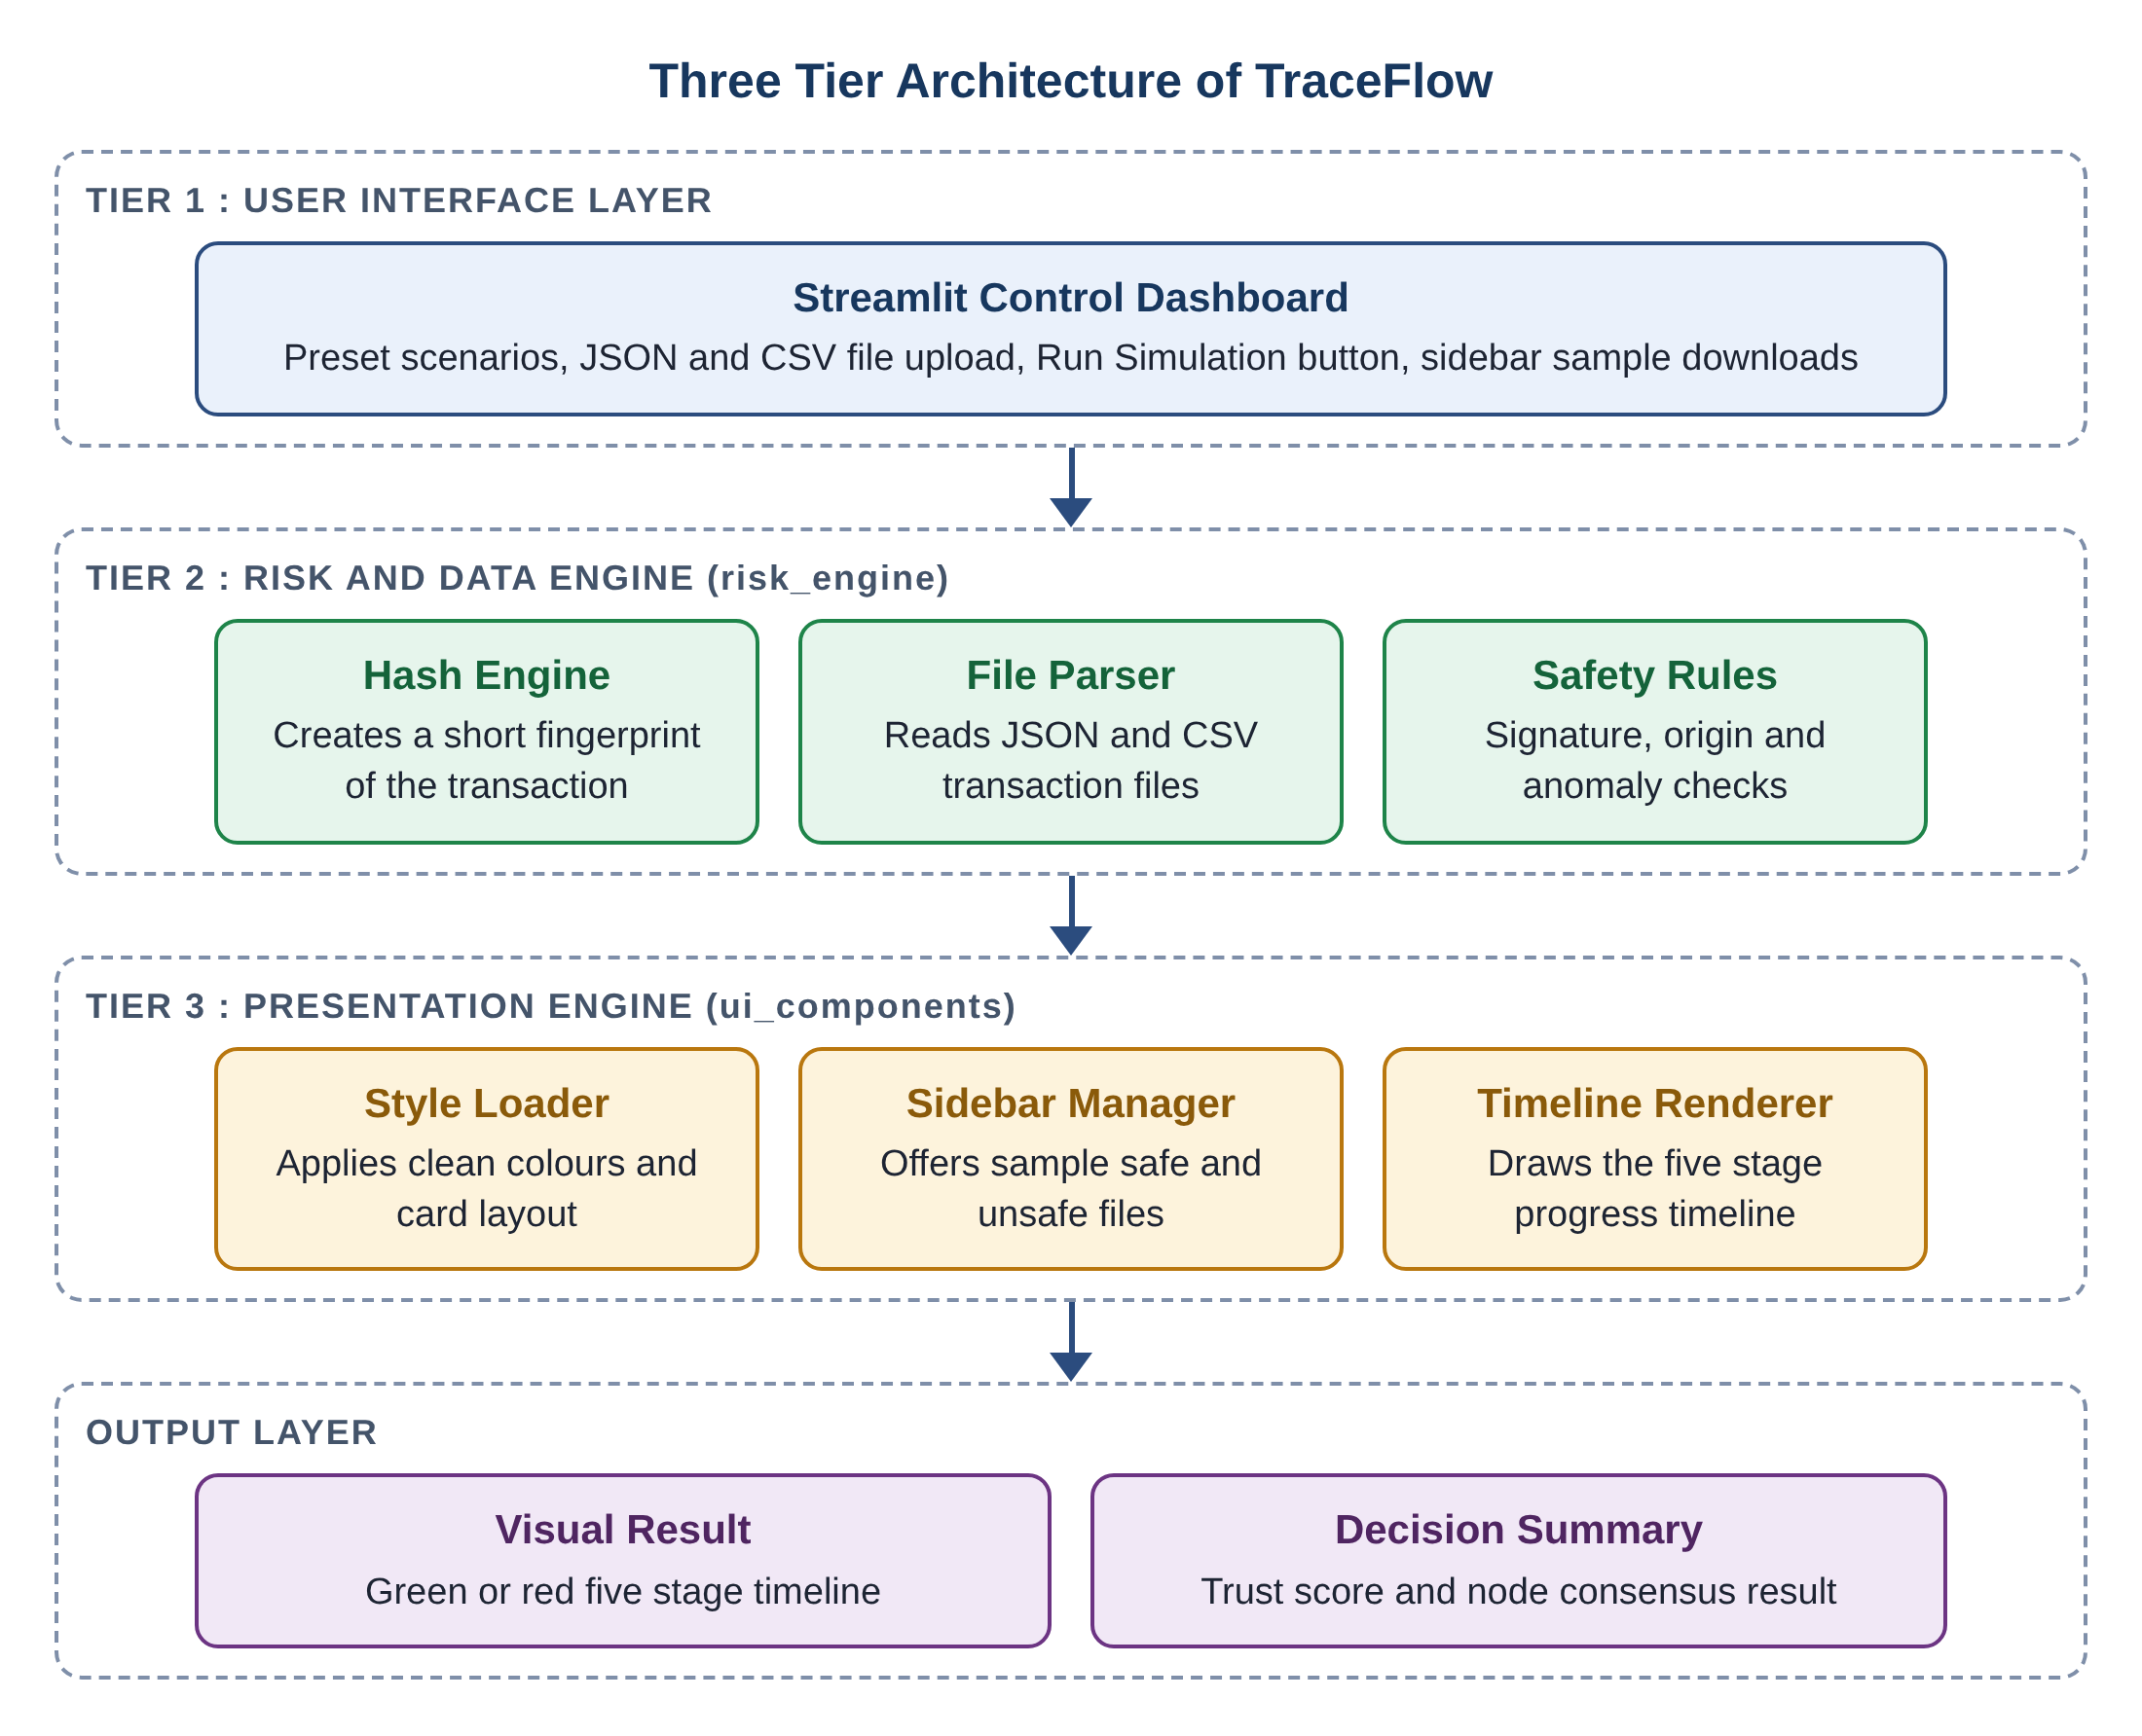
Figure 3.1 Three Tier Architecture Diagram of TraceFlow
Information moves downward through the tiers in a single direction. The dashboard collects the choice of the user, the risk engine turns that choice into a verdict, the presentation engine turns the verdict into a picture, and the output layer shows the picture together with the numbers.

3.2 THREE TIER MODULAR SOFTWARE ARCHITECTURE
The software itself is split into three Python files. Each file has a clear owner role.
The Risk and Data Engine (risk_engine). This is the thinking part of the platform. It creates a twelve character hash fingerprint from the transaction text, reads the JSON or CSV file that the user supplies, pulls out the fields that matter such as origin, destination, asset, signature status, origin verification and anomaly flag, and then applies the safety rules. It never draws anything on the screen.
The UI Component Library (ui_components). This is the drawing part of the platform. It loads the style sheet that gives the page its clean look, builds the sidebar with download buttons for the sample files, and produces the markup for the five stage timeline in green or red. It never makes any security decision.
The Application Orchestrator (app). This is the conductor. It starts the page, keeps the session memory, shows the controls, calls the risk engine for a verdict, hands the verdict to the presentation library and runs the step by step animation with a pause between stages.
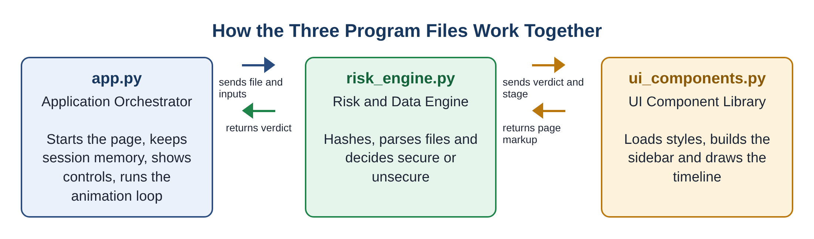
Figure 3.2 Interaction between the Three Program Modules
Table 3.1 Responsibilities of the Three Program Modules
Module | Main duties | What it does not do
risk_engine | Hashing, file reading, field extraction, safety evaluation, sample file supply | Does not draw or style anything
ui_components | Style loading, sidebar building, timeline drawing | Does not decide if a transaction is safe
app | Page layout, user choices, session memory, calling the other two, animation loop | Does not contain the safety rules or the drawing code

This separation brings real practical benefits. A change to the colours or wording of the timeline affects only the presentation library. A change to a rule affects only the risk engine. A new input format, such as an XML file, would need only a small addition to the file reader. The orchestrator stays almost the same in all of these cases.

3.3 SECURITY VERIFICATION RULES
The safety of a transaction is decided by three rules that are checked together. The transaction is classed as secure only when all three rules are satisfied at the same time. If even one rule fails, the transaction is classed as unsecure. In plain words, the verdict is secure when the signature is good, and the origin vendor is trusted, and the anomaly check is clear.
3.3.1 Rule one: digital signature verification
A digital signature is the cryptographic proof that a transaction really came from the stated sender and has not been altered on the way. The rule passes when the signature status in the file is the word VALID, or when the digital signature text begins with the prefix 0x, which is the usual starting mark of a cryptographic signature value. A missing signature, or a signature status marked INVALID without a proper signature value, makes this rule fail.
3.3.2 Rule two: origin vendor registry check
This rule asks whether the sender is a known and registered member of the network. It passes only when the origin verified setting is true and the name of the vendor does not contain untrusted words such as Unknown or Unregistered. A sender called Unknown Vendor Node 99, for example, fails the rule at once, even if the other fields look correct.
3.3.3 Rule three: artificial intelligence anomaly detection
This rule reads the anomaly flag that the artificial intelligence layer attaches to a transaction. It passes when the flag is NONE or empty. Any other value, such as a route anomaly, a spoofed identity or a changed batch hash, makes the rule fail. In this way the rule captures route tampering, identity spoofing and alteration of batch fingerprints.
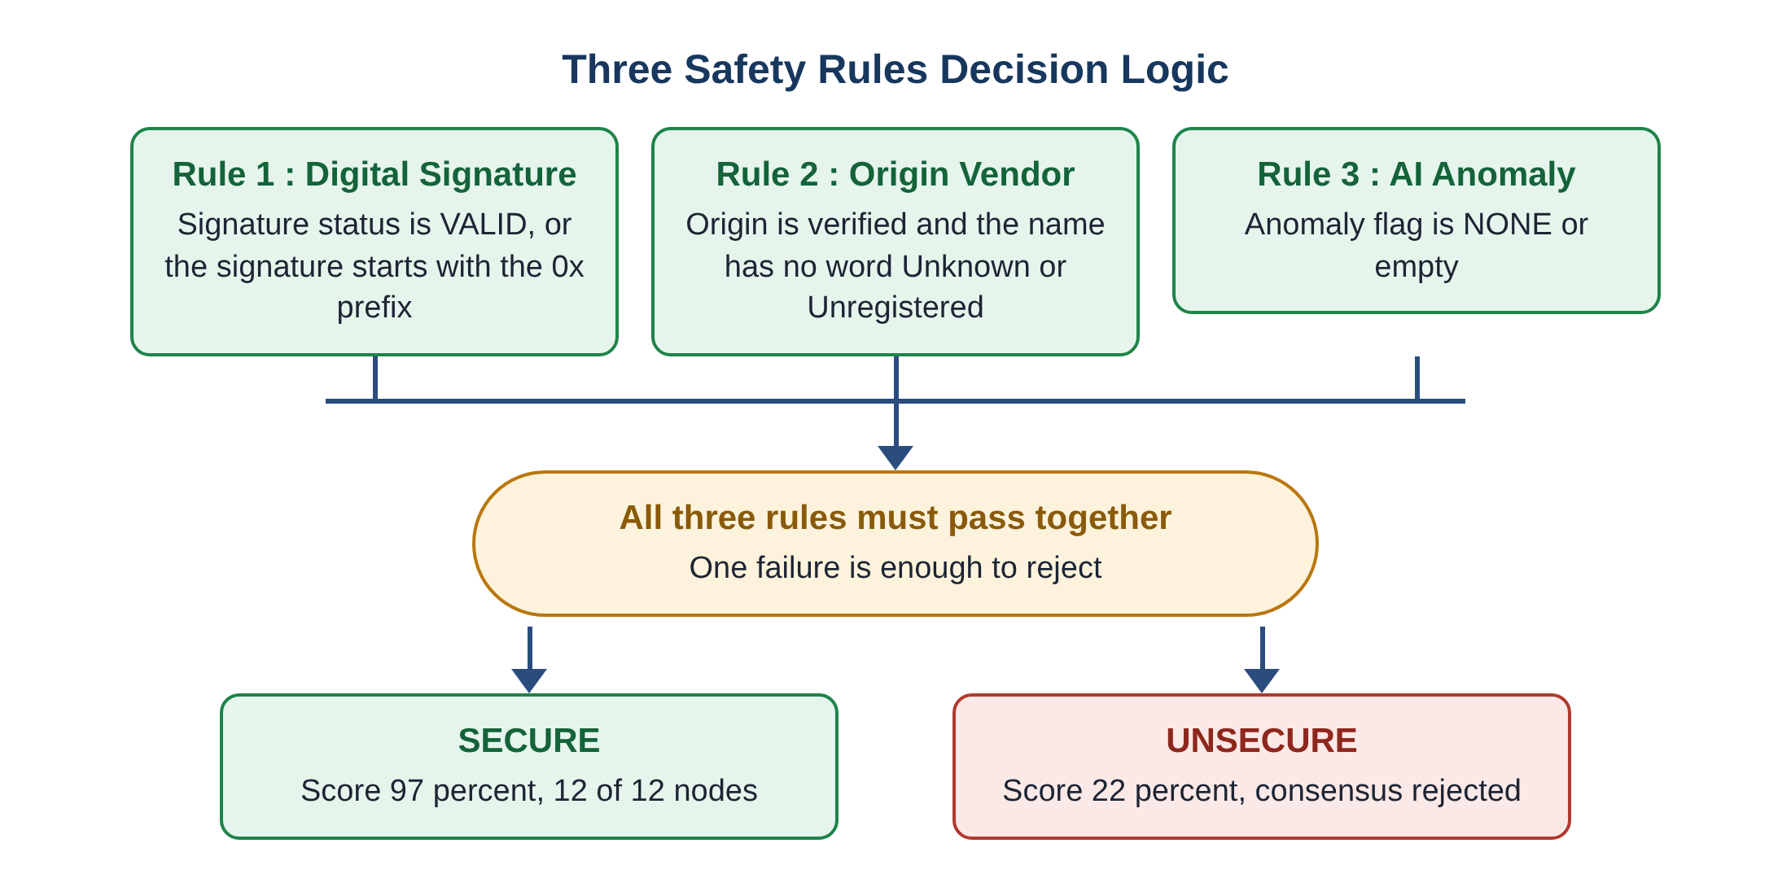
Figure 3.3 Decision Logic of the Three Safety Rules
Table 3.2 Multi Criteria Security Rule Matrix
Rule | Field examined | Passing condition | Typical failure
1 Digital signature | Signature status and digital signature text | Status is VALID, or text starts with 0x | Signature is MISSING, status INVALID
2 Origin vendor | Origin verified setting and vendor name | Verified is true and name has no Unknown or Unregistered | Unknown Vendor Node 99
3 AI anomaly | Anomaly flag | Flag is NONE or empty | ROUTE ANOMALY SPOOFED ID

When all three rules pass, the platform assigns an AI Trust Score of ninety seven percent and shows a consensus of twelve out of twelve nodes. When any rule fails, it assigns a trust score of twenty two percent and shows that consensus was rejected, with no node agreeing.
3.3.4 Every combination of rule results
Because there are three rules and each can either pass or fail, there are eight possible combinations. The strict design gives a very clear answer for each of them, shown in the table below. Only the first row leads to acceptance.
Table 3.3 All Eight Combinations of Rule Results and the Resulting Verdict
Signature | Origin vendor | AI anomaly | Verdict | Trust score
Pass | Pass | Pass | SECURE | 97 percent
Pass | Pass | Fail | UNSECURE | 22 percent
Pass | Fail | Pass | UNSECURE | 22 percent
Pass | Fail | Fail | UNSECURE | 22 percent
Fail | Pass | Pass | UNSECURE | 22 percent
Fail | Pass | Fail | UNSECURE | 22 percent
Fail | Fail | Pass | UNSECURE | 22 percent
Fail | Fail | Fail | UNSECURE | 22 percent

This table follows directly from the strict rule and shows that the platform has no hidden middle ground. A transaction is either trusted fully or not trusted at all. For a supply chain in which one faulty component can have serious consequences, such a strict approach is appropriate for a first line of defence.

3.4 HUMAN FRIENDLY NETWORK ANIMATION DESIGN
One of the main aims of TraceFlow is that the result should be understandable by a person who has no knowledge of cryptography. To achieve this, the technical life of a transaction is translated into five everyday stages and shown as a timeline of connected circles.
Secure flow. Identity Verified, then AI Analysis, then Block Minted, then In Transit, then Delivered. Every stage is shown in green.
Unsecure flow. Unverified Sender, then AI Warning, then Local Record, then In Transit, then Unverified Claim. Every stage is shown in red.
Table 3.4 Network Stage Definitions for Secure and Unsecure Flows
Stage | Secure flow meaning | Unsecure flow meaning
1 | Identity Verified: the sender is in the trusted registry | Unverified Sender: the sender cannot be confirmed
2 | AI Analysis: no abnormal pattern was found | AI Warning: abnormal route or identity was flagged
3 | Block Minted: all twelve nodes agree and a block is written | Local Record: consensus refused, kept only in a quarantine log
4 | In Transit: the goods travel with a ledger proof | In Transit: the goods travel without a ledger proof
5 | Delivered: receipt is confirmed on the ledger | Unverified Claim: the delivery claim cannot be trusted

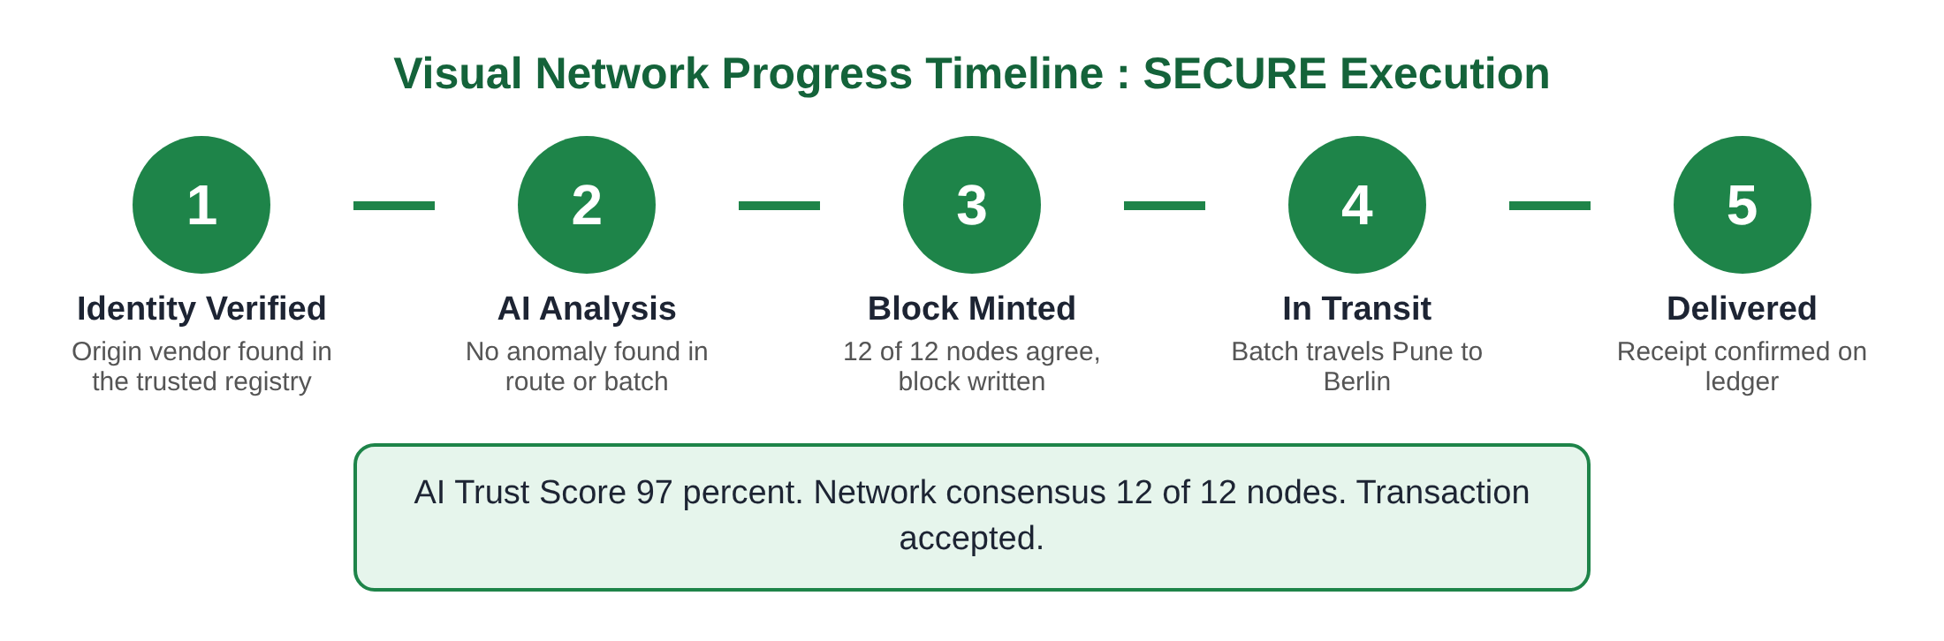
Figure 3.4 Five Stage Timeline Design for a Secure Flow
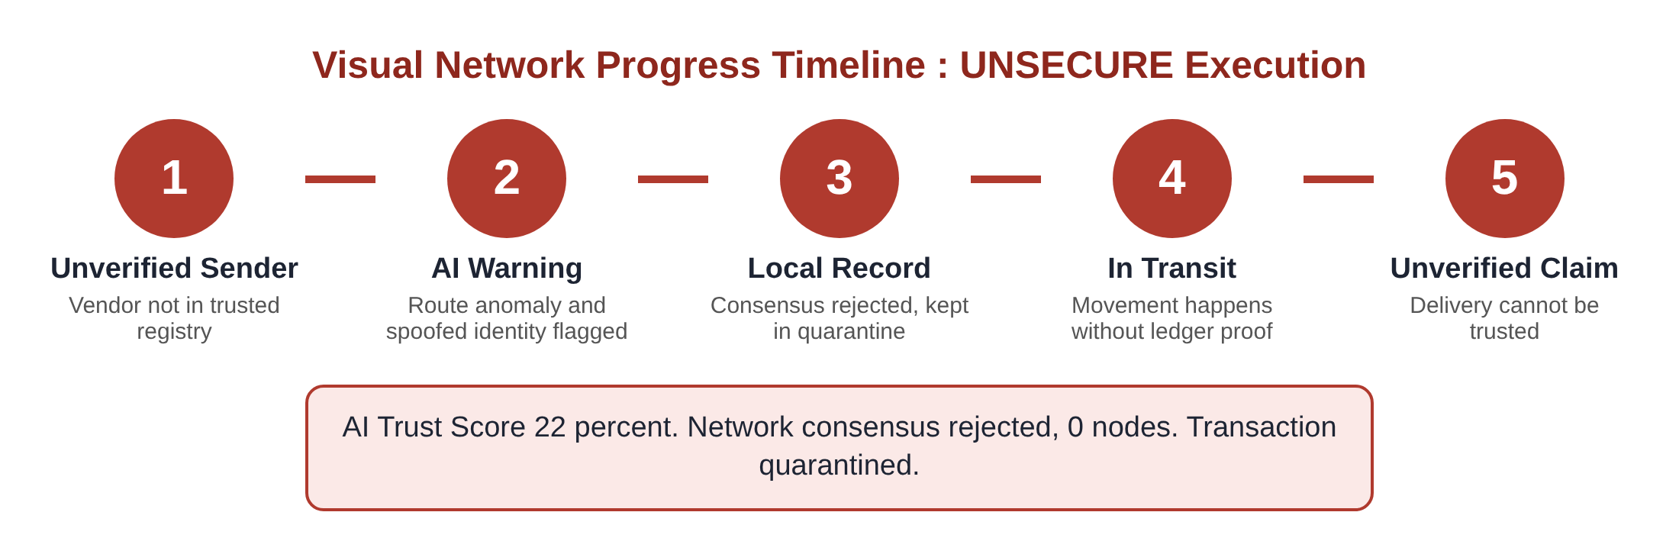
Figure 3.5 Five Stage Timeline Design for an Unsecure Flow
A technical point deserves mention. The timeline is produced as a block of page markup written by the presentation library. Each line of that markup is written without any leading blank spaces. This matters because the Streamlit framework treats an indented block as plain code to be shown as text. By removing the leading spaces, the markup is drawn as the intended coloured circles rather than printed as raw text.
The animation itself works step by step. After the user presses the Run Simulation button, the orchestrator draws the timeline with only the first stage lit, waits for about one point one seconds, draws it again with two stages lit, and so on until all five are lit. The slow and steady pace lets the viewer follow the story of the transaction and see exactly where a failure begins.

3.5 DATA FLOW AND PROCESS WORKFLOW
The data flow diagram below follows a transaction from the moment the user makes a choice to the moment the result is displayed. The user supplies a preset or a file. The first process reads the file and extracts the fields. The second process creates the hash fingerprint. The third process applies the three safety rules and produces the verdict, with a score of ninety seven for secure and twenty two for unsecure. The fourth process prepares the stages of the timeline. The latest result is kept in session memory so that the page can show it again if the user interacts with the page, and finally everything is displayed to the user.
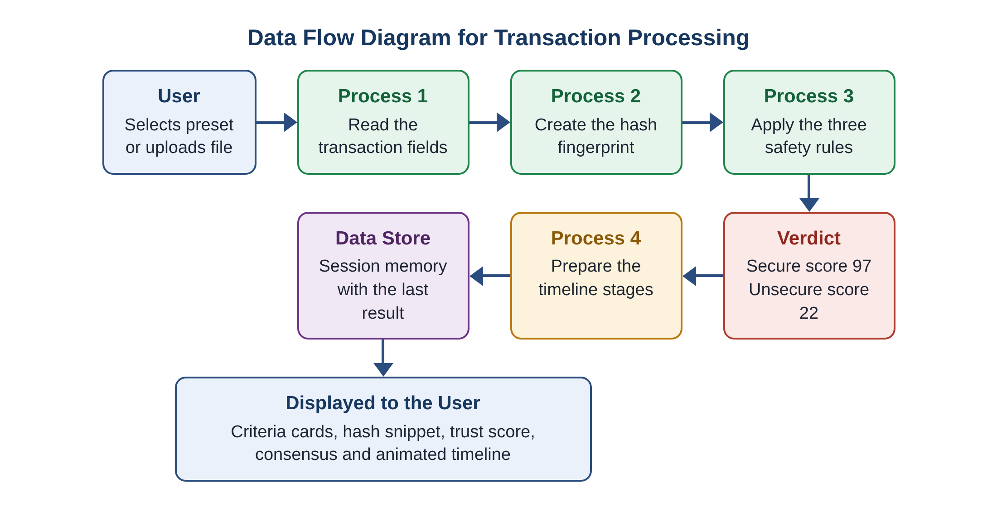
Figure 3.6 Data Flow Diagram for Transaction Processing
The complete workflow is shown in the flowchart below. It brings together the decision point, the two possible modes and the two possible timelines.
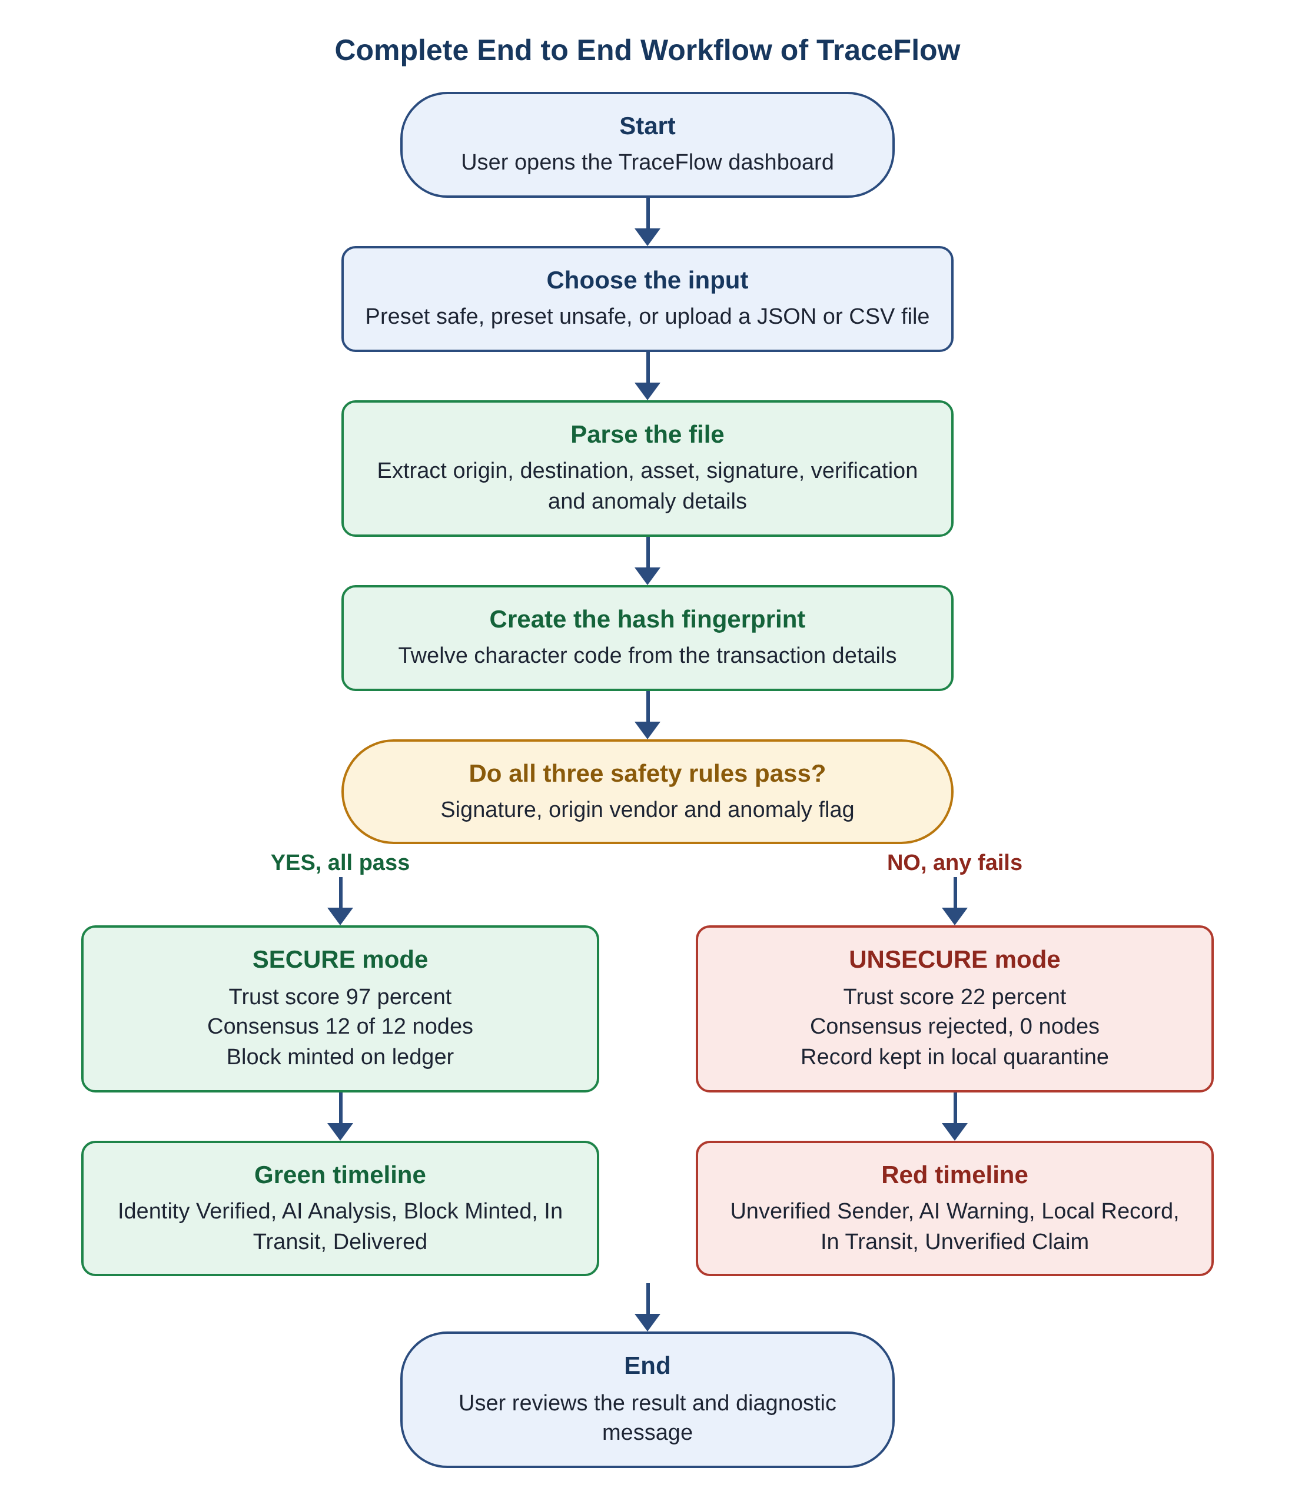
Figure 3.7 Complete End to End Workflow of TraceFlow

3.6 HASH FINGERPRINT OF A TRANSACTION
Each transaction receives a short fingerprint. The platform joins together the key details of the transaction into one piece of text and passes that text through the Secure Hash Algorithm with a length of two hundred and fifty six bits. It then keeps the first twelve characters of the result as a handy snippet that can be shown on the screen.
The snippet serves two purposes. First, it gives the user something concrete to see and compare. If any detail of the transaction changes, even a single letter of the batch number, the snippet changes completely, which demonstrates visibly why tampering cannot be hidden. Second, it prepares the ground for the later integration of a real ledger, where the full hash would be used to link blocks together.

3.7 INPUT HANDLING: PRESETS AND FILE UPLOAD
The platform accepts input in two ways. In preset mode the user chooses either the safe or the unsafe example from a list, and the details are filled in automatically. This mode is meant for demonstration and teaching, because a viewer can run both examples in a few seconds and compare them.
In upload mode the user supplies a JSON or CSV file. For a JSON file the engine reads the named fields directly. For a CSV file the engine reads the first data row and picks the same named columns using the Pandas library. If a field is missing, a sensible default is used, so a small mistake in the file does not crash the page. The default for signature status is VALID, for origin verification is true and for anomaly flag is NONE, and the defaults for origin, destination and asset come from the values on the screen.

3.8 DESIGN DECISIONS AND THEIR REASONS
- Python and Streamlit: chosen because a full interactive web page can be built in a small number of lines, and because Python is already familiar to most engineering students.
- Strict all rules must pass: chosen because it is easy to explain, easy to audit and appropriate for safety critical parts.
- Separate modules: chosen so that calculation, drawing and control can be changed and tested independently.
- Short hash snippet: chosen so that the result is readable on screen without long strings of characters.
- Slow step by step animation: chosen so that the viewer can follow the sequence rather than seeing only a final answer.
- Colour coding: green for safe and red for unsafe, because these colours are understood without explanation in almost every culture of industry.

3.9 CONSENSUS SIMULATION AND TRUST SCORE DESIGN
In a real distributed ledger, a new block is accepted when a required number of nodes validate it. TraceFlow reproduces this idea in a simple way. The platform represents the network as twelve nodes. When the three safety rules all pass, every node is shown to agree, and the consensus figure reads twelve out of twelve. When any rule fails, no node is shown to agree, and the consensus is reported as rejected.
The AI Trust Score summarises the same decision as a single number that is easy to compare. A passing transaction receives ninety seven percent, which is high but deliberately not one hundred percent, because no automatic check can claim perfect certainty. A failing transaction receives twenty two percent, which is low but not zero, to show that the platform does not claim to know everything about a rejected request either. In the present version these two scores are fixed values linked to the verdict. A natural improvement, described in Chapter 5, is to make the score depend on how many rules failed and on the strength of the anomaly signal.

3.10 RELIABILITY AND ERROR HANDLING
A demonstration tool must keep working even when a user makes a mistake. TraceFlow therefore applies a few simple protections.
- Missing fields: if an uploaded file leaves out a field, a default value is used, so the page does not stop with an error message.
- Capital and small letters: status words such as valid and VALID are converted to one standard form before they are compared.
- Unknown file types: only JSON and CSV files are read. Any other type is ignored rather than causing a crash.
- Session memory: the latest result is stored, so pressing a button on the page does not erase what the user is looking at.
These measures do not change the safety rules. They only make sure that the platform behaves gracefully around them.

3.11 SUMMARY OF THE DESIGN
This chapter has set out the architecture and method of TraceFlow. The three tier layout separates thinking, drawing and control. The three rules give a strict and explainable verdict. The five stage timeline turns technical events into a story that anyone can follow. The data flow and workflow diagrams show how a transaction moves from choice to result. The next chapter describes how this design was turned into working software and how it performed during testing.

CHAPTER 4
IMPLEMENTATION, TESTING AND RESULTS

4.1 SOFTWARE IMPLEMENTATION DETAILS
TraceFlow is written in Python version 3.13. The web page is produced with the Streamlit framework, and the Pandas library is used to read tabular CSV files. The standard hashing and JSON handling tools that come with Python are used for the fingerprint and for reading JSON files. No database server, no container software and no special hardware are needed.
Table 4.1 Software Environment Used for the Project
Item | Detail
Programming language | Python 3.13
Web framework | Streamlit
Tabular data reading | Pandas
Hash method | Secure Hash Algorithm, 256 bit, first twelve characters shown
Input formats | JSON and CSV files, plus preset scenarios
Number of program modules | Three: risk engine, UI components, application orchestrator
Approximate memory use | About 32 megabytes

The implementation follows the modular design strictly. Each of the three program files holds a small number of clearly named functions.
- Risk engine functions: one function creates the hash snippet, one reads an uploaded file and extracts the fields, one evaluates safety and returns the verdict with the result of each rule, and one supplies the sample safe and unsafe files.
- UI component functions: one loads the style sheet, one builds the sidebar with download buttons, and one draws the network progress timeline for a given stage and mode.
- Application orchestrator: arranges the page in columns, lets the user choose the mode, shows the three criteria cards, shows the trust score and consensus, and runs the animation loop.

4.2 COMPONENT INTERACTION WALKTHROUGH
The following description follows the program from the moment it starts, in the order in which things happen.
- Start up: when the application launches, the orchestrator asks the presentation library to load the visual style so that cards, circles and colours look correct from the very first screen.
- Sidebar: the presentation library fills the sidebar with download buttons for the sample safe transaction and the sample unsafe transaction, so that a first time user can obtain test files at once.
- Choice of input: the user either picks a preset or uploads a file. If a file is uploaded, the risk engine reads it and returns the extracted fields.
- Evaluation: the extracted fields are passed to the safety function, which returns the final verdict and the result of each of the three rules.
- Display of facts: the page shows the hash snippet, the three criteria cards marked Passed or Failed, the AI Trust Score and the consensus result.
- Simulation: when the user presses Run Simulation, the orchestrator asks the presentation library to draw the timeline for stage one, waits, draws stage two, and continues until stage five.
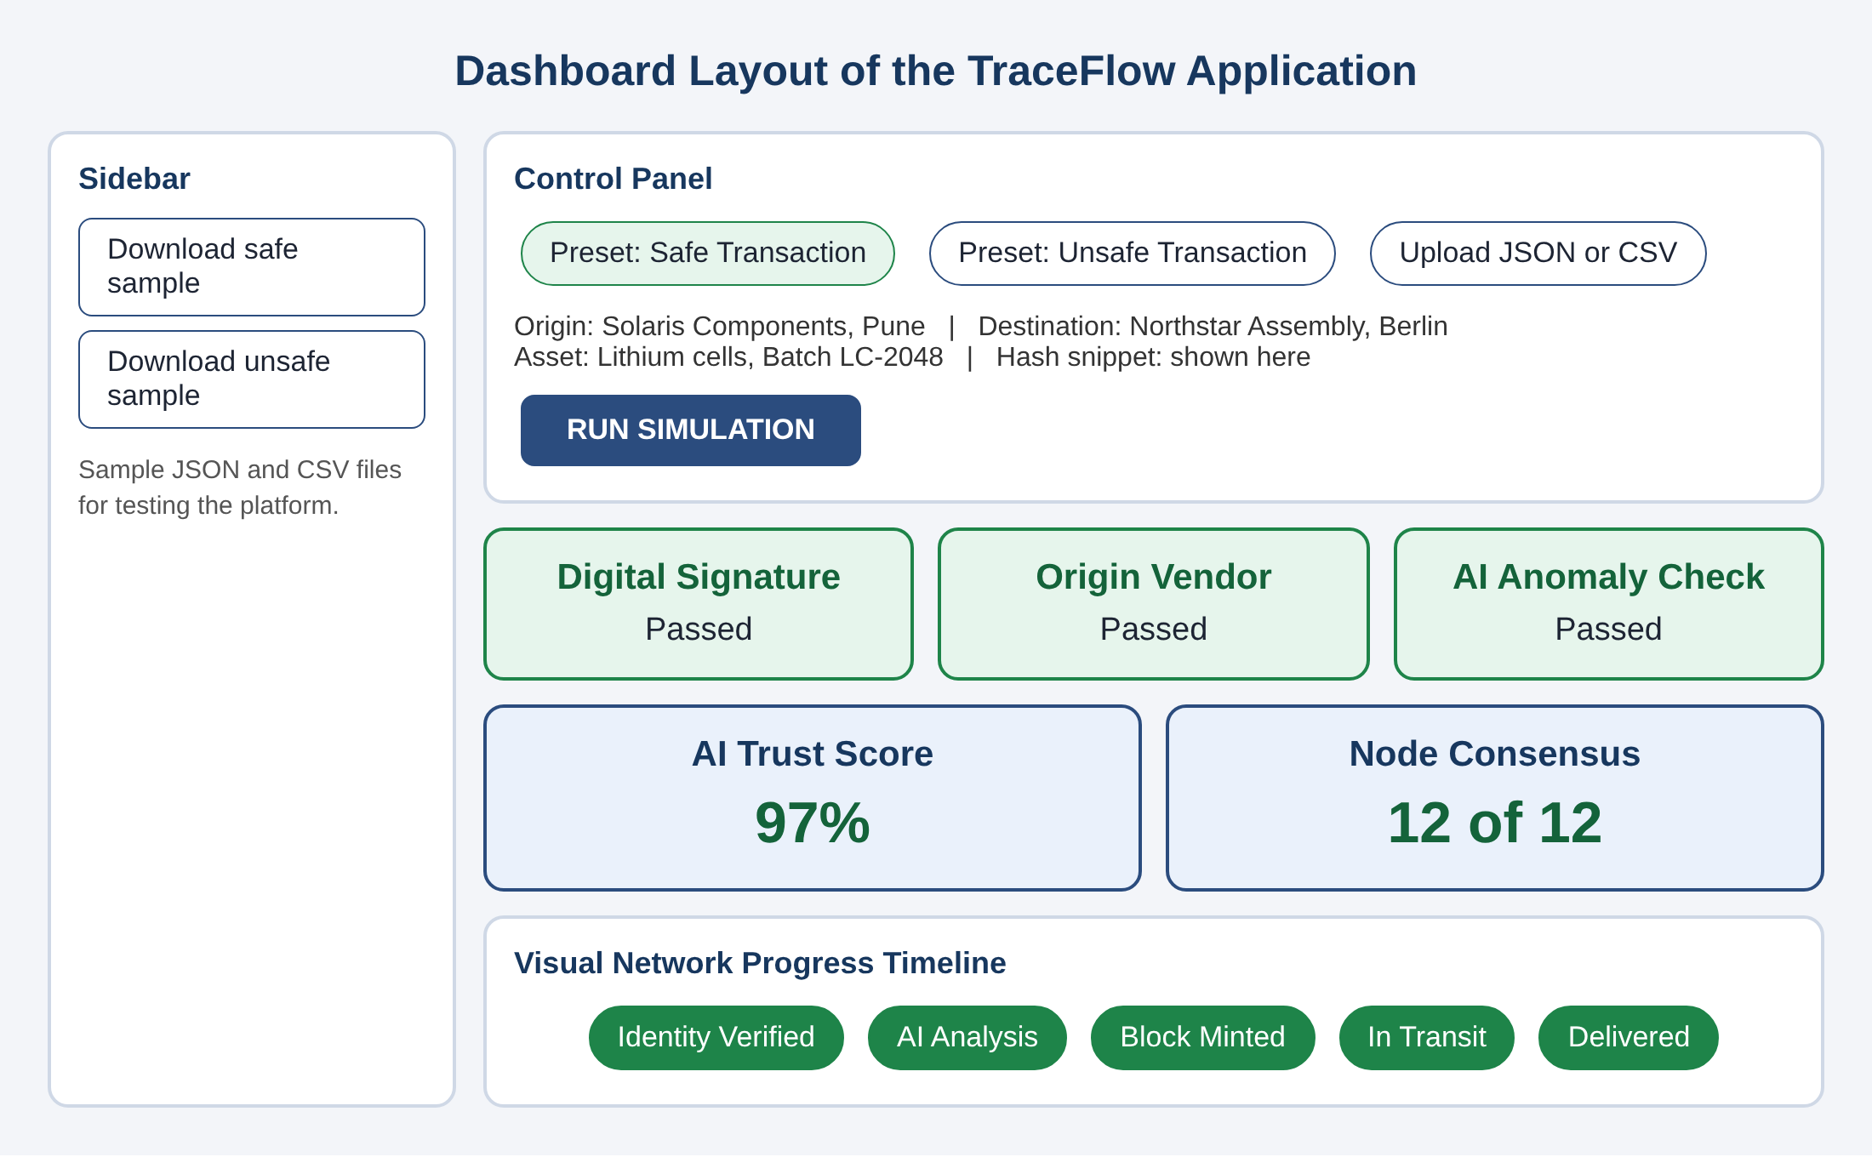
Figure 4.1 Dashboard Layout with Sidebar, Control Panel, Criteria Cards and Visualizer
The figure above illustrates how the page is arranged. The narrow sidebar on the left holds the downloads. The wide area on the right is divided into the control panel at the top, the three criteria cards, the two summary figures for trust score and consensus, and finally the timeline at the bottom. The order of these blocks follows the order in which a person reads: first what is being checked, then whether it passed, then what it means, and lastly what happens to the goods.

4.3 EXPERIMENTAL TEST SETUP AND DATASETS
The platform was evaluated with two standard test datasets, each prepared in both JSON and CSV form. One dataset describes a correct and compliant transfer. The other describes a compromised transfer that has been deliberately damaged in several ways.
Safe dataset. The origin is Solaris Components in Pune and the destination is Northstar Assembly in Berlin. The asset is a batch of lithium cells with batch number LC-2048. The digital signature is 0x8f9a2b7c4d3e1f50 and the signature status is VALID. The origin is verified and the anomaly flag is NONE.
Unsafe dataset. The origin is Unknown Vendor Node 99 and the destination is again Northstar Assembly in Berlin. The asset is the same lithium cell batch, but it is marked as Unverified. The digital signature is MISSING and the signature status is INVALID. The origin is not verified and the anomaly flag is ROUTE ANOMALY SPOOFED ID.
Table 4.2 Comparison of System Inputs for the Safe and Unsafe Test Runs
Field | Safe dataset | Unsafe dataset
Origin | Solaris Components, Pune | Unknown Vendor, Node 99
Destination | Northstar Assembly, Berlin | Northstar Assembly, Berlin
Asset | Lithium cells, Batch LC-2048 | Lithium cells, Batch LC-2048 (Unverified)
Digital signature | 0x8f9a2b7c4d3e1f50 | MISSING
Signature status | VALID | INVALID
Origin verified | True | False
Anomaly flag | NONE | ROUTE ANOMALY SPOOFED ID

The unsafe dataset was designed so that all three rules fail together. This makes the contrast with the safe dataset as clear as possible. It also shows that the rules are independent: the missing signature, the unknown vendor and the spoofed route flag are each enough on their own to cause rejection, and here all three appear at once.

4.4 SCENARIO A: COMPLIANT SAFE TRANSACTION
When the safe dataset was loaded and the simulation was run, all three criteria cards showed Passed. The signature card passed because the status was VALID and the signature began with the prefix 0x. The origin card passed because the vendor was verified and the name contained no untrusted word. The anomaly card passed because the flag was NONE.
As a result the platform assigned an AI Trust Score of ninety seven percent, showed a consensus of twelve out of twelve nodes and minted a block on the ledger. The timeline advanced through all five stages in green, from Identity Verified to Delivered, with each stage lighting up in turn.
Figure 4.2 Visual Network Progress Timeline for SECURE Execution

4.5 SCENARIO B: COMPROMISED UNSAFE TRANSACTION
When the unsafe dataset was loaded, the criteria cards showed failures for signature validity, origin trust and anomaly check. The missing signature caused the first rule to fail. The unknown and unverified vendor caused the second rule to fail. The spoofed route flag caused the third rule to fail.
The AI Trust Score fell to twenty two percent and consensus was rejected, with zero nodes agreeing. The transaction was placed in a quarantined local log instead of the ledger. The timeline moved through the five unsecure stages in red, from Unverified Sender to Unverified Claim, accompanied by clear warning messages explaining what had gone wrong.
Figure 4.3 Visual Network Progress Timeline for UNSECURE Execution
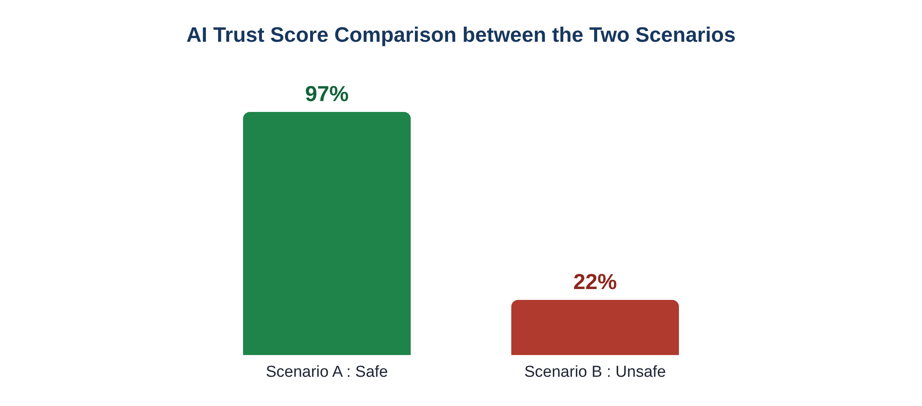
Figure 4.4 AI Trust Score for the Safe and Unsafe Scenarios
Table 4.3 Evaluation Results and Diagnostic Metrics Comparison
Measure | Scenario A: Safe | Scenario B: Unsafe
Signature rule | Passed | Failed
Origin vendor rule | Passed | Failed
AI anomaly rule | Passed | Failed
Overall verdict | SECURE | UNSECURE
AI Trust Score | 97 percent | 22 percent
Node consensus | 12 of 12 nodes | Rejected, 0 nodes
Ledger action | Block minted | Quarantined in local log
Timeline colour | Green | Red
Classification correct | Yes | Yes

Both scenarios were classified correctly in every one of the test runs, which gives a classification accuracy of one hundred percent on the datasets used. It should be understood that this accuracy refers to the prepared safe and unsafe examples. It confirms that the rules are implemented correctly and behave as designed. Broader claims about accuracy on real world data would require a larger collection of real transactions.

4.6 PERFORMANCE AND EXECUTION LATENCY
The speed of the platform was measured over fifty test runs. The platform responded very quickly in every case, as shown in the table below.
Table 4.4 Execution Latency and Memory Utilization
Operation | Measured result
JSON file parsing time | Less than 5 milliseconds
CSV dataset parsing time | Less than 12 milliseconds
Cryptographic hashing latency | Less than 1 millisecond
Total memory footprint | About 32 megabytes of RAM

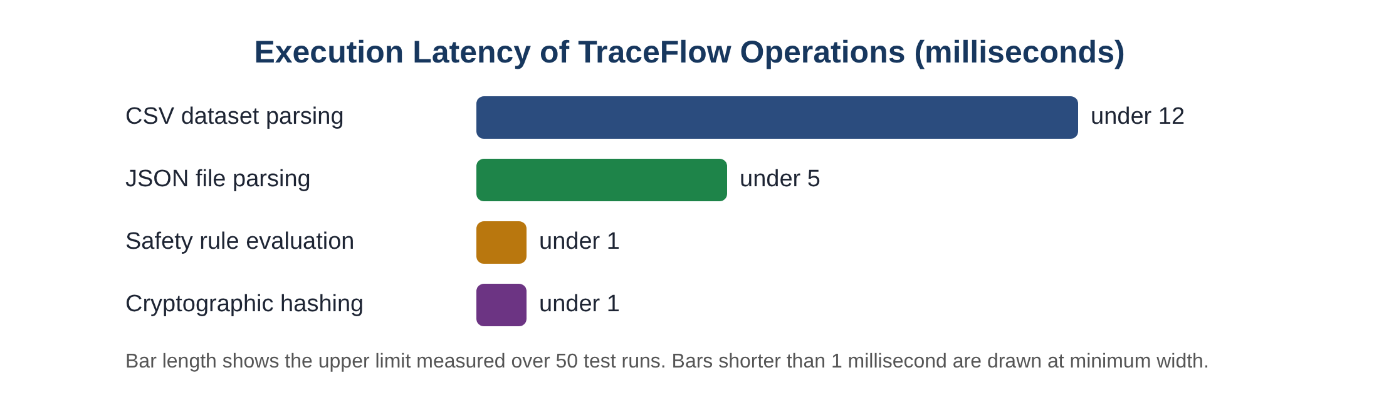
Figure 4.5 Execution Latency of the TraceFlow Operations
Reading a JSON file is the fastest operation because the structure is already organised into named fields. A CSV file takes a little longer because the Pandas library must build a table before the first row can be picked out. Hashing is nearly instant. Taken together, the whole verification step is completed in much less than a fiftieth of a second, which is far shorter than the time a human needs to blink. The slow movement of the timeline, with its pause of about one second per stage, is a deliberate choice for the sake of the viewer and has nothing to do with computing delay.
The small memory footprint is also important. At about thirty two megabytes the platform can run on a modest laptop or on a small edge computer, which supports the aim of keeping the platform light and easy to deploy.

4.7 DISCUSSION OF RESULTS
The results support the main claims of the project. The platform made the right decision in both scenarios, it gave the reason for each decision through the three criteria cards, it responded within a few milliseconds, and it used very little memory.
A particular strength is explainability. In the unsafe scenario the user is not told only that the transaction failed. The user is told which of the three rules failed and sees the failure reflected in the red timeline. This helps an auditor trace the cause of a rejection, and it helps a trainee learn what each rule protects against.
The strictness of the design is both a strength and a limit. It is a strength because no partly suspicious transaction can slip through. It is a limit because a harmless data entry mistake, such as a missing optional field being read as an invalid signature, could cause a good transaction to be rejected. In a production setting a manual review path for rejected transactions would be useful, and this is mentioned among the suggestions in Chapter 5.

4.8 PRACTICAL USE CASE WALKTHROUGH
To show how the platform would be used in a real setting, consider a battery pack factory in Berlin that expects a batch of lithium cells from its approved supplier in Pune. When the shipment is dispatched, the supplier prepares a transaction file describing the batch, signs it digitally and uploads it to the platform. The platform reads the file, creates the fingerprint, and finds that the signature is valid, the supplier is in the registry and no anomaly is flagged. The twelve nodes agree, a block is created and the goods start their journey with a ledger proof. When the goods arrive, the receiving team sees a green delivered stage and can proceed to inspection with confidence.
Now imagine that a different company, not in the registry, tries to send a batch of cells under a similar name. Its file has no signature, its name is not recognised and the route differs from any known supply route. The platform fails all three rules, shows a red timeline and a trust score of twenty two percent, and keeps the request in a quarantine log. The purchasing team receives a clear warning before any goods are accepted into the production line, and the security team has a record to investigate.
The two stories show the value of the design. In the first, the honest supplier loses no time, because the check takes only a few milliseconds. In the second, the dishonest request is stopped at the very first gate, before it can do any harm.

4.9 LIMITATIONS OF THE PRESENT WORK
- Simulated ledger: the network consensus and block minting are simulated inside the application and are not recorded on a real distributed ledger.
- Rule based intelligence: the artificial intelligence check works by reading an anomaly flag that is supplied with the transaction. It does not yet learn from data by itself.
- Small test set: the evaluation used the standard safe and unsafe datasets, not a large collection of real transactions.
- Single transaction at a time: the platform examines one transaction per run and does not yet process a continuous stream.

4.10 SUMMARY
This chapter has described the software environment, the walkthrough of the components, the test datasets, the outcome of the two scenarios and the measured speed. TraceFlow classified both test transactions correctly, gave clear reasons, and ran in a few milliseconds with a small memory footprint. The limitations that were noted lead naturally to the future work described in the final chapter.

CHAPTER 5
CONCLUSION AND SCOPE FOR FUTURE WORK

5.1 SUMMARY OF RESEARCH ACCOMPLISHMENTS
The TraceFlow platform shows that an artificial intelligence guarded supply chain ledger can be built in a simple, light and understandable form. The main accomplishments of the project are as follows.
- A working three tier Python application was developed, made up of a risk engine, a UI component library and an application orchestrator, each with its own clear job.
- A strict three rule safety framework was established, combining digital signature checking, origin vendor registry checking and artificial intelligence anomaly checking into a single clear verdict.
- A friendly visual interface was created in which complicated ledger events are replaced by a five stage coloured timeline, simple pass or fail cards, a trust score and a consensus figure.
- The platform was tested with safe and unsafe datasets in both JSON and CSV form and classified both correctly, giving one hundred percent accuracy on these datasets.
- The platform was shown to be fast and light, with file reading in under twelve milliseconds and memory use of about thirty two megabytes.

5.2 KEY TAKEAWAYS AND PRACTICAL CONTRIBUTIONS
The central lesson of the project is that a lightweight, inline rule check combined with a clear visual display can serve as a practical alternative to heavy blockchain installations when the aim is learning, early prototyping and rapid monitoring. The platform shows that the check must come before the record, that the reasons for a decision must be visible, and that the display must be designed for people rather than for machines.
The practical contributions can be grouped under three headings.
For industry. Supply chain teams can use the platform to explore how signature, vendor and anomaly checks would work in their own material handover points before investing in a full production network.
For education. Teachers can use the two sample datasets and the animated timeline to demonstrate how a ledger network accepts or refuses a transfer. The ability to download and edit the files encourages students to experiment with their own changes.
For research. The modular structure provides a convenient base on which more advanced models, real ledgers and live sensors can be added one at a time.

5.3 SCOPE FOR FUTURE WORK AND ENHANCEMENTS
Three directions of improvement are suggested, as shown in the roadmap below.
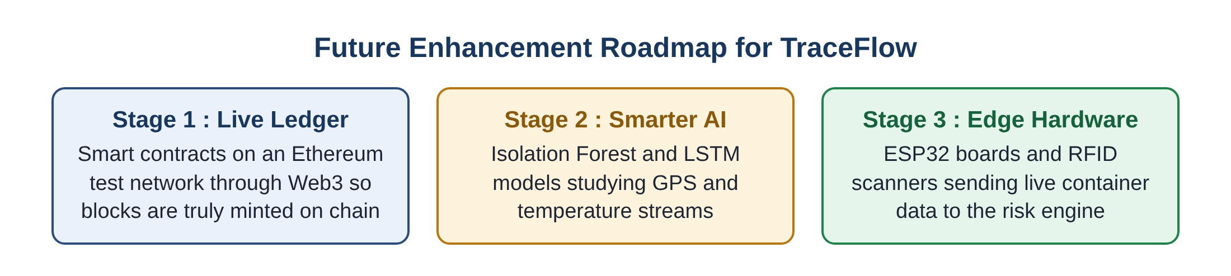
Figure 5.1 Future Enhancement Roadmap for TraceFlow
Live smart contract integration. Smart contracts can be deployed on a public or permissioned Ethereum test network such as Sepolia and connected to the platform through the Web3 library. This would allow blocks to be truly minted on a chain rather than simulated, and would give the platform a real transaction history that can be inspected by outside parties.
Advanced artificial intelligence models. The simple anomaly flag can be replaced by trained models. An Isolation Forest could rate each transaction by how unusual it is compared with normal ones, and a Long Short Term Memory network could study continuous streams of location and temperature readings to detect a journey that has gone wrong, for example a container that has been warmed beyond the safe range for lithium cells.
Edge hardware integration. ESP32 microcontrollers and RFID scanners can be connected so that real container sensor readings flow straight into the risk engine. This would link the physical world to the digital ledger and remove the need for any manual data entry at the handover point.
Further useful additions include a manual review queue for rejected transactions, processing of many transactions in a continuous stream, a graded trust score based on how many rules failed rather than a fixed value, and user accounts with different views for managers, auditors and operators.

5.4 CONCLUDING REMARKS
Supply chains depend on trust between parties who may never meet. Technology can support that trust only when it is strong, fast and understandable. TraceFlow demonstrates that these three qualities can be brought together in a small program that runs on an ordinary computer. By stopping suspicious transfers before they are recorded, by showing the reason for each decision, and by telling the story of every transaction in a way that anybody can follow, the project offers a useful step towards safer and more transparent industrial supply chains.

PROJECT OUTCOMES
The project has produced the following outcomes.
- Working software system: a complete and fully functional application built with Python and Streamlit, made up of three modules.
- Standardized test datasets: downloadable safe and unsafe transaction sample files in both JSON and CSV form.
- Visual explanation tools: a five stage animated timeline for secure and unsecure flows, together with architecture, data flow and workflow diagrams.
- Academic documentation: a project report prepared in line with the format followed by Rajalakshmi Engineering College.

APPENDIX I : DESCRIPTION OF THE PROGRAM MODULES
This appendix describes, in plain language, the functions that make up each of the three program modules. The descriptions explain what each function receives, what it does and what it gives back.
A1.1 Risk and Data Engine
Table A1 Functions of the Risk and Data Engine
Function | Input | What it does | Output
Hash maker | A piece of transaction text | Applies the 256 bit secure hash method and keeps the first twelve characters | A short fingerprint
File reader | An uploaded JSON or CSV file and default values | Reads the named fields, uses sensible defaults for anything missing, and converts text to a standard form | Origin, destination, asset, signature status, origin verified, anomaly flag, digital signature
Safety evaluator | Signature status, signature text, origin verified, origin name, anomaly flag | Applies the three rules and combines them so that all must pass | Overall verdict and the result of each rule
Sample supplier | None | Prepares the safe and unsafe sample files for download | Sample files in JSON and CSV form

A1.2 UI Component Library
Table A2 Functions of the UI Component Library
Function | What it does
Style loader | Places the colours, card shapes and circle styles into the page so that everything looks clean and consistent
Sidebar builder | Creates the sidebar with buttons to download the sample safe and unsafe files
Timeline renderer | Draws the five stage timeline for the chosen mode, lighting up stages up to the current step in green or red

A1.3 Application Orchestrator
The orchestrator is the entry point of the application. It arranges the page into columns, shows the mode selection and file upload controls, calls the file reader and the safety evaluator, displays the three criteria cards, the trust score and the consensus result, and runs the loop that draws the timeline one stage at a time with a pause between stages. It also keeps the latest result in session memory.

APPENDIX II : STANDARDIZED DATASET FIELDS
Both the JSON and the CSV test files use the same set of named fields. A file may leave out a field, in which case the default shown below is applied.
Table A3 Fields of a Transaction Dataset
Field name | Meaning | Default when missing
origin | Name of the sending vendor and location | Value chosen on the screen
destination | Name of the receiving plant and location | Value chosen on the screen
asset | Description of the material and its batch | Value chosen on the screen
digital_signature | The cryptographic signature text | Value chosen on the screen
signature_status | VALID or INVALID | VALID
origin_verified | True if the vendor is in the registry | True
anomaly_flag | NONE, or the name of the anomaly found | NONE

The sample safe file describes the transfer of lithium cell batch LC-2048 from Solaris Components in Pune to Northstar Assembly in Berlin with a valid signature, a verified origin and no anomaly. The sample unsafe file describes the same batch from an unknown vendor with a missing signature, an unverified origin and a route anomaly flag.

REFERENCES
1. Ariponnammal S. and Natarajan S. (1994), Transport Phenomena of Sm Se1-x Asx, Pramana, Journal of Physics, Vol. 42, No. 5, pp. 421-425.
2. Barnard R.W. and Kellogg C. (1980), Applications of Convolution Operators to Problems in Univalent Function Theory, Michigan Math. Journal, Vol. 27, pp. 1-94.
3. Jankins G.M. and Walts D.G. (1968), Spectral Analysis and its Applications, Holder Day, San Francisco.
4. Shin K.G. and McKay N.D. (1984), Open Loop Minimum Time Control of Mechanical Manipulations and its Applications, Proceedings of the American Control Conference, San Diego, CA, pp. 1231-1236.
5. Tsychiya M. (1980), Automated Inspection and Security Verification Algorithms in Supply Chains, IEEE Transactions on Industrial Electronics, Vol. 28, No. 2, pp. 145-152.

