Objective: To test basic programming knowledge (conditional constructs , loop etc) and collections. Implement all possible conditions.

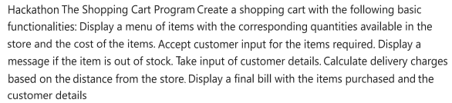

Question:

For delivery charges

If upto 15 km then 50 Rs

If 15 to 30 km then 100 rs

Create a console application for shopping cart program

Sample screen shot for reference. You are allowed to do slight modifications and additions to given requirements

**Development :**

Created an python class with hardcoded data set and applied the business logic based on different conditions that match all possible scenario

Sample Data Set :

"Biscuits": {"price": 1.50, "quantity": 5},  
"Cereals": {"price": 5.0, "quantity": 10},  
"Chicken": {"price": 80.0, "quantity": 20}

**Unit Testing Screen Shots**

**Case 1:**

Valid Scenario where all the three items matches with existing data

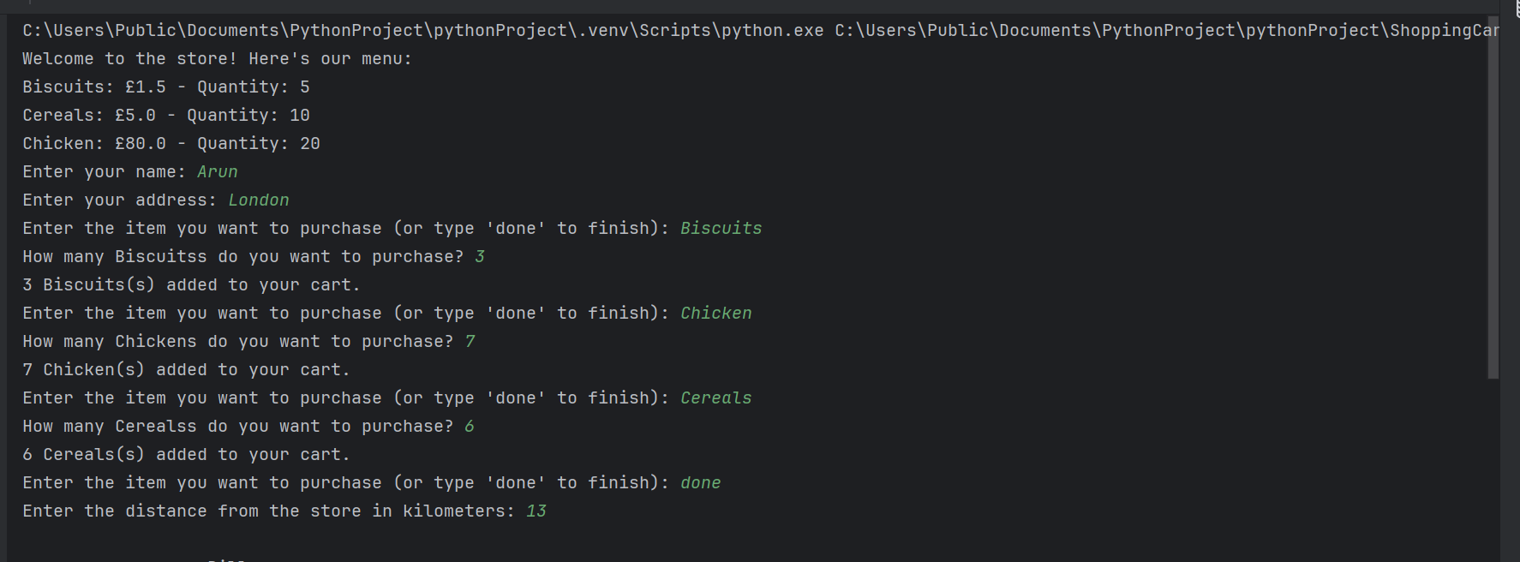

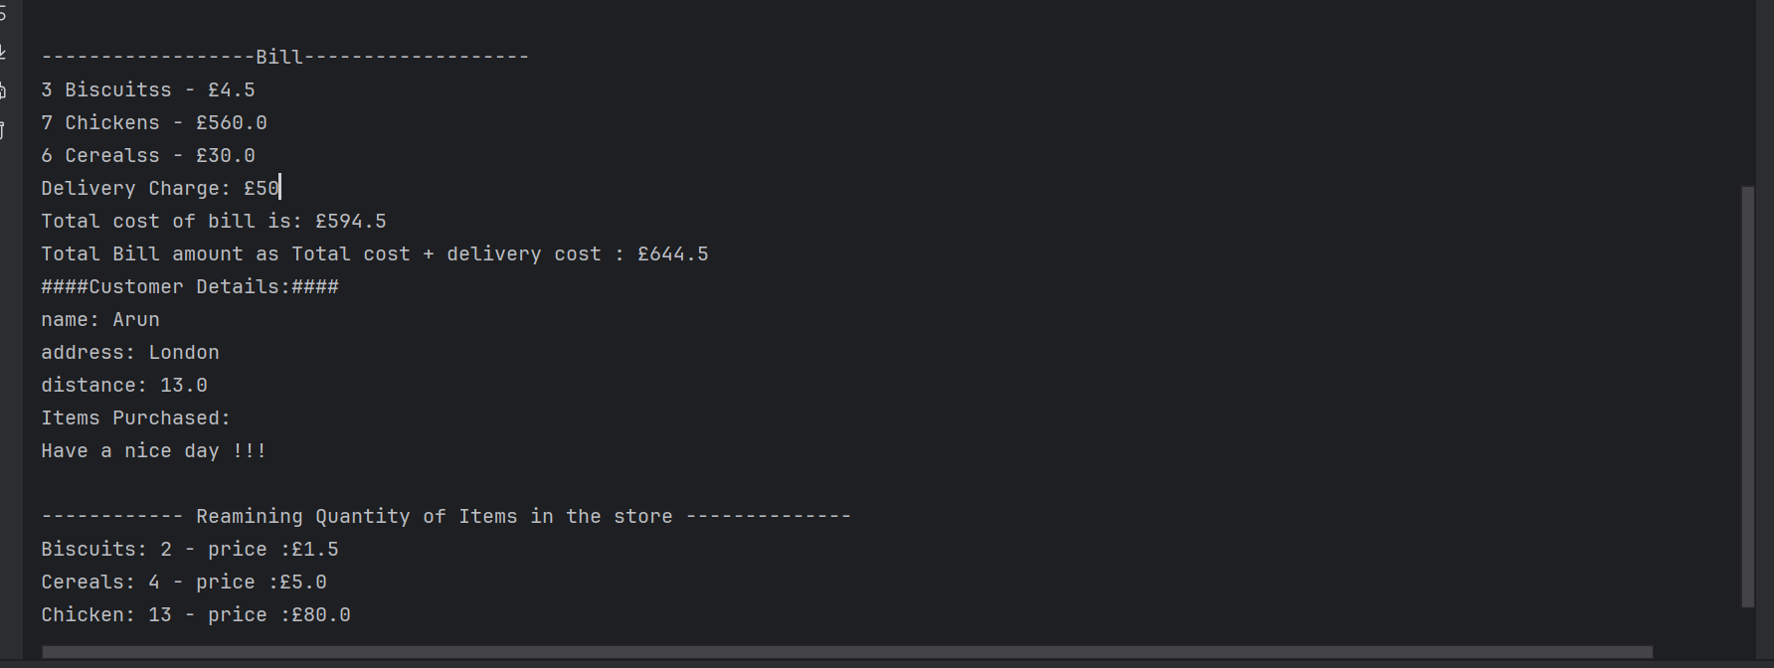

**Case 2 :**

**Where if we have deliver beyond 30 km and include outs of stock of existing items**

