**UNIT – 1**

**INTRODUCTION TO WIRELESS COMMUNICATION**

**WIRELESS COMMUNICATION**

Wireless communication involves transmitting information over a distance without the help of wires, cables, or any other form of electrical conductors. It is a type of communication that uses electromagnetic waves as a communication medium to transmit and receive signals (data signals and voice signals).

**APPLICATIONS OF WIRELESS COMMUNICATION**

1. Television and Radio Broadcasting
2. Satellite communications
3. Wi-fi
4. GPS (Global Positioning System)
5. Bluetooth
6. Mobile communications.
7. Paging
8. RADAR (Radio Detection and Ranging)
9. RFID (Radio-Frequency Identification)
10. Security Systems

**ADVANTAGES OF WIRELESS COMMUNICATION**

1. **Cost -** The cost of installing wires cables or other infrastructure is eliminated in wireless communications, reducing the overall cost of the system as compared to wired communication systems.
2. **Mobility –** It is the main advantage of wireless communication systems. It offers the freedom to move around while still connected to the network.
3. **Easy to install –** The setup andinstallationof wireless communication network equipment and infrastructure is very easy as compared to wired communication systems. The time required to set up and install a wireless communication system like a wi-fi network is much less when compared to setting up a full cable network.
4. **Reliability –** Since there are no cables and wires involved in wireless communication there is no chance of communication failure due to the damage to the cables which may be caused by environmental conditions.
5. **Disaster Recovery –** In case of an accident due to fire, flood, or other disasters the loss of communication infrastructure in wireless communications systems can be minimised.

**DISADVANTAGES OF WIRELESS COMMUNICATION**

1. **Interference -** Wireless communication systems use open space as the medium for transmitting signals as a result, there is a huge chance that radio signals from one wireless communication system or network might interfere with other signals. The best example is Bluetooth and wi-fi, both these technologies use the 2.4 GHz frequency for communication and when both devices are active at the same time then there is a chance of interference.
2. **Security –** One of the main concerns of wireless communication is the security of the data since the signals are transmitted over the open space, it is possible that anyone can interpret the signal and copy the sensitive information.
3. **Health concern –** Continuous exposure to any type of radiation is harmful, so it is advised to avoid radiofrequency radiation to the maximum extent possible.

**BASIC ELEMENTS OF WIRELESS COMMUNICATION**

A wireless communication system can be divided into three elements –

1. Transmitter End
2. Wireless Channel
3. Receiver End

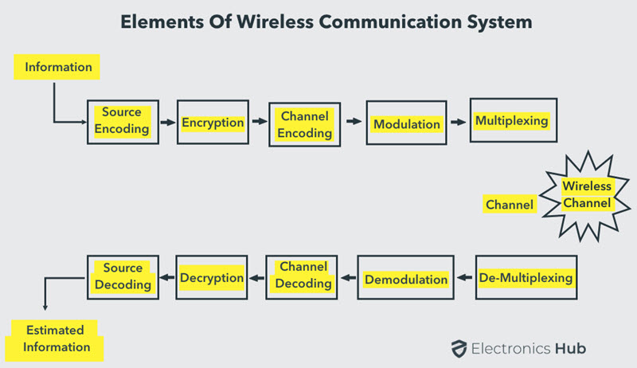

1. **Transmitter End –** The transmission end of a wireless communication system consists of –
2. **Source Encoder –** The signal from the source is passed through a source encoder which converts the signal into a suitable form for applying signal processing techniques. It is a device that compresses the data provided by the information source to reduce the amount of data to be transmitted by removing the redundancies of the data.
3. **Encryption –** This technique is used to secure the information and does not allow any unauthorized access to the data.
4. **Channel Encoding –** It is a technique that is applied to the signal to reduce the impairments like noise and interference etc. During this process, a small amount of redundancy is introduced to the signal so that it becomes powerful against noise.
5. **Modulation –** It is a device that converts the coded message into a signal so that it can be transmitted through the communication channel. It converts digital data into analogue signals.
6. **Multiplexer –** It is a device that allows multiple signals to share a single transmission line by combining them into a single composite signal.
7. **Antenna -** An antenna on the transmitter end is a crucial component in wireless communication systems. Its primary function is to convert electrical signals into electromagnetic waves, which can then propagate through the air and be received by another antenna, typically located on the receiver end.
8. **Wireless Channel –** It is a medium that carries the signal, **or** it is the medium through which the signal travels. It can be air, water or any other medium that allows the signal to propagate.
9. **Receiver Side –** The job of the receiver is to collect the signal from the channel and reproduce it as the source signal. The receiver path of wireless communication comprises of receiving antenna, demultiplexer, demodulator, channel decoder, decryption, and source decoder.From the component of the receiver path, the task of the receiver side is just the reverse of the transmitter.

The signal from the channel is received by the demultiplexer through the receiving antenna. Here it is separated from the other signals. The individual signals are demodulated using demodulation techniques and the original message signal is recovered. The redundant bits from the message are removed using the channel decoder. Since the message is encrypted, decryption of the signal removes the security and turns it into a simple sequence of bits. Finally, this signal is given to the source decoder to get back the original transmitted message.