**UNIT – 2**

**DATABASE SYSTEMS CONCEPTS AND ARCHITECTURE**

**DATA MODELS**

Data models give us an idea of how the final system will look after completion. It defines the data elements and the relationship between them. Data models represent how data is stored, connected, accessed, and updated in the DBMS. A set of symbols and text are used to represent the information so that members of the organisation can communicate and understand it. There are many data models, but the relational model is the most widely used data model. Some of the data models include -

1. **Hierarchical Model –** It was the first DBMS model. It organises data in a hierarchical tree-like structure. The hierarchy starts from the root which has the root data and then it expands in the form of a tree-like structure by adding a child node to the parent node. For example, we can represent the relationship between the shoes on a shopping website in the following way –

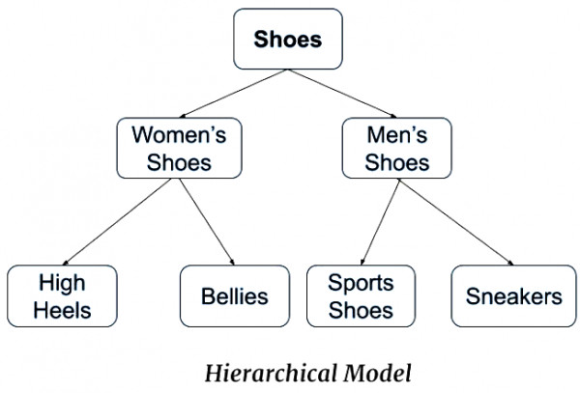

**SCHEMAS**

It is the overall description of the architecture of the database. Schema is the basic structure of the database which describes **“How data will be stored in the database”**. There are three types of schemas:

1. **Logical schema -** It describes the database design at the logical level.
2. **Physical schema –** It describes the database design at the physical level.
3. **View level schema -** It describes the database design at the view level.

**INSTANCES**

It is the collection of the information stored in the database at a particular moment.

**SCHEMAS V/S INSTANCES**

|  |  |  |
| --- | --- | --- |
|  | **SCHEMAS** | **INSTANCES** |
| **1.** | It is the overall description of the database. | It is the collection of information stored in the database at a particular moment. |
| **2.** | The schema is the same for the whole database. | Instances will be different such as insertion, deletion and Updation etc. |
| **3.** | It does not change frequently. | It changes frequently. |

**ANSI-SPARC ARCHITECTURE OF A DATABASE SYSTEM**

* In 1975 ANSI-SPARC (American National Standards Institute, Standards Planning and Requirements Committee) realised the need for a three-level architecture approach having an external level, conceptual level, and internal level.
* The purpose of this architecture is to separate each user's view of the database from the way it is physically represented. The three levels of the ANSI-SPARC model are shown in the figure below:

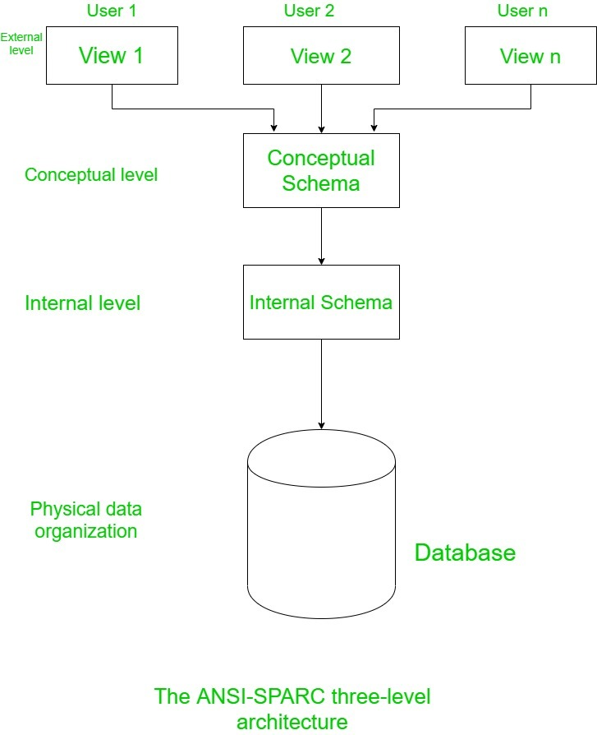

1. **External level**

* It is the view about, **“how users view the database”.**
* Data from the database which is relevant to the users is described at this level.
* This level consists of various views of the database.
* In this view, only required entities, attributes and relationships are included which are required by the user.
* The different views have different ways to represent the same data.
* For example, one user may view the name in the form as first name and last name and the second user may view the name in the form as last name and first name.

1. **Conceptual level** 
   * It is the community view of the database.
   * It describes **“but data is to be stored in the database”.**
   * This level represents the entities, attributes, and their relationship.
   * This level contains the logical structure of the entire database, and it represents the complete view of the database that organisations demand irrespective of the storage consideration.
2. **Internal level**

* At this level, the **“database is represented** **physically”** on the computer.
* It emphasises the physical implementation of the database to do storage space utilization and to achieve optimal (max) run time performance and data encryption techniques.
* This level interfaces with the Operating System to place data on storage and to retrieve the data.