123I need to build an ATS & CRM integration system with below features -

my company's structure: it's has 3 departments: Administration, Recruitment, and Sales with around 20 users (3 Login)

About the company structure and features of each login:

- Benefits of Associates: Different commissions for job offers -> The job board should show different commission rates of the hiring jobs

- Benefits of Full-time: Fixed salary + fixed commission rates of revenue (agreed outside) -> The job board don’t need to show commission for this kind of recruiter. Do you have any suggestion for me??

- Benefits of sales: fixed salary + commission of revenue (Agreed outside)

Other features are the same for both types of recruiters. When I post a new job, it’s visible for all recruiters. But before I click to “post” button, I would like to have another step to manually input commission rate for Associates.

Regarding the ATS features, it will display job lists from different clients, recruiters can submit candidates for each job and track their own candidates. When a recruiter submit an application (application means each candidate's application referred by the recruiter), it's automatically assigned to "Yet to process" status. only admin can change status.

ATS features are accessible by recruiters and admin (recruiters can only submit applications and access to their own candidates' data. Admin or sales will upload new jobs and clients' profile).

A recruiter can only access and track his candidates’ data. A sales executive can only access and track his client’s data.

I will be an admin to receive new applications every day, and process, change status for each application  
  
Regarding CRM, it's accessible by the admin and the sales executive, it shows client data we upload and show the status of each client. I would like to set featured image for each client’s profile. When I post a job, I can select the client’s profile for that job (the client can be under any status in the CRM). I can post a new job without a client’s profile as well.  
  
the sales executive can create new client profile, track job list of their own clients, know how many applications are processing for each job, but can't access to candidates' data (Clients don't need to access the webapp, the admin and saleswill upload client's profile) - job post mean the hiring jobs in my client's companies, and assigned for the recruiters to find talents

the sales executive can create new client profile, track job list, know how many applications are processing for each job, but can't access to candidates' data

The common features that all departments can use are: see jobs on the job board, processing applications for each job, job description for each job  
  
**this web app is not for candidates, it's an internal system for my company, candidates will contact recruiters, and recruiters submit new applications**

For Jobs, status are: Open/ Pending/ Closed/Hiden

If a job is under “hiden”, it’s only visible by the admin

If a job is under “open/pending/closed”, it’s visible by all logins

The admin can remove a job from the job board, then it doesn’t exist on the system anymore.

The recruiters can NOT change anything related to the job board

Each sales can just track the job and status of the jobs that are from their own clients. They can’t see the hiring jobs or clients from other sales executives.

In other words, each sales executive has their client data, and only track their own data.

For applications, status are: Yet to process/ Ready to submit/Under review/ Interview/Offered/Rejected/Under guarantee/ Expired.

For clients, status are: Prospects/Contacted/Negotiating/Ready to sign/Signed/ Rejected

Need CRM like below –

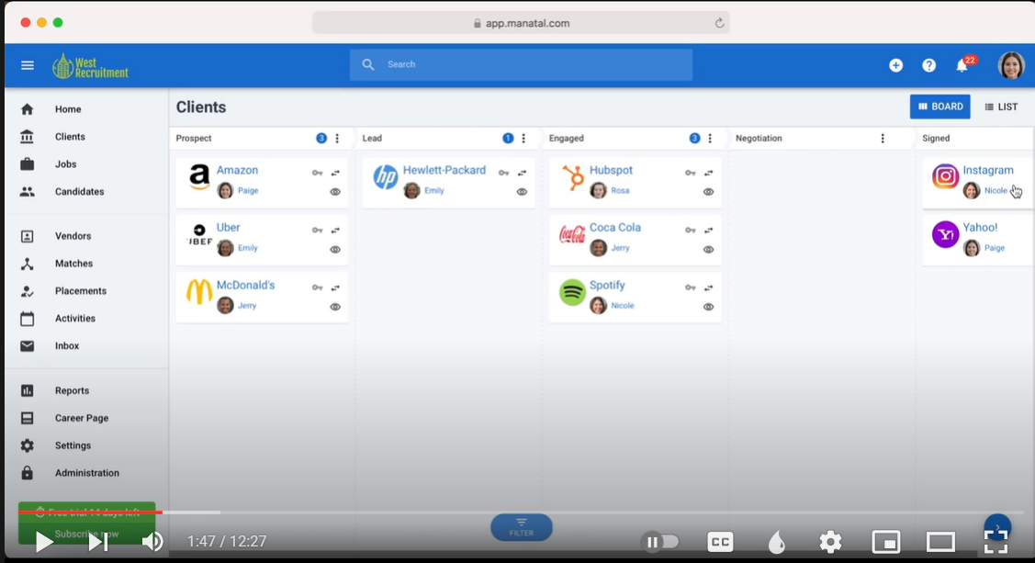

the job list that client will assign to the recruiter team is as below -   
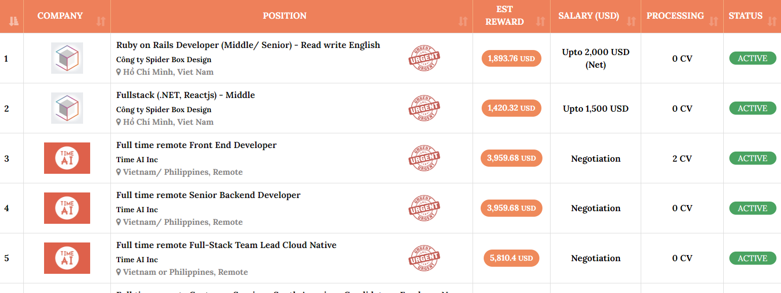

The location & job type information below each job title is input manually by admin.The admin can put “priority” label for the jobs that are urgent.

This is the information required when the recruiters submit applications -

<https://forms.zohopublic.com/globhunter/form/ReferralForm/formperma/qgoYbhdp6EOd5UhM021g9_S9HICP0O8aAInGQX8HvFQ>

Submit application form:

- Candidate’s full-name

- Email

- Phone number

- Nationality

- Current Location (Country)

- Linkedin profile

- Applied job code

- Applied job title

- Resume (need to limit data size when uploading resume). (Resume can be seen by the admin in a new tab without downloading)

- Portfolio (if have)

- Answers to screening questions & Notes

The recruiters can NOT edit application after submitting, but the admin can do it.

Also, the job list should display commission for each job. But my recruiter team has 2 kinds of recruiters: internal and external where Commission for 2 kinds are also different which is already decided by the admin client who will calculate offline and note on the system where client need a parameter to upload and note on the system.

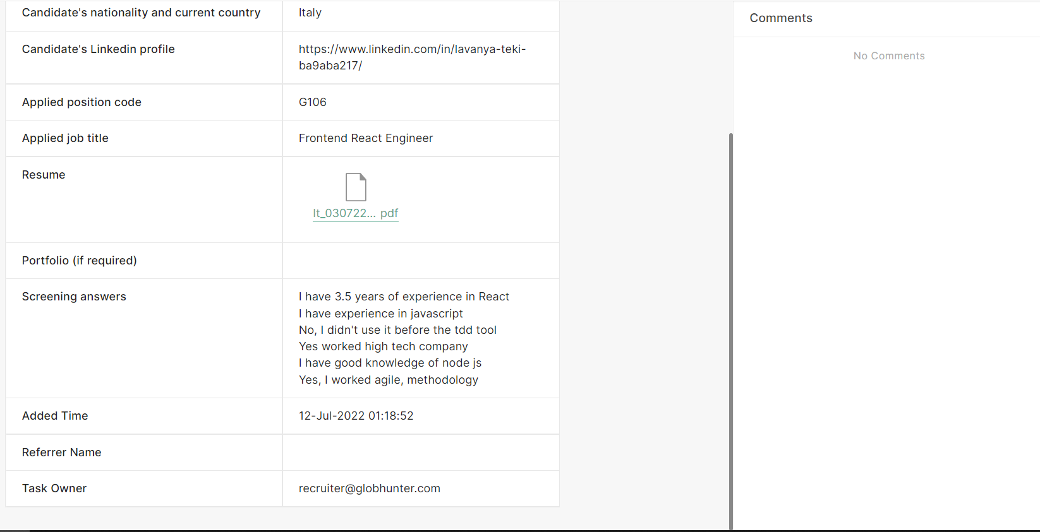

The note box is on the right hand side, used by admin because the admin will note the processing updates of each application on that note box. For the sales accounts, there will be note boxes for each client’ profile also, for sales executive to note anything during the customer acquisition.

Each job should include the client's informations, job description, commission, location, job type, salary

the client profile and logo on each job will be added manually by the admin, it's not needed to be synchronize with the client's profile of Sales login.

To summarize the functions of 3 logins, here are some bullets:

- Recruiter: access job board, see each job details, see how many PROCESSING APPLICATION of each job, submit applications, track their own application, get notifications if there is any update

- Sales: upload new clients, track current client profiles, see job of their clients, see how many processing application of each job, see how many offer of their client (because they get commission when we have offers), get notification if there is any updates

- Admin: admin have all functions of the 2 above logins (can work as a recruiter & sales executive as well), besides, admin can manage all accounts, change status of application, access to all clients on the systems, create accounts and profiles for each employee, note on each application, edit information of each candidate, post new jobs, set status of jobs, etc

Additional features of the ATS & CRM system:

1. Admin can create new accounts and also remove accounts when needed. When admin remove accounts, the profile of this employee will disappear but the related information such as: application, clients, history in general still exists and can be tracked.

2. The existing jobs are set under “Open/Pending/Hiden/Closed” status. One existing job only disappears when the admin remove one job, it will disappear, but the referral history of this job or client name is still be tracked and seen.

3. Ring button

Each login have a ring button on the top right hand side. The ring button will show how many notifications of each account are unread.

Recruiters get notifications when:

- A new job is posted

- A job is changed status by the admin (open/pending/closed)

- A candidate of them is changed status by admin. When clicking on this notification, they can see why that candidate is changed status, for ex. The reason why the candidate is rejected.

Sales get notification when:

- A candidate submitted to their own clients has been changed status into “Offered/Under guarantee/ Expired” and “Rejected” if this candidate has been under “Offered/Under guarantee” before

- A new job from their clients has been posted.

Admin get notifications when:

- A client profile has been created by sales

- Sales executives change the status of their clients

1. Accounts / Employees’ profile

Each profile has

- The employee’s full-name

- Title (position), for ex: Associate, Full-time recruiter, Account Manager (Account Manager = Sales Executive).

- Nationality/Current country

- Email

- Phone number

- Benefits

- A note box to record payment infor

All above information is input manually by the admin

1. Client’s profile on CRM

- Client’s logo

- Website

- Tax ID

- Owner of the client (I mean sales executive or admin)

- Industry

- Officer infor (this is information about the person I work with at that company client. It includes: Name, position, email, prefer contact)

- Fee

- Payment infor

- Offices

- A note box to record the history of customer acquisition.

1. Left-hand side part of the interface

Recruiter accounts:

- “Job board” (show jobs under “Open/Pending/Closed”)

- “My profile” (to show personal info, and check if their profile and infor created by the admin are true or false)

- “My referral history” (show their referral history and track their candidate’s status). The recruiter can NOT remove an application. Only admin can do it.

- “Terms”

- “Materials”

Sales accounts:

- “My clients”: CRM

- “My job” (show hiring jobs from their clients, including: job title, job location, salary, job status, the amounts of processing application . It’s just a list of jobs, not necessary to click on to get job details)

- “Commission history” (show the offered jobs and candidate names that are under “Offered/Under guarantee/Expired”

- “My profile”

- “Terms”

- “Materials”

Admin account:

- “Job board” (show jobs under Open/Pending/Hiden/Closed status)

- “All clients” (All clients uploaded to the CRM, from all sales executive) (it shows which sales executive one client is from)

- “My clients” (shows clients of the admin, because, the admin also work as a sales)

- “Referral history” (this is the main ATS feature, shows referral history of all recruiters including admin as a recruiter, the admin will change status of applications here, click on each application to note/edit any info)

- “Terms”

- “Material”

- “Employees”: to manage all accounts, create/edit profiles for each employees

“Terms” & “Materials” are like 2 pages of open website, where the admin post/note any information, and other accounts can see it and read

1. Filters

Where to put filters:

- “Referral history”: for recruiters & admins to search applications by clients’ name, candidates’ name, job titles

- “Job board”: for recruiters & admin to search job by job titles, clients’ name, location,

- “My clients”: for sales and admin to search by clients’ name, status

- “All clients”: for admin to seach by clients’ name, sales executive’s name, status

1. About “Referral history”

It categorizes candidates in status: “

Interface Sample: Job description of each job (will be shown when clicking on job title of the job list)

