VPC created with 10.0.0.0/23

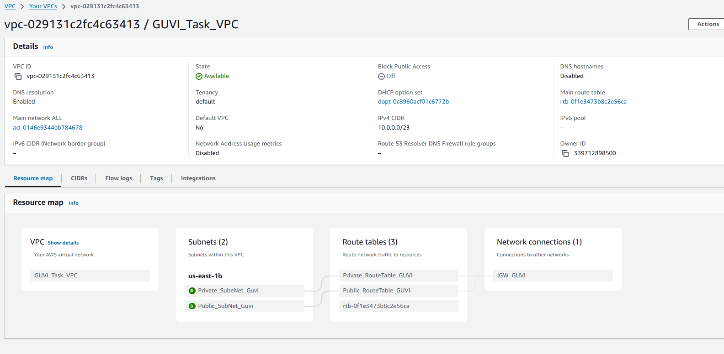

Public subnet with 10.0.0.0/24

Private Subnet with 10.0.1.0/24

Public and Private security group created

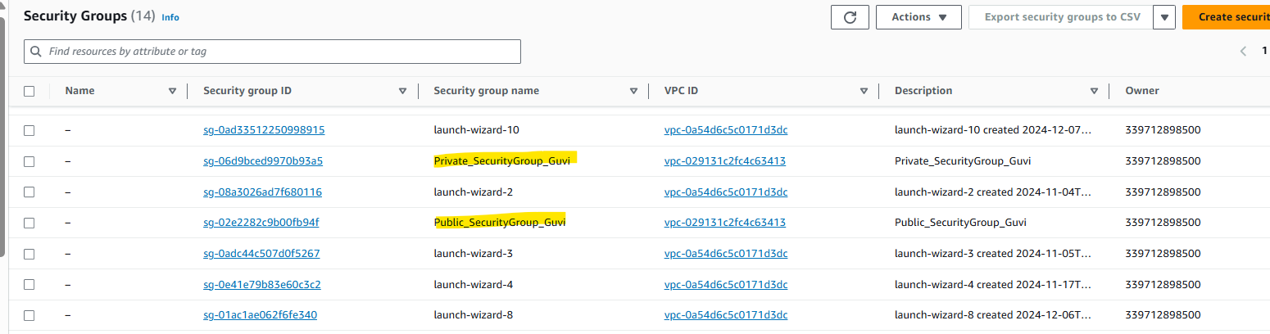

Instances

Private instance with no public IP

