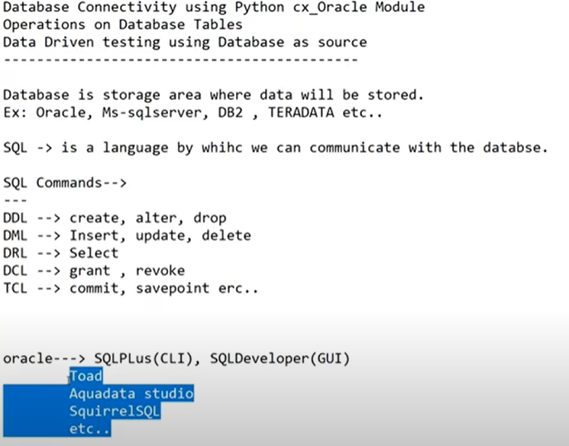

* Try to install Oracle Database by going through some online steps.
* Need to install Oracle Instant Client as per the operating system and python whether 32 or 64-bit

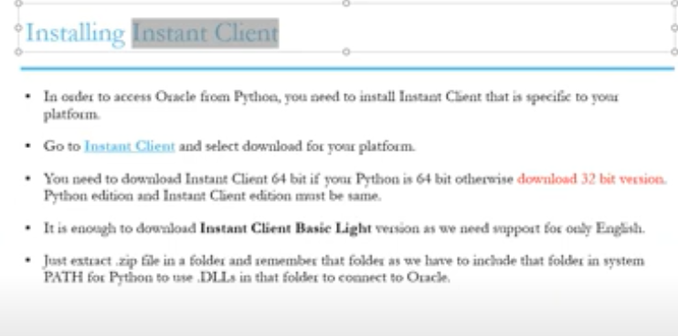

* Add the Instant client extracted folder path to the environment variable.