Schemas:

Schemas are like the header (column names) for that particular table.

All the records have to follow that particular schema for that particular table in SQL.

Primary Key:

Primary Key is a candidate key with No null values.

Candidate Key is a key through which we can identify each record uniquely.

Foreign Key:

Foreign key is similar to primary key with a reference to another table.

Since one of the column in table-2 is being referenced as primary key of table-1, the column in table-2 is referred as Foreign key

**Foreign key of any table should be the primary key of the referenced table**

Links:

<https://www.mysqltutorial.org/basic-mysql-tutorial.aspx>

1. Show databases;
2. Create database db_name;
3. Use database_name; (to select that particular database)
4. Status
5. CREATE TABLE Persons (PersonID int,LastName varchar(255),FirstName varchar(255),Address varchar(255),City varchar(255));
6. insert into persons values(1,"Kumar","Arun","K.R.Puram","Bangalore");
7. describe table_name;
8. select * from rally_mapping where job_name like ('%smoke%oci%test%')
9. update odm.global set test_result ='Passed' WHERE system = 'TEST'  
   and test_result = 'Completed';

Trouble shooting steps:

Click on "Connection properties"

4) Right click the "user properties" area and choose "Add new property"

5) Add two properties: "useSSL" and "allowPublicKeyRetrieval"

6) Set their values to "false" and "true" by double clicking on the "value" column

Data types:

char(3), char(52) -> Character of given length.

float(3,1), float(10,2) – This takes like 100.3, 1435582347.67

smallint - this takes like 4 digits

int

Varchar(255)

**VARCHAR** is a variable length string data type, so it holds only the **characters** you assign to it.

**CHAR** is a fixed length string data type, so any remaining space **in the** field is padded with blanks.

CODEMY.COM

1. Sublime text editor
2. ODBC – Oracle Database Connectivity
3. ✅ How To Insert One Record Into Table ✅ How To Insert Many Records Into Table ✅ Understanding Data Types ✅ How To Select Data From Table ✅ How To Format Our Results ✅ How To Use The Where Clause ✅ How To Use The Like Clause and Wildcards ✅ How To Use AND and OR ✅ How To Updating Records ✅ How To Limit and Order Results ✅ How To Delete Records ✅ How To Delete (Drop) A Table And Backups

* create table users (name varchar(100), email varchar(100), age integer(3), user_ID integer auto_increment primary key)
* Insert into table_name (column1,column2,..) values(“value1”,”value2”,…);

Inserting multiple rows in single command.

* Insert into table_name (column1,column2,..) values (value_list1), (value_list2);
* insert into table_name values (1, "Arun","kumar",560032);
* Insert into sports_students (name,class,Height) values("Ravi","7th","5.9inch"),("smitha","9th","5.3inch");
* Drop table table_name;
* Drop database database_name;
* To add a column to the existing table:
* Alter table table_name add column_1 varchar(230), column2 varchar(100)

NoSQL : (Ex: MongoDB)

* Collections are like tables in SQL.
* Documents are like records but here no need to follow any schema, so each record can have it’s own fields
* The data is a JSON
* It’s Super Flexible

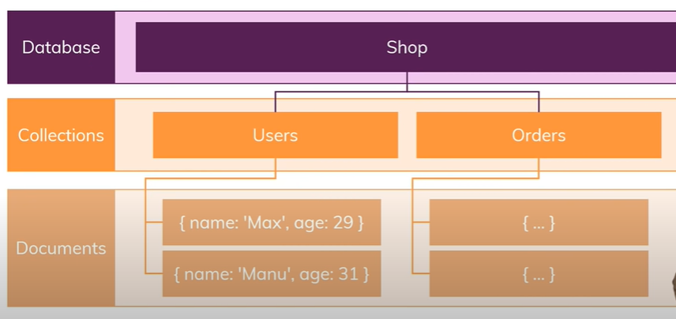

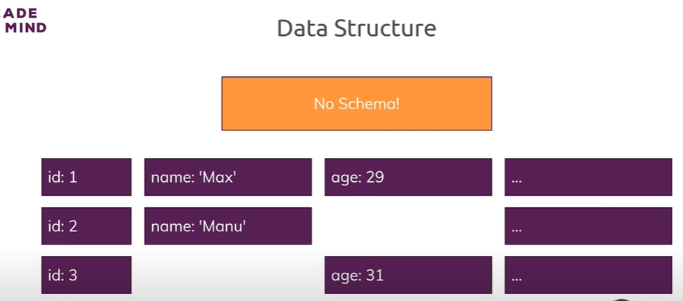

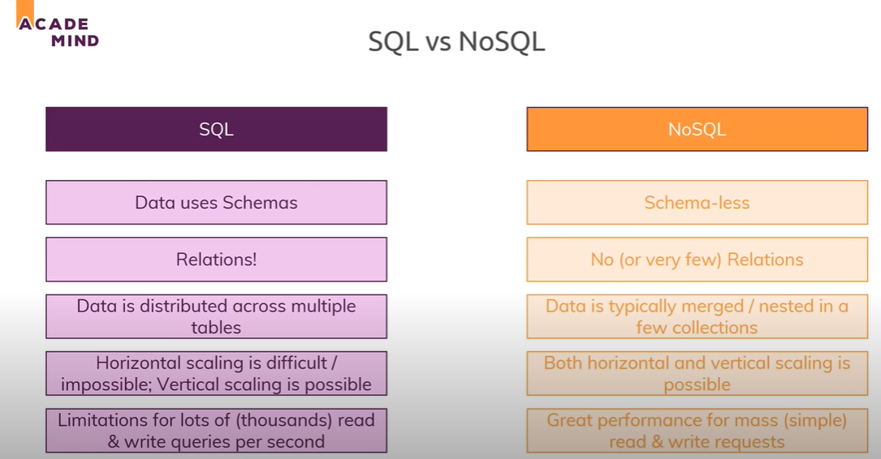

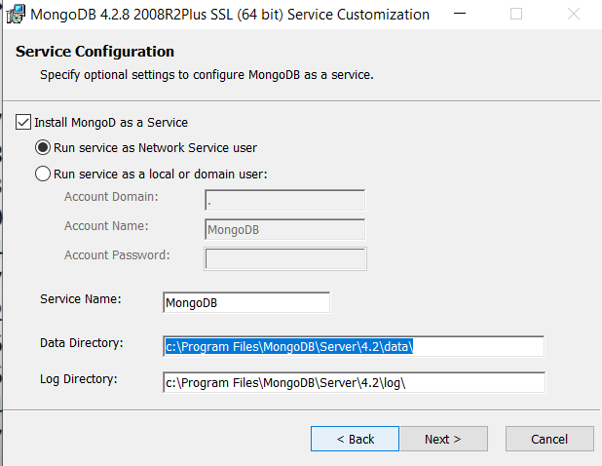

1. Create a ‘data’ directory in C://
2. Create a ‘db’ directory inside ‘data’

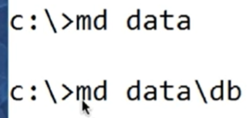

1. Then Open cmd and navigate to “C:\Program Files\MongoDB\Server\4.2\bin” and enter ‘mongod.exe’
2. In another command prompt, enter “mongo.exe” in the same path as above.
3. Add this path into the System path environment variables ““C:\Program Files\MongoDB\Server\4.2\bin””
4. Tutorial link : <https://www.youtube.com/watch?v=-0X8mr6Q8Ew&t=63s>

