Route Planner

**Introduction:**

Many time while traveling to new places we always wonder how the route is going to be. Is the route very desolate, will it (route) be having any restaurants, shops, coffee places, ATM and so on. The details can be taken from foursquare Knowing this helps a lot to plan the trip. For example- if I know my route is having enough restaurants on my way, I will not need to carry lot of food. Or if I know list of petrol pumps which are on my route, I can plan fuelling better. Or if I know there are any gift shop, I can plan to buy gifts en-route. There are location services, which provide these details but it’s based on current location. My idea will give the details en route. You have to provide the start and end point. This will plot the map of places along the route (as of now 500mtr radius).To avoid clumsy display, we can filter it based on category such as ATM or shops or restaurants.

**Data:**

The datasets which will be used are as follows-

1. Using start and end point of journey, we will create a dataset of longitudes and latitudes for the route with the help of openrouteservice API. We can use other API as well, I have used this as this was free.
2. Using each coordinates, we will find the nearby places using foursquare API.
3. I have randomly created a dataset of petrol pumps for show and use purpose, but you can get it online
4. Optional and can be done - since foursquare provides few categories, we are able to display only those. But if we have more datasets of say petrol pumps, visiting places like museums or forts, fun parks etc. we can combine them and display them along the route. The idea remains the same of getting to know my route.

**Methodology:**

1. Save the Start/source and End/destination in start_address and end_address respectively. Get the coordinates for same.

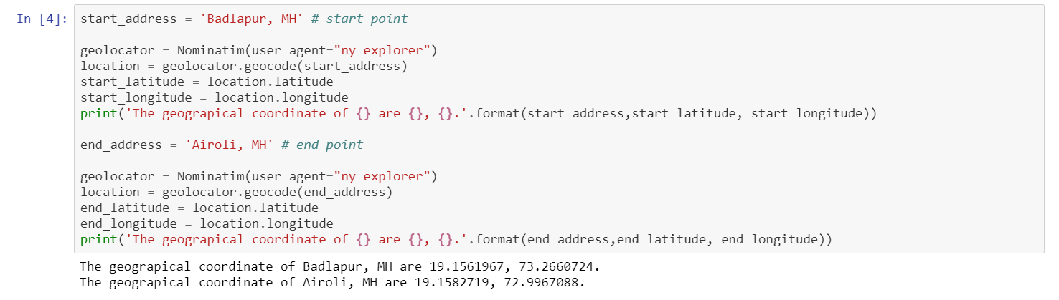

1. Using openrouteservice API, get the route between start and end addresses. You can use any location API.
2. The output of pt.2 is a json file. Extract the coordinate of all route points for the json file. Create the dataset with the same with adding column as CPxx where xx is sr.no.

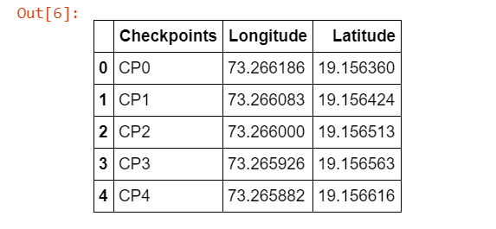

1. Now, using foursquare API. Get the nearby places for each of the coordinate in pt.3. Create a dataset with columns as venue, venue latitude, venue longitude, venue category.

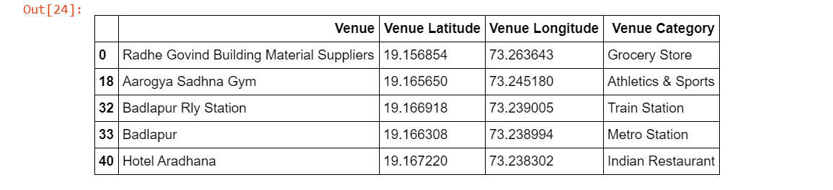

1. Optional: As foursquare does not give fuel pumps information. I have cooked up the data for my route and merged it with dataset if pt. 4. You can get the data online.

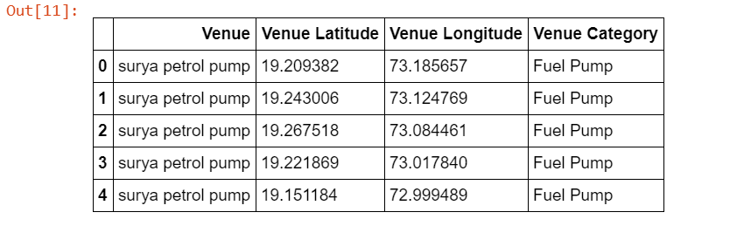

1. Create a list of tuples of all the coordinates of route dataset from pt.3. This will be used to mark route in folium map for route display.
2. Create a folium map with data set of pt.5. Here to avoid clumsy mapping, I have filtered the dataset by category and showing only the restaurants or Fuel pumps along my route. You can display complete dataset or filter as per requirement. Add route using polyline feature and the list from pt.6 .

**Results:**

The final output is a map showing list of places (for my example I have taken Restaurants and Fuel pumps) along the route.

Restaurant Map enroute-

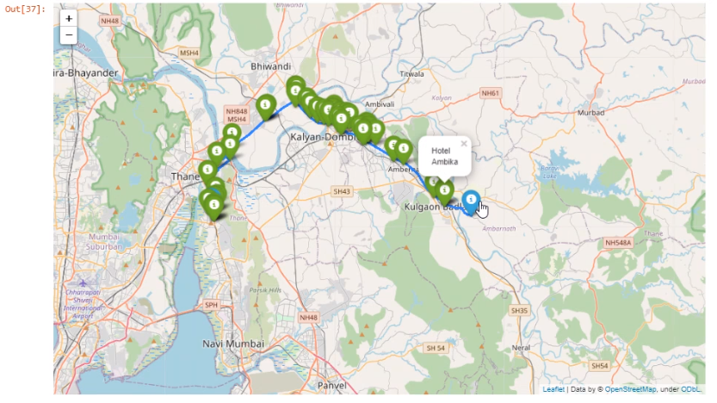

Fuel Map enroute-

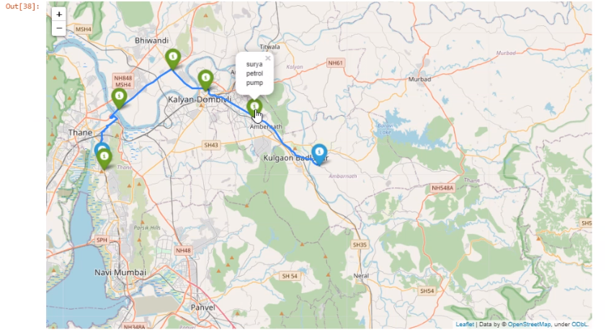

**Discussion:**

My final map (filtered with restaurants) shows the list of restaurant and other shows fuel pumps along my route. I can now plan pit stop for my breakfast/ lunch/ dinner.

**Conclusion:**

Using above map, we can plan the trip in advance. For example- I know my route is having enough restaurants on my way, so I will not need to carry lot of food. Or I know list of petrol pumps which are on my route, I can plan fuelling better.