**AMBULANCE TRACKING SYSTEM FOR 108 SERVICES**

**PROBLEM STATEMENT:** Ambulance tracing of 108 service like that of OLA through App, so that nearby persons can plan whether to wait for ambulance or take the patient to thehospital through his own resource in emergency, can track the nearest ambulance before booking and can contact the driver allotted.

**USERS VIEW:**

**I)Locate departure point:**

The user will select the departure point where the accident occurred.

**II)Getting location of nearby ambulance:**

User will now see all the ambulance locations that are nearby from which the user will locate the nearest ambulance and sends indication to the ambulance driver.

**III)Receiving response:**

User will receive the driver’s response if he accepts the indication, if he rejects due to some reasons users need to do the location process once again.

**DRIVERS VIEW:**

**I)Receiving User request:**

Driver will receive a notification or a call from the user along with the location where the accident has occurred.

**II)Sending confirmation:**

The driver need to confirm his acceptance of the request if he is not ready then he needs to reject the request.

**III)Navigate to place:**

After accepting the request he navigates to the accident place using the location shared by the user.

**TECHNOLOGY STACK:**

**ANDROID STUDIO**

Android Studio is an official integrated development environment for Android operating system

**FIREBASE**

Firebase is a cost-free app measurement and data storage solution by google (open source)

**GOOGLE MAP API**

Google Map API allows us to map and locations in our application

**MAP:**

**USER**

Select Departure point

Get information of all nearby ambulances

No

Send request to nearest ambulance driver

Wait for driver’s response

Yes

Get driver’s acceptance notification

**DRIVER**

Receives user request

Sends response to user

Navigate to the place

**APPLICATION VIEW:**

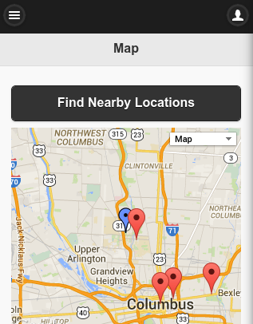

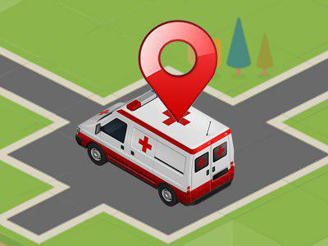

**DEPENDENCIES:**

1. Google Maps
2. GPS of Ambulance