

Usage User Manual

Revision History

|  |  |  |  |
| --- | --- | --- | --- |
| Author | Date | Version | Comments |
| Arun Ganesh.A | 08/06/2017 | 1 |  |
|  |  |  |  |
|  |  |  |  |
|  |  |  |  |

Table of Contents

1 Introduction 3

2 Login and Navigation 3

3 Usage Screen Field details 4

4 Usage Scenarios 7

4.1 Voice on net local 7

4.2 Outgoing Roaming Scenario 11

4.3 Incoming Roaming 17

# Introduction

The usage module in the test automation tool is used to generate CDR. The following document aims to provide the users with the required details to work on the Usage module of the test automation tool.

# Login and Navigation

When the tool is installed and it is started. Open the browser and type the URL ‘http://localhost:8081’ The Login screen will open. In the login screen enter the user name and password and click on login

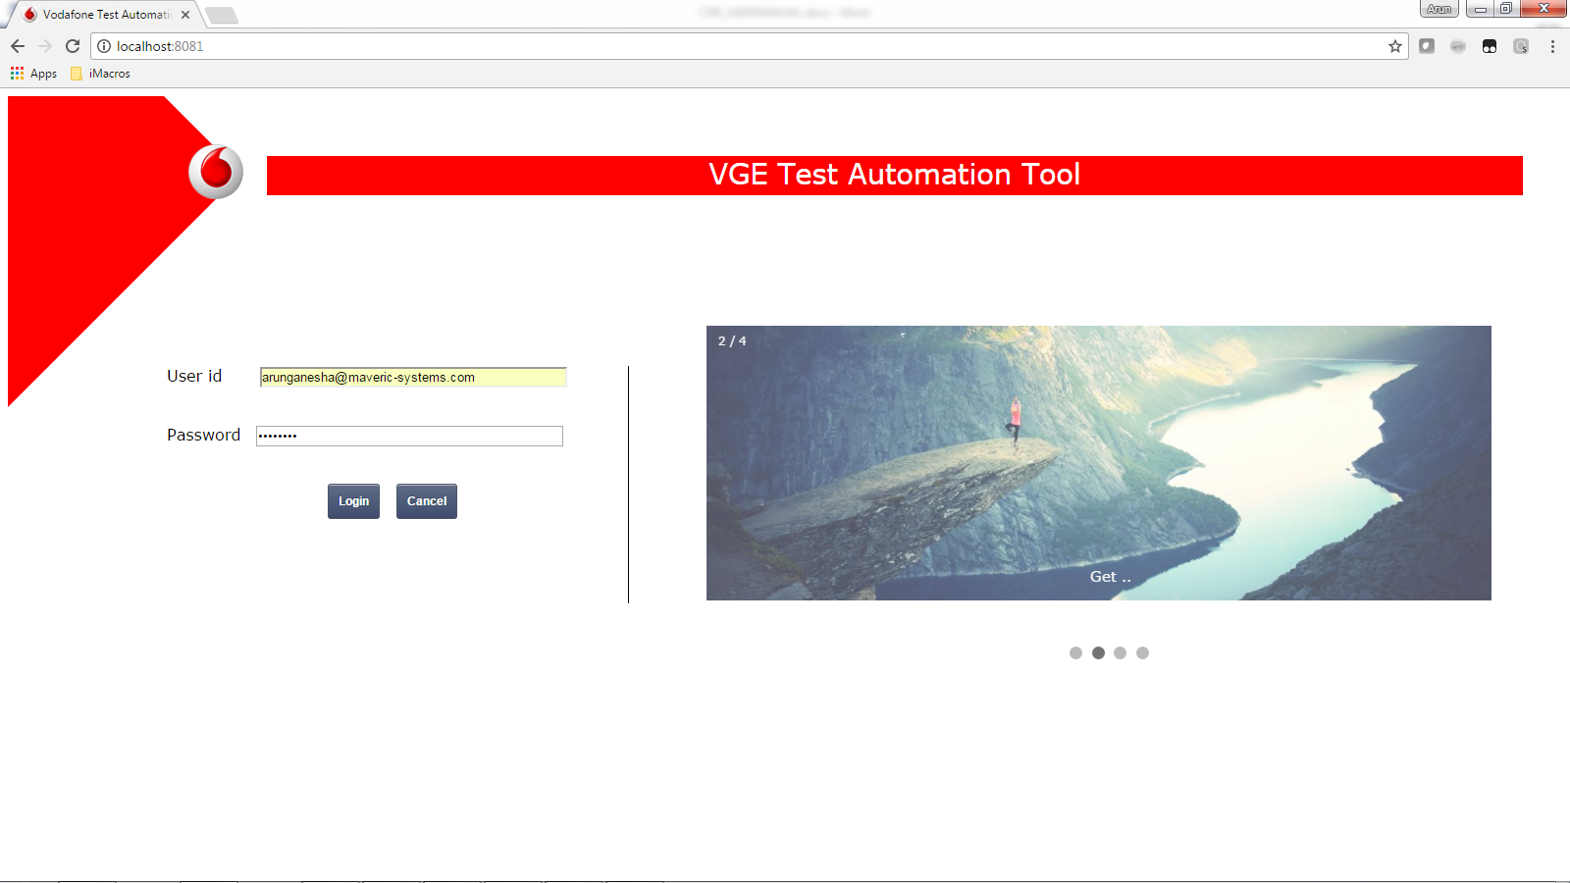

The tool will navigate to the home screen. Navigate to the usage screen by mouse over on Test Data Generation -> Usage and click on Usage option in the drop down.

The tool will now navigate to the usage generation screen.

# Usage Screen Field details

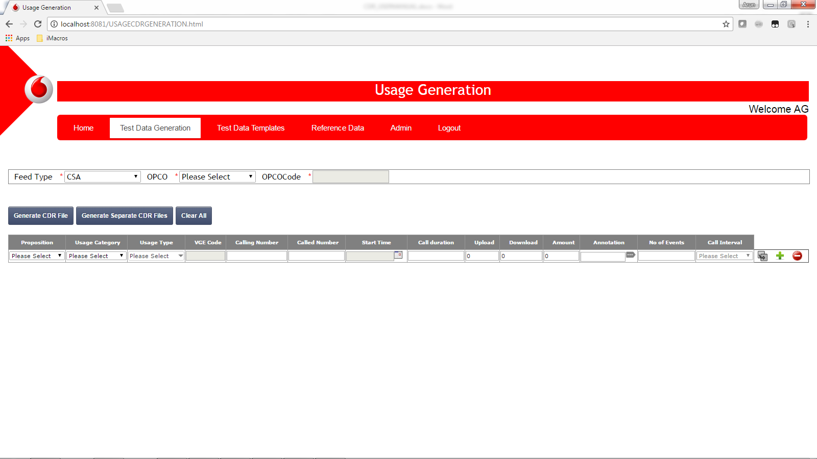

1. Feed type Selection: Has the list of values of source feed. By default CSA will be selected.
2. Opco Selection: Has the list of OPCO and the user can select the OPCO for which the usage has to be generated.
3. Opco Code: This field will be auto populated based on the value selected in the opco field.
4. Proposition: The drop down will be populated with propositions based on the opco selected and the user can select the proposition for which the CDR has to be created.
5. Usage Category: The drop down will be populated with the usage categories like Voice, SMS, MMS, etc. that are applicable for the proposition selected.
6. Usage Type: The drop down will be populated with the usage types applicable for the selected proposition and usage category.
7. VGE CODE: The value will be populated based on the usage type selected and the field is not editable
8. Calling Number: Calling number is an open text field. The call origin number will be entered here.
9. Called Number: This is an open text field. The target number should be entered here.
10. Start Time: This field by default is not editable. To enter the date and time click on the calendar icon  and select the date and enter the time in the calendar popup and click on the OK button.

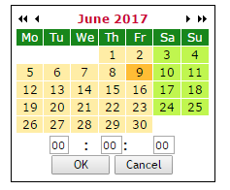

1. Call Duration: This field accepts only numeric values. The duration of the call should be entered here.
2. Upload: This field is specific to usage category Data to denote the upload usage. This field will be disabled automatically when the call duration has a value greater than ‘0’
3. Download: This field is specific to usage category Data to denote the download usage. This field will be disabled automatically when the call duration has a value greater than ‘0’

Please note when the upload or download has a value greater than ‘0’ then the call duration field will be disabled.

1. Amount: This field is a numeric field and will accept numbers greater than or equal to zero. The OPCO pre rated amount will be entered here.
2. Annotation: This is an open text field. If the user has the annotation for the usage then it can be directly entered here. It can also be populated through the annotation view.
3. Annotation View Display:  click on the icon. The annotation view will be displayed. For the annotation view to be displayed usage type, calling number and called number should be filled.

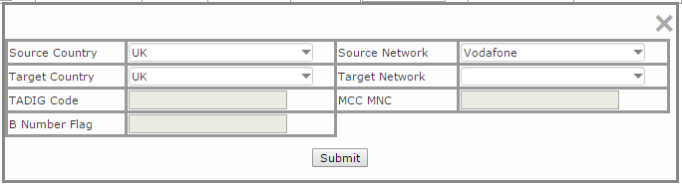

Based on the calling number and called number entered the source country, Source network, Target country, Target network will be populated. If required the values can be modified with the values in the drop down. After all the required values are entered click on submit to generate the annotation. Please note the annotation view will be displayed only if the annotation specification is available in the tool else the user has to populate the annotation manually. The annotation will be generated only if all the mandatory values are filled in, the mandatory values varies from one usage type to another.

1. No. of Records: This is a numeric fields. This field is used to specify how many records has to be generated with the same set of data.
2. Call interval: By default this field will be disabled. When the No. of Records has a value greater than ‘1’ then it will be enabled. This is used to specify the time interval between the usages when the number of records is more than 1.
3. Copy Row: when this button is clicked then a new row will be created and all the data in the row will be copied to the new row, and the duration mentioned in the current row will be added to the date and time field.
4. Delete Row: Delete row will delete the current row and if the user tries to delete the first row. All the values will be cleared in the first row and the row will still exist.
5. Add Row: This will add a new blank row at the end.
6. Menu Bar: This bar will help in navigating from one module to another.
7. Heading Bar: This bar has the title of the current module.
8. Generate CDR: When this button is clicked the CDR will be generated with the data entered.
9. Generate separate CDR: When there is more than one row of data and this button is clicked then each row of data will be created as a separate CDR and a zip file will be returned.
10. Clear All: When this button is clicked all the records will be erased.

# Usage Scenarios

## Voice on net local

1. Select the required opco, Proposition and select the usage type as Voice outgoing national on net.

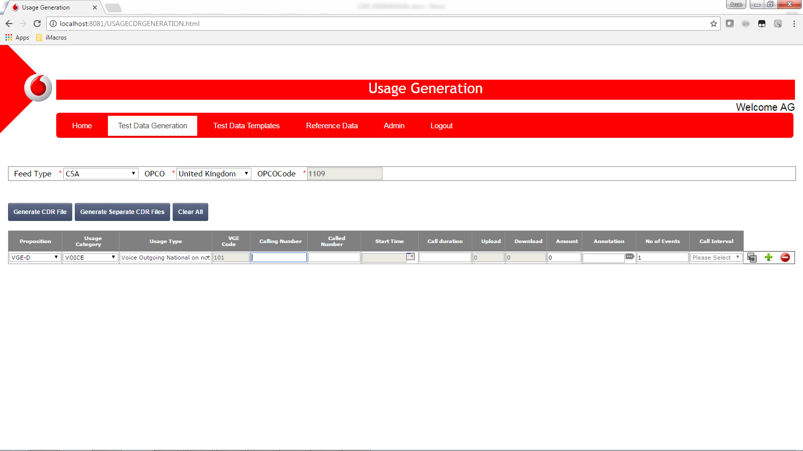

1. Enter the calling number and called number with country code.

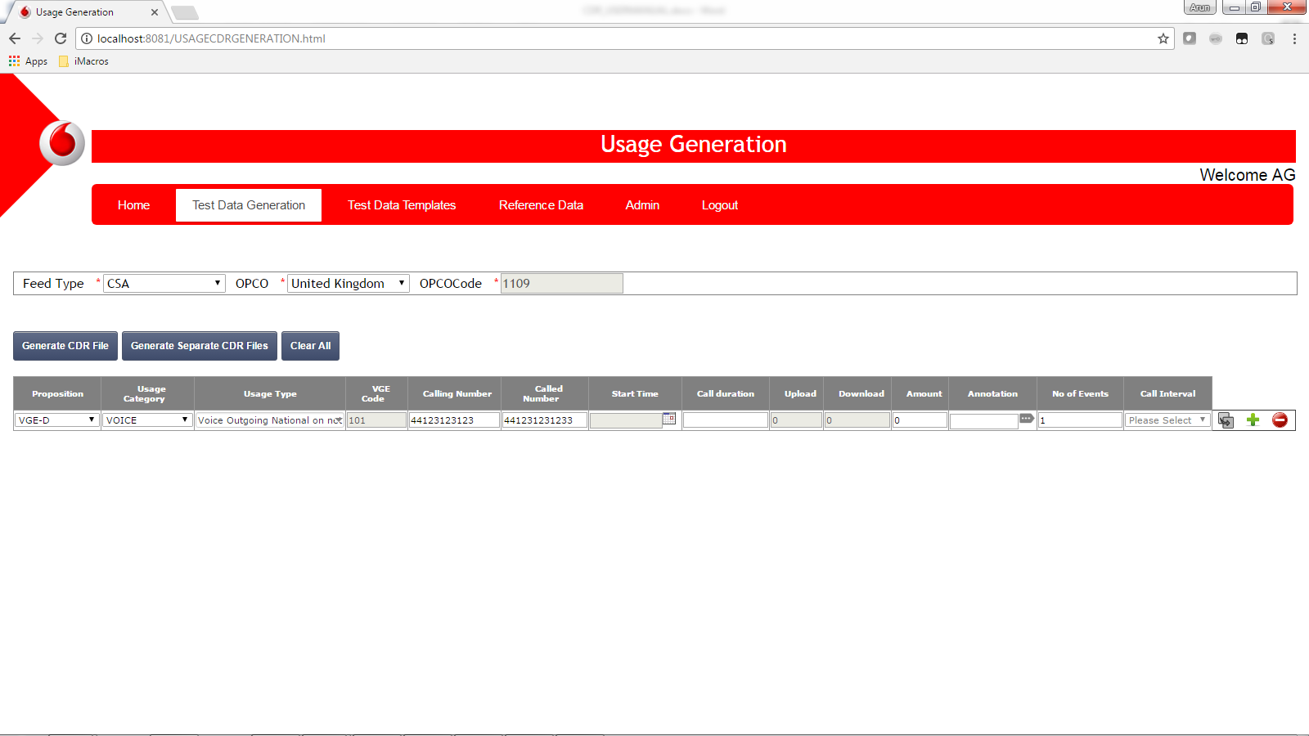

1. Select the call start time, duration and Pre rated amount.

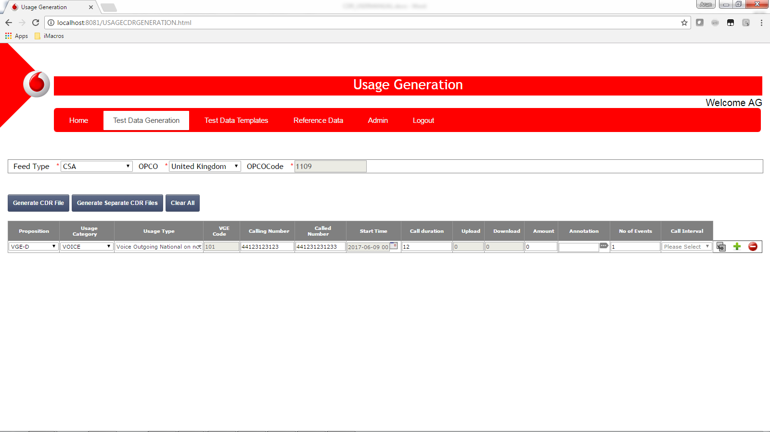

1. Click on the annotation view button

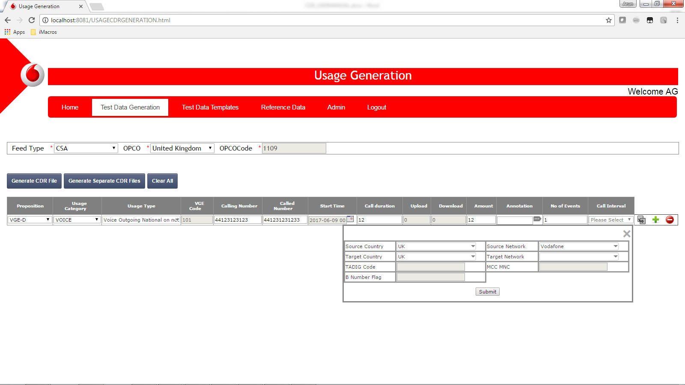

Based on the calling number and called number the source country source network, target country and target network will be populated.

1. Click on the submit button

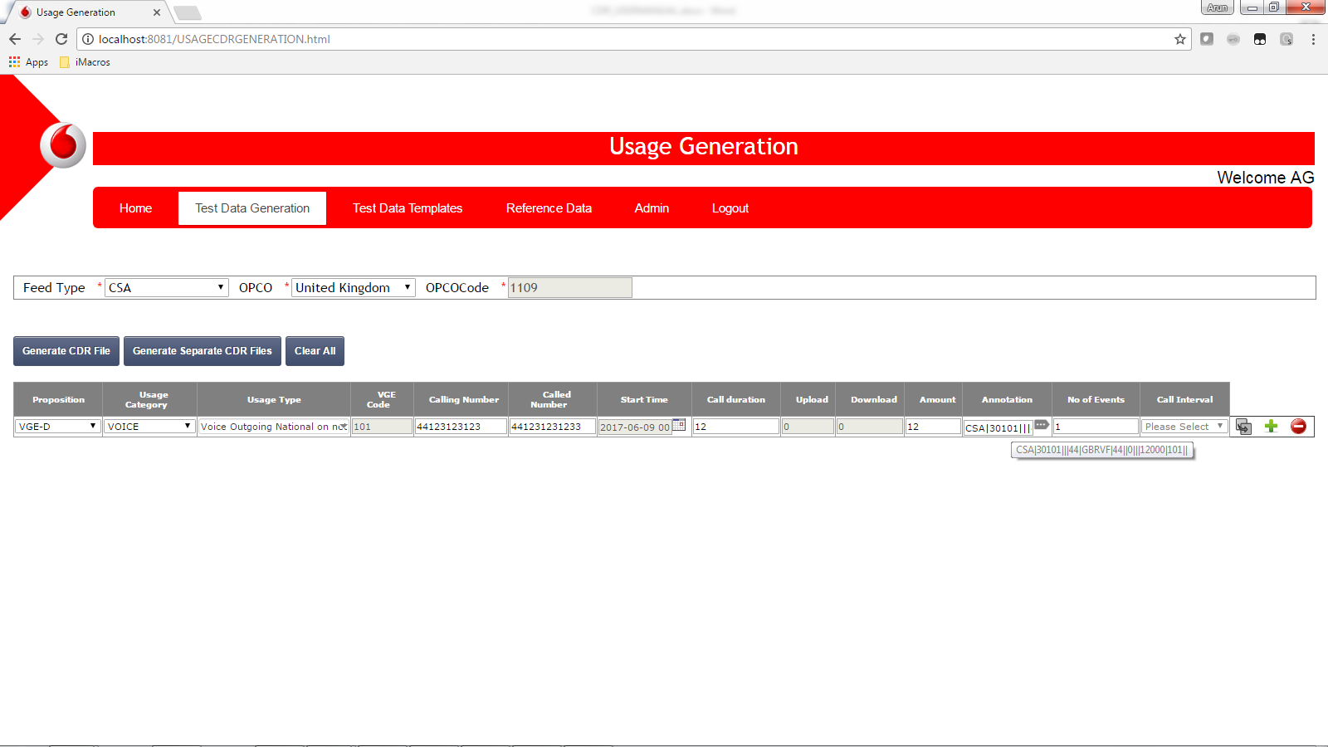

The annotation will be generated.

1. Enter the number of events and the call interval

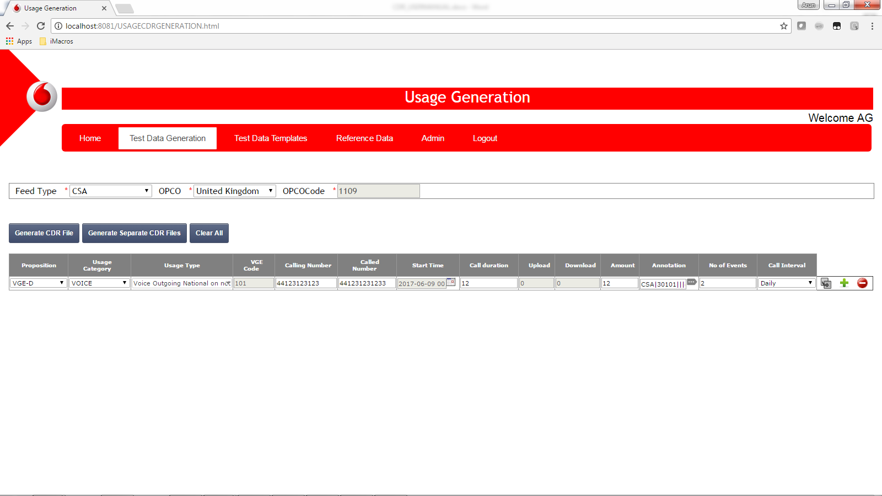

1. Click on the generate CDR Button and save the file generated in the required folder.

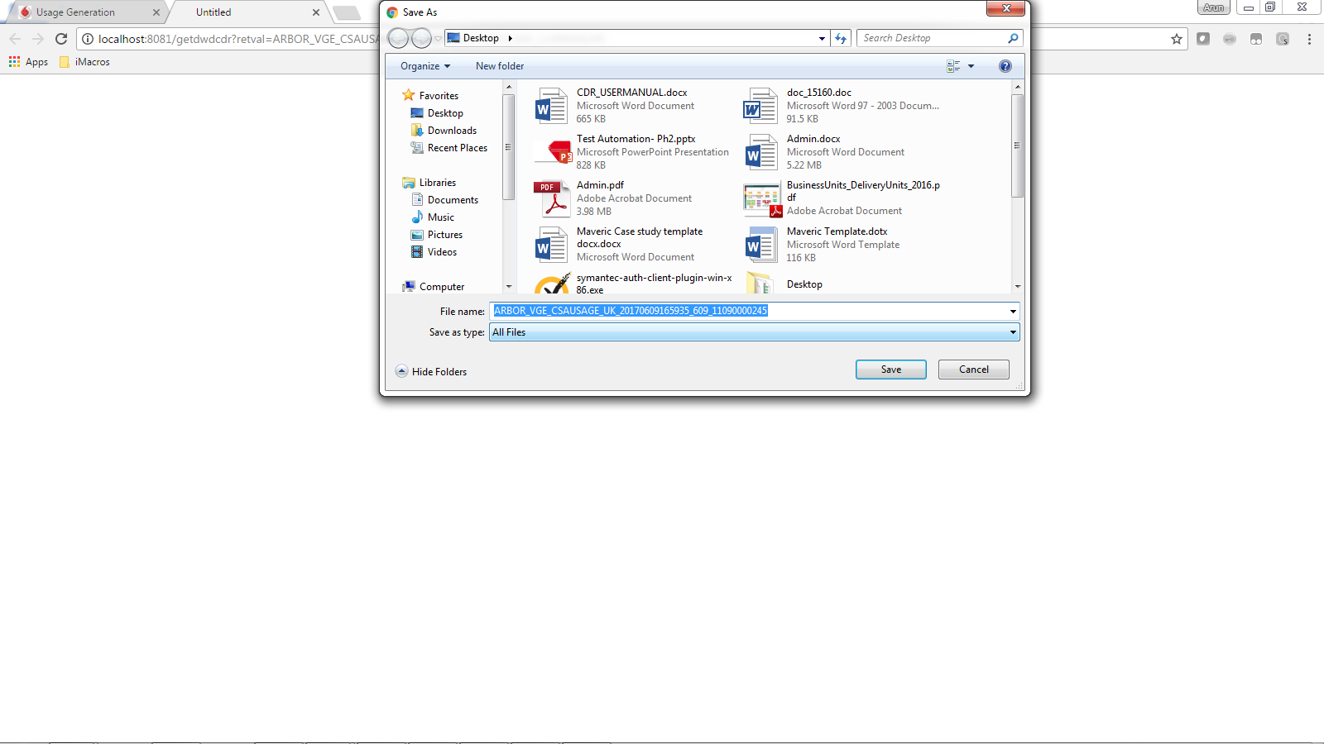

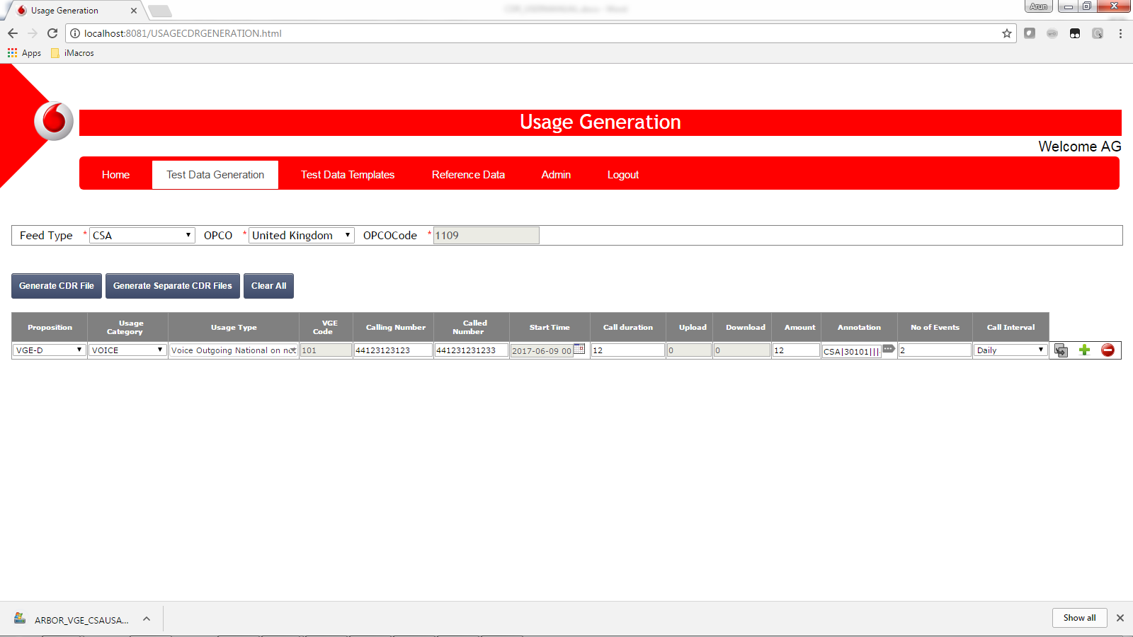

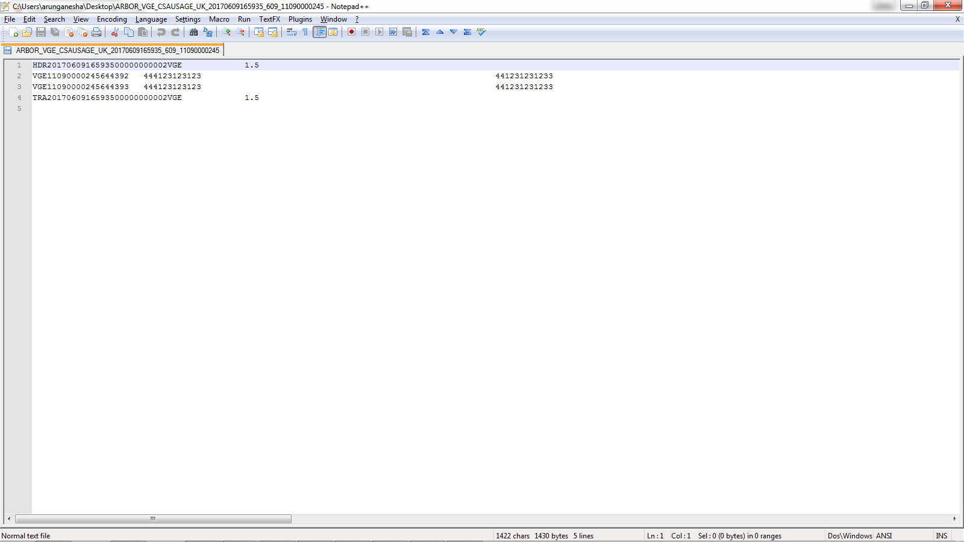

## Outgoing Roaming Scenario

1. Select the required opco, proposition, and usage category as voice.

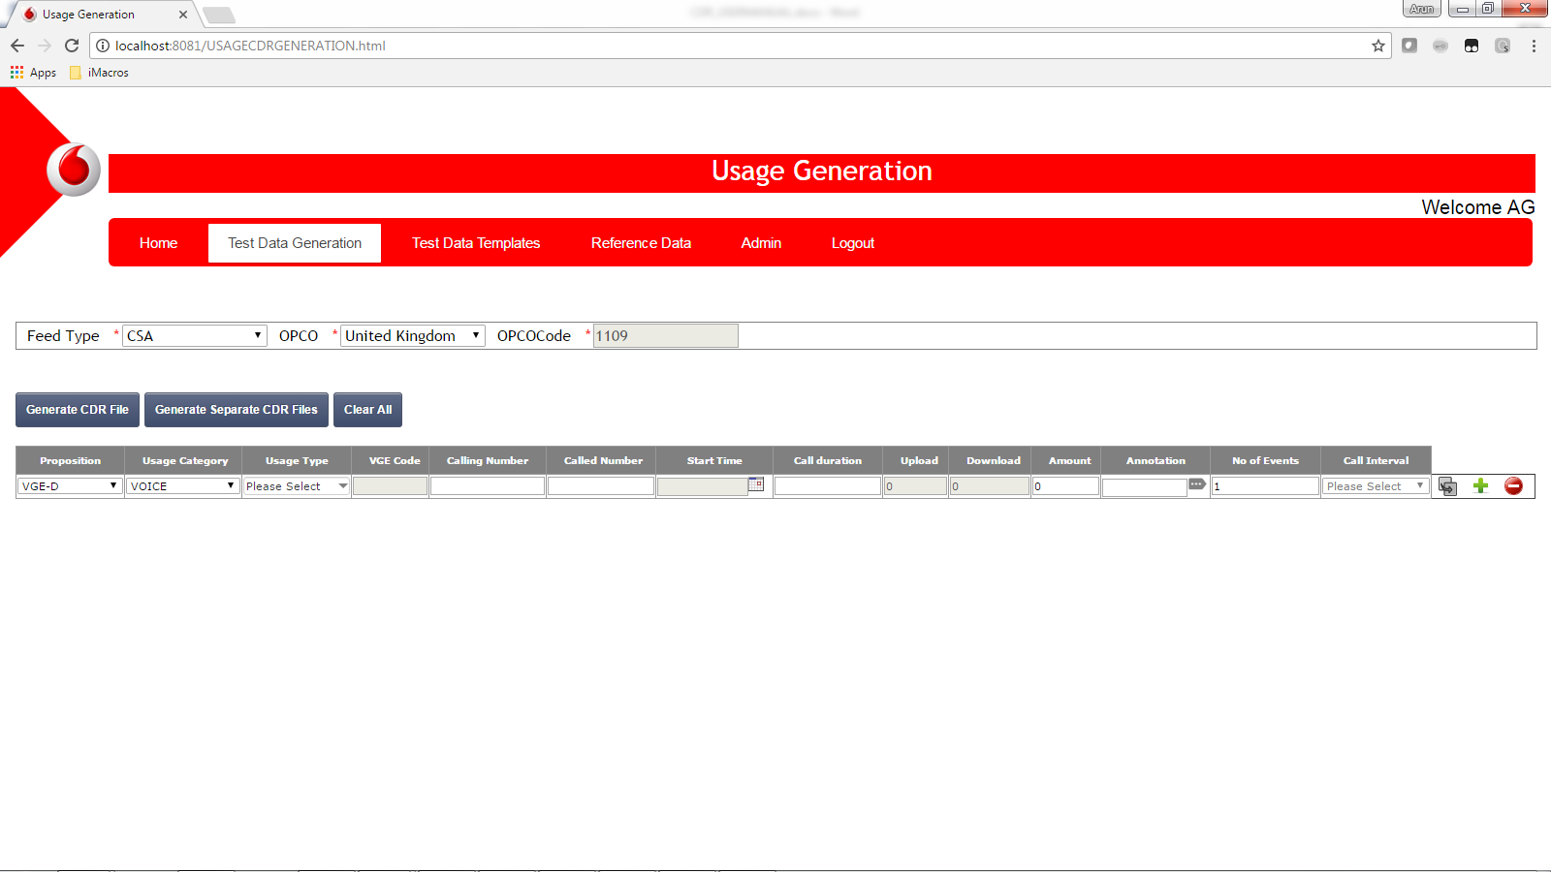

1. Select the usage type as Outgoing Roaming – MO- Local

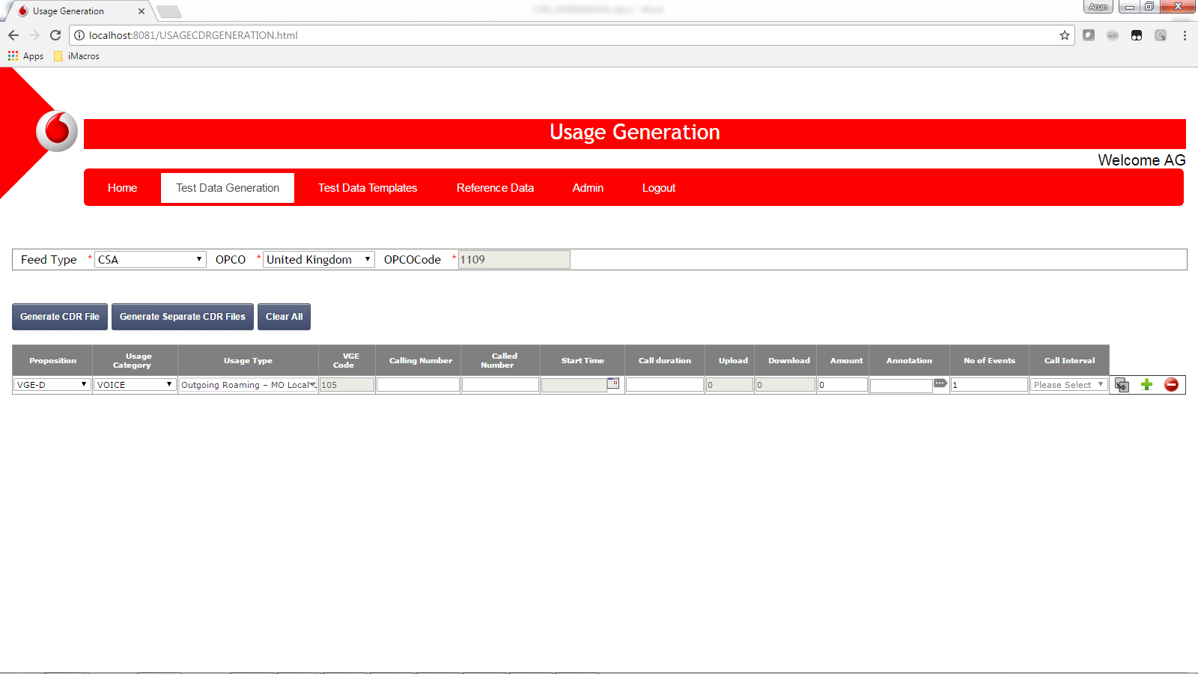

1. Enter the calling number and the called number

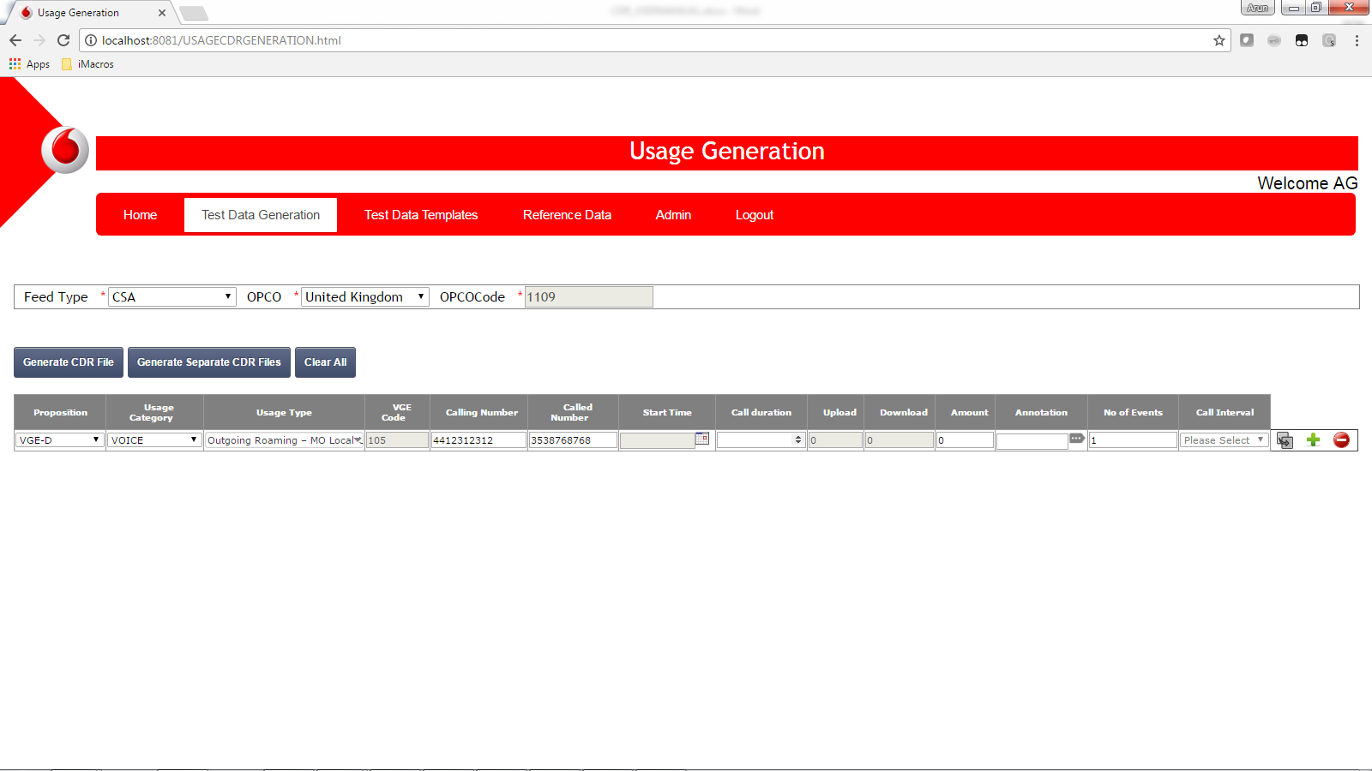

1. Enter the start time, call duration, and amount field.

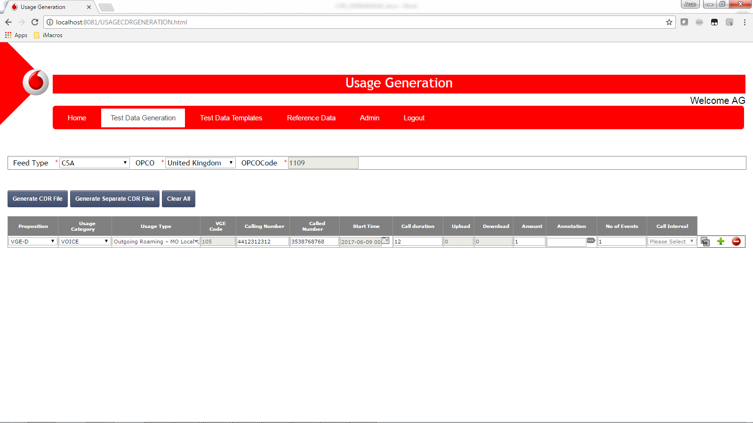

1. Click on the annotation view button

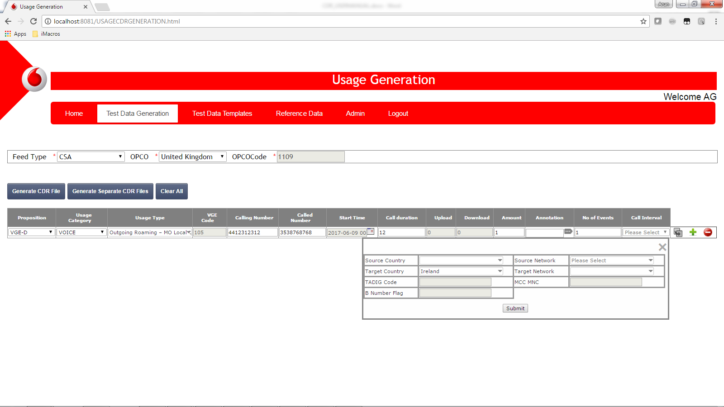

In this scenario the user has to select the Source country and source network according to the roamed country. While the target country will be auto populated.

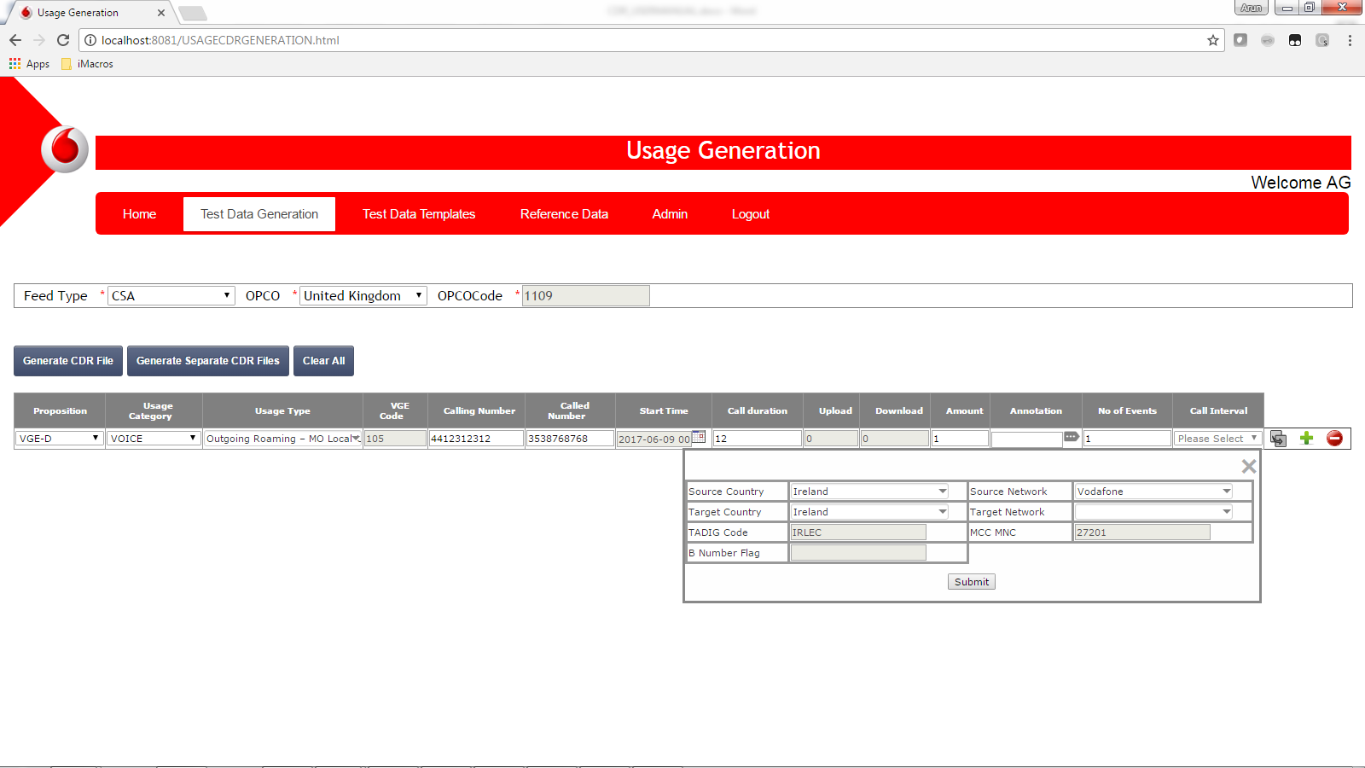

Click on submit.

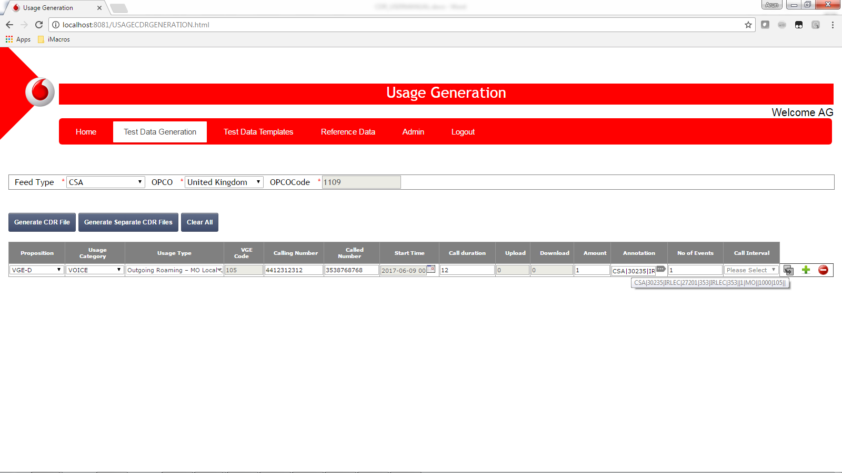

1. Enter the number of events and call interval

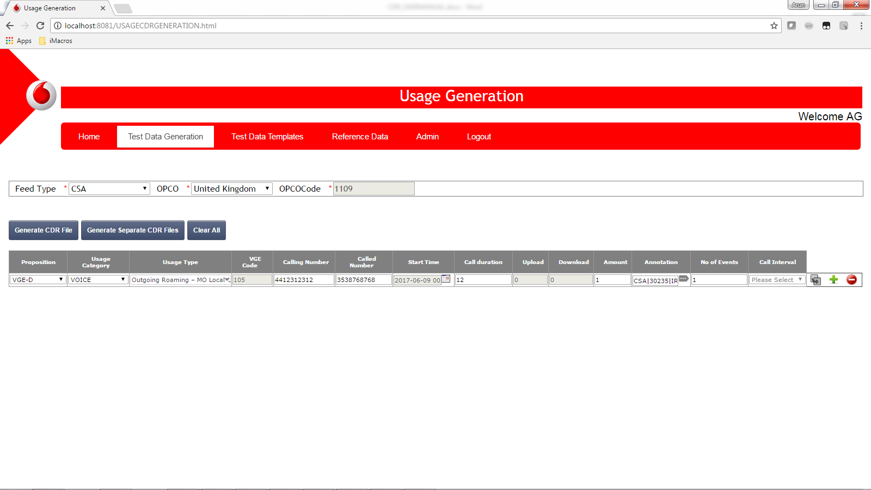

1. Click on Generate CDR

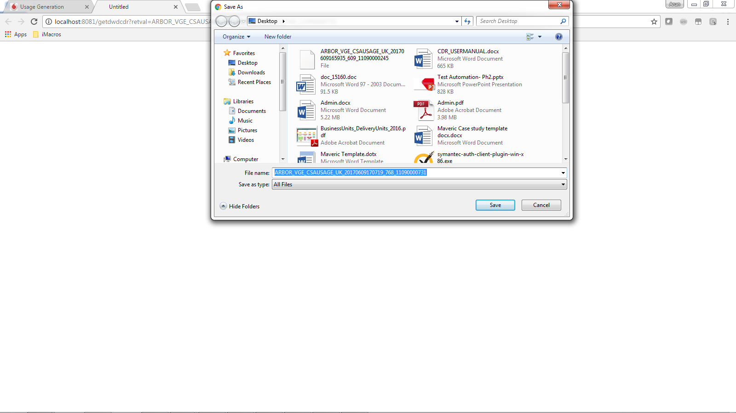

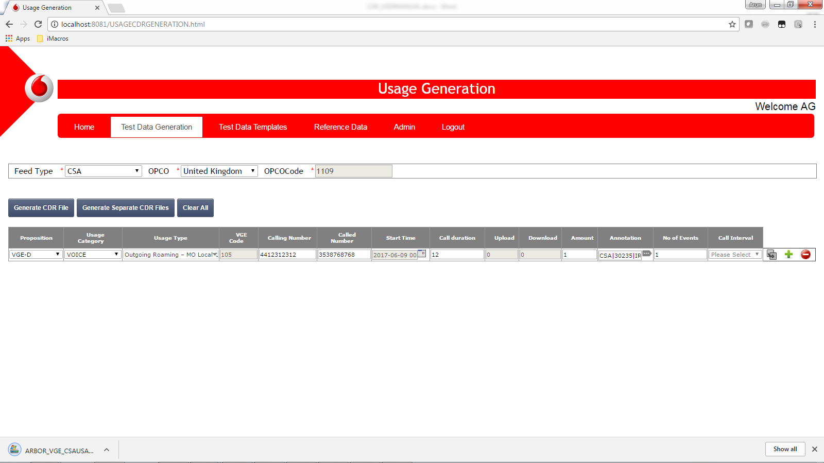

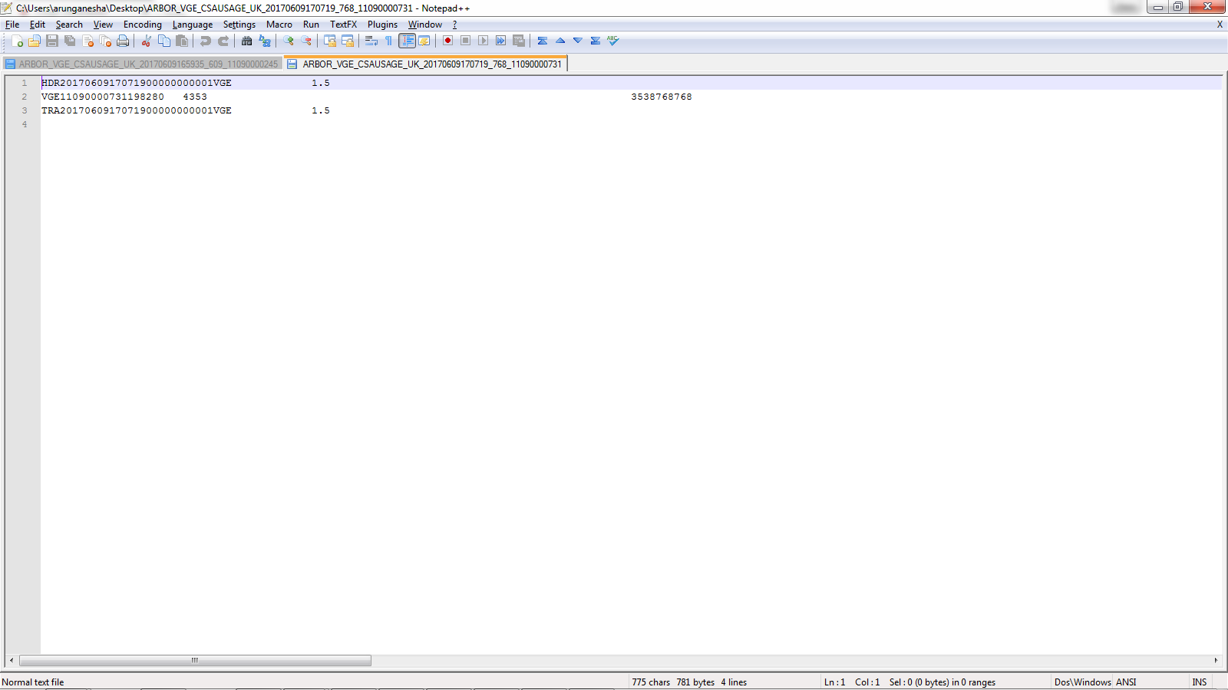

## Incoming Roaming

1. Select the OPCO, Proposition, and the usage category as voice

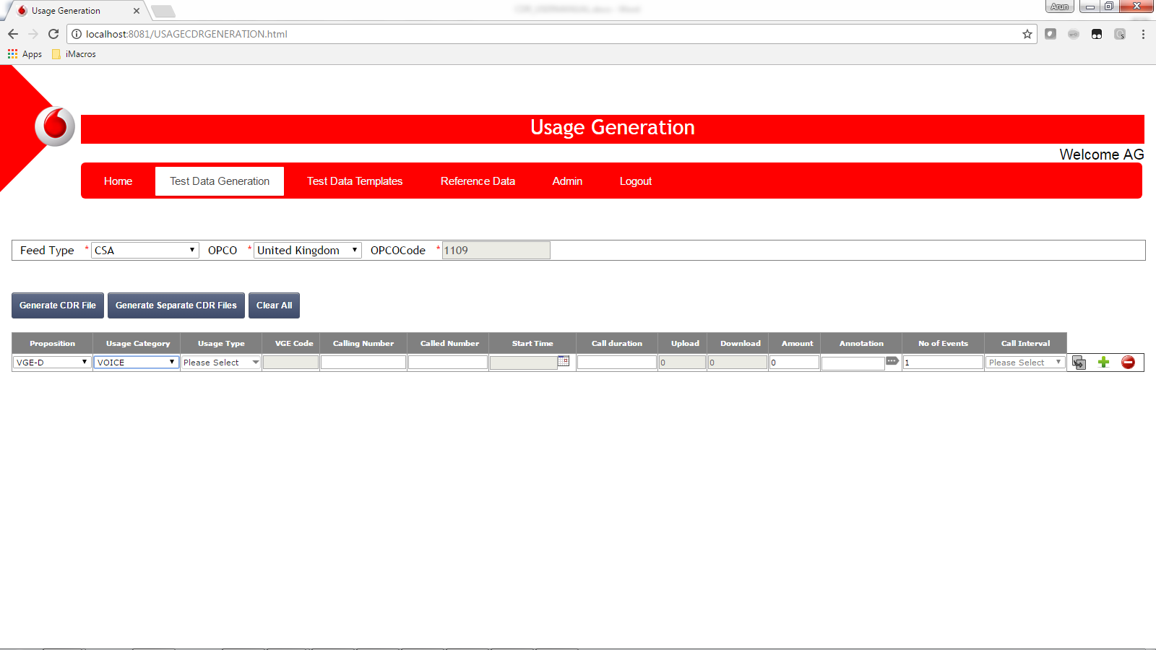

1. Select the usage type as Voice incoming International-Roaming

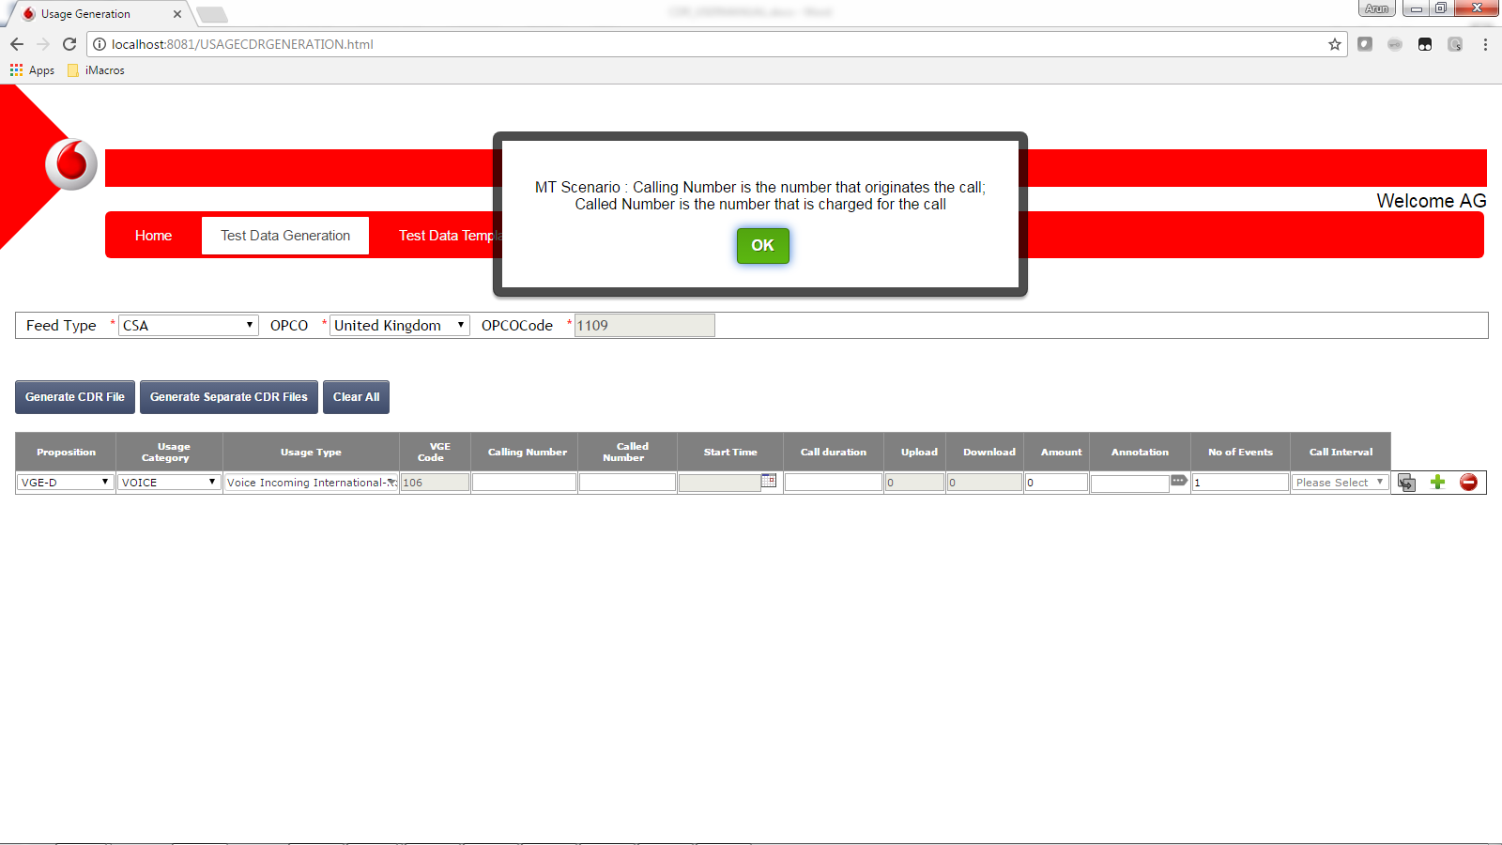

For mobile terminated scenarios a popup will be displayed informing the user that the called number will be the number that will be charged. Click ok on the pop up message and proceed.

1. Enter the calling number and called number

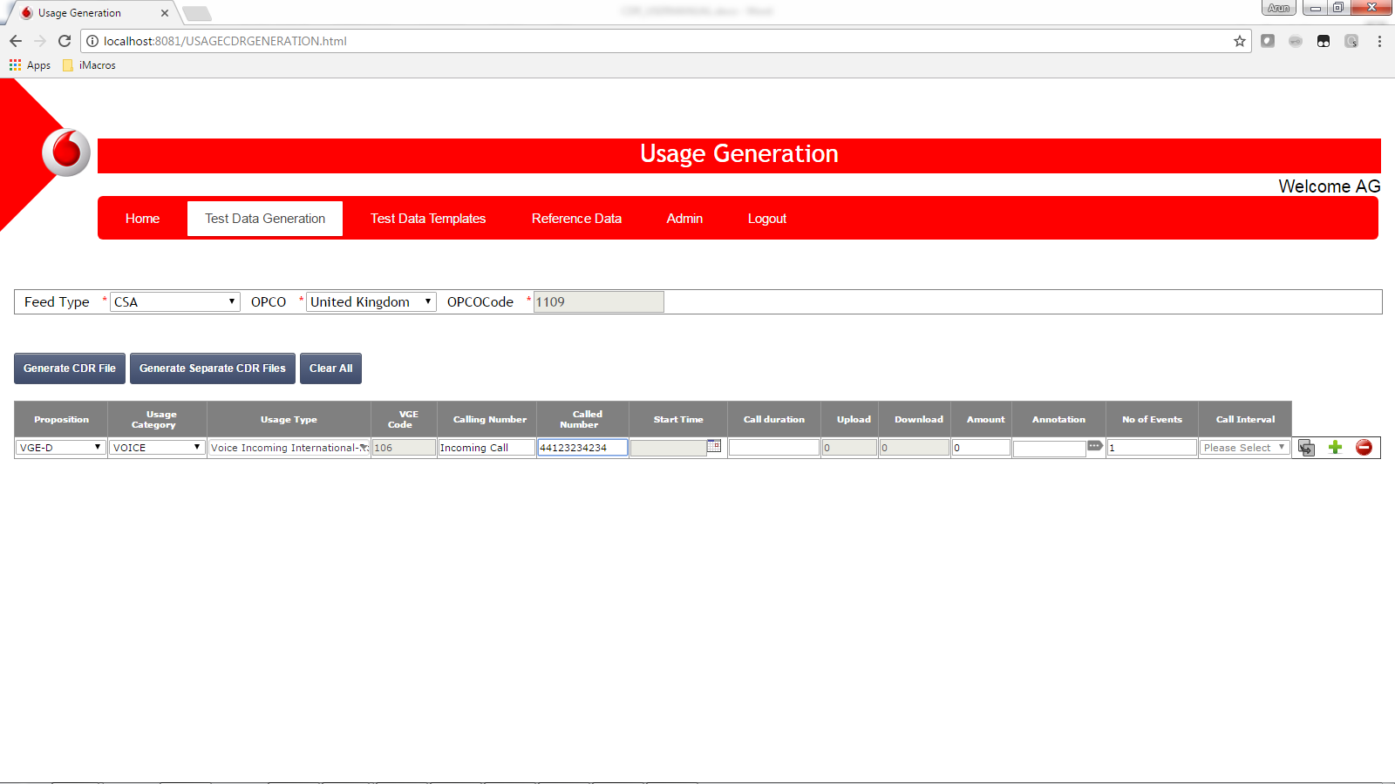

1. Enter the start time, duration and the pre rated amount

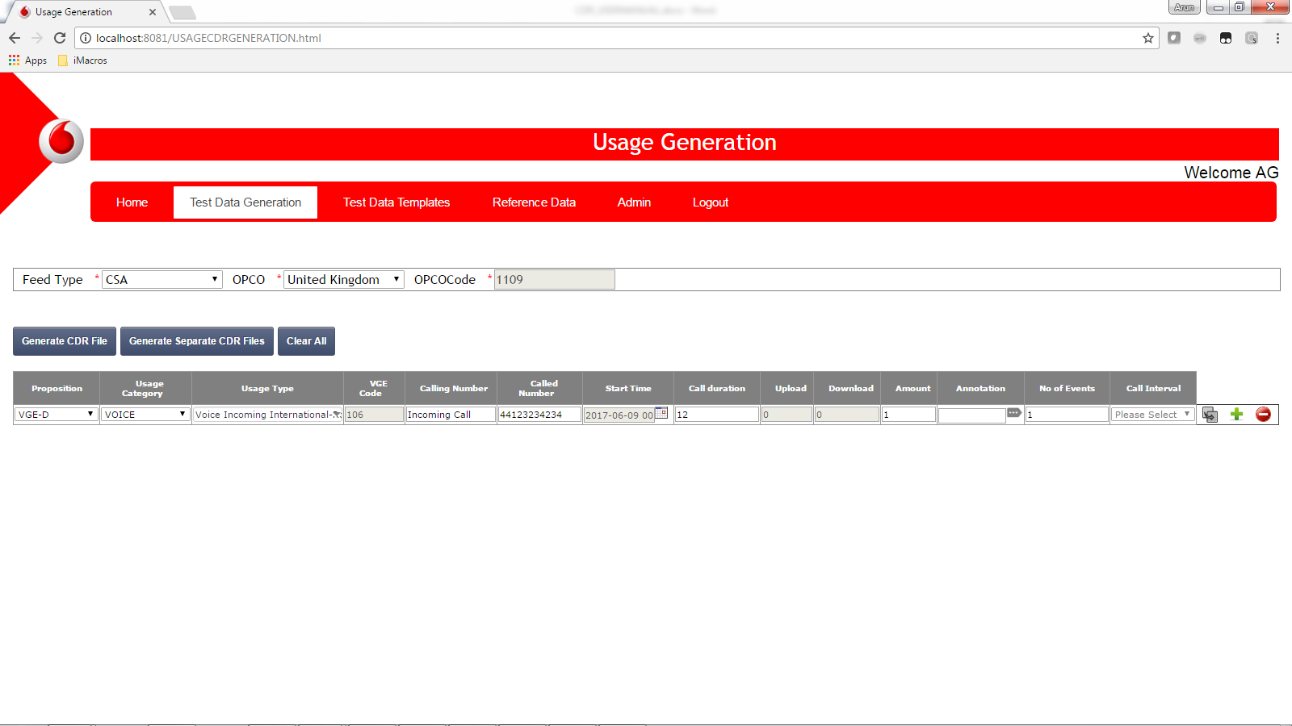

1. Click on the display annotation view button.

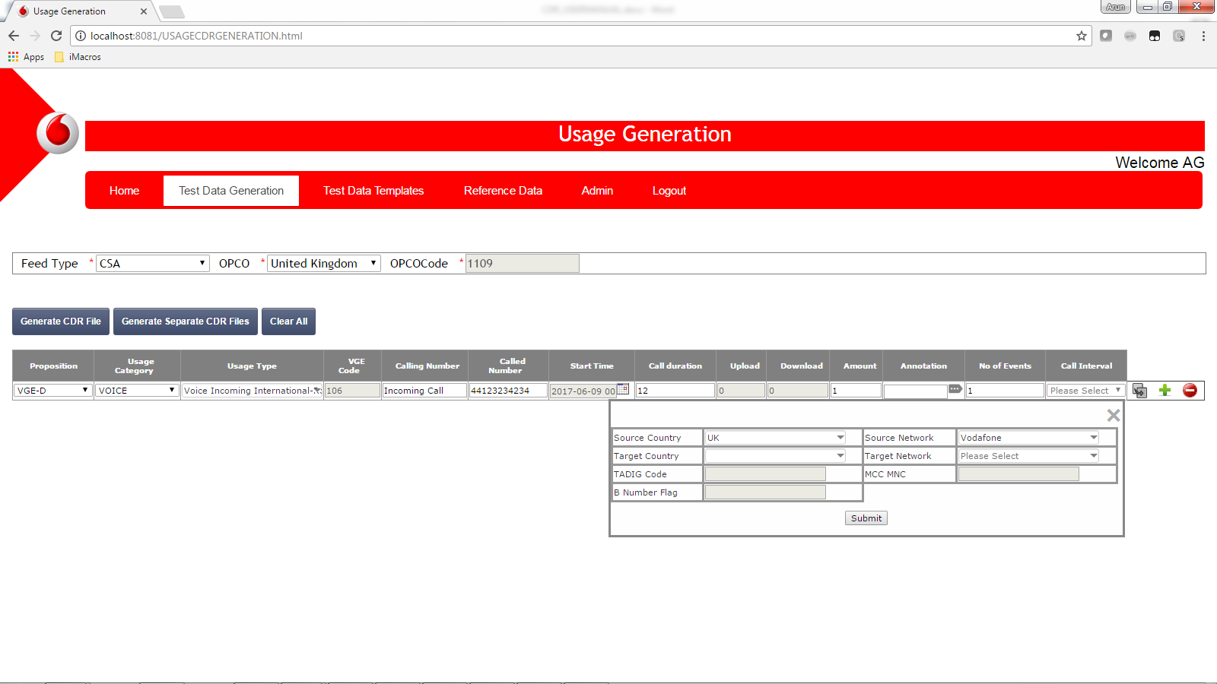

For mobile terminated scenario the called number country code will be considered as the source country and accordingly the country and network details are populated. Based on the incoming call details user should enter target country and target network

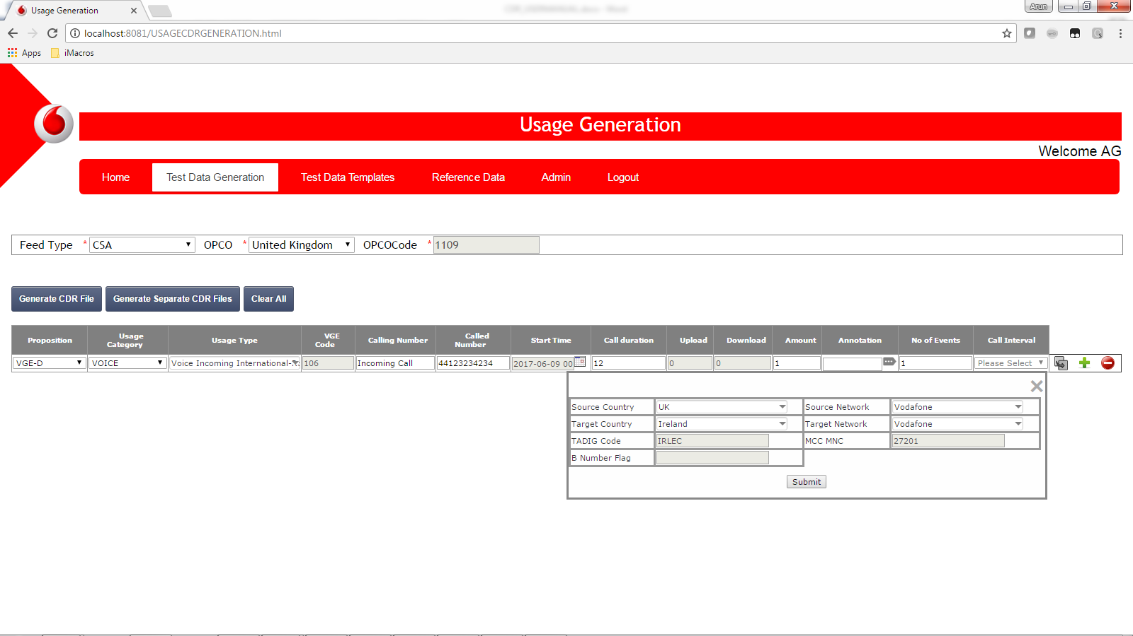

Click on submit button to generate the annotation

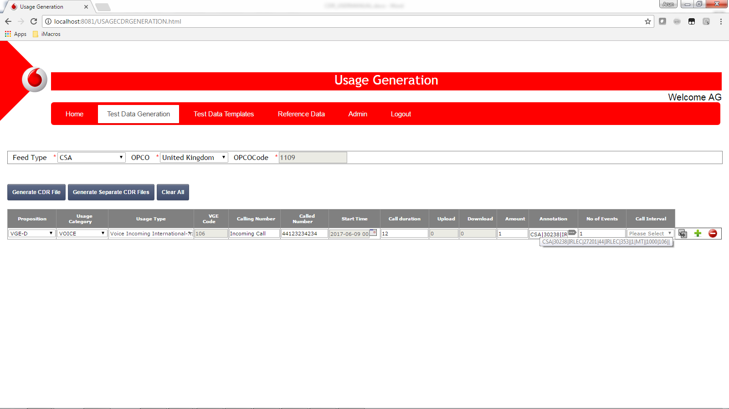

1. Enter the number of events and call interval

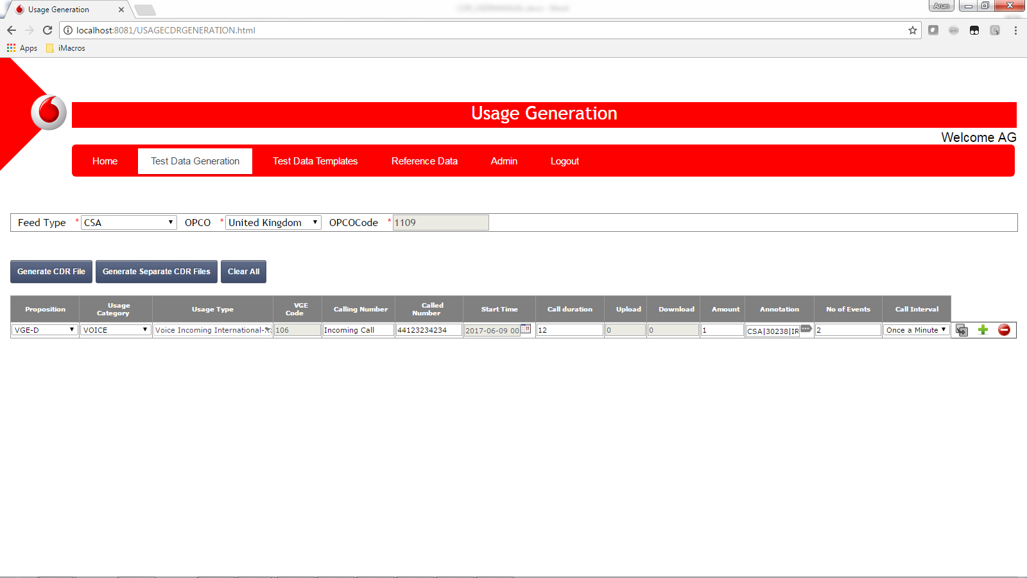

1. Generate the CDR by clicking on the generate CDR button

