**Exercise 1: Control Structures**

**Scenario 1:**

**Code:**

BEGIN

FOR rec IN (SELECT l.loan_id, l.interest_rate, c.age

FROM loans l

JOIN customers c ON l.customer_id = c.customer_id)

LOOP

IF rec.age > 60 THEN

UPDATE loans

SET interest_rate = interest_rate - 1

WHERE loan_id = rec.loan_id;

END IF;

END LOOP;

COMMIT;

END;

/

SELECT * from loans;

**OUTPUT:**

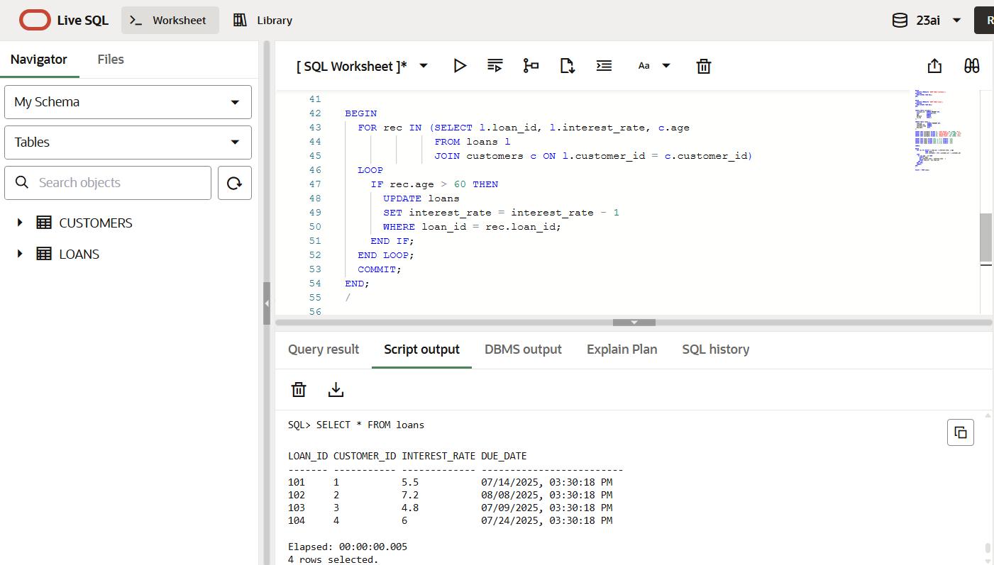

**Scenario 2:**

**Code:**

BEGIN

FOR rec IN (SELECT customer_id, balance FROM customers)

LOOP

IF rec.balance > 10000 THEN

UPDATE customers

SET is_vip = 'Y'

WHERE customer_id = rec.customer_id;

END IF;

END LOOP;

COMMIT;

END;

/

SELECT * FROM customers

**OUTPUT:**

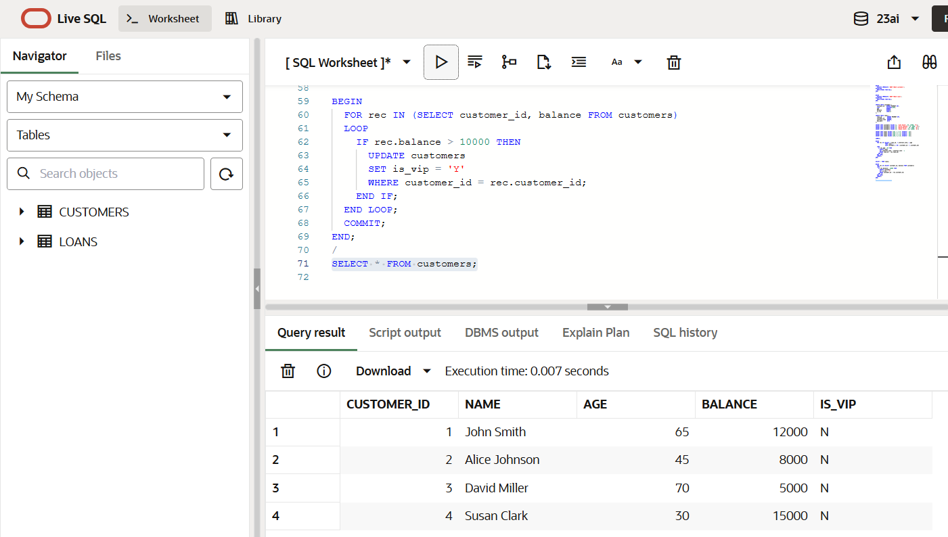

**Scenario 3:**

**Code:**

BEGIN

FOR rec IN (

SELECT c.name, l.due_date

FROM loans l

JOIN customers c ON l.customer_id = c.customer_id

WHERE l.due_date BETWEEN SYSDATE AND SYSDATE + 30

)

LOOP

DBMS_OUTPUT.PUT_LINE('Reminder: Loan due for ' || rec.name || ' on ' || TO_CHAR(rec.due_date, 'DD-MON-YYYY'));

ENDc LOOP;

END;

/

SET SERVEROUTPUT ON;

**OUTPUT:**

