MULTI-ENVIRONMENT CONFIGURATION
MANAGEMENT WITH HELM
A PROJECT REPORT
Submitted by
Arun Kumar T (Reg.No.953724243007)
Priyan M (Reg.No.953724243040)
In partial fulfillment for the award of the degree
of
BACHELOR OF TECHNOLOGY
in
ARTIFICIAL INTELLIGENCE AND DATA SCIENCE
AAA COLLEGE OF ENGINEERING AND TECHNOLOGY, SIVAKASI
(AN AUTONOMOUS INSTITUTION)
NOVEMBER 2026

BONAFIDE CERTIFICATE
Certified that this project report “Multi-​Environment Configuration Management with Helm” is the bonafide work of Arun Kumar T (Reg.​No.​953724243007), Priyan M (Reg.​No.​953724243040), who carried out this project under my supervision.
SIGNATURE  SUPERVISOR NAME, QUALIFICATION  SUPERVISOR &  DESIGNATION  Department of Artificial Intelligence and Data Science  AAA College of Engineering and Technology  Sivakasi | SIGNATURE  Dr.​M.​KARUPPASAMY, M.Tech., Ph.D.,  ASSOCIATE PROFESSOR &  HEAD OF THE DEPARTMENT  Department of Artificial Intelligence and Data Science  AAA College of Engineering and Technology  Sivakasi
Submitted for viva - voce examination held on ………………………….
INTERNAL EXAMINER | EXTERNAL EXAMINER

ACKNOWLEDGEMENT
We would first like to thank Almighty for the blessings that made this work possible. We thank our Management, AAA College of Engineering and Technology, Sivakasi, for providing the facilities and infrastructure needed for the project.
We express our sincere thanks to Dr. M. SEKAR M.E., Ph.D., (S.Korea), Principal, AAA College of Engineering and Technology, Sivakasi, for the necessary facilities and for permitting us to carry out this work.
We express our gratitude to Dr.​M.​KARUPPASAMY M.Tech., Ph.D., Associate Professor and Head of the Department, Department of Artificial Intelligence and Data Science, for his constant encouragement, which helped us to complete the project.
We wish to express our deep sense of gratitude to our Project Guide SUPERVISOR NAME, DESIGNATION, for the guidance, supervision and information provided throughout the project.
We express our gratitude to our Project Coordinator PROJECT COORDINATOR NAME, DESIGNATION, Department of Artificial Intelligence and Data Science, for valuable advice and constant encouragement.
It is our privilege to record our gratitude to all the faculty members and supporting staff of the Department of Artificial Intelligence and Data Science, whose encouragement and suggestions have been a source of inspiration to us.

ABSTRACT
Teams that deploy one application to development, test, staging and production often copy a set of Kubernetes manifests for every environment. The copies drift apart, a change must be repeated several times, and a wrong value is found only after the deployment. This project describes the application once, as the Helm chart multi-env-app, and expresses every difference between the environments in a values file of 28 to 43 lines. A JSON Schema rejects unknown environments, wrong types, out-of-range numbers and secrets in the configuration before anything reaches a cluster, and a checksum annotation restarts the Pods when a setting changes.
The application is a Flask dashboard with Bootstrap that shows its name, environment, version and configuration. It is packaged as one image of 126 MB that is promoted unchanged through the four environments. Nine scripts install, validate, test, upgrade and roll back the releases, 62 pytest cases check the application and the chart, and a GitHub Actions workflow lints, renders and validates the chart, builds the image and deploys all four environments to a kind cluster.
On the cluster, all four releases were deployed in 40 s, 56 of 56 compared settings of the running Pods equalled the values files, all 26 live checks passed, a rollback restored an earlier revision, and --atomic restored a release after an upgrade to a non-existent image. A measurement of 13 rolling updates showed that maxUnavailable: 0 keeps full capacity but still lost 1.2 to 1.5 % of the requests in short bursts, which a preStop delay removed; “zero downtime” is therefore not claimed. The report states for every result whether it was run on a cluster, run locally or derived. Minikube, which the scripts support, was not executed.
Keywords: Helm, Kubernetes, Configuration Management, Multi-​Environment Deployment, Values Files, JSON Schema, Rolling Update, GitHub Actions, Release Rollback

TABLE OF CONTENTS
CHAPTER NO. DESCRIPTION PAGE NO.
ABSTRACT iv
LIST OF FIGURES vii
LIST OF TABLES viii
LIST OF ABBREVIATIONS ix
GLOSSARY OF TECHNICAL TERMS ix
I INTRODUCTION 1
1.1 Background and Motivation 1
1.2 The Multi-​Environment Configuration Problem 1
1.3 Problem Statement 2
1.4 Objectives of the Project 2
1.5 Scope, Limitations and Contribution 3
1.6 Organisation of the Report 3
II LITERATURE SURVEY 4
2.1 Research Papers and Documentation 4
2.2 Existing Approaches to Configuration Management 4
2.3 Research Gaps and Objective 5
III PROPOSED METHODOLOGY 6
3.1 Existing and Proposed System 6
3.2 System Requirements 6
3.3 Block Diagram and Explanation 7
3.4 Application Design 8
3.4.1 Routes, Configuration and Secret Handling 8
3.4.2 Dashboard and Probes 9
3.5 Containerisation 10
3.6 Helm Chart Design 10
3.7 Values and Environment-​Specific Configuration 11
3.7.1 Layering of Values 11
3.7.2 Configuration of the Four Environments 12
3.7.3 Schema Validation of Values 12
3.8 Helm Templates 13
3.8.1 Rolling-Update Strategy 14
3.9 Kubernetes Topology and Objects 14
3.10 Release Management with Helm 15
3.11 Automation Scripts and Testing Strategy 16
3.12 Continuous Integration with GitHub Actions 17
3.13 Security and Secret Handling 17
3.14 Resource Requirements of the Four Environments 18
IV RESULTS AND DISCUSSION 19
4.1 Basis of the Results 19
4.2 Deployment of the Four Environments 19
4.3 Dashboards of the Four Environments 21
4.4 Test Cases and Results 23
4.5 Reduction of Duplicated Configuration 25
4.6 Schema Validation Results 26
4.7 Upgrade and Rollback 27
4.8 Forced Failures 28
4.9 Availability during Rolling Updates 29
4.10 Image and Pipeline Results 31
4.11 Discussion 32
V CONCLUSION AND FUTURE ENHANCEMENTS 34
5.1 Conclusion 34
5.2 Summary of Contributions 34
5.3 Comparison with the Literature 35
5.4 Practical Considerations and Limitations 35
5.5 Future Enhancements 36
VI APPENDICES 37
Appendix A – Directory structure of the project 37
Appendix B – Application source code 37
Appendix C – Container files 42
Appendix D – Helm chart 42
Appendix E – Scripts 48
Appendix F – GitHub Actions validation workflow 51
Appendix G – Other files and reproduction of the results 53
VII REFERENCES 54

LIST OF FIGURES
FIGURE NO. TITLE PAGE NO.
1.1 Copied manifests per environment compared with one chart and four values files 2
3.1 Block diagram of the multi-​environment Helm solution 7
3.2 Application inside a Pod: sources of configuration, request flow and probes 8
3.3 Parts of the dashboard (production release) 10
3.4 Layered structure of the application image (instruction and purpose) 10
3.5 Values layering and schema validation 11
3.6 Cluster topology: one namespace and one Helm release per environment 15
3.7 Lifecycle of a Helm release 15
4.1 Helm releases after scripts/​deploy.​sh all (helm list -A, update time omitted) 19
4.2 Secrets of the production namespace (kubectl get secret -n prod) 20
4.3 Deployment of the production environment (kubectl describe deployment, selected lines) 20
4.4 Upper part of the dashboards of development, testing, staging and production (level A) 21
4.5 Dashboard of the production environment, served by the Pod myapp-​prod-​multi-​env-​app-​78c6bddb45-​4xx97 21
4.6 Logs of a development Pod and a production Pod (kubectl logs, probe requests omitted) 22
4.7 Result of the pytest run on the development machine 23
4.8 Output of scripts/​validate-​helm.​sh (the three stages of each environment) 24
4.9 Lines to maintain: copied manifests compared with the chart and values files (level C) 25
4.10 Upgrade, history, rollback and history of the development release (update times omitted) 27
4.11 Dashboard of the development release after the upgrade (revision 2) and after the rollback (revision 3); upper part of the page 27
4.12 Failed upgrade with --atomic: the old Pod keeps running and Helm restores revision 1 as revision 3 28
4.13 Production installed without its Secret (helm install, kubectl get pods, events) 29
4.14 Failed requests per rollout in the five scenarios (bars: mean; dots: individual runs) 30
4.15 Timeline of the four jobs of the validation workflow (run 6, commit 9f0e6bc) 32
5.1 Roadmap of future enhancements 36

LIST OF TABLES
TABLE NO. TITLE PAGE NO.
1.1 Project objectives and where they are addressed 2
2.1 Surveyed literature and its consequence for the design 4
2.2 Comparison of configuration-​management approaches 5
3.1 Existing and proposed systems compared 6
3.2 Software and hardware environment 7
3.3 Application routes 9
3.4 Environment variables read by the application 9
3.5 Effective values of a staging release with two command-line overrides 11
3.6 Environment-​specific configuration (values that differ) 12
3.7 Rules of values.​schema.​json 12
3.8 Rendered manifests and size of the environment files 14
3.9 Helm commands used in the project 16
3.10 Scripts of the project 16
3.11 Test levels 17
3.12 Jobs of the workflow helm-​validation.​yml 17
3.13 Security measures 18
3.14 Resources requested by the four environments (m = millicores, Mi = mebibytes) 18
4.1 Evidence levels used in this report 19
4.2 Releases of the four environments in the cluster (level A) 20
4.3 Settings reported by the running Pods through /api/config (level A) 22
4.4 Test cases and results 23
4.5 Live checks of the four environments (level A; – = check not made) 24
4.6 Invalid values rejected by values.​schema.​json 26
4.7 Failed requests during rolling updates (level A; totals over the runs of a scenario) 30
4.8 Objectives compared with the results 32
5.1 Observations of this project compared with the literature 35
5.2 Future enhancements and their reasons 36
A.1 Files of the repository that are not printed 53

LIST OF ABBREVIATIONS
API | Application Programming Interface
CI | Continuous Integration
CPU | Central Processing Unit
CSS | Cascading Style Sheets
HPA | Horizontal Pod Autoscaler
HTML | HyperText Markup Language
HTTP | HyperText Transfer Protocol
JSON | JavaScript Object Notation
kind | Kubernetes in Docker
OCI | Open Container Initiative
PDB | Pod Disruption Budget
TLS | Transport Layer Security
UID | User Identifier
WSGI | Web Server Gateway Interface
YAML | YAML Ain't Markup Language

GLOSSARY OF TECHNICAL TERMS
Terms | Definition
Atomic upgrade | An upgrade started with --atomic: if the release does not become ready within the timeout, Helm rolls it back.
Chart | A Helm package: templates, default values and metadata that describe an application.
Checksum annotation | An annotation of the Pod template with the hash of the ConfigMap, so that a changed configuration restarts the Pods.
ConfigMap | A Kubernetes object that holds non-​confidential settings as key-value pairs.
Deployment | A Kubernetes object that keeps a desired number of identical Pods running and performs rolling updates.
Evidence level | The label A to D of this report that states where and how a result was obtained.
Namespace | A Kubernetes mechanism that separates groups of objects in one cluster; one per environment here.
Pod | The smallest deployable unit of Kubernetes; one or more containers that share a network address.
Readiness probe | A periodic check; while it fails, the Pod receives no traffic from its Service.
Release, revision | A release is one installation of a chart with one set of values; every install, upgrade and rollback creates a numbered revision.
Rolling update | Step-by-step replacement of the Pods of a Deployment, controlled by maxSurge and maxUnavailable.
Secret | A Kubernetes object for confidential data; base64-encoded unless encryption at rest is configured.
Service | A Kubernetes object that gives a set of Pods a stable address and balances requests between them.
Values file | A YAML file whose entries override the defaults of a chart; one per environment here.

CHAPTER 1
INTRODUCTION

1.1 Background and Motivation
Every application that reaches users passes through several environments: development, testing, staging and production. The code is the same in all of them; the configuration is not. Replica counts, resource limits, log levels, host names, image versions and feature flags change from one environment to the next. The Twelve-Factor App method states that such configuration must be strictly separated from code [1], and empirical studies of configuration errors show why this deserves engineering discipline of its own: a wrong value can stop a perfectly correct program [2, 3].
DevOps practice sends every change through the same automated steps to every environment [4, 5]. Containers package an application with its dependencies so that it behaves identically wherever it runs [6], and Kubernetes, whose design draws on Google's Borg [7, 8], keeps the desired number of containers running and replaces them gradually during updates [9]. What Kubernetes does not provide is a convenient way to describe one application several times with controlled differences. Helm fills this gap. A chart holds templates, default values and metadata [10]; values files passed with -f and --set override the defaults in a fixed order [11]; and every installation is a numbered revision that one command can restore [12]. Studies of public charts also report outdated components and security risks [13], which is why this project fixes the versions of its image, tools and dependencies.

1.2 The Multi-​Environment Configuration Problem
The simplest way to support four environments is to keep four folders of manifests. Over time a fix applied to production is forgotten in staging, a new variable is added to development only, and nobody can say which differences are intentional. Configuration code is itself defect-prone and needs the same review and testing as application code [14, 15], and public Kubernetes manifests contain security misconfigurations [16]. Most of the content of the four folders is identical and only a few values differ. Figure 1.1 contrasts the two organisations: the project treats the manifests as one template and the differences as data.
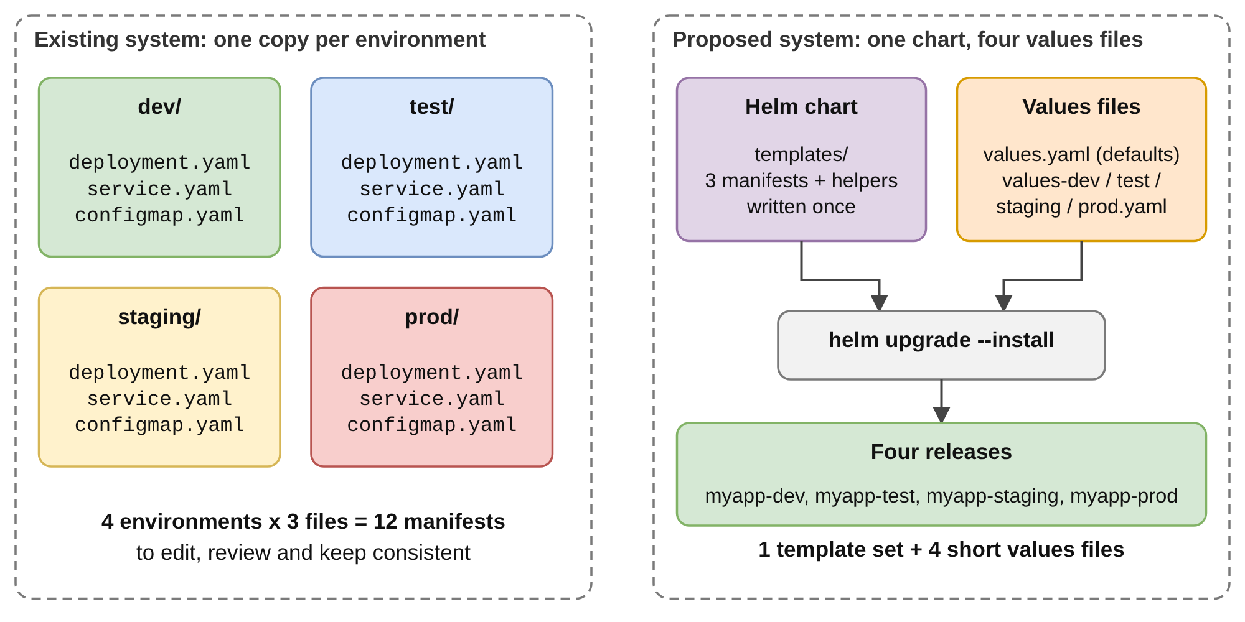
Figure 1.1 – Copied manifests per environment compared with one chart and four values files

1.3 Problem Statement
Design and implement a configuration-​management solution in which one application is described once, can be deployed to development, test, staging and production with environment-​specific settings, validates those settings before deployment, can be upgraded and rolled back safely, and is checked automatically on every change. The solution must be reproducible on a laptop cluster, must not contain hard-coded secrets and must not require copying manifests between environments.

1.4 Objectives of the Project
The project pursues ten objectives, taken from the project brief. Table 1.1 lists them with the artefact that realises each one and the section where it is discussed.
Table 1.1 – Project objectives and where they are addressed
No. | Objective | Realised by | Discussed in
O1 | Simple web application with Flask, HTML, CSS and Bootstrap | app/ | Section 3.4
O2 | Dashboard with application name, environment, version and configuration | index.html, /api/config | Section 3.4.2, Section 4.3
O3 | Four environments: development, testing, staging, production | values-​<env>.​yaml | Section 3.7.2, Section 4.2
O4 | Reusable Helm chart with the required files | helm/​multi-​env-​app/ | Section 3.6, Section 3.8
O5 | Docker configuration to containerise the application | Dockerfile | Section 3.5
O6 | Kubernetes deployment on Minikube | minikube-​setup.​sh, deploy.sh | Section 3.9, Section 4.1
O7 | Helm commands for install, validation, upgrade and rollback | helm upgrade --install, helm rollback | Section 3.10, Section 4.7
O8 | GitHub Actions integration for automatic validation | helm-​validation.​yml | Section 3.12
O9 | Testing scripts for environment-​specific configuration | tests/, test-​environments.​sh | Section 3.11, Section 4.4
O10 | No hard-coded secrets; consistent configuration | values.​schema.​json, Secret | Section 3.13, Section 4.6

1.5 Scope, Limitations and Contribution
The deployed workload is a small stateless Flask application whose behaviour depends entirely on configuration, which makes the effect of every value visible on its dashboard. The four environments are separated by namespaces in one cluster. The chart contains no Secret: the production SECRET_KEY is created by the deployment script and never stored in Git. Ingress, autoscaling and a GitOps controller are not used and are listed as extensions in Chapter V. The chart, scripts and tests were executed on the development machine and in GitHub Actions, where a temporary kind cluster [17] runs all four environments. Minikube [18] is the documented local platform and the scripts support it, but it was not executed; Section 4.1 states for every result where and how it was obtained.
The main contribution is a small, reproducible example of configuration management with Helm that a student team can read in one sitting and run on a laptop: a reusable chart, a schema-​validated values interface, release management with rollback and a workflow that deploys every environment to a real cluster. The report goes beyond a demonstration with two deliberate failures (a missing image and a missing Secret) and a measurement of the requests that fail while a release is updated.

1.6 Organisation of the Report
Chapter II surveys the literature. Chapter III presents the methodology: requirements, architecture, application, container, chart, values, release management, scripts, tests and the CI workflow. Chapter IV states the evidence levels and presents the results of the cluster runs, tests and experiments. Chapter V concludes and lists future enhancements. The appendices print the core source files.

CHAPTER 2
LITERATURE SURVEY

2.1 Research Papers and Documentation
The works in Table 2.1 were reviewed for their relevance to configuration errors, configuration code, container platforms and automated delivery. The table states only what each work reports and what the project takes from it.
Table 2.1 – Surveyed literature and its consequence for the design
Source | What it reports | Consequence for this project
Wiggins, The Twelve-Factor App [1] | Configuration that varies between deploys must be stored in the environment, strictly separated from code | All settings are environment variables; Helm supplies them from a ConfigMap and, in production, a Secret
Yin et al., SOSP 2011 [2] | 546 real misconfigurations; most are mistakes in setting parameters, a large share of them illegal values | Typed and bounded values checked by values.​schema.​json
Xu and Zhou, 2015 [3] | Survey of techniques to prevent, detect and diagnose configuration errors | Prevention (schema) and detection (lint, rendering, tests, CI) before deployment
Rahman and Williams, 2018; Rahman et al., 2019 [14, 15] | Configuration scripts are defect-prone; a mapping study of 31 infrastructure-​as-​code publications finds testing little studied | Chart and values are reviewed, versioned and tested like code
Rahman et al., 2023 [16] | 2,039 Kubernetes manifests from 92 repositories show 11 categories of security misconfiguration, such as missing limits | Resource limits in every environment, non-root user, all capabilities dropped
Zerouali et al., 2023 [13] | 9,482 Helm charts: most are unofficial and many images carry known vulnerabilities | Pinned versions, slim base image, few dependencies
Verma et al., 2015; Burns et al., 2016 [7, 8] | Borg and the lessons that led to Kubernetes, including declarative specifications | Desired state is declared; restarts, rolling updates and probes are left to the platform
Limoncelli, 2018 [19] | GitOps: desired state in version control, changed by reviewed commits | All files, including every environment's values, are in Git and checked by one workflow
Humble and Farley, 2010; Forsgren et al., 2018 [4, 5] | The deployment pipeline; automation and version control are associated with better delivery performance | GitHub Actions: tests, lint, render, build, deploy to kind
Merkel, 2014 [6] | Containers give a consistent environment from development to deployment | One image is built once and promoted unchanged

The research literature describes problems and principles; the behaviour of the tools is described in their documentation, the second class of sources. The Helm documentation defines the layering of values [11], chart tests [20], the linter [21] and the upgrade and rollback commands [12, 22]; the Kubernetes documentation describes ConfigMaps [23], Secrets [24], probes [25] and Services [26]; and the GitHub documentation defines the workflow syntax [27].

2.2 Existing Approaches to Configuration Management
Four approaches are common: copying manifests per environment; injecting settings through environment variables or files baked into images [1]; layering overlays on a shared base, for example with Kustomize [28]; and packaging the application as a chart with layered values [11]. A GitOps controller can reconcile any of them from Git [19]. Table 2.2 compares them on the criteria that matter here.
Table 2.2 – Comparison of configuration-​management approaches
Approach | Duplication | Input validation | History and rollback | Remark
Copied manifests per environment | High: every object is repeated | None beyond the API server checks | Only through Git history | Drift is likely
Environment variables or baked-in files | Low for settings, none for structure | Application-​specific | Image tags only | Does not describe Kubernetes objects
Overlays and patches on a base | Low | The rendered output can be validated | Not built in; relies on Git | No release concept
Helm chart with values layering | Low: one template set | Schema in values.​schema.​json; lint | Numbered revisions; helm rollback [12] | Chosen approach
GitOps controller over any of these | Depends on the source | Depends on the source | Git revert and controller history | Planned extension

2.3 Research Gaps and Objective
The survey leads to four requirements: configuration must be separated from structure; every value must be validated against an explicit contract before deployment; every deployment must be recorded so that it can be reversed; and every change must pass the same automated checks (Section 3.2). The studies cited analyse existing repositories and describe the problems found in them; they do not supply a small, executable reference with the following properties, which motivate this project:
1. A small, complete, reproducible reference. A reusable chart, validated values, per-environment configuration, rollback and CI are rarely available together in an example that can be read in one sitting and run on a laptop.
2. Results with a stated origin. Reports on deployment tooling seldom say whether a result was measured on a cluster or only derived; this report labels every result with its evidence level (Section 4.1).
3. Attention to what happens during a rollout. A rolling update is often called “zero downtime” without measurement; the project measures the failed requests (Section 4.9).
4. Silent failure modes. The behaviour of a release when a prerequisite such as an image or a Secret is missing is rarely shown; the project provokes both failures (Section 4.8).

CHAPTER 3
PROPOSED METHODOLOGY

3.1 Existing and Proposed System
In the existing arrangement each environment has its own directory of manifests: a Deployment, a Service and a ConfigMap are written for development and copied, with edited values, for test, staging and production. This needs no special tooling, but differences between the copies are not visible as differences, a change must be repeated in every copy, nothing checks the edited values before the cluster accepts or rejects them, and there is no recorded history to restore. The proposed system replaces the copies with one Helm chart and four small values files; Table 3.1 compares the two. The application reads all settings from environment variables, so the same image runs in every environment, and a GitHub Actions workflow repeats the validation on every change and deploys all four environments to a temporary cluster.
Table 3.1 – Existing and proposed systems compared
Aspect | Existing system | Proposed system
Structure | One set of manifests per environment | One set of templates for all environments
Environment differences | Hidden inside the copies | Explicit in values-​<env>.​yaml (28 to 43 lines each)
Application image | Often rebuilt or edited per environment | One image multi-​env-​app:​1.​0.​0 promoted unchanged
Validation | By the API server at deploy time | Schema, lint, render and manifest checks before deploy
Deploy command | Apply several files by hand | helm upgrade --install with one values file
Secrets | Often written into the manifests | Never in Git; Secret created at deploy time
History and rollback | Search Git for an older file | helm history and helm rollback

3.2 System Requirements
The functional requirements follow from the objectives and the survey: (FR1) render one application for four named environments from one chart, taking every environment-​specific setting from a values file; (FR2) reject unknown environments, wrong types, out-of-range values and secrets in the configuration before deployment; (FR3) show the name, environment, version and configuration on a dashboard and as JSON; (FR4) install, upgrade, test and list the revisions of a release with one command each; (FR5) restore an earlier revision with one command, and automatically after a failed upgrade; (FR6) run lint, rendering, manifest validation and a deployment test on every change; (FR7) keep secrets out of the repository, so that production reads its SECRET_KEY from a Kubernetes Secret. The non-functional requirements are reproducibility on a laptop cluster, readable files, secure defaults, pinned tool versions and honest reporting of results. Table 3.2 lists the software and hardware used.
Table 3.2 – Software and hardware environment
Component | Version or specification | Purpose
Helm | v3.16.2 (pinned in CI and used locally) | Packaging, rendering, release management
Kubernetes | v1.35.0 on kind v0.31.0 (CI); manifests schema-checked for 1.31.0 | Target platform; local cluster
Minikube | Any current version (documented, not executed); 2 CPUs and 4 GB, a practical minimum that was not measured | Local cluster on a laptop
Docker, Python | Docker 28.0.4 (CI), 29.9 (development machine); Python 3.12 (image, CI), 3.13 (development machine) | Image build; Flask application and tests
CI runner | GitHub-hosted ubuntu-latest (details in Section 4.1) | Runs all workflows

3.3 Block Diagram and Explanation
Figure 3.1 shows the end-to-end flow; the numbers of the explanation below are those of the figure.
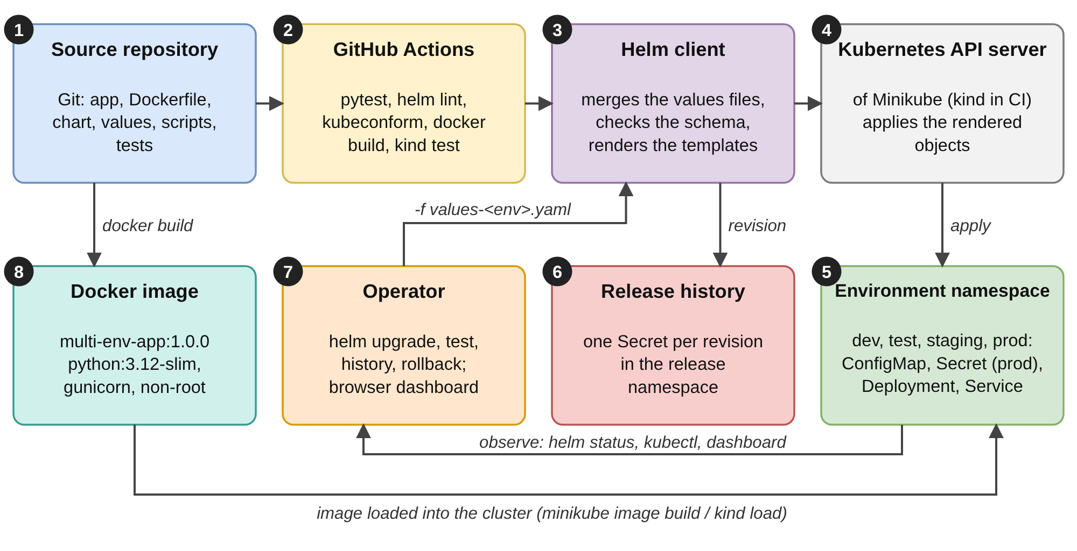
Figure 3.1 – Block diagram of the multi-​environment Helm solution
1. Source repository and GitHub Actions. Git holds the application, Dockerfile, chart, scripts, tests and workflows. On every push the workflow runs the tests, lints and renders the chart for the four environments, validates the manifests, builds the image and deploys all four environments to a temporary kind cluster (Section 3.12).
2. Helm client. For one release the client merges values.yaml, one environment file and the command-line overrides, checks the result against values.​schema.​json and renders the templates into plain manifests.
3. Kubernetes API server and namespaces. The API server of Minikube (or kind) receives the rendered ConfigMap, Deployment and Service and the controllers create the Pods. Each environment has its own namespace (dev, test, staging, prod); production also holds the Secret multi-​env-​app-​secrets.
4. Release history. Helm stores every revision as a Secret of type helm.​sh/​release.​v1 in the namespace of the release; helm history and helm rollback read it.
5. Operator and image. The operator uses helm upgrade, helm test, helm history, helm rollback, kubectl and the dashboard. The image is built once and loaded into the cluster (minikube image build or kind load); no registry is needed.

3.4 Application Design
The application is a small Flask [29] service whose only job is to make the configuration that Helm injected visible (Figure 3.2). Its complete code is in Appendix B.
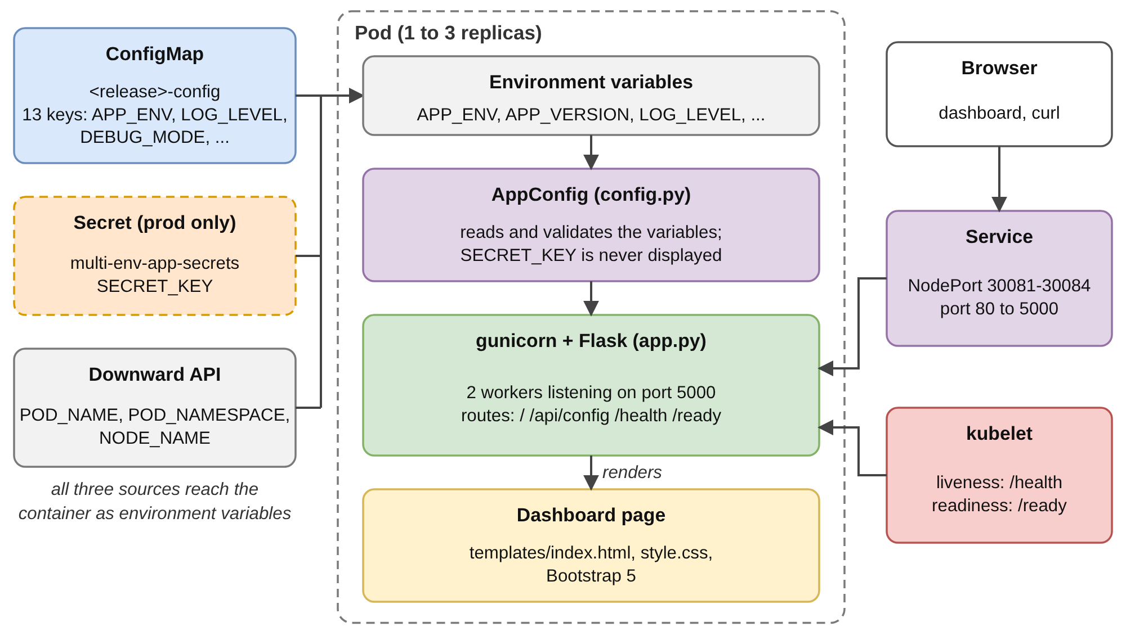
Figure 3.2 – Application inside a Pod: sources of configuration, request flow and probes

3.4.1 Routes, Configuration and Secret Handling
Four read-only routes (Table 3.3) serve people and scripts and Kubernetes. create_app() builds the configuration once and every route uses it, so the dashboard, the JSON and the probes cannot disagree about the environment. AppConfig takes a snapshot of the environment variables at start, validates APP_ENV against the four environments, converts booleans and integers with safe defaults and separates the settings that may be shown from the secret key. If no SECRET_KEY is supplied a random key is generated per process, so no key is ever committed; the dashboard and the API show only the source of the key (kubernetes-​secret or auto-generated). Settings such as MAX_CONNECTIONS or DATABASE_HOST are displayed but not used by a database; they stand for settings that differ between environments. Table 3.4 lists the variables.
Table 3.3 – Application routes
Route | Purpose | Response | Used by
/ | Dashboard index.html | HTML, 200 | Browser
/api/config | Name, environment, version, settings (secret masked), runtime | JSON, 200 | curl, helm test, live checks
/health | Liveness: the process answers | JSON, 200: status ok | kubelet, Docker HEALTHCHECK
/ready | Readiness: ready for traffic | JSON, 200: status ready, environment | kubelet, availability probe

Table 3.4 – Environment variables read by the application
Variable | Default in code | Set by
APP_NAME, APP_VERSION, REPLICA_COUNT | Multi-Env Config Dashboard, 1.0.0, 1 | ConfigMap, from app.name, app.version (or the image tag), replicaCount
APP_ENV | development; an unknown value falls back to it with a warning | ConfigMap, from environment
LOG_LEVEL, DEBUG_MODE, FEATURE_​BETA_​BANNER | INFO, false, false | ConfigMap, config.*
MAX_CONNECTIONS, CACHE_​TTL_​SECONDS, DATABASE_HOST, API_BASE_URL | 10, 60, localhost, http://​localhost:​5000/​api | ConfigMap, config.* (illustrative settings)
HELM_RELEASE, HELM_​CHART_​VERSION | not-​deployed-​with-​helm, n/a | ConfigMap, from the release and the chart
SECRET_KEY | random per process; shown only as a masked value | Secret multi-​env-​app-​secrets (production)
POD_NAME, POD_NAMESPACE, NODE_NAME, PORT | local, local, local, 5000 | Downward API [30]; Deployment

3.4.2 Dashboard and Probes
The dashboard is a Jinja2 template styled with Bootstrap 5 [31] from a CDN and a short style.css; it is rendered on the server and needs no JavaScript. Figure 3.3 labels its parts: (1) the navigation bar with the application name and the badge of the environment; (2) cards for the name, environment, version and desired replicas; (3) the configuration table, which is the content of the ConfigMap as the application sees it; (4) the Kubernetes runtime panel with Pod, namespace, node, release and chart version; (5) links to /api/config, /health and /ready; and (6) the footer. The colour of the bar, cards and table header comes from the environment (green for development, cyan for testing, yellow for staging, striped red for production), so that the audience can tell at a glance which environment is shown. Kubernetes calls /health for the liveness probe and /ready for the readiness probe [25]; the logger level is taken from LOG_LEVEL, so the effect of the setting is visible in the logs (Section 4.3).
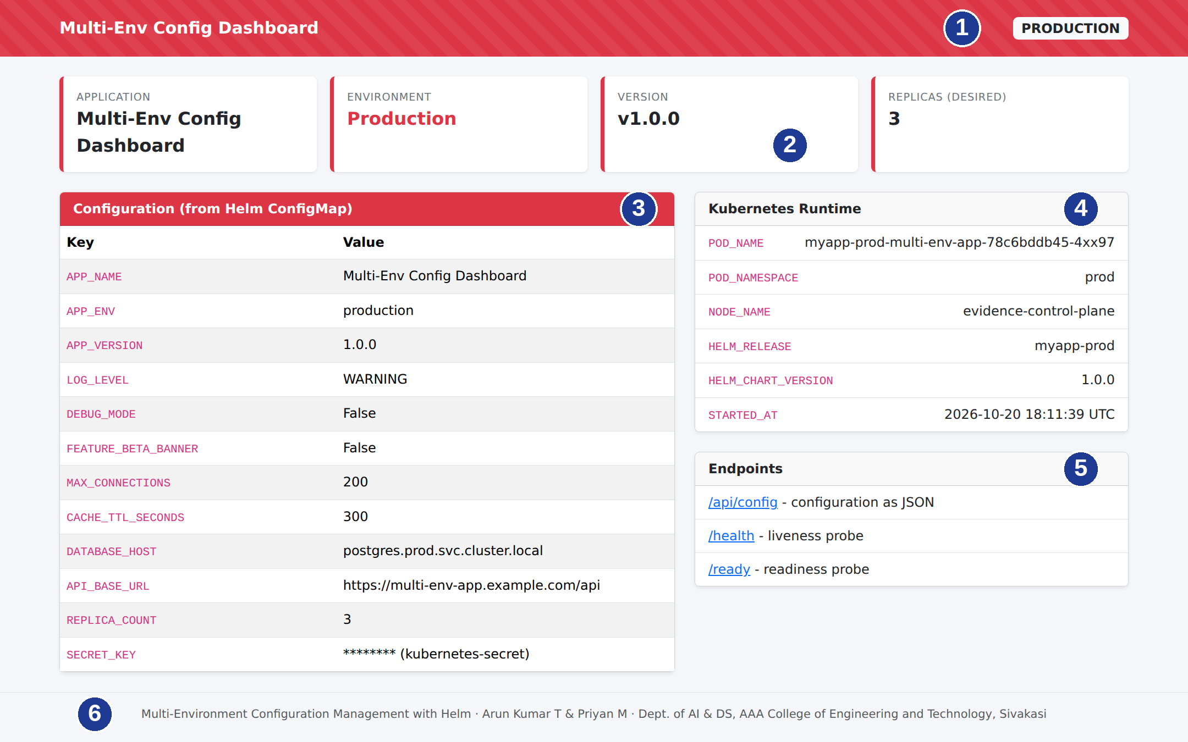
Figure 3.3 – Parts of the dashboard (production release)

3.5 Containerisation
The Dockerfile builds one image that is used in all four environments (Figure 3.4). Dependencies are installed before the code is copied, so that Docker can reuse the cached dependency layer when only the code changes [32]. The container runs as the unprivileged user 10001, which matches the securityContext of the chart; a HEALTHCHECK lets Docker report its state outside Kubernetes; and gunicorn [33] with two workers replaces the Flask development server, started with exec so that it receives the termination signal of Kubernetes. The file is printed in Appendix C.
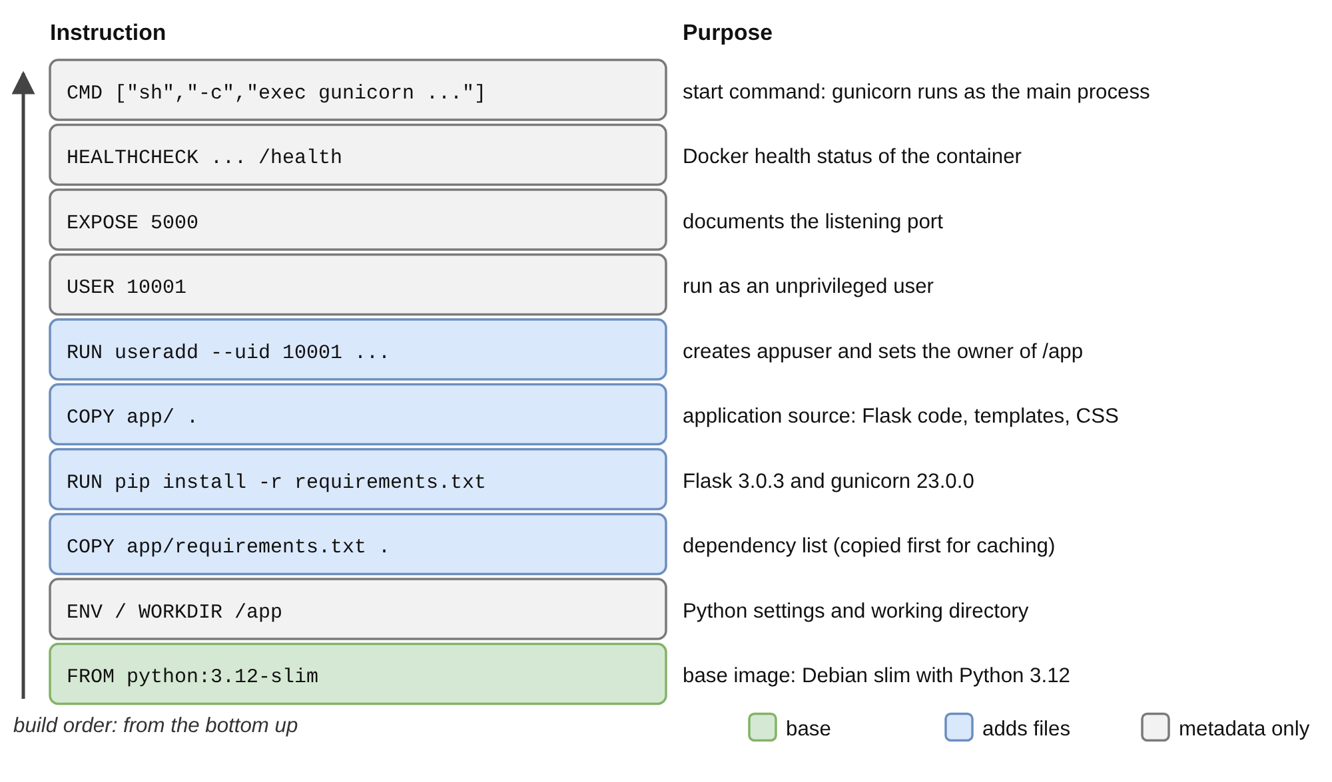
Figure 3.4 – Layered structure of the application image (instruction and purpose)

3.6 Helm Chart Design
The chart multi-env-app (apiVersion: v2, chart version and application version 1.0.0 [10]) consists of Chart.yaml, values.yaml, four environment files, values.​schema.​json, _helpers.tpl, templates for the ConfigMap, Deployment and Service, a test Pod and NOTES.txt; the directory tree is in Appendix A. Names and labels are produced once in _helpers.tpl and included by every template. An object is named after the release (myapp-​dev-​multi-​env-​app), and two label sets exist: the selector labels, which must not change between upgrades because the selector of a Deployment is immutable, and the common labels, which add chart, version, manager and environment.

3.7 Values and Environment-​Specific Configuration

3.7.1 Layering of Values
Helm builds the values in layers [11]: values.yaml has the lowest precedence, files passed with -f override it in the order given, and --set has the highest precedence; maps are merged key by key, so an environment file mentions only what differs (Figure 3.5). deploy.sh passes exactly one environment file, so -f values-​prod.​yaml is all that distinguishes a production release from a development release. Table 3.5 resolves six values for a staging release started with --set replicaCount=3 --set config.​LOG_​LEVEL=DEBUG; the last column was produced with helm template. Settings under config are strings because they end up in a ConfigMap, so numbers must be given with --set-string, as --set config.​CACHE_​TTL_​SECONDS=130 is rejected by the schema; Helm itself recommends clearly typed values [34].
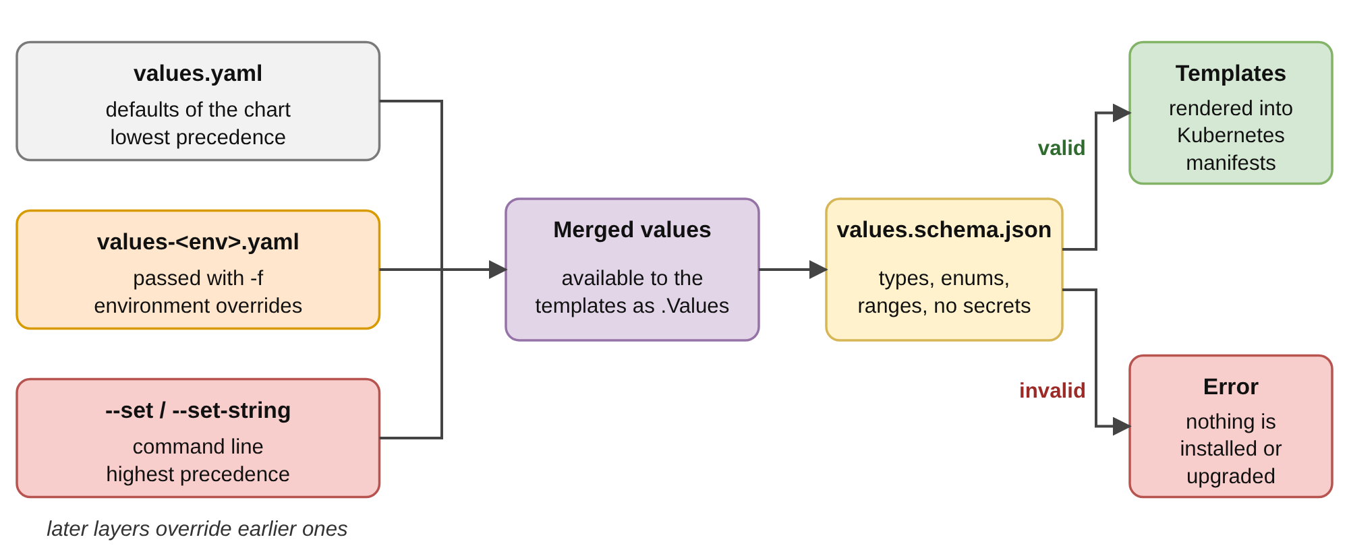
Figure 3.5 – Values layering and schema validation
Table 3.5 – Effective values of a staging release with two command-line overrides
Value | values.yaml | values-​staging.​yaml | Command line | Effective value
replicaCount | 1 | 2 | 3 | 3 (command line)
config.​LOG_​LEVEL | INFO | INFO | DEBUG | DEBUG (command line)
config.​MAX_​CONNECTIONS | 10 | 50 | none | 50 (file)
config.​FEATURE_​BETA_​BANNER | false | false | none | false
service.​nodePort | empty | 30083 | none | 30083 (file)
image.tag | empty | not set | none | empty, so 1.0.0 from appVersion

3.7.2 Configuration of the Four Environments
Table 3.6 lists the settings that differ between the environments, read from the values files. Development is the smallest and most verbose; testing adds information-​level logs and the beta banner; staging has the flags of production, two replicas and larger limits; production has three replicas, warning-level logs, the largest limits and its secret key from a Kubernetes Secret. The values are design choices for demonstration; a real project would tune them from measurements.
Table 3.6 – Environment-​specific configuration (values that differ)
Setting | dev | test | staging | prod
Release / namespace | myapp-dev / dev | myapp-test / test | myapp-staging / staging | myapp-prod / prod
environment | development | testing | staging | production
Replicas | 1 | 1 | 2 | 3
LOG_LEVEL | DEBUG | INFO | INFO | WARNING
DEBUG_MODE | true | false | false | false
FEATURE_​BETA_​BANNER | true | true | false | false
MAX_CONNECTIONS | 5 | 10 | 50 | 200
CACHE_​TTL_​SECONDS | 10 | 30 | 120 | 300
CPU request / limit | 25m / 100m | 50m / 150m | 100m / 250m | 100m / 500m
Memory request / limit | 64Mi / 128Mi | 64Mi / 128Mi | 96Mi / 192Mi | 128Mi / 256Mi
NodePort | 30081 | 30082 | 30083 | 30084
Secret | none (key generated) | none (key generated) | none (key generated) | multi-​env-​app-​secrets
Lines in the values file | 28 | 28 | 28 | 43

3.7.3 Schema Validation of Values
values.​schema.​json is a JSON Schema (draft-07) [35] that Helm checks against the merged values on install, upgrade, lint and template [10]. Table 3.7 summarises its rules. It requires the top-level keys environment, replicaCount, image, app, config and service, and it forbids the keys SECRET_KEY, PASSWORD, DB_PASSWORD and API_TOKEN inside config, so that a secret cannot end up in a ConfigMap by mistake.
Table 3.7 – Rules of values.​schema.​json
Value | Rule | Purpose
environment | One of development, testing, staging, production | An unknown environment cannot be deployed
replicaCount | Integer, 1 to 10 | No empty or runaway Deployments
config.​LOG_​LEVEL | DEBUG, INFO, WARNING, ERROR or CRITICAL | Levels the application understands
config.​DEBUG_​MODE, config.​FEATURE_​BETA_​BANNER | The string true or false | ConfigMap values are strings
config.​MAX_​CONNECTIONS, config.​CACHE_​TTL_​SECONDS | String of digits | Numbers the application can parse
Keys of config | Upper-case letters, digits and underscores | Valid environment-​variable names
SECRET_KEY, PASSWORD, DB_PASSWORD, API_TOKEN in config | Forbidden | No secrets in a ConfigMap or in Git
image.​pullPolicy, service.type | Always, IfNotPresent, Never; ClusterIP, NodePort, LoadBalancer | Valid Kubernetes values
containerPort, service.port, service.​nodePort | Integer 1 to 65535; NodePort empty or 30000 to 32767 | Valid ports

3.8 Helm Templates
Three templates create the ConfigMap, Deployment and Service, a fourth creates the Pod run by helm test, and NOTES.txt prints a message after an install. All read their settings from .Values, so no environment name or number appears in a template.
ConfigMap. Six keys are fixed (APP_NAME, APP_ENV, APP_VERSION, REPLICA_COUNT, HELM_RELEASE, HELM_​CHART_​VERSION); the others are generated with a range loop over the config map, each value converted to a quoted string. A new setting needs no template change: it is added to config and appears as an environment variable. The production ConfigMap has 13 keys (Section 4.2).
Deployment. The container receives the ConfigMap with envFrom; if existingSecret is set, a secretRef is added to the same list. POD_NAME, POD_NAMESPACE and NODE_NAME come from the Downward API. Probes, resources, security contexts and the strategy are copied from the values with toYaml, so an environment can change them without a template change. Variables from a ConfigMap are read only when a container starts, so the template stores the SHA-256 checksum of the rendered ConfigMap in the annotation checksum/config of the Pod template; when a value in config changes, the Pod template changes and the Deployment performs a rolling update. The pytest case test_​config_​change_​changes_​checksum verifies this.
Code Snippet – Checksum annotation (templates/​deployment.​yaml, lines 21–23)
annotations:
# Roll the pods automatically whenever the ConfigMap content changes.
checksum/config: {{ include (print $.Template.BasePath "/configmap.yaml") . | sha256sum }}

Service and test. The Service selects only the Pods of its own release through the selector labels; its target port is the name http, so a change of containerPort needs no change in the Service. A fixed nodePort (30081 to 30084) is rendered only for the type NodePort [26]. The test Pod has the annotation helm.sh/hook: test, is created only by helm test [20], requests /health and /api/config with busybox and checks that the answer contains the environment name of the release, so a production release fails the test if it answers with another environment.

3.8.1 Rolling-Update Strategy
The strategy is a value: values.yaml sets RollingUpdate with maxSurge: 1 and maxUnavailable: 0. For a Deployment of N replicas the controller keeps the number of available Pods A(t) and the total number of Pods P(t) within the bounds Equation (3.1) and Equation (3.2) [9], where s is maxSurge and u is maxUnavailable.
N − u ≤ A(t) (3.1)
P(t) ≤ N + s (3.2)
With u = 0 and s = 1 an old Pod is removed only after a new one is ready, so A(t) never falls below N and P(t) never exceeds N + 1; in production this means at least three and at most four Pods. The alternative s = 0 and u = 1 allows A(t) to fall to N − 1, which is zero for a single replica. The bounds describe Pods, not requests; Section 4.9 measures what they mean for a client. Table 3.8 gives the size of the rendered manifests (four objects per environment: ConfigMap, Service, Deployment and test Pod), used in Section 4.5.
Table 3.8 – Rendered manifests and size of the environment files
Environment | Rendered lines | Values that differ from values.yaml | Lines in the values file
dev | 177 | 11 | 28
test | 177 | 8 | 28
staging | 177 | 12 | 28
prod | 179 | 13 | 43
16 settings are changed by at least one environment; 139 of the 177 lines of the development manifest occur in each of the other three manifests. Production is two lines longer because of the secretRef.

3.9 Kubernetes Topology and Objects
Figure 3.6 shows the cluster as deployed by scripts/​deploy.​sh all: one cluster, four namespaces, and in each one release with its ConfigMap, Deployment, Service and Pods. The objects of the production release are the namespace prod; the ConfigMap myapp-​prod-​multi-​env-​app-​config; the Secret multi-​env-​app-​secrets, which deploy.sh creates and the chart only refers to; the Deployment myapp-​prod-​multi-​env-​app with its ReplicaSet (one for every distinct Pod template) and three Pods; the Service with the NodePort 30084; one Secret of type helm.​sh/​release.​v1 for every revision, such as sh.​helm.​release.​v1.​myapp-​prod.​v1 [10, 36]; and the test Pod that helm test creates. All objects of a release carry the labels app.​kubernetes.​io/​instance and app.​kubernetes.​io/​name; the live objects are shown in Section 4.2.
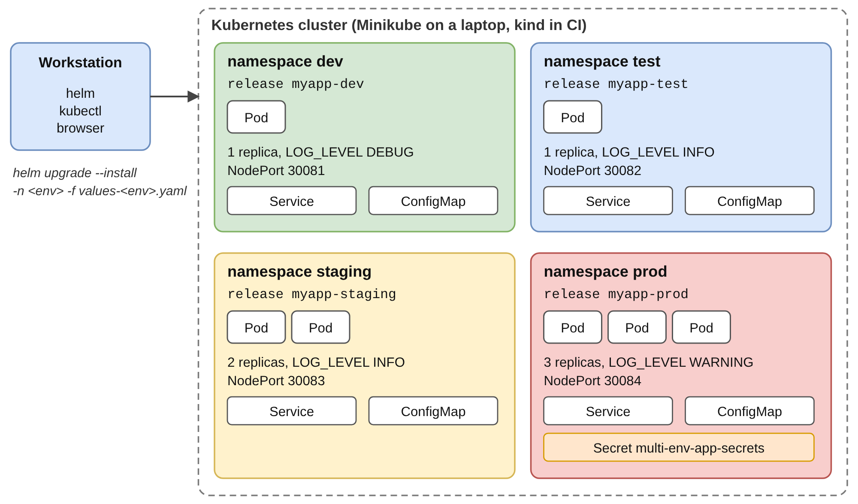
Figure 3.6 – Cluster topology: one namespace and one Helm release per environment

3.10 Release Management with Helm
A release is one installation of a chart with one set of values; the releases are named myapp-<env> and installed into the namespace <env> (Figure 3.7). helm upgrade --install creates the release if it does not exist and upgrades it otherwise; every change creates a numbered revision, and helm rollback creates another revision with the content of an earlier one [12]. --wait makes Helm return only after the Pods are ready, and --atomic implies --wait and rolls the release back if the upgrade does not become ready within the timeout [22]. The upgrade script does not use --reuse-values: the values file of the environment is always the source of truth. Table 3.9 lists the commands used.
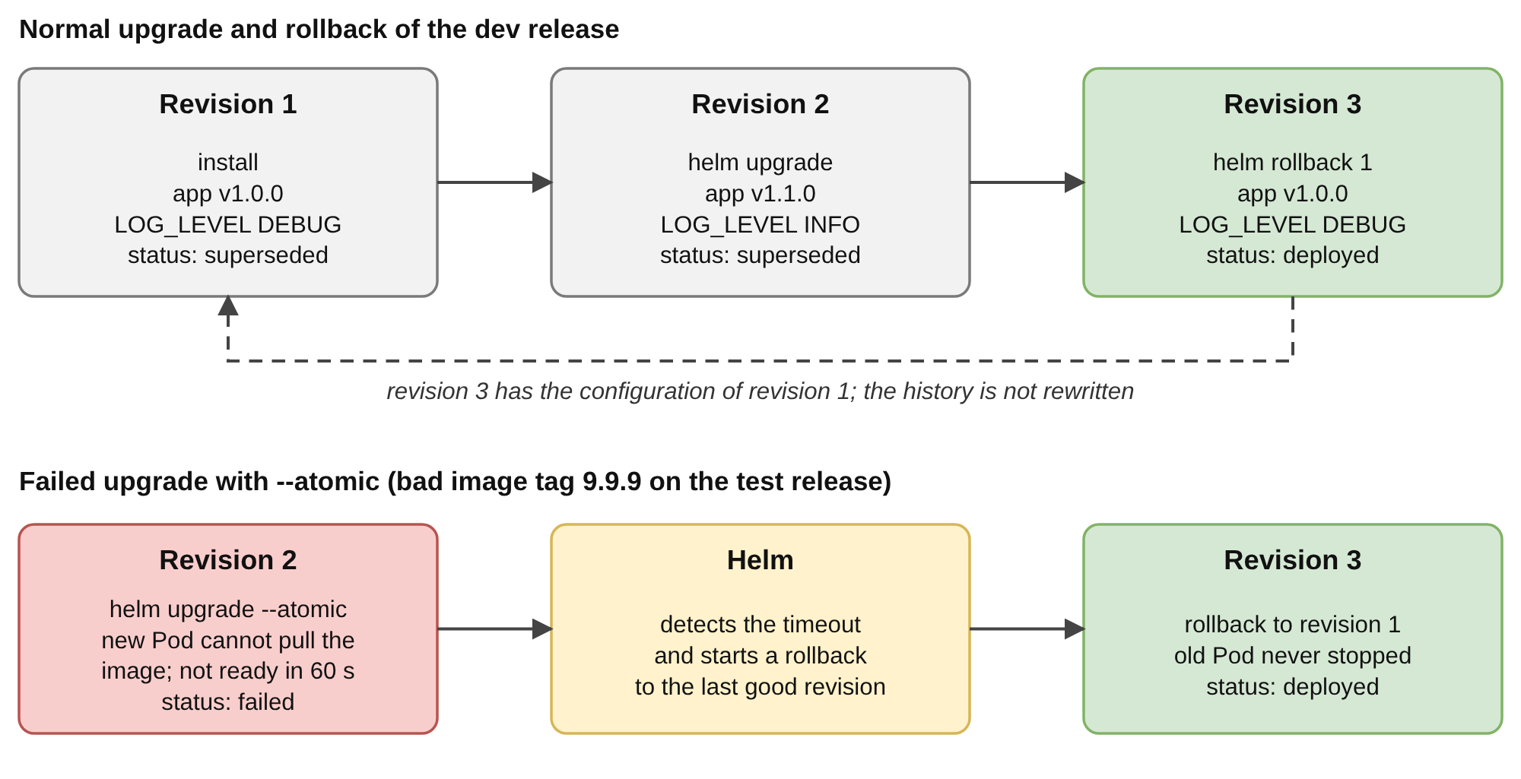
Figure 3.7 – Lifecycle of a Helm release
Table 3.9 – Helm commands used in the project
Command | Purpose | Used by
helm lint ./​helm/​multi-​env-​app --strict -f values-dev.yaml | Static checks; enforces the schema; warnings are errors | validate-​helm.​sh, CI, pytest
helm template myapp-dev ./​helm/​multi-​env-​app -f values-dev.yaml | Renders the manifests without a cluster | validate-​helm.​sh, pytest
helm upgrade --install myapp-dev ./​helm/​multi-​env-​app -n dev -f values-dev.yaml --atomic --wait --timeout 5m | Installs or upgrades and waits until ready | deploy.sh
helm test myapp-dev -n dev | Runs the test Pod of the release | test-​environments.​sh
helm history, helm get values, helm list -A | Revisions, supplied or computed values, releases | Demo script, evidence capture
helm rollback myapp-dev <previous> -n dev --wait --timeout 5m | New revision with the content of the previous revision (revision 1 in the demonstration) | upgrade-​rollback-​demo.​sh
helm uninstall myapp-dev -n dev | Removes a release and its objects | cleanup.sh

3.11 Automation Scripts and Testing Strategy
Nine shell scripts in scripts/ share the settings of common.sh (namespace, values file, release name, expected APP_ENV and NodePort of each environment), stop at the first error and check that the tools they need are installed (Table 3.10). A session on a laptop runs minikube-​setup.​sh, validate-​helm.​sh, deploy.sh all, test-​environments.​sh all, upgrade-​rollback-​demo.​sh dev and cleanup.sh in this order. validate-​helm.​sh needs no cluster.
Table 3.10 – Scripts of the project
Script | Lines | Purpose
common.sh | 43 | Shared settings and helper functions
minikube-​setup.​sh | 25 | Starts Minikube (2 CPUs, 4096 MB), builds the image inside it, creates the namespaces
deploy.sh <env|all> | 49 | Creates the namespace and the production Secret; runs helm upgrade --install
validate-​helm.​sh | 45 | Lint, render and kubeconform check of four environments, no cluster
test-​environments.​sh | 68 | 26 live checks of the deployed releases, including helm test
upgrade-​rollback-​demo.​sh | 50 | Upgrade to 1.1.0, history, rollback, verify
docker-demo.sh, cleanup.sh | 63, 12 | Four environments as plain Docker containers; uninstall and delete the namespaces
capture-​evidence.​sh | 238 | Records the evidence of this report on a cluster (Section 4.1)

The project is tested at four levels (Table 3.11). The first three run without a cluster and give feedback in seconds; the fourth needs a cluster. All 62 pytest cases [37] pass on the development machine and in CI, and the 26 live checks pass on kind. The cases that need Helm are skipped, not failed, when the binary is absent. test_​production_​hardening states the rules for production as assertions, so an edit of values-​prod.​yaml that enables debug mode or removes the Secret fails before it reaches a cluster.
Table 3.11 – Test levels
Level | Tool and file | Cases | Examples
1. Application | pytest, test_app.py | 15 | Dashboard shows name, environment and version; probes answer; the secret is masked; an unknown environment falls back to development
2. Static configuration | pytest, test_​helm_​config.​py | 32 | Required files; same config keys in every environment; unique NodePorts in range; production hardening; no secret-like key has a value
3. Chart behaviour | pytest, test_​helm_​config.​py | 15 | helm lint --strict for four environments; rendered objects match the values; checksum changes with the config; five invalid values rejected
4. Live cluster | test-​environments.​sh, helm test | 26 | Release deployed; replicas ready; APP_ENV, REPLICA_COUNT; /health; production debug off and secret from a Secret; four helm test runs

3.12 Continuous Integration with GitHub Actions
The workflow helm-​validation.​yml runs on every push and pull request and on demand. It has four jobs (Table 3.12, timeline in Section 4.10); the first three run in parallel and the fourth, which deploys to a cluster, starts only if all three pass (needs:). The versions of Helm (v3.16.2) and kubeconform (v0.6.7) [38] and the Kubernetes version of the manifest schemas (1.31.0) are fixed in the env: block, so that a new tool release cannot change the result for an unchanged commit [27]. A second workflow, capture-​evidence.​yml, records the evidence of this report on a kind cluster and commits it with [skip ci] (Section 4.1).
Table 3.12 – Jobs of the workflow helm-​validation.​yml
Job | Steps | Failure means
Unit and configuration tests | Install dependencies; python -m pytest -v (62 cases) | Application, values or chart logic is wrong
Helm lint, template, kubeconform | validate-​helm.​sh for four environments; upload the rendered manifests | Schema violation, template error or invalid Kubernetes object
Docker build and smoke test | Build the image; run it with APP_ENV=testing; check /health, /api/config and the dashboard | The image does not build or start
Deploy to a kind cluster | Create cluster; load image; deploy.sh all; test-​environments.​sh all; upgrade-​rollback-​demo.​sh dev | A release is not ready, a live check fails, or an upgrade or rollback fails

3.13 Security and Secret Handling
Table 3.13 lists the risks that the design addresses, the measure for each and where it can be checked. The project is a teaching example and does not claim to be a hardened production system.
Table 3.13 – Security measures
Risk | Measure | Where
Secret committed to Git | No secret in any values file; production reads SECRET_KEY from the Secret that deploy.sh creates with a random key | values-​prod.​yaml, deploy.sh, test_​no_​hardcoded_​secrets
Secret placed in a ConfigMap | The schema forbids SECRET_KEY, PASSWORD, DB_PASSWORD and API_TOKEN in config | values.​schema.​json
Secret shown by the dashboard or API | The key is replaced by ******** (<source>) | config.py, test_​secret_​key_​is_​never_​exposed
Container runs as root | UID 10001, runAsNonRoot, no privilege escalation, all capabilities dropped | Dockerfile, values.yaml
Resource exhaustion | CPU and memory requests and limits in every environment | values-*.yaml
A bad release stays in service | --atomic rollback; the readiness probe keeps new Pods out of service until they answer | deploy.sh, values.yaml
Moving dependencies | Pinned Flask 3.0.3, gunicorn 23.0.0, Helm, kubeconform and schema versions; slim base image | requirements.​txt, workflow env:

Kubernetes Secrets are only base64-encoded by default and can be read by anyone who may read Secrets in the namespace, so encryption at rest, role-based access control and an external secret manager are needed in a real cluster [24]. The image was not scanned for vulnerabilities and the base image is selected by tag, not digest (Chapter V).

3.14 Resource Requirements of the Four Environments
Table 3.14 multiplies the requests and limits of Table 3.6 by the number of replicas (level C: computed, not measured). All four environments request 0.575 CPU and 704 MiB, and their limits add up to 2.25 CPU and 1,408 MiB. The requests fit easily into the Minikube cluster of 2 CPUs and 4096 MB that minikube-​setup.​sh creates, which must also run the Kubernetes system Pods (not measured). The limits exceed two CPUs; this is normal, because a limit is a ceiling that is not reserved, but all Pods could not run at their limits at the same time.
Table 3.14 – Resources requested by the four environments (m = millicores, Mi = mebibytes)
Environment | Replicas | CPU request / limit per Pod | Memory request / limit per Pod | Total requests | Total limits
dev | 1 | 25 m / 100 m | 64 Mi / 128 Mi | 25 m, 64 Mi | 100 m, 128 Mi
test | 1 | 50 m / 150 m | 64 Mi / 128 Mi | 50 m, 64 Mi | 150 m, 128 Mi
staging | 2 | 100 m / 250 m | 96 Mi / 192 Mi | 200 m, 192 Mi | 500 m, 384 Mi
prod | 3 | 100 m / 500 m | 128 Mi / 256 Mi | 300 m, 384 Mi | 1,500 m, 768 Mi
All four | 7 |  |  | 575 m, 704 Mi | 2,250 m, 1,408 Mi

CHAPTER 4
RESULTS AND DISCUSSION

4.1 Basis of the Results
Every result in this chapter carries one of four evidence levels (Table 4.1), and the text states the level where a result is introduced.
Table 4.1 – Evidence levels used in this report
Level | How the result was obtained | Used for
A Cluster run | Executed on a kind cluster in GitHub Actions; output in docs/evidence/ (capture-​evidence.​yml, run 2) or from the validation workflow (run 6) | Deployments, dashboards, live checks, upgrade, rollback, failures, availability, CI timings
B Local run | Executed on the development machine (Python 3.13, Helm v3.16.2, kubeconform v0.6.7) without a cluster | 62 pytest cases, validate-​helm.​sh, schema rejection tests
C Derived | Computed from level A or B data or from the repository files | Line counts, break-even analysis, failure rates, resource totals
D Documented only | Described in the README and supported by the scripts, but not executed | Minikube on a laptop, Windows, cloud clusters

The level A results were recorded on a GitHub-hosted runner (ubuntu-latest, Linux 7.0.0, AMD EPYC 7763, 4 vCPUs, 15 GiB) with Docker 28.0.4, kind v0.31.0 (one control-plane node, containerd 2.2.0), Kubernetes v1.35.0, Helm v3.16.2 and headless Google Chrome 155 for the screenshots. The dashboards are screenshots of pages served by the Pods through kubectl port-forward, not mock-ups, and the terminal figures are rendered from the text files in docs/evidence/ (omissions are stated in the captions). The cluster has a single node. Not executed were: a run on Minikube (the scripts support it), a run on Windows, a multi-node or cloud cluster, a load test, a vulnerability scan of the image and tests with other browsers.

4.2 Deployment of the Four Environments
scripts/​deploy.​sh all created the four namespaces and installed the four releases; in the validation workflow this took 40 s, and in the evidence run every release reached the status deployed at revision 1 (Figure 4.1). Table 4.2 summarises the objects of the four releases as the cluster reported them.
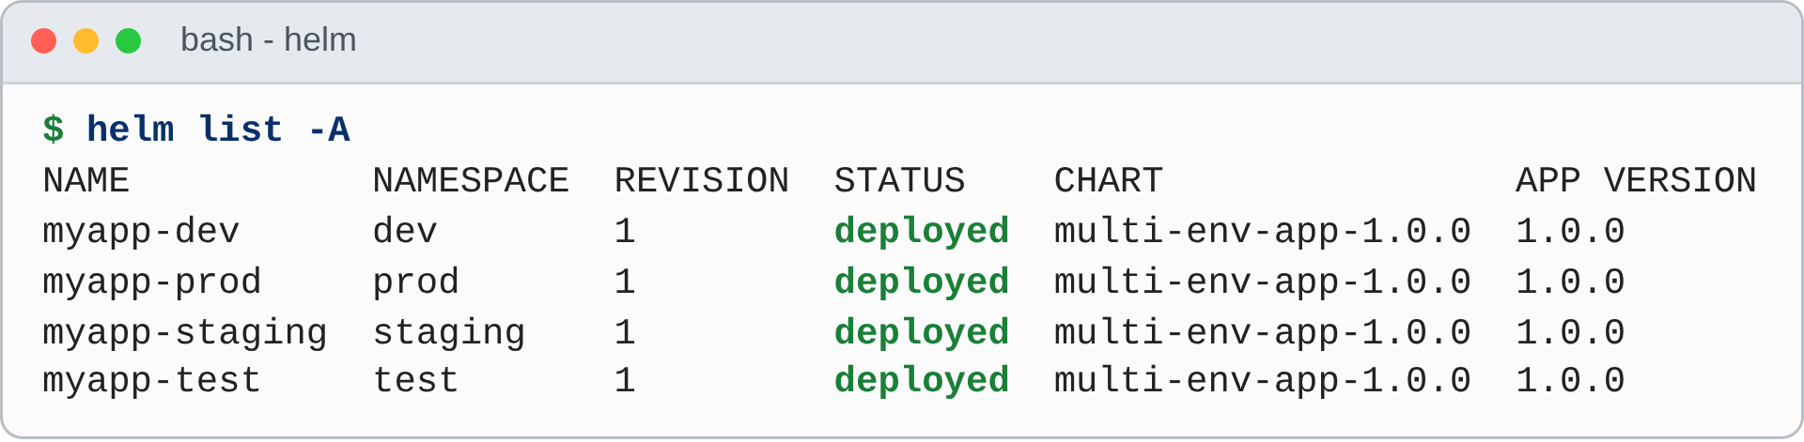
Figure 4.1 – Helm releases after scripts/​deploy.​sh all (helm list -A, update time omitted)
Table 4.2 – Releases of the four environments in the cluster (level A)
Environment | Namespace | Release | Ready / desired | Pods | NodePort | ConfigMap keys
Development | dev | myapp-dev | 1/1 | 1 | 30081 | 13
Testing | test | myapp-test | 1/1 | 1 | 30082 | 13
Staging | staging | myapp-staging | 2/2 | 2 | 30083 | 13
Production | prod | myapp-prod | 3/3 | 3 | 30084 | 13

Two Secrets exist in the production namespace (Figure 4.2). multi-​env-​app-​secrets holds the SECRET_KEY and was created by deploy.sh, not by the chart; sh.​helm.​release.​v1.​myapp-​prod.​v1 is the record of revision 1 that Helm stores and helm rollback reads.
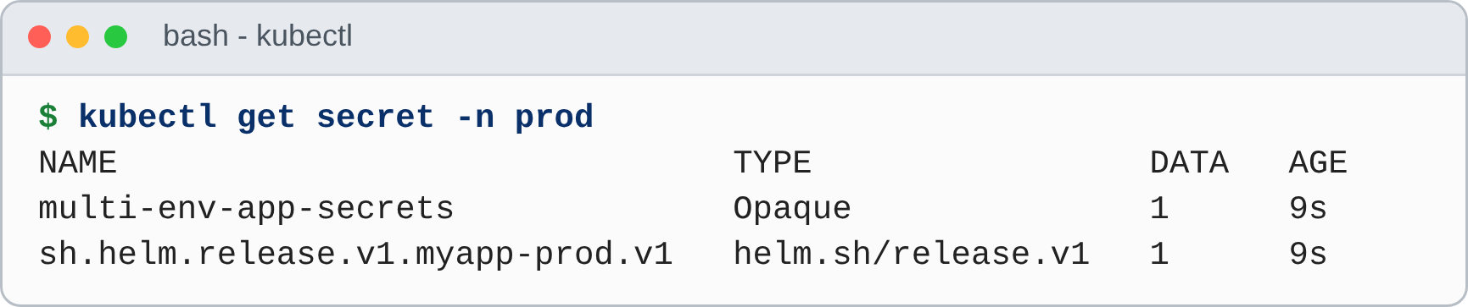
Figure 4.2 – Secrets of the production namespace (kubectl get secret -n prod)
Figure 4.3 shows the production Deployment as described by Kubernetes. It confirms that the values reached the cluster: three replicas; the strategy RollingUpdate with 0 maximum unavailable and 1 maximum surge; the checksum annotation; the image multi-​env-​app:​1.​0.​0; the resource requests and limits of production; the two probes; the environment taken from the ConfigMap and from the Secret multi-​env-​app-​secrets; and the Downward API variables.
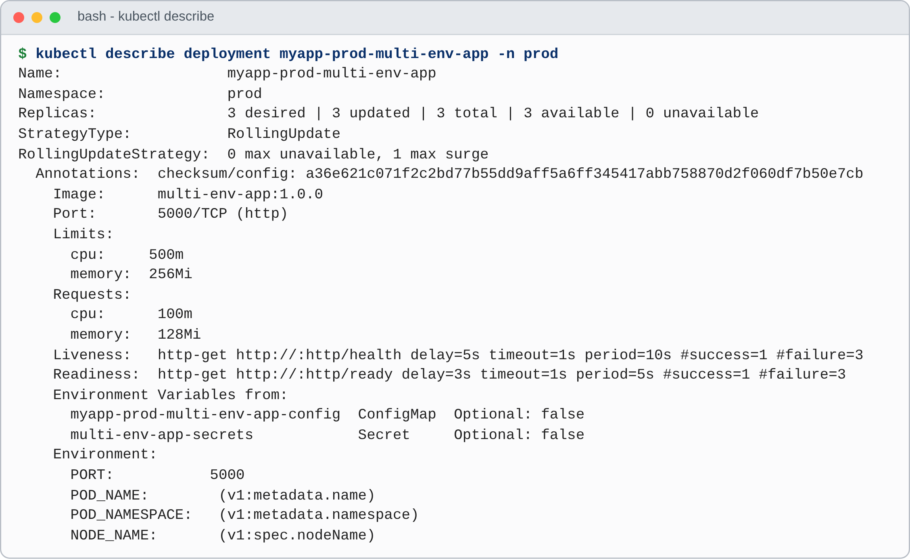
Figure 4.3 – Deployment of the production environment (kubectl describe deployment, selected lines)

4.3 Dashboards of the Four Environments
Figure 4.4 shows the upper part of the four dashboards, and Figure 4.5 the complete production dashboard. They are produced by the same image and the same templates; only the values file differs. The colour of the banner, the cards and the table header identifies the environment (green, cyan, yellow and striped red); development and testing show the beta banner because FEATURE_​BETA_​BANNER is true there. The replica cards show 1, 1, 2 and 3.
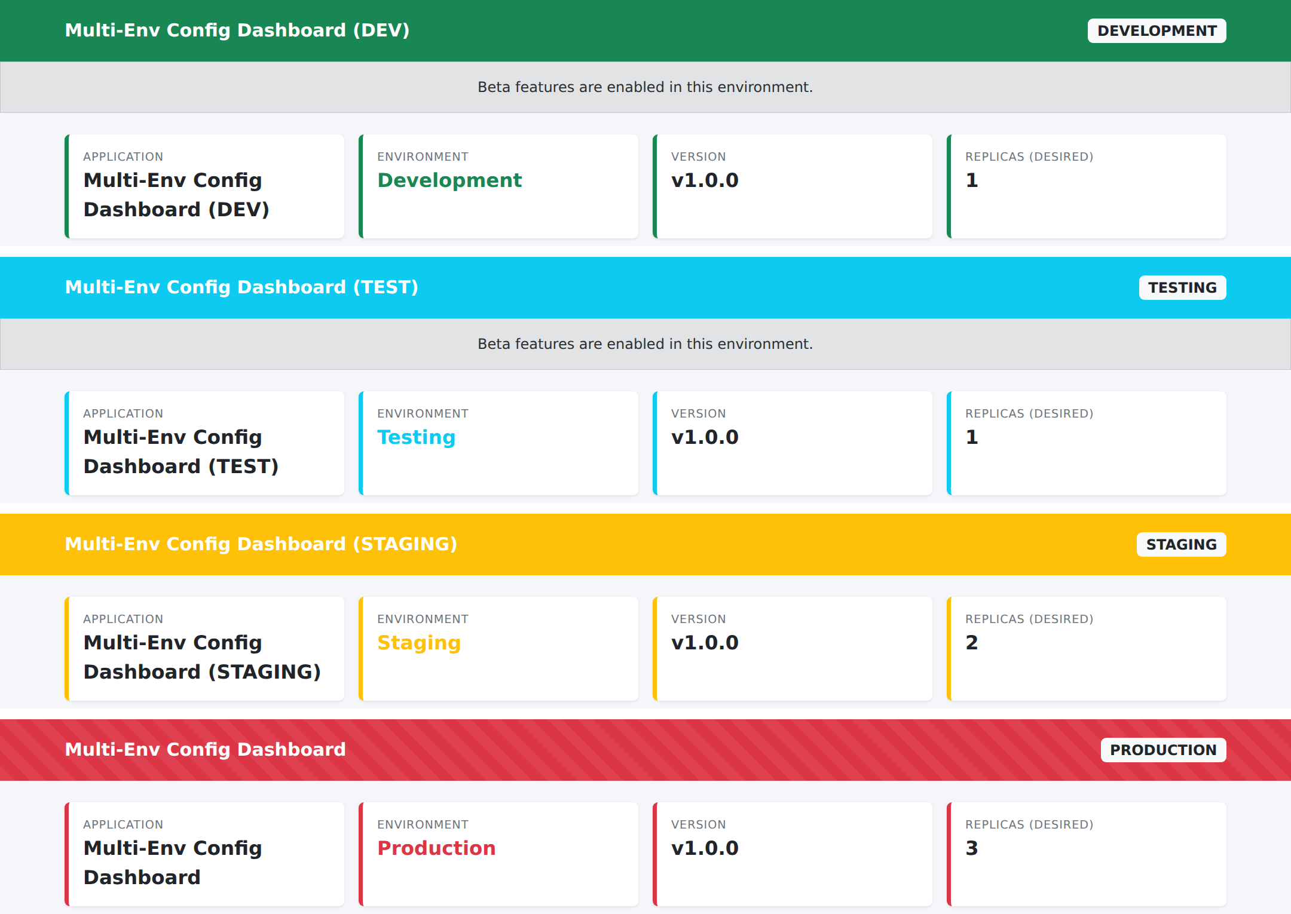
Figure 4.4 – Upper part of the dashboards of development, testing, staging and production (level A)
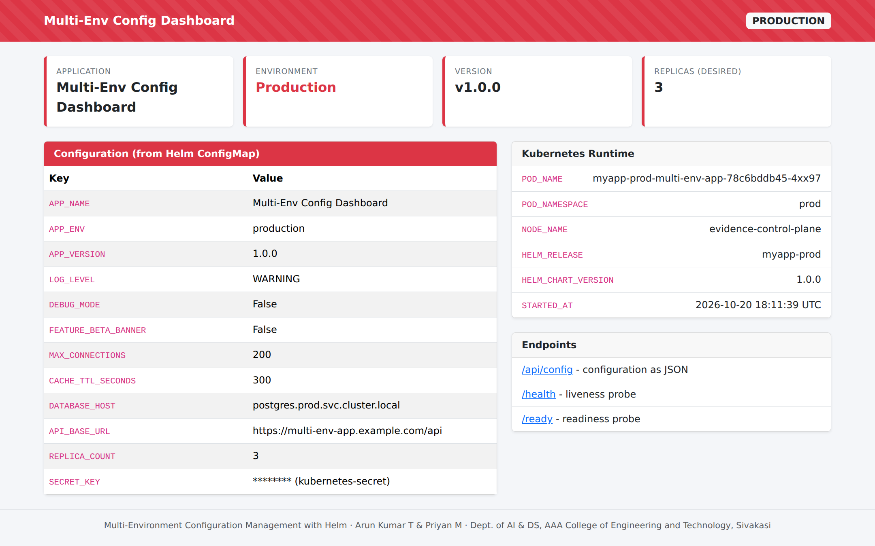
Figure 4.5 – Dashboard of the production environment, served by the Pod myapp-​prod-​multi-​env-​app-​78c6bddb45-​4xx97
The JSON that every Pod returns from /api/config was compared, value by value, with the values that Helm merges from values.yaml and the environment file: 11 settings in each of the four environments (44 comparisons) plus the source of the secret key, the release name and the namespace (12 comparisons). All 56 comparisons were equal (Table 4.3), which closes the chain from the file to the running container. The SECRET_KEY is shown only as a masked value with its source: auto-generated in development, testing and staging, and kubernetes-secret in production.
Table 4.3 – Settings reported by the running Pods through /api/config (level A)
Setting | dev | test | staging | prod
APP_NAME | Multi-Env Config Dashboard (DEV) | Multi-Env Config Dashboard (TEST) | Multi-Env Config Dashboard (STAGING) | Multi-Env Config Dashboard
APP_ENV | development | testing | staging | production
APP_VERSION | 1.0.0 | 1.0.0 | 1.0.0 | 1.0.0
LOG_LEVEL | DEBUG | INFO | INFO | WARNING
DEBUG_MODE | true | false | false | false
FEATURE_​BETA_​BANNER | true | true | false | false
MAX_CONNECTIONS | 5 | 10 | 50 | 200
CACHE_​TTL_​SECONDS | 10 | 30 | 120 | 300
DATABASE_HOST | postgres.​dev.​svc.​cluster.​local | postgres.​test.​svc.​cluster.​local | postgres.​staging.​svc.​cluster.​local | postgres.​prod.​svc.​cluster.​local
API_BASE_URL | http://​dev.​multi-​env-​app.​local/​api | http://​test.​multi-​env-​app.​local/​api | https://​staging.​multi-​env-​app.​example.​com/​api | https://​multi-​env-​app.​example.​com/​api
REPLICA_COUNT | 1 | 1 | 2 | 3
SECRET_KEY | (auto-​generated) | (auto-​generated) | (auto-​generated) | (kubernetes-​secret)
HELM_RELEASE | myapp-dev | myapp-test | myapp-staging | myapp-prod
POD_NAMESPACE | dev | test | staging | prod

The effect of LOG_LEVEL is visible in the logs (Figure 4.6): the development Pod, with the level DEBUG, prints the start-up message of the application and the access log of gunicorn; the production Pod, with the level WARNING, prints only the messages of gunicorn and the access log, and the start-up message of the application is suppressed.
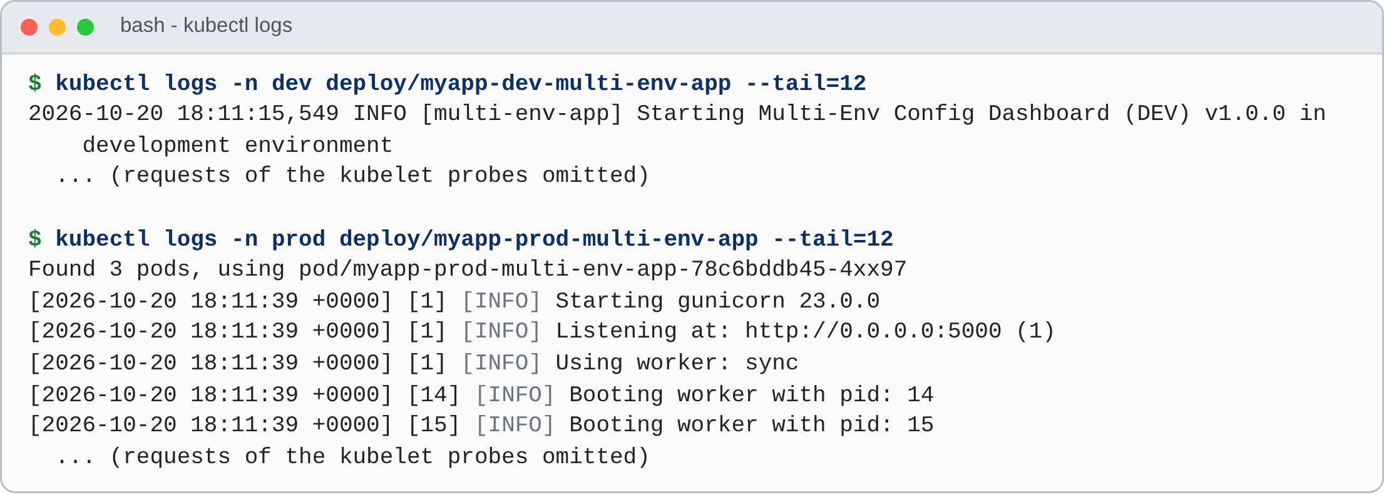
Figure 4.6 – Logs of a development Pod and a production Pod (kubectl logs, probe requests omitted)

4.4 Test Cases and Results
Table 4.4 lists the test cases and their results; all automated cases passed. The runs behind TC-01 to TC-06 are described below.
Table 4.4 – Test cases and results
ID | Test | Expected result | Result | Level
TC-01 | Application tests (tests/​test_​app.​py) | 15 cases pass | 15 passed | B, A
TC-02 | Static configuration tests (values files) | 32 cases pass | 32 passed | B, A
TC-03 | Chart tests with Helm (lint, render, checksum, schema) | 15 cases pass | 15 passed | B, A
TC-04 | validate-​helm.​sh: lint, render and kubeconform for 4 environments | No error; APP_ENV rendered correctly; 4 of 4 objects valid per environment | Passed for all four environments | B, A
TC-05 | Docker smoke test in CI | Container starts; /health, /api/config and the dashboard answer | Job succeeded | A
TC-06 | Live checks test-​environments.​sh all, including helm test | 26 checks pass; test Pod phase Succeeded | 26 passed, 0 failed; 4 of 4 helm test succeeded | A
TC-07 | Schema rejection of invalid values | 14 invalid inputs are rejected before deployment | 14 of 14 rejected | B
TC-08 | Upgrade and rollback of development | Revision 2 shows 1.1.0 and INFO; revision 3 restores 1.0.0 and DEBUG | As expected | A
TC-09 | Upgrade to a non-existent image with --atomic | Rollback to the previous revision; old Pod keeps running | As expected | A
TC-10 | Production installed without its Secret | Pods do not start; the cause is visible in the events | CreateContainerConfigError; Secret not found | A
TC-11 | Availability during rolling updates (13 runs) | Measured, not asserted | Failed requests found; see Section 4.9 | A
TC-12 | Validation workflow | All four jobs succeed | Succeeded (run 6) | A

Unit and configuration tests (TC-01 to TC-03). All 62 pytest cases passed on the development machine in about one and a half seconds (Figure 4.7); the CI job runs the same command with Helm installed, so the cases that need Helm are run there as well.
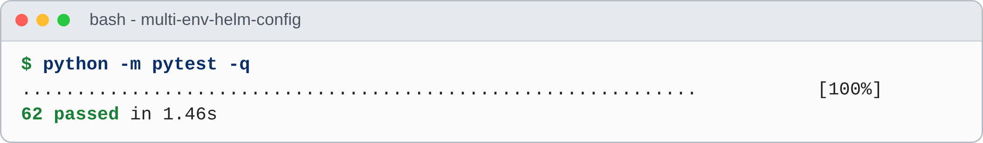
Figure 4.7 – Result of the pytest run on the development machine
Validation without a cluster (TC-04). validate-​helm.​sh lints, renders and validates each environment (Figure 4.8). All twelve stages succeeded: helm lint --strict reported no failed chart, every environment rendered the expected APP_ENV, and kubeconform found four of four objects valid in each environment.
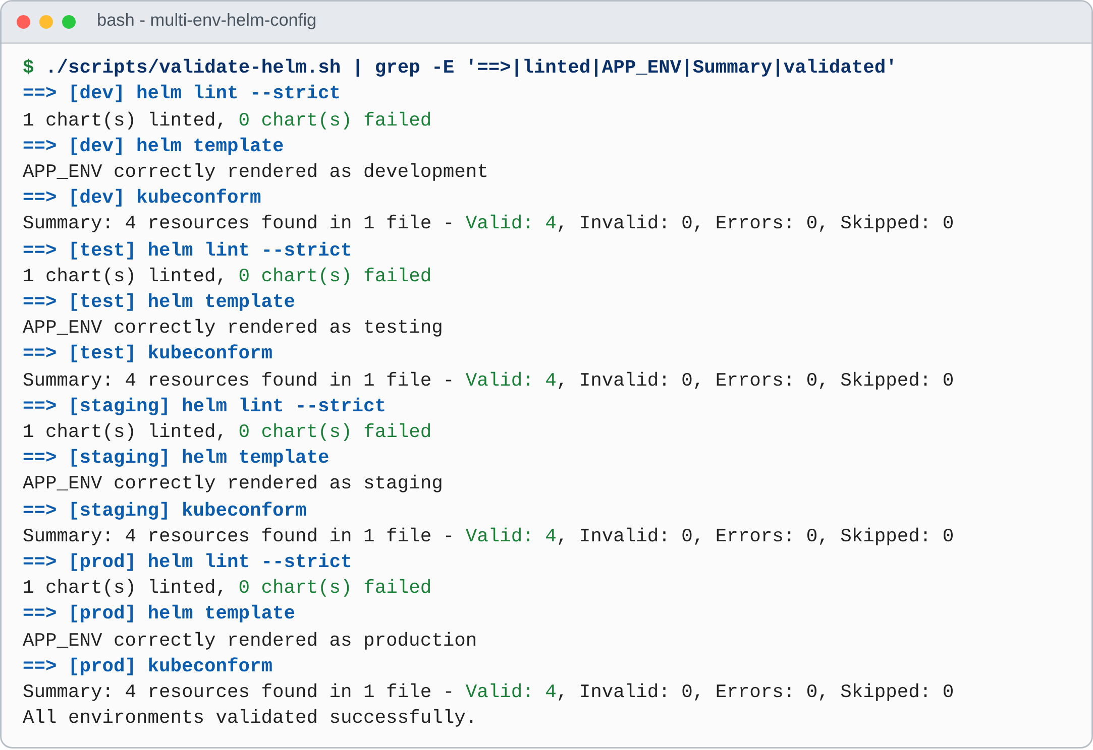
Figure 4.8 – Output of scripts/​validate-​helm.​sh (the three stages of each environment)
Live checks (TC-06). test-​environments.​sh all ran 26 checks on the cluster (Table 4.5): six for each of development, testing and staging and eight for production, which has two more checks, one for the debug mode and one for the source of the secret key. The last check of every environment is helm test, whose Pod requests /health and /api/config and compares the environment name; all four passed. The complete output is in docs/​evidence/​05-​live-​tests.​txt and 05-​helm-​test.​txt.
Table 4.5 – Live checks of the four environments (level A; – = check not made)
Check | dev | test | staging | prod
Helm release status is deployed | PASS | PASS | PASS | PASS
Replicas ready | PASS (1/1) | PASS (1/1) | PASS (2/2) | PASS (3/3)
APP_ENV equals the expected value | PASS (development) | PASS (testing) | PASS (staging) | PASS (production)
REPLICA_COUNT in the ConfigMap equals the Deployment | PASS (1) | PASS (1) | PASS (2) | PASS (3)
/health returns ok | PASS | PASS | PASS | PASS
Production DEBUG_MODE is False | – | – | – | PASS
Production SECRET_KEY comes from a Secret | – | – | – | PASS
helm test of the release | PASS | PASS | PASS | PASS

A test that never fails proves little, so the suite was also checked from the other side: the 14 invalid inputs of Section 4.6 are rejected, the two failures of Section 4.8 are detected, and the availability experiment of Section 4.9 was designed to find a problem and found one. The automated cases cannot detect what they do not test: they do not measure traffic, scan the image or cover Minikube and Windows.

4.5 Reduction of Duplicated Configuration
To make the argument for the chart measurable, the effort of keeping E environments consistent is modelled by the number of lines that must be maintained (level C; lines are only a proxy for effort). Copied manifests need R lines for every environment; the chart has one fixed part, T lines of templates and V lines of default values, and every environment adds a values file of d lines:
L_{copy}(E) = E · R (4.1)
L_{chart}(E) = T + V + E · d (4.2)
The chart needs fewer lines than copies as soon as E exceeds the break-even number of Equation (4.3).
E* = (T + V) / (R − d) (4.3)
Counted from the repository, T = 186 lines (five templates including the test), V = 98 lines, R = 177.5 lines (the average rendered size, Table 3.8) and d = 31.75 lines (the average size of the environment files). The break-even number is E* = 1.95, or 2.59 if the schema (75 lines) and Chart.yaml (18 lines) count as fixed cost; the chart is therefore smaller than copies from the third environment onwards. For the four environments, copies would amount to 710 lines and the chart to 411 lines, which is 42 % fewer (29 % fewer with schema and metadata); a fifth environment would add 31.75 lines instead of 177.5, a saving of 82 % per additional environment (Figure 4.9). The model shows the size of the maintained text, not the time a change takes; its more important consequence is qualitative: a template is changed once, and the differences between the environments are visible as the few lines of a values file.
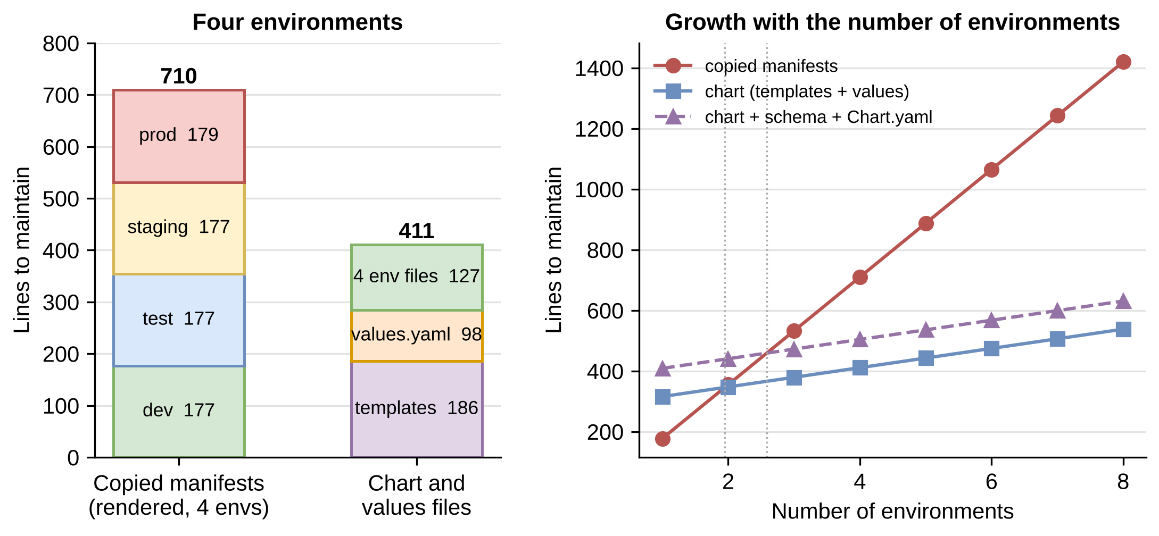
Figure 4.9 – Lines to maintain: copied manifests compared with the chart and values files (level C)

4.6 Schema Validation Results
To test the schema from the outside, 14 invalid inputs were each given to helm lint ./​helm/​multi-​env-​app --strict --set <input> (level B). All 14 were rejected with the exit status 1 and a message that names the offending key (Table 4.6); five of them are also pytest cases. The four environment files pass the same command (TC-04).
Table 4.6 – Invalid values rejected by values.​schema.​json
Input (--set) | Exit | Message of Helm
environment=qa | 1 | environment: environment must be one of the following: "development", "testing", "staging", "production"
replicaCount=0 | 1 | replicaCount: Must be greater than or equal to 1
replicaCount=11 | 1 | replicaCount: Must be less than or equal to 10
config.​LOG_​LEVEL=VERBOSE | 1 | config.​LOG_​LEVEL: config.​LOG_​LEVEL must be one of the following: "DEBUG", "INFO", "WARNING", "ERROR", "CRITICAL"
config.​DEBUG_​MODE=maybe | 1 | config.​DEBUG_​MODE: config.​DEBUG_​MODE must be one of the following: "true", "false"
config.​SECRET_​KEY=abc | 1 | config: Must not validate the schema (not)
config.​log_​level=info | 1 | config: Does not match pattern '^[A-​Z][A-​Z0-​9_]*$'
service.​type=Foo | 1 | service.type: service.type must be one of the following: "ClusterIP", "NodePort", "LoadBalancer"
service.​nodePort=80 | 1 | service.​nodePort: Must be greater than or equal to 30000
image.​pullPolicy=Sometimes | 1 | image.​pullPolicy: image.​pullPolicy must be one of the following: "Always", "IfNotPresent", "Never"
containerPort=0 | 1 | containerPort: Must be greater than or equal to 1
config.​MAX_​CONNECTIONS=abc | 1 | config.​MAX_​CONNECTIONS: Does not match pattern '^[0-9]+$'
config.​CACHE_​TTL_​SECONDS=130 (number, not string) | 1 | config.​CACHE_​TTL_​SECONDS: Invalid type. Expected: string, given: integer
image.​repository="" | 1 | image.​repository: String length must be greater than or equal to 1

The rejected inputs cover the classes of mistake that the studies of Chapter II report as frequent: an unknown name, numbers outside their range, values outside an enumeration, values with the wrong format or type, an empty required string, and a secret placed in the ConfigMap. Two observations are worth recording. First, --set config.​CACHE_​TTL_​SECONDS=130 is rejected because Helm reads 130 as an integer, whereas the schema and the ConfigMap require a string; the correct form is --set-string. Second, the message for a forbidden key (Must not validate the schema (not)) does not name the key, which makes this one rule harder to diagnose than the others. The cases were written by the authors of the schema, so they show that the rules do what they were written to do, not that the set of rules is complete.

4.7 Upgrade and Rollback
The release lifecycle was exercised on the development release with scripts/​upgrade-​rollback-​demo.​sh dev (level A). The upgrade set app.version to 1.1.0 and LOG_LEVEL to INFO with --set; the rollback returned to revision 1. Figure 4.10 shows the commands and the history, and Figure 4.11 the dashboards of the two later revisions.
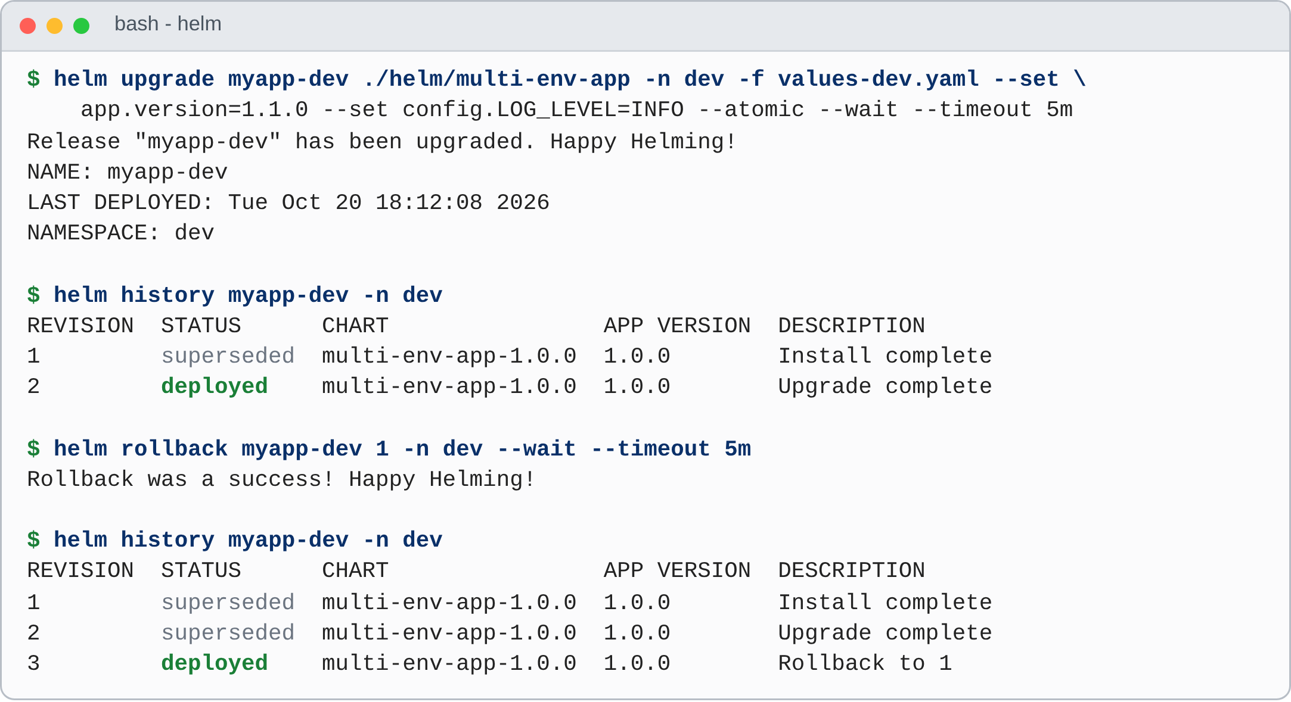
Figure 4.10 – Upgrade, history, rollback and history of the development release (update times omitted)
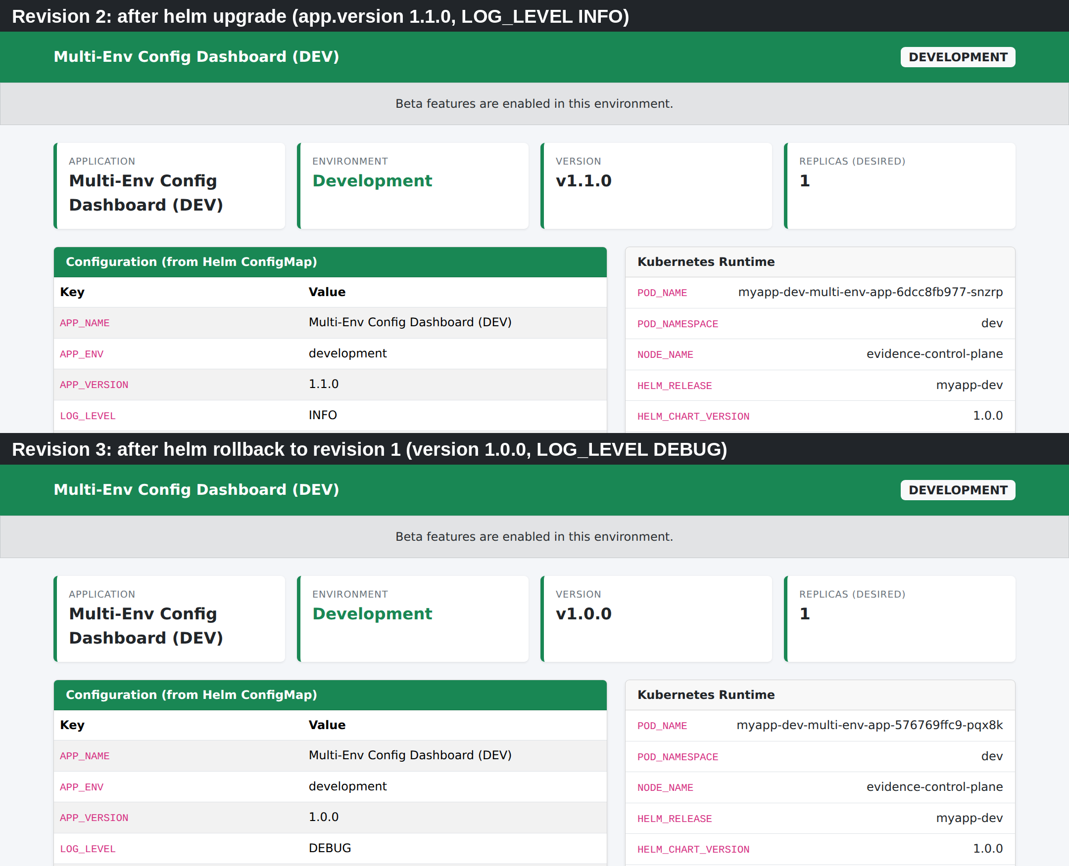
Figure 4.11 – Dashboard of the development release after the upgrade (revision 2) and after the rollback (revision 3); upper part of the page
Four points follow. (1) The upgrade replaced the Pod: the change of LOG_LEVEL and app.version changed the ConfigMap, therefore the checksum annotation and the Pod template, so a new ReplicaSet and a new Pod were created without a manual restart. (2) The rollback did not delete revision 2; it created revision 3 with the description Rollback to 1, so the history stays a complete record. (3) The Pod of revision 3 carries the same template hash (576769ffc9) as the Pod of revision 1, which shows that the Deployment reused the ReplicaSet of revision 1. (4) The column APP VERSION of helm history stays at 1.0.0 for revision 2 because it shows the appVersion of the chart, not the value app.version that the dashboard displays.

4.8 Forced Failures
Two failures were provoked on purpose, both on the kind cluster (level A). First, the test release was upgraded with --set image.tag=9.9.9, an image that does not exist, with --atomic --wait --timeout 60s (Figure 4.12). The new Pod stayed in ErrImagePull and later ImagePullBackOff, while the old Pod was still Running and Ready (1/1) 35 s into the upgrade: this is the guarantee of maxUnavailable: 0, an old Pod is removed only after a new one is ready. After the timeout Helm reported UPGRADE FAILED ... has been rolled back due to atomic being set; the history shows revision 2 as failed and a new revision 3 Rollback to 1 as deployed. deploy.sh always uses --atomic with a timeout of five minutes, so every deployment has this protection; the experiment also shows that a failed deployment is detected only after that time.
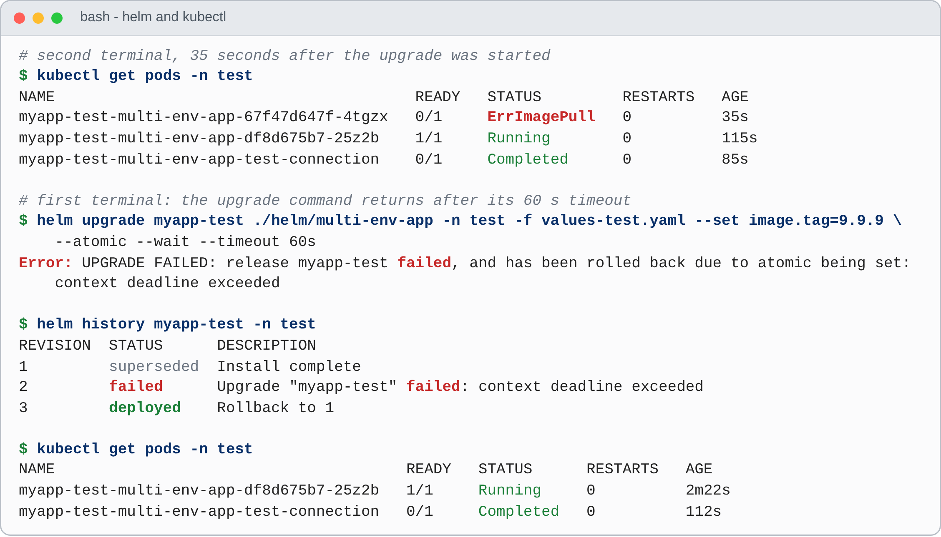
Figure 4.12 – Failed upgrade with --atomic: the old Pod keeps running and Helm restores revision 1 as revision 3
Second, the production values were installed as the release demo-prod in an empty namespace without the Secret multi-​env-​app-​secrets (Figure 4.13). The command ended with INSTALLATION FAILED: context deadline exceeded after 40 s; the three Pods were in the state CreateContainerConfigError, and the events name the cause: secret “multi-env-app-secrets” not found. Helm cannot detect this problem because the chart only refers to the Secret by name, and its message (a timeout) does not mention the Secret, so the diagnosis needs kubectl get events. This is why deploy.sh creates the Secret before it installs production. A check with the function lookup (which works only against a live cluster), a pre-install hook or an external secrets operator would detect the problem earlier (Chapter V). --atomic was not used in this experiment; the evidence script removed the release and the namespace afterwards.
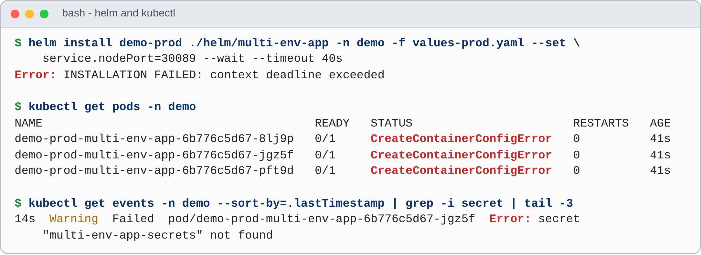
Figure 4.13 – Production installed without its Secret (helm install, kubectl get pods, events)

4.9 Availability during Rolling Updates
The bounds Equation (3.1) and Equation (3.2) say how many Pods exist during an update, not whether a client notices it. A probe Pod (busybox:1.36) in the namespace of the release requested /ready from the Service with wget about nine times per second for 45 s and logged the second of every failed request. Eight seconds after the start, helm upgrade --wait changed config.​CACHE_​TTL_​SECONDS (with --set-string), which changed the ConfigMap and the checksum annotation and started a rolling update. Five scenarios were run (Table 4.7): a control without an update; the strategy of the chart on two replicas (A, staging) and on one replica (B, test); the alternative maxSurge: 0, maxUnavailable: 1 (C); and the chart strategy with a preStop hook that sleeps for 5 s (D). The hook was added to the live Deployment with kubectl patch and is not part of the delivered chart.
Table 4.7 – Failed requests during rolling updates (level A; totals over the runs of a scenario)
Scenario | Runs | Requests | Failed | Failure rate | Failed per run | Longest burst (s)
Z control: release unchanged (test, 1 replica) | 1 | 424 | 0 | 0.00 % | 0 | none
A chart strategy, staging, 2 replicas | 3 | 1,205 | 18 | 1.49 % | 5–7 | 1–3
B chart strategy, test, 1 replica | 3 | 1,247 | 15 | 1.20 % | 3–7 | 2–4
C maxSurge: 0, maxUnavailable: 1, test, 1 replica | 3 | 1,074 | 38 | 3.54 % | 12–13 | 8–10
D chart strategy + preStop sleep 5 s (experiment only), test | 3 | 1,285 | 0 | 0.00 % | 0 | none
A burst is a group of failed requests whose times differ by at most 3 s. Rollout times reported by Helm: A 15–16 s, B 8–9 s, C 2–3 s, D 8 s.
The control produced no failure in 424 requests, so the probe and the path through the Service are reliable and the failures of the other scenarios are caused by the rollouts. With the strategy of the chart, 18 of 1,205 requests failed in scenario A (1.49 %) and 15 of 1,247 in scenario B (1.20 %); the alternative lost 38 of 1,074 (3.54 %); with the preStop delay none of 1,285 failed (Figure 4.14).
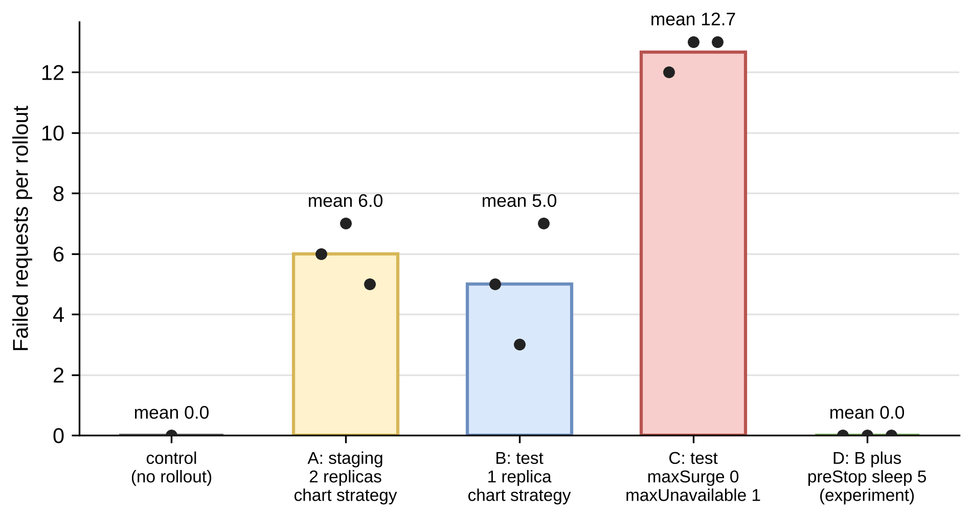
Figure 4.14 – Failed requests per rollout in the five scenarios (bars: mean; dots: individual runs)
1. The chart strategy loses few requests, but not none. Although the number of available Pods never fell below N, 1.2 to 1.5 % of the requests failed, in short bursts of 1 to 4 s just after the new Pod became ready, when the old Pod is shut down (Connection refused, Connection reset by peer, download timed out). A terminating Pod is removed from the endpoints of the Service while its container receives the termination signal, and for a short time the Service can still send a request to it [39]. With two replicas every run shows two bursts about 7 s apart, one for each replaced Pod.
2. The alternative strategy is worse. With one replica and maxUnavailable: 1 the old Pod is removed first and the Service has no ready Pod until the new one passes its readiness probe: one burst of 8 to 10 s. Helm reported the rollout as finished after 2 to 3 s because --wait waits for the number of replicas minus maxUnavailable ready Pods [22, 40], which is zero here; with this strategy --wait and --atomic could not detect a broken revision, a second reason for maxUnavailable: 0.
3. A preStop delay removed the failures in this experiment. With sleep 5 the old Pod keeps answering for 5 s after its deletion has started, which gives the endpoint update time to reach the Service. With zero failures in n = 1,285 requests the rule of three gives an upper bound of 0.23 % for the failure rate with 95 % confidence (level C).
4. Consequence. The strategy of the chart is the better of the two that were compared, but it does not give zero downtime for a client that is connected while an old Pod is removed; the documentation therefore says that the rollout keeps full capacity. A preStop hook, a terminationGracePeriodSeconds and a graceful shutdown of gunicorn are the first item of future work; they were not added to the chart because the finding was made after the chart had been tested, and the report describes the chart as delivered.
The experiment has limits: one node, a probe inside the cluster that uses the cluster address of the Service (not a NodePort or a load balancer), one client at about nine requests per second, three runs per scenario, and a failing wget slows the client down, so the numbers should be compared only within this experiment. A multi-node cluster may propagate endpoint changes more slowly, which would make the effect larger, not smaller. A first run was discarded because the command that waited for the probe Pod had a timeout without a unit and returned at once; the script was corrected and the whole experiment repeated, and only the second run is reported.

4.10 Image and Pipeline Results
Image. The image multi-​env-​app:​1.​0.​0 is 126 MB: the Debian base layer (78.8 MB) and the Python runtime layers (40.6 MB) account for 95 % of it, Flask and gunicorn add 6.39 MB, and the application code and the user add 27 kB (docker history, level A). Because the dependencies are installed before the code is copied, a change of the code rebuilds only the last two, very small layers; the build took 9 s in the validation workflow.
Pipeline. Figure 4.15 shows the timeline of the validation workflow for commit 9f0e6bc. The three independent jobs took 10 s, 17 s and 10 s and ran in parallel; the cluster job, which started when they had finished, took 143 s: 41 s to create the kind cluster, 40 s to deploy the four environments, 12 s for the live checks and 29 s for the upgrade and rollback. The whole run needed 164 s. All six runs of the workflow on the branch up to this commit succeeded; the workflow capture-​evidence.​yml (run 2) took 15 min 41 s, most of it for the 13 runs of the availability experiment.
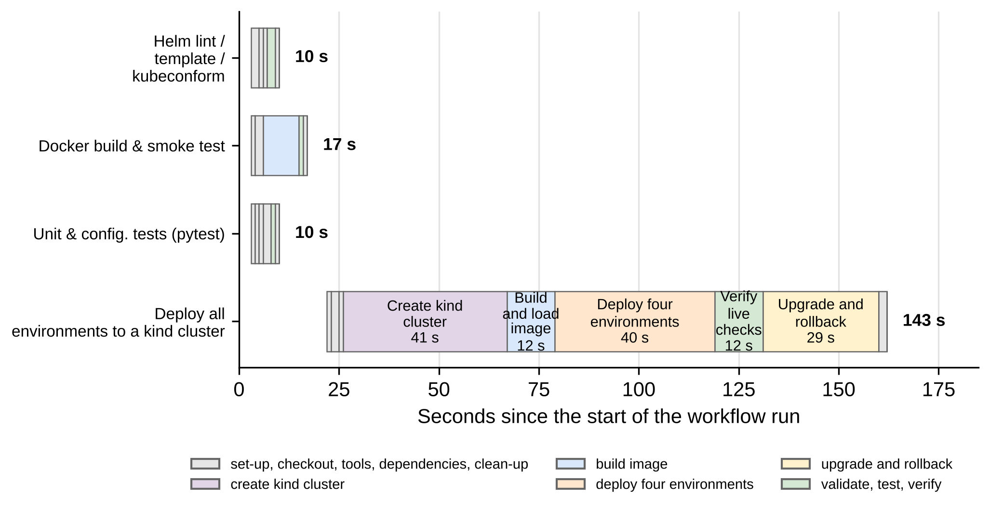
Figure 4.15 – Timeline of the four jobs of the validation workflow (run 6, commit 9f0e6bc)

4.11 Discussion
Table 4.8 compares the objectives of Section 1.4 with the results. Nine of the ten were achieved as stated; objective O6 was achieved on a kind cluster, and the Minikube path is supported by the scripts but was not executed (level D).
Table 4.8 – Objectives compared with the results
No. | Objective | Result | Evidence
O1 | Flask, HTML, CSS and Bootstrap application | Achieved | Figure 4.4; 15 application tests
O2 | Dashboard with name, environment, version and configuration | Achieved | Table 4.3: 56 of 56 values equal to the files
O3 | Four environments | Achieved | Table 4.2; Figure 4.1
O4 | Reusable chart with the required files | Achieved | Appendix A; lint, render and kubeconform valid
O5 | Docker configuration | Achieved | Image of 126 MB; smoke test in CI; non-root user
O6 | Kubernetes deployment on Minikube | Achieved on kind; Minikube not executed | Section 4.1; minikube-​setup.​sh
O7 | Install, validation, upgrade and rollback | Achieved | TC-08, TC-09; Section 4.7
O8 | GitHub Actions validation | Achieved | Figure 4.15; six successful runs
O9 | Test scripts for environment-​specific configuration | Achieved | 62 pytest cases; 26 live checks; 4 helm test runs
O10 | No hard-coded secrets; consistent configuration | Achieved within the stated limits | Table 3.13; Section 4.6

1. Separation of configuration works. One set of templates and four values files of 28 to 43 lines produced four different environments; all 56 compared values of the running Pods equalled the files, and the chart is smaller than copied manifests from the third environment onwards.
2. Validation before deployment is effective and cheap. The schema rejected all 14 invalid inputs before any cluster was contacted; its weak point is the message for forbidden keys.
3. Release history makes changes reversible. The rollback restored version 1.0.0 and the level DEBUG as revision 3, and --atomic restored revision 1 after a failed upgrade while the old Pod kept serving.
4. “Zero downtime” needs a measurement. A rolling update with maxUnavailable: 0 keeps capacity but lost 1.2 to 1.5 % of the requests in short bursts; a preStop delay removed these failures in three of three runs.
5. Helm does not see a missing Secret, and strict types cost a little convenience: numeric settings need --set-string.
The findings are consistent with the literature of Chapter II: misconfigurations are frequent and often consist of illegal values [2], which the schema turns into a check before deployment, and security studies of manifests [16] report missing resource limits and weak security contexts, which the chart avoids by default without claiming to remove all such misconfigurations. Threats to validity: one single-node kind cluster on one type of runner (Minikube and Windows not executed); a synthetic application without a real database or traffic; three runs per availability scenario with one client and no statistical test; line counts as a proxy for effort against a hypothetical baseline; tests and schema cases written by the authors of the code; and manifests checked against the schemas of Kubernetes 1.31.0 while the cluster ran v1.35.0 (the chart uses only the stable APIs v1 and apps/v1).

CHAPTER 5
CONCLUSION AND FUTURE ENHANCEMENTS

5.1 Conclusion
The project set out to show that one application can be deployed to development, testing, staging and production from a single Helm chart, without copying manifests, and that the result can be validated, tested, upgraded and reverted. The delivered solution consists of a Flask dashboard with Bootstrap, one container image of 126 MB, the chart multi-env-app with one file of default values, four environment files of 28 to 43 lines, a JSON Schema for the values, nine scripts, 62 automated tests and a GitHub Actions workflow of four jobs. On a kind cluster in GitHub Actions all four releases were deployed in 40 s; every one of the 56 compared settings of the running Pods equalled the values of the files; all 26 live checks, which include the four chart tests, passed; a rollback restored an earlier revision as a new revision; and --atomic restored a release after an upgrade to an image that does not exist. The schema rejected all 14 invalid inputs before any cluster was contacted, and the model of the effort shows that the chart is smaller than copied manifests from the third environment onwards.
The report also records two results that go against a simple story. A rolling update with maxUnavailable: 0 keeps full capacity, but 1.5 % and 1.2 % of the requests failed in short bursts while old Pods were removed, whereas a preStop delay removed the failures in the experiment; “zero downtime” is therefore not claimed anywhere in the project. And Helm cannot detect that a Secret is missing, because the chart refers to it only by name. The report states for every result whether it was run on a cluster, run locally or derived, and it lists what was not executed, most importantly Minikube.

5.2 Summary of Contributions
1. A small, complete and reproducible reference for multi-​environment configuration management with Helm that can be read in one sitting and run on a laptop cluster.
2. A typed interface for the values, enforced by a JSON Schema, that rejects unknown environments, wrong types, out-of-range numbers and secrets placed in the configuration.
3. A deployment workflow with --atomic, history and rollback, scripts for each step, a live test of every environment and a CI workflow that deploys all four environments to a real cluster on every change.
4. Measurements that go beyond a demonstration (two forced failures and a rolling-update experiment with a control, two strategies and a mitigation) and an explicit evidence level for every result.

5.3 Comparison with the Literature
Table 5.1 relates the observations of this report to the sources of Chapter II. The relation is one of consistency, not of replication: the project is a single small example, and the studies cited analyse hundreds or thousands of real repositories.
Table 5.1 – Observations of this project compared with the literature
Source | What the literature reports | What this project observed | Relation
Wiggins [1] | Configuration that varies between deploys belongs in the environment | All settings come from environment variables; one image runs in all four environments | Followed
Yin et al. [2] | Many misconfigurations are illegal parameter values | The schema rejected 14 of 14 invalid inputs before deployment | Consistent
Xu and Zhou [3] | Prevention, detection and diagnosis are separate tasks | Schema (prevention), lint, tests, CI (detection); diagnosis relied on events and logs | Partly addressed
Rahman et al. [14, 15] | Configuration code is defect-prone and needs testing | 62 tests and four validation stages; the rollout failures were found by an experiment, not a test | Consistent
Rahman et al. [16] | Missing limits and weak security contexts are common | Limits in every environment, non-root user, capabilities dropped; no policy scanner | Addressed within limits
Zerouali et al. [13] | Public charts contain outdated and vulnerable components | Versions pinned, slim base image; no vulnerability scan was run | Not verified
Limoncelli; Humble and Farley; Forsgren et al. [4, 5, 19] | Desired state in version control; automated delivery pipeline | All files in Git; one workflow, six successful runs; no GitOps controller | Partly

5.4 Practical Considerations and Limitations
The project is a teaching example. Before a similar chart is used for a real application: use separate clusters where production requires them (namespaces separate names, not failure domains; only the values file and the cluster addressed by helm change); use an external secrets operator or sealed secrets with encryption at rest; measure the application under load and tune the requests and limits; place an Ingress with TLS and a disruption budget in front of the Service; promote the same chart version and image tag from environment to environment; and add metrics, logs and alerts, for which the probe of the availability experiment could become a permanent synthetic check.
The limitations of this report are: Minikube, Windows, multi-node and cloud clusters were not executed (level D, Section 4.1); the application is synthetic and stateless, without a database, real traffic or persistent storage; the chart contains no Ingress, TLS, autoscaling, disruption budget or network policy, and the production Secret is created outside the chart by a script; the rollout of the chart is not free of request failures (Section 4.9) and the preStop hook that removed them is not part of the chart; the image was not scanned and its base image is selected by tag, not by digest; and the availability experiment is small (one single-node cluster, one client, three runs per scenario).

5.5 Future Enhancements
Figure 5.1 orders the enhancements by effort and dependency, and Table 5.2 gives the reason for each one, taken from the results of this report. The first two follow directly from the failures found in Section 4.8 and Section 4.9.
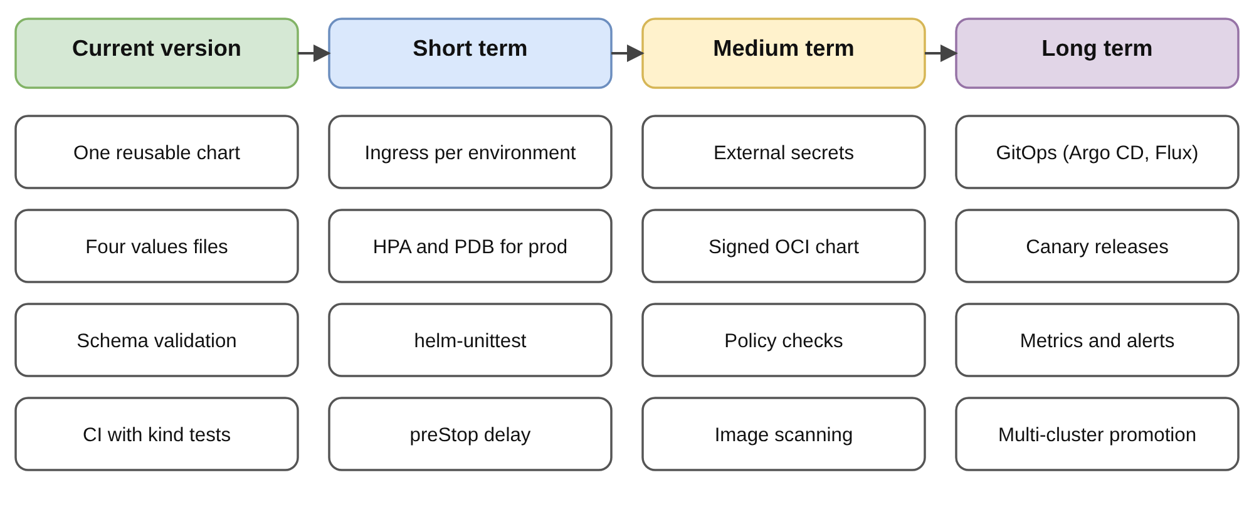
Figure 5.1 – Roadmap of future enhancements
Table 5.2 – Future enhancements and their reasons
Enhancement | Reason (evidence in this report) | Outline
Graceful shutdown: preStop delay, terminationGracePeriodSeconds, SIGTERM handling in gunicorn | 1.2 to 1.5 % of the requests failed during rollouts; none with a 5 s delay (Section 4.9) | Add a lifecycle.​preStop value to the chart; repeat the experiment with the delivered chart
Check or provide the Secret | Helm did not detect the missing Secret (Section 4.8) | A lookup check, a pre-install hook, or an external secrets operator
Ingress per environment with TLS; HPA and PDB for production | The dashboards are reached by NodePort only; three fixed replicas, no protection against node drains | One Ingress host per environment, cert-manager; HorizontalPodAutoscaler and PodDisruptionBudget in values-​prod.​yaml
Unit tests for templates; policy checks | Template logic and hardening are checked by pytest and hand-written assertions | helm-unittest suites; Conftest or Kyverno policies on the rendered manifests
Image scanning and a signed OCI chart | The image was not scanned; the base image is selected by tag | Trivy in CI; helm push to an OCI registry; signatures
GitOps controller, metrics and alerts, canary releases | Deployments are started by scripts and CI; failures were found by a probe written for this report | Argo CD or Flux reconcile the values files; Prometheus metrics and alert rules
Run on Minikube, Windows, a multi-node and a cloud cluster | These platforms are level D | Repeat the evidence workflow on each platform

None of these enhancements changes the central idea of the project: the application is described once, the differences between the environments are data, the data are validated before deployment, and every deployment is a numbered revision that can be reverted.

APPENDICES

Appendix A – Directory structure of the project
The line count of each file is given at the right. The files in the folder docs/ (the diagram, the video and the evidence files) are not listed.
Code Snippet – Directory structure (git ls-files)
multi-env-helm-config/
├── .github/
│ └── workflows/
│ ├── capture-evidence.yml 56 lines
│ └── helm-validation.yml 117 lines
├── app/
│ ├── static/
│ │ └── css/
│ │ └── style.css 43 lines
│ ├── templates/
│ │ └── index.html 111 lines
│ ├── app.py 73 lines
│ ├── config.py 101 lines
│ └── requirements.txt 2 lines
├── helm/
│ └── multi-env-app/
│ ├── templates/
│ │ ├── tests/
│ │ │ └── test-connection.yaml 27 lines
│ │ ├── _helpers.tpl 48 lines
│ │ ├── configmap.yaml 16 lines
│ │ ├── deployment.yaml 77 lines
│ │ ├── NOTES.txt 17 lines
│ │ └── service.yaml 18 lines
│ ├── .helmignore 10 lines
│ ├── Chart.yaml 18 lines
│ ├── values-dev.yaml 28 lines
│ ├── values-prod.yaml 43 lines
│ ├── values-staging.yaml 28 lines
│ ├── values-test.yaml 28 lines
│ ├── values.schema.json 75 lines
│ └── values.yaml 98 lines
├── scripts/
│ ├── capture-evidence.sh 238 lines
│ ├── cleanup.sh 12 lines
│ ├── common.sh 43 lines
│ ├── deploy.sh 49 lines
│ ├── docker-demo.sh 63 lines
│ ├── minikube-setup.sh 25 lines
│ ├── test-environments.sh 68 lines
│ ├── upgrade-rollback-demo.sh 50 lines
│ └── validate-helm.sh 45 lines
├── tests/
│ ├── conftest.py 9 lines
│ ├── test_app.py 93 lines
│ └── test_helm_config.py 230 lines
├── .dockerignore 13 lines
├── Dockerfile 31 lines
├── README.md 447 lines
└── requirements-dev.txt 3 lines

docs/ diagram, video, evidence files

Appendix B – Application source code
Appendices B to F print complete files of the repository: a program wrote their lines, with the line numbers of the file, into the report, and the finished document was compared with the files. Files not printed are listed in Appendix G.
Code Snippet – app/app.py (complete, 73 lines)
1 """Flask web application that displays its environment-specific configuration.
2
3 Endpoints:
4 / HTML dashboard (Bootstrap)
5 /health Liveness probe
6 /ready Readiness probe
7 /api/config JSON view of the (non-secret) configuration
8 """
9
10 import logging
11 import os
12 from datetime import datetime, timezone
13
14 from flask import Flask, jsonify, render_template
15
16 from config import AppConfig
17
18 STARTED_AT = datetime.now(timezone.utc)
19
20
21 def create_app(environ=None):
22 cfg = AppConfig(environ)
23
24 app = Flask(__name__)
25 app.config["SECRET_KEY"] = cfg.secret_key
26 app.config["APP_CONFIG"] = cfg
27
28 logging.basicConfig(
29 level=getattr(logging, cfg.log_level, logging.INFO),
30 format="%(asctime)s %(levelname)s [%(name)s] %(message)s",
31 )
32 log = logging.getLogger("multi-env-app")
33 if not cfg.environment_is_valid:
34 log.warning("APP_ENV is not one of the supported environments; defaulting to 'development'")
35 log.info("Starting %s v%s in %s environment", cfg.app_name, cfg.app_version, cfg.environment)
36
37 @app.route("/")
38 def dashboard():
39 return render_template(
40 "index.html",
41 cfg=cfg,
42 settings=cfg.public_settings(),
43 runtime=cfg.runtime_info(),
44 started_at=STARTED_AT.strftime("%Y-%m-%d %H:%M:%S UTC"),
45 )
46
47 @app.route("/health")
48 def health():
49 return jsonify(status="ok"), 200
50
51 @app.route("/ready")
52 def ready():
53 return jsonify(status="ready", environment=cfg.environment), 200
54
55 @app.route("/api/config")
56 def api_config():
57 return jsonify(
58 application=cfg.app_name,
59 environment=cfg.environment,
60 version=cfg.app_version,
61 settings=cfg.public_settings(),
62 runtime=cfg.runtime_info(),
63 )
64
65 return app
66
67
68 app = create_app()
69
70
71 if __name__ == "__main__":
72 # Local development server only. In containers the app runs under gunicorn.
73 app.run(host="0.0.0.0", port=int(os.environ.get("PORT", "5000")), debug=app.config["APP_CONFIG"].debug)

Code Snippet – app/config.py (complete, 101 lines)
1 """Runtime configuration for the Multi-Environment Config Dashboard.
2
3 All values are read from environment variables. In Kubernetes these
4 variables are injected from the Helm-generated ConfigMap (non-sensitive
5 settings) and, optionally, from a pre-created Kubernetes Secret.
6 Nothing sensitive is hardcoded here.
7 """
8
9 import os
10 import secrets
11
12 VALID_ENVIRONMENTS = ("development", "testing", "staging", "production")
13
14 # Bootstrap colour used for the environment badge / banner on the dashboard.
15 ENVIRONMENT_THEMES = {
16 "development": "success",
17 "testing": "info",
18 "staging": "warning",
19 "production": "danger",
20 }
21
22 # Keys whose values must never be displayed or returned by the API.
23 SENSITIVE_KEYS = ("SECRET_KEY",)
24
25
26 def _as_bool(value, default=False):
27 if value is None:
28 return default
29 return str(value).strip().lower() in ("1", "true", "yes", "on")
30
31
32 def _as_int(value, default):
33 try:
34 return int(value)
35 except (TypeError, ValueError):
36 return default
37
38
39 class AppConfig:
40 """Snapshot of the application configuration taken from the environment."""
41
42 def __init__(self, environ=None):
43 env = os.environ if environ is None else environ
44
45 self.app_name = env.get("APP_NAME", "Multi-Env Config Dashboard")
46 raw_env = env.get("APP_ENV", "development").strip().lower()
47 self.environment_is_valid = raw_env in VALID_ENVIRONMENTS
48 self.environment = raw_env if self.environment_is_valid else "development"
49 self.app_version = env.get("APP_VERSION", "1.0.0")
50
51 self.log_level = env.get("LOG_LEVEL", "INFO").upper()
52 self.debug = _as_bool(env.get("DEBUG_MODE"), default=False)
53 self.feature_beta_banner = _as_bool(env.get("FEATURE_BETA_BANNER"))
54 self.max_connections = _as_int(env.get("MAX_CONNECTIONS"), 10)
55 self.cache_ttl_seconds = _as_int(env.get("CACHE_TTL_SECONDS"), 60)
56 self.database_host = env.get("DATABASE_HOST", "localhost")
57 self.api_base_url = env.get("API_BASE_URL", "http://localhost:5000/api")
58 self.replica_count = env.get("REPLICA_COUNT", "1")
59
60 # Kubernetes downward-API values (present only inside a pod).
61 self.pod_name = env.get("POD_NAME", "local")
62 self.pod_namespace = env.get("POD_NAMESPACE", "local")
63 self.node_name = env.get("NODE_NAME", "local")
64 self.helm_release = env.get("HELM_RELEASE", "not-deployed-with-helm")
65 self.chart_version = env.get("HELM_CHART_VERSION", "n/a")
66
67 # Secret key: supplied via a Kubernetes Secret, or generated per
68 # process so that no secret is ever committed to source control.
69 provided_secret = env.get("SECRET_KEY")
70 self.secret_key_source = "kubernetes-secret" if provided_secret else "auto-generated"
71 self.secret_key = provided_secret or secrets.token_hex(32)
72
73 @property
74 def theme(self):
75 return ENVIRONMENT_THEMES[self.environment]
76
77 def public_settings(self):
78 """Settings that are safe to show on the dashboard / JSON API."""
79 return {
80 "APP_NAME": self.app_name,
81 "APP_ENV": self.environment,
82 "APP_VERSION": self.app_version,
83 "LOG_LEVEL": self.log_level,
84 "DEBUG_MODE": self.debug,
85 "FEATURE_BETA_BANNER": self.feature_beta_banner,
86 "MAX_CONNECTIONS": self.max_connections,
87 "CACHE_TTL_SECONDS": self.cache_ttl_seconds,
88 "DATABASE_HOST": self.database_host,
89 "API_BASE_URL": self.api_base_url,
90 "REPLICA_COUNT": self.replica_count,
91 "SECRET_KEY": "******** ({})".format(self.secret_key_source),
92 }
93
94 def runtime_info(self):
95 return {
96 "POD_NAME": self.pod_name,
97 "POD_NAMESPACE": self.pod_namespace,
98 "NODE_NAME": self.node_name,
99 "HELM_RELEASE": self.helm_release,
100 "HELM_CHART_VERSION": self.chart_version,
101 }

Code Snippet – app/​templates/​index.​html (complete, 111 lines)
1 <!DOCTYPE html>
2 <html lang="en">
3 <head>
4 <meta charset="utf-8">
5 <meta name="viewport" content="width=device-width, initial-scale=1">
6 <title>{{ cfg.app_name }} - {{ cfg.environment|capitalize }}</title>
7 <link rel="stylesheet" href="https://cdn.jsdelivr.net/npm/bootstrap@5.3.3/dist/css/bootstrap.min.css">
8 <link rel="stylesheet" href="{{ url_for('static', filename='css/style.css') }}">
9 </head>
10 <body class="env-{{ cfg.environment }}">
11 <nav class="navbar navbar-dark bg-{{ cfg.theme }} env-banner">
12 <div class="container">
13 <span class="navbar-brand fw-bold">{{ cfg.app_name }}</span>
14 <span class="badge bg-light text-dark fs-6" id="env-badge">{{ cfg.environment|upper }}</span>
15 </div>
16 </nav>
17
18 {% if cfg.feature_beta_banner %}
19 <div class="alert alert-secondary rounded-0 mb-0 text-center" role="alert">
20 Beta features are enabled in this environment.
21 </div>
22 {% endif %}
23
24 <main class="container py-4">
25 <div class="row g-3 mb-4">
26 <div class="col-md-3 col-sm-6">
27 <div class="card stat-card border-{{ cfg.theme }} h-100">
28 <div class="card-body">
29 <div class="stat-label">Application</div>
30 <div class="stat-value" id="app-name">{{ cfg.app_name }}</div>
31 </div>
32 </div>
33 </div>
34 <div class="col-md-3 col-sm-6">
35 <div class="card stat-card border-{{ cfg.theme }} h-100">
36 <div class="card-body">
37 <div class="stat-label">Environment</div>
38 <div class="stat-value text-{{ cfg.theme }}" id="app-env">{{ cfg.environment|capitalize }}</div>
39 </div>
40 </div>
41 </div>
42 <div class="col-md-3 col-sm-6">
43 <div class="card stat-card border-{{ cfg.theme }} h-100">
44 <div class="card-body">
45 <div class="stat-label">Version</div>
46 <div class="stat-value" id="app-version">v{{ cfg.app_version }}</div>
47 </div>
48 </div>
49 </div>
50 <div class="col-md-3 col-sm-6">
51 <div class="card stat-card border-{{ cfg.theme }} h-100">
52 <div class="card-body">
53 <div class="stat-label">Replicas (desired)</div>
54 <div class="stat-value">{{ cfg.replica_count }}</div>
55 </div>
56 </div>
57 </div>
58 </div>
59
60 <div class="row g-4">
61 <div class="col-lg-7">
62 <div class="card shadow-sm">
63 <div class="card-header bg-{{ cfg.theme }} text-white fw-semibold">
64 Configuration (from Helm ConfigMap)
65 </div>
66 <div class="table-responsive">
67 <table class="table table-striped mb-0 config-table">
68 <thead><tr><th>Key</th><th>Value</th></tr></thead>
69 <tbody>
70 {% for key, value in settings.items() %}
71 <tr><td><code>{{ key }}</code></td><td>{{ value }}</td></tr>
72 {% endfor %}
73 </tbody>
74 </table>
75 </div>
76 </div>
77 </div>
78
79 <div class="col-lg-5">
80 <div class="card shadow-sm mb-4">
81 <div class="card-header fw-semibold">Kubernetes Runtime</div>
82 <ul class="list-group list-group-flush">
83 {% for key, value in runtime.items() %}
84 <li class="list-group-item d-flex justify-content-between">
85 <span><code>{{ key }}</code></span><span class="text-break text-end">{{ value }}</span>
86 </li>
87 {% endfor %}
88 <li class="list-group-item d-flex justify-content-between">
89 <span><code>STARTED_AT</code></span><span>{{ started_at }}</span>
90 </li>
91 </ul>
92 </div>
93
94 <div class="card shadow-sm">
95 <div class="card-header fw-semibold">Endpoints</div>
96 <ul class="list-group list-group-flush">
97 <li class="list-group-item"><a href="/api/config">/api/config</a> - configuration as JSON</li>
98 <li class="list-group-item"><a href="/health">/health</a> - liveness probe</li>
99 <li class="list-group-item"><a href="/ready">/ready</a> - readiness probe</li>
100 </ul>
101 </div>
102 </div>
103 </div>
104 </main>
105
106 <footer class="text-center text-muted small py-3 border-top">
107 Multi-Environment Configuration Management with Helm &middot;
108 Arun Kumar T &amp; Priyan M &middot; Dept. of AI &amp; DS, AAA College of Engineering and Technology, Sivakasi
109 </footer>
110 </body>
111 </html>

Code Snippet – app/​static/​css/​style.​css (complete, 43 lines)
1 /* Custom styles layered on top of Bootstrap 5. */
2
3 body {
4 background-color: #f4f6f9;
5 font-family: system-ui, -apple-system, "Segoe UI", Roboto, sans-serif;
6 }
7
8 .env-banner {
9 padding-top: 0.9rem;
10 padding-bottom: 0.9rem;
11 }
12
13 .stat-card {
14 border-width: 0 0 0 5px;
15 border-style: solid;
16 box-shadow: 0 1px 3px rgba(0, 0, 0, 0.08);
17 }
18
19 .stat-label {
20 font-size: 0.8rem;
21 text-transform: uppercase;
22 letter-spacing: 0.05em;
23 color: #6c757d;
24 }
25
26 .stat-value {
27 font-size: 1.35rem;
28 font-weight: 600;
29 word-break: break-word;
30 }
31
32 .config-table td:first-child {
33 width: 45%;
34 }
35
36 /* Production gets a subtle warning stripe so it is never mistaken for dev. */
37 body.env-production .env-banner {
38 background-image: repeating-linear-gradient(
39 45deg,
40 rgba(255, 255, 255, 0.06) 0 12px,
41 transparent 12px 24px
42 );
43 }

Code Snippet – app/​requirements.​txt (complete, 2 lines)
1 Flask==3.0.3
2 gunicorn==23.0.0

Appendix C – Container files
Code Snippet – Dockerfile (complete, 31 lines)
1 # ---------------------------------------------------------------
2 # Multi-Environment Config Dashboard - container image
3 # The same image is promoted through dev -> test -> staging -> prod;
4 # only the Helm values (ConfigMap) change between environments.
5 # ---------------------------------------------------------------
6 FROM python:3.12-slim
7
8 ENV PYTHONDONTWRITEBYTECODE=1 \
9 PYTHONUNBUFFERED=1 \
10 PIP_NO_CACHE_DIR=1 \
11 PORT=5000
12
13 WORKDIR /app
14
15 # Install dependencies first to make good use of the layer cache.
16 COPY app/requirements.txt .
17 RUN pip install --no-cache-dir -r requirements.txt
18
19 COPY app/ .
20
21 # Run as an unprivileged user (UID matches the Helm securityContext).
22 RUN useradd --uid 10001 --no-create-home --shell /usr/sbin/nologin appuser \
23 && chown -R appuser /app
24 USER 10001
25
26 EXPOSE 5000
27
28 HEALTHCHECK --interval=30s --timeout=3s --start-period=10s --retries=3 \
29 CMD python -c "import urllib.request,sys; sys.exit(0 if urllib.request.urlopen('http://127.0.0.1:5000/health').status == 200 else 1)"
30
31 CMD ["sh", "-c", "exec gunicorn --bind 0.0.0.0:${PORT} --workers 2 --access-logfile - app:app"]

Code Snippet – .dockerignore (complete, 13 lines)
1 .git
2 .github
3 helm
4 docs
5 scripts
6 tests
7 dist
8 **/__pycache__
9 **/*.pyc
10 .pytest_cache
11 .venv
12 venv
13 *.md

Appendix D – Helm chart
The chart is listed in the order in which Helm reads it: metadata, defaults, the environment files of development and production (the other two have the same structure), the schema, the helpers and the templates.
Code Snippet – helm/​multi-​env-​app/​Chart.​yaml (complete, 18 lines)
1 apiVersion: v2
2 name: multi-env-app
3 description: >-
4 Reusable Helm chart that deploys the Multi-Environment Config Dashboard
5 (Flask) to Development, Testing, Staging and Production using
6 environment-specific values files.
7 type: application
8 # Chart version - bump whenever the chart templates change.
9 version: 1.0.0
10 # Application version - used as the default image tag and APP_VERSION.
11 appVersion: "1.0.0"
12 keywords:
13 - flask
14 - multi-environment
15 - configuration-management
16 maintainers:
17 - name: Arun Kumar T
18 - name: Priyan M

Code Snippet – helm/​multi-​env-​app/​values.​yaml (complete, 98 lines)
1 # ---------------------------------------------------------------------------
2 # Default (base) values for the multi-env-app chart.
3 # Environment files (values-dev.yaml, values-test.yaml, values-staging.yaml,
4 # values-prod.yaml) override only what differs from these defaults:
5 #
6 # helm install myapp-dev ./helm/multi-env-app -f ./helm/multi-env-app/values-dev.yaml
7 #
8 # Do NOT put passwords, tokens or keys here. Sensitive values belong in a
9 # Kubernetes Secret that is referenced through `existingSecret`.
10 # ---------------------------------------------------------------------------
11
12 # One of: development, testing, staging, production
13 environment: development
14
15 replicaCount: 1
16
17 image:
18 repository: multi-env-app
19 # Defaults to .Chart.AppVersion when empty.
20 tag: ""
21 pullPolicy: IfNotPresent
22
23 nameOverride: ""
24 fullnameOverride: ""
25
26 app:
27 name: "Multi-Env Config Dashboard"
28 # Version shown on the dashboard. Defaults to the image tag, then appVersion.
29 version: ""
30
31 # Non-sensitive settings. Every key becomes an environment variable via the
32 # ConfigMap (templates/configmap.yaml). Values are always rendered as strings.
33 config:
34 LOG_LEVEL: "INFO"
35 DEBUG_MODE: "false"
36 FEATURE_BETA_BANNER: "false"
37 MAX_CONNECTIONS: "10"
38 CACHE_TTL_SECONDS: "60"
39 DATABASE_HOST: "localhost"
40 API_BASE_URL: "http://localhost:5000/api"
41
42 # Name of a pre-existing Secret whose keys are exposed as env vars
43 # (for example SECRET_KEY). Leave empty to let the app generate a random key.
44 # kubectl create secret generic myapp-secrets -n prod --from-literal=SECRET_KEY=$(openssl rand -hex 32)
45 existingSecret: ""
46
47 containerPort: 5000
48
49 service:
50 type: NodePort
51 port: 80
52 # Fixed NodePort (30000-32767) so each environment has a predictable URL.
53 # Leave empty to let Kubernetes choose one.
54 nodePort: ""
55
56 strategy:
57 type: RollingUpdate
58 rollingUpdate:
59 maxSurge: 1
60 maxUnavailable: 0
61
62 resources:
63 requests:
64 cpu: 50m
65 memory: 64Mi
66 limits:
67 cpu: 200m
68 memory: 128Mi
69
70 livenessProbe:
71 httpGet:
72 path: /health
73 port: http
74 initialDelaySeconds: 5
75 periodSeconds: 10
76
77 readinessProbe:
78 httpGet:
79 path: /ready
80 port: http
81 initialDelaySeconds: 3
82 periodSeconds: 5
83
84 podAnnotations: {}
85
86 podSecurityContext:
87 runAsNonRoot: true
88 runAsUser: 10001
89 fsGroup: 10001
90
91 securityContext:
92 allowPrivilegeEscalation: false
93 capabilities:
94 drop: ["ALL"]
95
96 # Image used by `helm test` (templates/tests/test-connection.yaml).
97 tests:
98 image: busybox:1.36

Code Snippet – helm/​multi-​env-​app/​values-​dev.​yaml (complete, 28 lines)
1 # Development: fast feedback, verbose logging, single replica, beta features on.
2 environment: development
3
4 replicaCount: 1
5
6 app:
7 name: "Multi-Env Config Dashboard (DEV)"
8
9 config:
10 LOG_LEVEL: "DEBUG"
11 DEBUG_MODE: "true"
12 FEATURE_BETA_BANNER: "true"
13 MAX_CONNECTIONS: "5"
14 CACHE_TTL_SECONDS: "10"
15 DATABASE_HOST: "postgres.dev.svc.cluster.local"
16 API_BASE_URL: "http://dev.multi-env-app.local/api"
17
18 service:
19 type: NodePort
20 nodePort: 30081
21
22 resources:
23 requests:
24 cpu: 25m
25 memory: 64Mi
26 limits:
27 cpu: 100m
28 memory: 128Mi

Code Snippet – helm/​multi-​env-​app/​values-​prod.​yaml (complete, 43 lines)
1 # Production: high availability, minimal logging, debug disabled.
2 # Sensitive values (SECRET_KEY) come from a pre-created Kubernetes Secret.
3 environment: production
4
5 replicaCount: 3
6
7 image:
8 pullPolicy: IfNotPresent
9
10 app:
11 name: "Multi-Env Config Dashboard"
12
13 config:
14 LOG_LEVEL: "WARNING"
15 DEBUG_MODE: "false"
16 FEATURE_BETA_BANNER: "false"
17 MAX_CONNECTIONS: "200"
18 CACHE_TTL_SECONDS: "300"
19 DATABASE_HOST: "postgres.prod.svc.cluster.local"
20 API_BASE_URL: "https://multi-env-app.example.com/api"
21
22 # Create before installing (see README):
23 # kubectl create secret generic multi-env-app-secrets -n prod \
24 # --from-literal=SECRET_KEY="$(openssl rand -hex 32)"
25 existingSecret: "multi-env-app-secrets"
26
27 service:
28 type: NodePort
29 nodePort: 30084
30
31 strategy:
32 type: RollingUpdate
33 rollingUpdate:
34 maxSurge: 1
35 maxUnavailable: 0
36
37 resources:
38 requests:
39 cpu: 100m
40 memory: 128Mi
41 limits:
42 cpu: 500m
43 memory: 256Mi

Code Snippet – helm/​multi-​env-​app/​values.​schema.​json (complete, 75 lines)
1 {
2 "$schema": "https://json-schema.org/draft-07/schema#",
3 "title": "multi-env-app values",
4 "type": "object",
5 "required": ["environment", "replicaCount", "image", "app", "config", "service"],
6 "properties": {
7 "environment": {
8 "type": "string",
9 "enum": ["development", "testing", "staging", "production"],
10 "description": "Target environment"
11 },
12 "replicaCount": {
13 "type": "integer",
14 "minimum": 1,
15 "maximum": 10
16 },
17 "image": {
18 "type": "object",
19 "required": ["repository", "pullPolicy"],
20 "properties": {
21 "repository": { "type": "string", "minLength": 1 },
22 "tag": { "type": "string" },
23 "pullPolicy": { "type": "string", "enum": ["Always", "IfNotPresent", "Never"] }
24 }
25 },
26 "app": {
27 "type": "object",
28 "required": ["name"],
29 "properties": {
30 "name": { "type": "string", "minLength": 1 },
31 "version": { "type": "string" }
32 }
33 },
34 "config": {
35 "type": "object",
36 "required": ["LOG_LEVEL", "DEBUG_MODE"],
37 "properties": {
38 "LOG_LEVEL": { "type": "string", "enum": ["DEBUG", "INFO", "WARNING", "ERROR", "CRITICAL"] },
39 "DEBUG_MODE": { "type": "string", "enum": ["true", "false"] },
40 "FEATURE_BETA_BANNER": { "type": "string", "enum": ["true", "false"] },
41 "MAX_CONNECTIONS": { "type": "string", "pattern": "^[0-9]+$" },
42 "CACHE_TTL_SECONDS": { "type": "string", "pattern": "^[0-9]+$" }
43 },
44 "propertyNames": { "pattern": "^[A-Z][A-Z0-9_]*$" },
45 "not": {
46 "anyOf": [
47 { "required": ["SECRET_KEY"] },
48 { "required": ["PASSWORD"] },
49 { "required": ["DB_PASSWORD"] },
50 { "required": ["API_TOKEN"] }
51 ]
52 }
53 },
54 "existingSecret": { "type": "string" },
55 "containerPort": { "type": "integer", "minimum": 1, "maximum": 65535 },
56 "service": {
57 "type": "object",
58 "required": ["type", "port"],
59 "properties": {
60 "type": { "type": "string", "enum": ["ClusterIP", "NodePort", "LoadBalancer"] },
61 "port": { "type": "integer", "minimum": 1, "maximum": 65535 },
62 "nodePort": {
63 "oneOf": [
64 { "type": "string", "maxLength": 0 },
65 { "type": "integer", "minimum": 30000, "maximum": 32767 }
66 ]
67 }
68 }
69 },
70 "tests": {
71 "type": "object",
72 "properties": { "image": { "type": "string", "minLength": 1 } }
73 }
74 }
75 }

Code Snippet – helm/​multi-​env-​app/​templates/_​helpers.​tpl (complete, 48 lines)
1 {{/* Chart name, overridable with .Values.nameOverride. */}}
2 {{- define "multi-env-app.name" -}}
3 {{- default .Chart.Name .Values.nameOverride | trunc 63 | trimSuffix "-" }}
4 {{- end }}
5
6 {{/*
7 Fully qualified app name. Uses the release name so several environments
8 can live side by side (myapp-dev, myapp-test, ...).
9 */}}
10 {{- define "multi-env-app.fullname" -}}
11 {{- if .Values.fullnameOverride }}
12 {{- .Values.fullnameOverride | trunc 63 | trimSuffix "-" }}
13 {{- else }}
14 {{- $name := default .Chart.Name .Values.nameOverride }}
15 {{- if contains $name .Release.Name }}
16 {{- .Release.Name | trunc 63 | trimSuffix "-" }}
17 {{- else }}
18 {{- printf "%s-%s" .Release.Name $name | trunc 63 | trimSuffix "-" }}
19 {{- end }}
20 {{- end }}
21 {{- end }}
22
23 {{- define "multi-env-app.chart" -}}
24 {{- printf "%s-%s" .Chart.Name .Chart.Version | replace "+" "_" | trunc 63 | trimSuffix "-" }}
25 {{- end }}
26
27 {{/* Image tag: explicit value or the chart's appVersion. */}}
28 {{- define "multi-env-app.imageTag" -}}
29 {{- .Values.image.tag | default .Chart.AppVersion }}
30 {{- end }}
31
32 {{/* Application version shown on the dashboard. */}}
33 {{- define "multi-env-app.appVersion" -}}
34 {{- .Values.app.version | default (include "multi-env-app.imageTag" .) }}
35 {{- end }}
36
37 {{- define "multi-env-app.selectorLabels" -}}
38 app.kubernetes.io/name: {{ include "multi-env-app.name" . }}
39 app.kubernetes.io/instance: {{ .Release.Name }}
40 {{- end }}
41
42 {{- define "multi-env-app.labels" -}}
43 helm.sh/chart: {{ include "multi-env-app.chart" . }}
44 {{ include "multi-env-app.selectorLabels" . }}
45 app.kubernetes.io/version: {{ include "multi-env-app.appVersion" . | quote }}
46 app.kubernetes.io/managed-by: {{ .Release.Service }}
47 app.kubernetes.io/environment: {{ .Values.environment }}
48 {{- end }}

Code Snippet – helm/​multi-​env-​app/​templates/​configmap.​yaml (complete, 16 lines)
1 apiVersion: v1
2 kind: ConfigMap
3 metadata:
4 name: {{ include "multi-env-app.fullname" . }}-config
5 labels:
6 {{- include "multi-env-app.labels" . | nindent 4 }}
7 data:
8 APP_NAME: {{ .Values.app.name | quote }}
9 APP_ENV: {{ .Values.environment | quote }}
10 APP_VERSION: {{ include "multi-env-app.appVersion" . | quote }}
11 REPLICA_COUNT: {{ .Values.replicaCount | quote }}
12 HELM_RELEASE: {{ .Release.Name | quote }}
13 HELM_CHART_VERSION: {{ .Chart.Version | quote }}
14 {{- range $key, $value := .Values.config }}
15 {{ $key }}: {{ $value | toString | quote }}
16 {{- end }}

Code Snippet – helm/​multi-​env-​app/​templates/​deployment.​yaml (complete, 77 lines)
1 apiVersion: apps/v1
2 kind: Deployment
3 metadata:
4 name: {{ include "multi-env-app.fullname" . }}
5 labels:
6 {{- include "multi-env-app.labels" . | nindent 4 }}
7 spec:
8 replicas: {{ .Values.replicaCount }}
9 revisionHistoryLimit: 5
10 {{- with .Values.strategy }}
11 strategy:
12 {{- toYaml . | nindent 4 }}
13 {{- end }}
14 selector:
15 matchLabels:
16 {{- include "multi-env-app.selectorLabels" . | nindent 6 }}
17 template:
18 metadata:
19 labels:
20 {{- include "multi-env-app.labels" . | nindent 8 }}
21 annotations:
22 # Roll the pods automatically whenever the ConfigMap content changes.
23 checksum/config: {{ include (print $.Template.BasePath "/configmap.yaml") . | sha256sum }}
24 {{- with .Values.podAnnotations }}
25 {{- toYaml . | nindent 8 }}
26 {{- end }}
27 spec:
28 {{- with .Values.podSecurityContext }}
29 securityContext:
30 {{- toYaml . | nindent 8 }}
31 {{- end }}
32 containers:
33 - name: {{ .Chart.Name }}
34 image: "{{ .Values.image.repository }}:{{ include "multi-env-app.imageTag" . }}"
35 imagePullPolicy: {{ .Values.image.pullPolicy }}
36 {{- with .Values.securityContext }}
37 securityContext:
38 {{- toYaml . | nindent 12 }}
39 {{- end }}
40 ports:
41 - name: http
42 containerPort: {{ .Values.containerPort }}
43 protocol: TCP
44 envFrom:
45 - configMapRef:
46 name: {{ include "multi-env-app.fullname" . }}-config
47 {{- if .Values.existingSecret }}
48 - secretRef:
49 name: {{ .Values.existingSecret }}
50 {{- end }}
51 env:
52 - name: PORT
53 value: {{ .Values.containerPort | quote }}
54 - name: POD_NAME
55 valueFrom:
56 fieldRef:
57 fieldPath: metadata.name
58 - name: POD_NAMESPACE
59 valueFrom:
60 fieldRef:
61 fieldPath: metadata.namespace
62 - name: NODE_NAME
63 valueFrom:
64 fieldRef:
65 fieldPath: spec.nodeName
66 {{- with .Values.livenessProbe }}
67 livenessProbe:
68 {{- toYaml . | nindent 12 }}
69 {{- end }}
70 {{- with .Values.readinessProbe }}
71 readinessProbe:
72 {{- toYaml . | nindent 12 }}
73 {{- end }}
74 {{- with .Values.resources }}
75 resources:
76 {{- toYaml . | nindent 12 }}
77 {{- end }}

Code Snippet – helm/​multi-​env-​app/​templates/​service.​yaml (complete, 18 lines)
1 apiVersion: v1
2 kind: Service
3 metadata:
4 name: {{ include "multi-env-app.fullname" . }}
5 labels:
6 {{- include "multi-env-app.labels" . | nindent 4 }}
7 spec:
8 type: {{ .Values.service.type }}
9 selector:
10 {{- include "multi-env-app.selectorLabels" . | nindent 4 }}
11 ports:
12 - name: http
13 port: {{ .Values.service.port }}
14 targetPort: http
15 protocol: TCP
16 {{- if and (eq .Values.service.type "NodePort") .Values.service.nodePort }}
17 nodePort: {{ .Values.service.nodePort }}
18 {{- end }}

Code Snippet – helm/​multi-​env-​app/​templates/​tests/​test-​connection.​yaml (complete, 27 lines)
1 # Run with: helm test <release> -n <namespace>
2 # Checks that the Service answers and that the pod reports the expected environment.
3 apiVersion: v1
4 kind: Pod
5 metadata:
6 name: {{ include "multi-env-app.fullname" . }}-test-connection
7 labels:
8 {{- include "multi-env-app.labels" . | nindent 4 }}
9 annotations:
10 "helm.sh/hook": test
11 "helm.sh/hook-delete-policy": before-hook-creation
12 spec:
13 restartPolicy: Never
14 containers:
15 - name: check-environment
16 image: {{ .Values.tests.image }}
17 imagePullPolicy: IfNotPresent
18 command: ["sh", "-c"]
19 args:
20 - |
21 set -e
22 URL="http://{{ include "multi-env-app.fullname" . }}:{{ .Values.service.port }}"
23 wget -qO- "$URL/health"
24 BODY="$(wget -qO- "$URL/api/config")"
25 echo "$BODY"
26 echo "$BODY" | grep -Eq '"environment": ?"{{ .Values.environment }}"'
27 echo "OK: service reachable and environment is {{ .Values.environment }}"

Appendix E – Scripts
Code Snippet – scripts/​common.​sh (complete, 43 lines)
1 #!/usr/bin/env bash
2 # Shared settings for all scripts. Source this file; do not execute it.
3
4 PROJECT_ROOT="$(cd "$(dirname "${BASH_SOURCE[0]}")/.." && pwd)"
5 CHART_DIR="${PROJECT_ROOT}/helm/multi-env-app"
6 IMAGE_REPO="${IMAGE_REPO:-multi-env-app}"
7 IMAGE_TAG="${IMAGE_TAG:-$(awk '/^appVersion:/ {gsub(/"/, "", $2); print $2}' "${CHART_DIR}/Chart.yaml")}"
8 RELEASE_PREFIX="${RELEASE_PREFIX:-myapp}"
9 SECRET_NAME="multi-env-app-secrets"
10 ALL_ENVS=(dev test staging prod)
11
12 # Environment short name -> namespace / values file / expected APP_ENV / NodePort.
13 namespace_for() { echo "$1"; }
14 values_for() { echo "${CHART_DIR}/values-$1.yaml"; }
15 release_for() { echo "${RELEASE_PREFIX}-$1"; }
16 app_env_for() {
17 case "$1" in
18 dev) echo development ;; test) echo testing ;;
19 staging) echo staging ;; prod) echo production ;;
20 *) return 1 ;;
21 esac
22 }
23 node_port_for() {
24 case "$1" in
25 dev) echo 30081 ;; test) echo 30082 ;; staging) echo 30083 ;; prod) echo 30084 ;;
26 *) return 1 ;;
27 esac
28 }
29
30 require_env() {
31 if ! app_env_for "${1:-}" >/dev/null; then
32 echo "ERROR: environment must be one of: ${ALL_ENVS[*]} (got '${1:-}')" >&2
33 exit 1
34 fi
35 }
36
37 require_cmd() {
38 for cmd in "$@"; do
39 command -v "$cmd" >/dev/null 2>&1 || { echo "ERROR: '$cmd' is not installed or not on PATH" >&2; exit 1; }
40 done
41 }
42
43 log() { printf '\n\033[1;34m==> %s\033[0m\n' "$*"; }

Code Snippet – scripts/​deploy.​sh (complete, 49 lines)
1 #!/usr/bin/env bash
2 # Install or upgrade the chart for one environment (or all of them).
3 #
4 # Usage: ./scripts/deploy.sh <dev|test|staging|prod|all> [extra helm args...]
5 # Example: ./scripts/deploy.sh staging --set replicaCount=3
6 set -euo pipefail
7 source "$(dirname "$0")/common.sh"
8 require_cmd kubectl helm
9
10 TARGET="${1:-}"
11 shift || true
12
13 ensure_prod_secret() {
14 local ns="$1"
15 if ! kubectl get secret "${SECRET_NAME}" -n "$ns" >/dev/null 2>&1; then
16 log "Creating Secret ${SECRET_NAME} in ${ns} with a random SECRET_KEY"
17 # Generated at deploy time - never stored in Git.
18 local key
19 key="$(head -c 32 /dev/urandom | od -An -tx1 | tr -d ' \n')"
20 kubectl create secret generic "${SECRET_NAME}" -n "$ns" --from-literal=SECRET_KEY="${key}"
21 fi
22 }
23
24 deploy_one() {
25 local env="$1"; shift
26 require_env "$env"
27 local ns release values
28 ns="$(namespace_for "$env")"
29 release="$(release_for "$env")"
30 values="$(values_for "$env")"
31
32 log "Deploying ${release} to namespace ${ns} using $(basename "$values")"
33 kubectl create namespace "$ns" --dry-run=client -o yaml | kubectl apply -f - >/dev/null
34 [[ "$env" == "prod" ]] && ensure_prod_secret "$ns"
35
36 helm upgrade --install "$release" "$CHART_DIR" \
37 --namespace "$ns" \
38 -f "$values" \
39 --atomic --wait --timeout 5m \
40 "$@"
41
42 kubectl get deploy,svc,configmap,pods -n "$ns" -l "app.kubernetes.io/instance=${release}"
43 }
44
45 if [[ "$TARGET" == "all" ]]; then
46 for env in "${ALL_ENVS[@]}"; do deploy_one "$env" "$@"; done
47 else
48 deploy_one "$TARGET" "$@"
49 fi

Code Snippet – scripts/​validate-​helm.​sh (complete, 45 lines)
1 #!/usr/bin/env bash
2 # Validate the Helm chart for every environment WITHOUT touching a cluster:
3 # 1. helm lint --strict (also enforces values.schema.json)
4 # 2. helm template (render) for each values file
5 # 3. kubeconform schema validation of the rendered manifests (if installed)
6 #
7 # Usage: ./scripts/validate-helm.sh
8 set -euo pipefail
9 source "$(dirname "$0")/common.sh"
10 require_cmd helm
11
12 OUT_DIR="${PROJECT_ROOT}/dist/rendered"
13 mkdir -p "$OUT_DIR"
14 failures=0
15
16 for env in "${ALL_ENVS[@]}"; do
17 values="$(values_for "$env")"
18 log "[$env] helm lint --strict"
19 helm lint "$CHART_DIR" --strict -f "$values" || failures=$((failures + 1))
20
21 log "[$env] helm template"
22 out="${OUT_DIR}/${env}.yaml"
23 if helm template "$(release_for "$env")" "$CHART_DIR" -f "$values" -n "$(namespace_for "$env")" > "$out"; then
24 grep -q "APP_ENV: \"$(app_env_for "$env")\"" "$out" \
25 && echo "APP_ENV correctly rendered as $(app_env_for "$env")" \
26 || { echo "APP_ENV mismatch in $out"; failures=$((failures + 1)); }
27 else
28 failures=$((failures + 1))
29 fi
30
31 if command -v kubeconform >/dev/null 2>&1; then
32 log "[$env] kubeconform"
33 kubeconform -strict -summary -kubernetes-version "${KUBERNETES_VERSION:-1.31.0}" "$out" \
34 || failures=$((failures + 1))
35 else
36 echo "kubeconform not installed - skipping Kubernetes schema validation"
37 fi
38 done
39
40 log "Rendered manifests written to ${OUT_DIR}"
41 if [[ $failures -gt 0 ]]; then
42 echo "VALIDATION FAILED (${failures} problem(s))" >&2
43 exit 1
44 fi
45 echo "All environments validated successfully."

Code Snippet – scripts/​test-​environments.​sh (complete, 68 lines)
1 #!/usr/bin/env bash
2 # Live verification of deployed environments. For each environment it checks:
3 # - the Helm release is deployed
4 # - all desired replicas are ready
5 # - the running app reports the expected environment (via /api/config)
6 # - /health returns ok
7 # - `helm test` passes
8 #
9 # Usage: ./scripts/test-environments.sh [dev|test|staging|prod|all] (default: all)
10 set -uo pipefail
11 source "$(dirname "$0")/common.sh"
12 require_cmd kubectl helm curl python3
13
14 TARGET="${1:-all}"
15 [[ "$TARGET" == "all" ]] && ENVS=("${ALL_ENVS[@]}") || { require_env "$TARGET"; ENVS=("$TARGET"); }
16
17 pass=0; fail=0
18 check() { # check <description> <command...>
19 local desc="$1"; shift
20 if "$@"; then echo " PASS $desc"; pass=$((pass + 1)); else echo " FAIL $desc"; fail=$((fail + 1)); fi
21 }
22
23 json_field() { # json_field <python expression on d>
24 python3 -c "import json,sys; d=json.load(sys.stdin); print($1)"
25 }
26
27 local_port=18080
28 for env in "${ENVS[@]}"; do
29 ns="$(namespace_for "$env")"; release="$(release_for "$env")"; expected="$(app_env_for "$env")"
30 log "Testing environment '${env}' (release ${release}, namespace ${ns})"
31
32 if ! helm status "$release" -n "$ns" >/dev/null 2>&1; then
33 echo " FAIL release ${release} is not installed"; fail=$((fail + 1)); continue
34 fi
35 check "helm release status is deployed" \
36 bash -c "helm status '$release' -n '$ns' -o json | python3 -c 'import json,sys; sys.exit(json.load(sys.stdin)[\"info\"][\"status\"] != \"deployed\")'"
37
38 deploy="$(kubectl get deploy -n "$ns" -l "app.kubernetes.io/instance=${release}" -o jsonpath='{.items[0].metadata.name}')"
39 desired="$(kubectl get deploy "$deploy" -n "$ns" -o jsonpath='{.spec.replicas}')"
40 ready="$(kubectl get deploy "$deploy" -n "$ns" -o jsonpath='{.status.readyReplicas}')"
41 check "replicas ready (${ready:-0}/${desired})" test "${ready:-0}" = "$desired"
42
43 svc="$(kubectl get svc -n "$ns" -l "app.kubernetes.io/instance=${release}" -o jsonpath='{.items[0].metadata.name}')"
44 kubectl port-forward -n "$ns" "svc/${svc}" "${local_port}:80" >/dev/null 2>&1 &
45 pf_pid=$!
46 for _ in $(seq 1 20); do curl -fs "http://127.0.0.1:${local_port}/health" >/dev/null 2>&1 && break; sleep 0.5; done
47
48 body="$(curl -fs "http://127.0.0.1:${local_port}/api/config" || echo '{}')"
49 actual="$(echo "$body" | json_field 'd.get("environment")')"
50 check "APP_ENV is '${expected}' (got '${actual}')" test "$actual" = "$expected"
51 replicas_cfg="$(echo "$body" | json_field 'd.get("settings",{}).get("REPLICA_COUNT")')"
52 check "REPLICA_COUNT in ConfigMap matches deployment (${replicas_cfg})" test "$replicas_cfg" = "$desired"
53 check "/health returns ok" bash -c "curl -fs http://127.0.0.1:${local_port}/health | grep -q ok"
54 if [[ "$env" == "prod" ]]; then
55 debug="$(echo "$body" | json_field 'd["settings"]["DEBUG_MODE"]')"
56 check "production DEBUG_MODE is False" test "$debug" = "False"
57 src="$(echo "$body" | json_field 'd["settings"]["SECRET_KEY"]')"
58 check "production SECRET_KEY comes from a Kubernetes Secret" bash -c "echo '$src' | grep -q kubernetes-secret"
59 fi
60 kill "$pf_pid" >/dev/null 2>&1; wait "$pf_pid" 2>/dev/null
61 local_port=$((local_port + 1))
62
63 check "helm test ${release}" bash -c "helm test '$release' -n '$ns' --timeout 2m >/dev/null"
64 done
65
66 echo
67 echo "Result: ${pass} passed, ${fail} failed"
68 [[ $fail -eq 0 ]]

Code Snippet – scripts/​upgrade-​rollback-​demo.​sh (complete, 50 lines)
1 #!/usr/bin/env bash
2 # Demonstrates the Helm release lifecycle on one environment:
3 # install (v1.0.0) -> upgrade (v1.1.0) -> history -> rollback -> history
4 #
5 # Usage: ./scripts/upgrade-rollback-demo.sh [dev|test|staging|prod] (default: dev)
6 set -euo pipefail
7 source "$(dirname "$0")/common.sh"
8 require_cmd kubectl helm
9
10 ENV_NAME="${1:-dev}"
11 require_env "$ENV_NAME"
12 NS="$(namespace_for "$ENV_NAME")"
13 RELEASE="$(release_for "$ENV_NAME")"
14 VALUES="$(values_for "$ENV_NAME")"
15 NEW_VERSION="${NEW_VERSION:-1.1.0}"
16
17 show_version() {
18 kubectl get configmap -n "$NS" -l "app.kubernetes.io/instance=${RELEASE}" \
19 -o jsonpath='{.items[0].data.APP_VERSION}'
20 }
21
22 if ! helm status "$RELEASE" -n "$NS" >/dev/null 2>&1; then
23 log "Release not found - installing first"
24 "$(dirname "$0")/deploy.sh" "$ENV_NAME"
25 fi
26
27 ORIGINAL="$(show_version)"
28 log "Current version: ${ORIGINAL}"
29
30 log "Upgrading ${RELEASE} to APP_VERSION ${NEW_VERSION} and LOG_LEVEL=INFO"
31 # --reuse-values is NOT used on purpose: the values file is always the source of truth.
32 helm upgrade "$RELEASE" "$CHART_DIR" -n "$NS" -f "$VALUES" \
33 --set app.version="${NEW_VERSION}" --set config.LOG_LEVEL=INFO \
34 --atomic --wait --timeout 5m
35 UPGRADED="$(show_version)"
36 echo "Version after upgrade: ${UPGRADED}"
37 [[ "$UPGRADED" == "$NEW_VERSION" ]] || { echo "ERROR: upgrade did not apply" >&2; exit 1; }
38
39 log "Release history"
40 helm history "$RELEASE" -n "$NS"
41
42 PREVIOUS="$(helm history "$RELEASE" -n "$NS" -o json | python3 -c 'import json,sys; h=json.load(sys.stdin); print(h[-2]["revision"])')"
43 log "Rolling back to revision ${PREVIOUS}"
44 helm rollback "$RELEASE" "$PREVIOUS" -n "$NS" --wait --timeout 5m
45 RESTORED="$(show_version)"
46 echo "Version after rollback: ${RESTORED}"
47 [[ "$RESTORED" == "$ORIGINAL" ]] || { echo "ERROR: rollback did not restore ${ORIGINAL}" >&2; exit 1; }
48
49 log "Release history after rollback"
50 helm history "$RELEASE" -n "$NS"

Appendix F – GitHub Actions validation workflow
Code Snippet – .​github/​workflows/​helm-​validation.​yml (complete, 117 lines)
1 name: Helm Chart Validation
2
3 on:
4 push:
5 pull_request:
6 workflow_dispatch:
7
8 permissions:
9 contents: read
10
11 env:
12 HELM_VERSION: v3.16.2
13 KUBECONFORM_VERSION: v0.6.7
14 KUBERNETES_VERSION: 1.31.0
15 IMAGE: multi-env-app:1.0.0
16
17 jobs:
18 python-tests:
19 name: Unit & configuration tests (pytest)
20 runs-on: ubuntu-latest
21 steps:
22 - uses: actions/checkout@v5
23
24 - uses: actions/setup-python@v6
25 with:
26 python-version: "3.12"
27
28 - uses: azure/setup-helm@v4
29 with:
30 version: ${{ env.HELM_VERSION }}
31
32 - name: Install dependencies
33 run: pip install -r requirements-dev.txt
34
35 - name: Run pytest (app + per-environment Helm config tests)
36 run: python -m pytest -v
37
38 helm-validate:
39 name: Helm lint / template / kubeconform
40 runs-on: ubuntu-latest
41 steps:
42 - uses: actions/checkout@v5
43
44 - uses: azure/setup-helm@v4
45 with:
46 version: ${{ env.HELM_VERSION }}
47
48 - name: Install kubeconform
49 run: |
50 curl -sSL "https://github.com/yannh/kubeconform/releases/download/${KUBECONFORM_VERSION}/kubeconform-linux-amd64.tar.gz" \
51 | tar -xz -C /usr/local/bin kubeconform
52 kubeconform -v
53
54 - name: Validate chart for dev, test, staging and prod
55 run: ./scripts/validate-helm.sh
56
57 - name: Upload rendered manifests
58 uses: actions/upload-artifact@v4
59 with:
60 name: rendered-manifests
61 path: dist/rendered/
62
63 docker-build:
64 name: Docker build & smoke test
65 runs-on: ubuntu-latest
66 steps:
67 - uses: actions/checkout@v5
68
69 - name: Build image
70 run: docker build -t "$IMAGE" .
71
72 - name: Run container and check endpoints
73 run: |
74 docker run -d --name smoke -p 5000:5000 -e APP_ENV=testing "$IMAGE"
75 for i in $(seq 1 20); do curl -fs http://127.0.0.1:5000/health && break; sleep 1; done
76 curl -fs http://127.0.0.1:5000/api/config | tee /tmp/config.json
77 python3 -c "import json; d=json.load(open('/tmp/config.json')); assert d['environment']=='testing', d"
78 curl -fs http://127.0.0.1:5000/ | grep -q 'id="app-env"'
79 docker rm -f smoke
80
81 deploy-kind:
82 name: Deploy all environments to a kind cluster
83 runs-on: ubuntu-latest
84 needs: [python-tests, helm-validate, docker-build]
85 steps:
86 - uses: actions/checkout@v5
87
88 - uses: azure/setup-helm@v4
89 with:
90 version: ${{ env.HELM_VERSION }}
91
92 - name: Create kind cluster
93 uses: helm/kind-action@v1
94 with:
95 cluster_name: chart-testing
96
97 - name: Build image and load it into kind
98 run: |
99 docker build -t "$IMAGE" .
100 kind load docker-image "$IMAGE" --name chart-testing
101 docker pull busybox:1.36
102 kind load docker-image busybox:1.36 --name chart-testing
103
104 - name: Deploy dev, test, staging and prod
105 run: ./scripts/deploy.sh all
106
107 - name: Verify environment-specific configuration (live)
108 run: ./scripts/test-environments.sh all
109
110 - name: Upgrade and rollback (dev)
111 run: ./scripts/upgrade-rollback-demo.sh dev
112
113 - name: Show cluster state
114 if: always()
115 run: |
116 helm list -A
117 kubectl get pods -A -l app.kubernetes.io/name=multi-env-app -o wide

Appendix G – Other files and reproduction of the results
Table A.1 lists the files of the repository that are not printed above; they are part of the repository and of the delivered archive. The evidence files of Chapter IV are in docs/evidence/ (outputs of the cluster run 00-* to 10-*, the availability results 08-​availability.​csv, and the screenshots and /api/config answers dashboard-*).
Table A.1 – Files of the repository that are not printed
File | Lines | Purpose
.​github/​workflows/​capture-​evidence.​yml | 56 | Workflow that records the evidence on kind and commits it
README.md | 447 | Documentation: setup on Minikube and Windows, commands, troubleshooting
helm/​multi-​env-​app/.​helmignore | 10 | Files excluded from the chart package
helm/​multi-​env-​app/​templates/​NOTES.​txt | 17 | Notes printed after an install
helm/​multi-​env-​app/​values-​staging.​yaml | 28 | Values of the staging environment
helm/​multi-​env-​app/​values-​test.​yaml | 28 | Values of the testing environment
requirements-​dev.​txt | 3 | Test dependencies (pytest, PyYAML)
scripts/​capture-​evidence.​sh | 238 | Records the evidence of Chapter IV on a cluster
scripts/​cleanup.​sh | 12 | Uninstalls the releases and deletes the namespaces
scripts/​docker-​demo.​sh | 63 | Runs the four environments as plain Docker containers
scripts/​minikube-​setup.​sh | 25 | Starts Minikube, builds the image inside it, creates the namespaces
tests/​conftest.​py | 9 | Adds the application folder to the import path
tests/​test_​app.​py | 93 | 15 application tests
tests/​test_​helm_​config.​py | 230 | 32 static and 15 Helm-based tests of the values and the chart

The commands below reproduce the results on a machine with Python, Docker, Helm, kubectl and either Minikube or kind. The first two need no cluster.
Code Snippet – Reproduction of the results
pip install -r requirements-dev.txt
python -m pytest -q # 62 cases (some need helm)
./scripts/validate-helm.sh # lint, render, kubeconform

./scripts/minikube-setup.sh # or: a kind cluster + image
./scripts/deploy.sh all # four environments
./scripts/test-environments.sh all # 26 live checks
./scripts/upgrade-rollback-demo.sh dev # upgrade, history, rollback
./scripts/capture-evidence.sh # evidence (needs Chrome)
./scripts/cleanup.sh

REFERENCES
[1] A. Wiggins, “III. Config,” The Twelve-Factor App. https://​12factor.​net/​config [Accessed: 20 Oct. 2026.]
[2] Z. Yin, X. Ma, J. Zheng, Y. Zhou, L. N. Bairavasundaram, and S. Pasupathy, “An empirical study on configuration errors in commercial and open source systems,” in Proc. 23rd ACM Symp. Operating Systems Principles (SOSP '11), Cascais, Portugal, 2011, pp. 159–172, doi: 10.​1145/​2043556.​2043572.
[3] T. Xu and Y. Zhou, “Systems approaches to tackling configuration errors: A survey,” ACM Comput. Surv., vol. 47, no. 4, Art. 70, Jul. 2015, doi: 10.​1145/​2791577.
[4] J. Humble and D. Farley, Continuous Delivery: Reliable Software Releases through Build, Test, and Deployment Automation. Upper Saddle River, NJ, USA: Addison-Wesley, 2010.
[5] N. Forsgren, J. Humble, and G. Kim, Accelerate: The Science of Lean Software and DevOps: Building and Scaling High Performing Technology Organizations. Portland, OR, USA: IT Revolution Press, 2018.
[6] D. Merkel, “Docker: Lightweight Linux containers for consistent development and deployment,” Linux J., vol. 2014, no. 239, Mar. 2014.
[7] A. Verma, L. Pedrosa, M. Korupolu, D. Oppenheimer, E. Tune, and J. Wilkes, “Large-scale cluster management at Google with Borg,” in Proc. 10th European Conf. Computer Systems (EuroSys '15), Bordeaux, France, 2015.
[8] B. Burns, B. Grant, D. Oppenheimer, E. Brewer, and J. Wilkes, “Borg, Omega, and Kubernetes,” ACM Queue, vol. 14, no. 1, pp. 70–93, 2016. https://​queue.​acm.​org/​detail.​cfm?id=2898444
[9] The Kubernetes Authors, “Deployments,” Kubernetes Documentation. https://​kubernetes.​io/​docs/​concepts/​workloads/​controllers/​deployment/ [Accessed: 20 Oct. 2026.]
[10] The Helm Authors, “Charts,” Helm Documentation. https://​helm.​sh/​docs/​topics/​charts/ [Accessed: 20 Oct. 2026.]
[11] The Helm Authors, “Values files,” Helm Documentation. https://​helm.​sh/​docs/​chart_​template_​guide/​values_​files/ [Accessed: 20 Oct. 2026.]
[12] The Helm Authors, “helm rollback,” Helm Documentation. https://​helm.​sh/​docs/​helm/​helm_​rollback/ [Accessed: 20 Oct. 2026.]
[13] A. Zerouali, R. Opdebeeck, and C. De Roover, “Helm charts for Kubernetes applications: Evolution, outdatedness and security risks,” in Proc. 20th IEEE/ACM Int. Conf. Mining Software Repositories (MSR), Melbourne, Australia, 2023.
[14] A. Rahman and L. Williams, “Characterizing defective configuration scripts used for continuous deployment,” in Proc. 11th IEEE Int. Conf. Software Testing, Verification and Validation (ICST), 2018.
[15] A. Rahman, R. Mahdavi-​Hezaveh, and L. Williams, “A systematic mapping study of infrastructure as code research,” Inf. Softw. Technol., vol. 108, pp. 65–77, 2019.
[16] A. Rahman, S. I. Shamim, D. B. Bose, and R. Pandita, “Security misconfigurations in open source Kubernetes manifests: An empirical study,” ACM Trans. Softw. Eng. Methodol., 2023.
[17] The Kubernetes Authors, “kind,” Kubernetes SIGs. https://​kind.​sigs.​k8s.​io/ [Accessed: 20 Oct. 2026.]
[18] The Kubernetes Authors, “minikube start,” Minikube Documentation. https://​minikube.​sigs.​k8s.​io/​docs/​start/ [Accessed: 20 Oct. 2026.]
[19] T. A. Limoncelli, “GitOps: A path to more self-service IT,” ACM Queue, vol. 16, no. 3, pp. 13–26, 2018, doi: 10.​1145/​3236386.​3237207.
[20] The Helm Authors, “Chart tests,” Helm Documentation. https://​helm.​sh/​docs/​topics/​chart_​tests/ [Accessed: 20 Oct. 2026.]
[21] The Helm Authors, “helm lint,” Helm Documentation. https://​helm.​sh/​docs/​helm/​helm_​lint/ [Accessed: 20 Oct. 2026.]
[22] The Helm Authors, “helm upgrade,” Helm Documentation. https://​helm.​sh/​docs/​helm/​helm_​upgrade/ [Accessed: 20 Oct. 2026.]
[23] The Kubernetes Authors, “ConfigMaps,” Kubernetes Documentation. https://​kubernetes.​io/​docs/​concepts/​configuration/​configmap/ [Accessed: 20 Oct. 2026.]
[24] The Kubernetes Authors, “Secrets,” Kubernetes Documentation. https://​kubernetes.​io/​docs/​concepts/​configuration/​secret/ [Accessed: 20 Oct. 2026.]
[25] The Kubernetes Authors, “Configure liveness, readiness and startup probes,” Kubernetes Documentation. https://​kubernetes.​io/​docs/​tasks/​configure-​pod-​container/​configure-​liveness-​readiness-​startup-​probes/ [Accessed: 20 Oct. 2026.]
[26] The Kubernetes Authors, “Service,” Kubernetes Documentation. https://​kubernetes.​io/​docs/​concepts/​services-​networking/​service/ [Accessed: 20 Oct. 2026.]
[27] GitHub, Inc., “Workflow syntax for GitHub Actions,” GitHub Docs. https://​docs.​github.​com/​en/​actions/​writing-​workflows/​workflow-​syntax-​for-​github-​actions [Accessed: 20 Oct. 2026.]
[28] The Kubernetes Authors, “Declarative management of Kubernetes objects using Kustomize,” Kubernetes Documentation. https://​kubernetes.​io/​docs/​tasks/​manage-​kubernetes-​objects/​kustomization/ [Accessed: 20 Oct. 2026.]
[29] Pallets Projects, “Flask Documentation.” https://​flask.​palletsprojects.​com/ [Accessed: 20 Oct. 2026.]
[30] The Kubernetes Authors, “Expose Pod information to containers through environment variables,” Kubernetes Documentation. https://​kubernetes.​io/​docs/​tasks/​inject-​data-​application/​environment-​variable-​expose-​pod-​information/ [Accessed: 20 Oct. 2026.]
[31] Bootstrap contributors, “Bootstrap 5.3 Documentation.” https://​getbootstrap.​com/​docs/​5.​3/ [Accessed: 20 Oct. 2026.]
[32] Docker Inc., “Dockerfile reference,” Docker Documentation. https://​docs.​docker.​com/​reference/​dockerfile/ [Accessed: 20 Oct. 2026.]
[33] B. Chesneau and contributors, “Gunicorn – Python WSGI HTTP Server for UNIX.” https://​docs.​gunicorn.​org/ [Accessed: 20 Oct. 2026.]
[34] The Helm Authors, “Values” (Chart Best Practices), Helm Documentation. https://​helm.​sh/​docs/​chart_​best_​practices/​values/ [Accessed: 20 Oct. 2026.]
[35] JSON Schema organization, “JSON Schema.” https://​json-​schema.​org/ [Accessed: 20 Oct. 2026.]
[36] The Kubernetes Authors, “Namespaces,” Kubernetes Documentation. https://​kubernetes.​io/​docs/​concepts/​overview/​working-​with-​objects/​namespaces/ [Accessed: 20 Oct. 2026.]
[37] pytest-dev, “pytest documentation.” https://​docs.​pytest.​org/ [Accessed: 20 Oct. 2026.]
[38] The kubeconform contributors, “kubeconform,” GitHub repository. https://​github.​com/​yannh/​kubeconform [Accessed: 20 Oct. 2026.]
[39] The Kubernetes Authors, “Pod lifecycle: termination of Pods,” Kubernetes Documentation. https://​kubernetes.​io/​docs/​concepts/​workloads/​pods/​pod-​lifecycle/#pod-​termination [Accessed: 20 Oct. 2026.]
[40] The Helm Authors, “pkg/​kube/​ready.​go,” Helm source code, tag v3.16.2. https://​github.​com/​helm/​helm/​blob/​v3.​16.​2/​pkg/​kube/​ready.​go [Accessed: 20 Oct. 2026.]

