INTRODUCTION

**PROJECT TITLE: COOKBOOK**

**TEAM MEMBERS** NAME:ARUN KUMAR.S– PROJECT LEAD

EMAIL

ID:[212201812@newprinc](mailto:212201840@newprincearts.edu.in) [earts.edu.in](mailto:212201840@newprincearts.edu.in)

NAME:KARTHICK.A EMAIL ID :

[212201822@newprincea](mailto:212201810@newprincearts.edu.in)

[rts.edu.in](mailto:212201810@newprincearts.edu.in) NAME:PUSHPARAJ.S

EMAIL ID:

[212201834@newprincea](mailto:212201819@newprincearts.edu.in) [rts.edu.in](mailto:212201819@newprincearts.edu.in) NAME:LOKESH.M

EMAIL ID:

[212201827@newprincea](mailto:212201813@newprincearts.edu.in)

[rts.edu.in](mailto:212201813@newprincearts.edu.in)

NAME:MOHAN PRASAD.M EMAIL ID:

[212201829@newprincearts.edu.in](mailto:212201829@newprincearts.edu.in)

###### 1 . PROJECT OVERVIEW PURPOSE

**The purpose of FlavorFlow is to transform the way users discover, explore, and experience recipes by providing a seamless, intuitive, and engaging platform. It aims to enhance cooking accessibility by offering categorized recipe collections and dynamic search features, ensuring users can easily find the latest and most relevant dishes. By promoting a community-driven approach, FlavorFlow encourages interaction, discussion, and sharing among home cooks, professional chefs, and food enthusiasts.**

**The platform bridges innovative culinary techniques with traditional cooking methods, maintaining culinary integrity while leveraging modern technology to optimize the cooking experience. Additionally, FlavorFlow fosters global awareness by delivering diverse recipes from various cultures and encouraging thoughtful culinary discussions. With a focus on user-friendly design and an immersive experience, it seeks to redefine digital cooking by making it more accessible, interactive, and impactful for food lovers worldwide.**

#### 1.FEATURES

**Recipe Discovery from Global Sources**: Access a vast library of recipes from around the world, spanning various cuisines, dietary preferences, and skill levels, ensuring a diverse and well-rounded cooking experience.

**Visual Recipe Exploration**: Discover mouth-watering dishes and explore different categories of recipes through curated image galleries, enhancing the visual appeal and inspiration for your next meal.

**Intuitive Design**: Navigate the application effortlessly with a clean, modern interface designed for optimal user experience, making it easy to find and follow recipes with clarity.

**Advanced Search Feature**: Quickly find recipes based on ingredients, cuisine, cooking methods, or dietary restrictions using a powerful search feature, offering tailored results to meet your specific tastes and needs.

Here’s the updated component structure for a **Cookbook Project**, keeping modularity and reusability in mind:

**ARCHITECTURE OF COOKBOOK PROJECT COMPONENT STRUCTURE**

The project is structured with reusable UI components for modularity and efficiency:

* **Footer.jsx** – Displays the website footer across all pages.
* **Hero.jsx** – Highlights featured recipes and special dishes from the cookbook.
* **RecipeList.jsx** – Dynamically showcases recipes on the homepage.
* **NavbarComponent.jsx** – Manages site navigation, including categories like Breakfast, Lunch, Dinner, and Desserts.
* **FeaturedRecipes.jsx** – Displays popular or editor’s choice recipes.
* **RecipeDetails.jsx** – Provides complete recipe information, including ingredients, cooking instructions, and user ratings.
* **UserProfile.jsx** – Shows user details, saved recipes, and personal cookbook contributions.

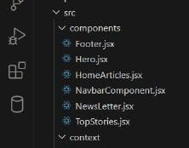

**STATE MANAGEMENT IN COOKBOOK PROJECT**

The **GlobalContextProvider** manages state using the **React Context API**, enabling seamless data sharing across components. It fetches cookbook recipes from an external API or database, storing them in state variables such as:

* **featuredRecipes** – Editor’s choice and must-try recipes.
* **quickRecipes** – Easy and fast recipes for busy schedules.
* **vegetarianDishes** – Plant-based and vegan-friendly meals.
* **dessertCollection** – A selection of sweet treats and baked goods.
* **userSavedRecipes** – Recipes bookmarked or saved by users for later reference.

The API retrieves recipes based on **cuisine, category, meal type, or dietary preferences**, ensuring a smooth and **efficient user experience** with minimal API calls.

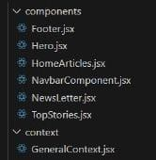

# ROUTING IN COOKBOOK PROJECT

In this project, **React Router** is used to manage

navigation between different pages, ensuring a seamless user experience. The **App.js** file sets up the routing structure using the **Routes** and **Route** components from react-router-dom.

# Routing Structure

1. **Navigation Bar**
   * The <NavbarComponent /> is placed at the top, ensuring that the navigation bar remains visible across all pages.
   * It allows users to navigate between different sections of the cookbook, such as **Home, Categories, Saved Recipes, and Profile**.

# Routes Setup

The <Routes> component acts as a wrapper for multiple <Route> components, defining paths and their corresponding components:

# Home Route (/)

* + - Renders the <Home /> component, displaying featured recipes and recent additions.

# Category Route (/category/:id)

* + - Dynamically renders the

<CategoryPage /> component based on the selected category.

* + - The :id in the URL represents a dynamic parameter, allowing the page to fetch and display recipes from a specific category (e.g., Breakfast, Vegan, Desserts).

# Recipe Details Route (/recipe/:id)

* + - Loads the <RecipeDetails /> component, displaying the full recipe, including ingredients, instructions, and user reviews.

# User Profile Route (/profile)

* + - Displays the <UserProfile /> component, showing user information, saved recipes, and contributions.

# Footer Component

* + The <Footer /> component is placed below the routes to ensure a **consistent footer section** across all pages.

# How React Router Works in This Project

* **Client-Side Navigation**: Users can switch

between pages **without a full reload**,

making the experience smooth and fast.

* **Dynamic Routes (:id)**: Recipe and category pages load content dynamically based on the selected recipe or category.
* **Modular & Organized**: The structure ensures easy management of multiple pages and sections of the cookbook.

Would you like to add extra routes for **meal planning** or **favorite recipes**? ●•l1s.•¸'˙7

#### SETUP INSTRUCTIONS PREREQUISITES

* 1. **Node.js and npm** – Node.js is required to run JavaScript in the development environment, and npm (Node Package Manager) is essential for managing dependencies. You can download Node.js from [Node.js Official Website.](https://nodejs.org/en/download/)
  2. **React.js** – The core library used to build dynamic and interactive user interfaces. It is installed via

**npx create-react-app** to set up a React project quickly.

* 1. **Visual Studio Code (VS Code)** – A powerful code editor used for writing and managing React.js code. It provides extensions and debugging tools that enhance development efficiency. Download it from [VS Code](https://code.visualstudio.com/) [Official Website.](https://code.visualstudio.com/)

**HTML, CSS, and JavaScript** – Fundamental knowledge of **HTML** (for structuring web pages), **CSS** (for styling and layout), and **JavaScript** (for adding interactivity) is necessary to work with React.js.

**Command Line Interface (CLI)** – Basic familiarity with using the command line or terminal for installing dependencies, running the development server, and managing the React project.

With these prerequisites in place, you can efficiently develop, style, and manage your **React.js frontend application** using **Visual Studio Code, Node.js, and JavaScript**.

**INSTALLATION**

##### Clone the Repository

**Steps to Clone the Repository:**

1. **Open Visual Studio Code (VS Code)** and launch the terminal (Ctrl +shift on Windows).
2. **Navigate to the directory** where you want to clone the project:

sh cd

path/to/your/folder

##### Move into the project directory

Run the command in vscode terminal: sh cd project-folder-

name

##### Install Dependencies

Make sure **Node.js** is installed. If not, download and install it from [Node.js Official Site.](https://nodejs.org/en/download/)

##### Steps to Install Dependencies:

1. Inside the project folder, **check if Node.js and npm are installed**:

sh node -v # Displays Node.js version

npm -v # Displays npm version

**Install all required dependencies** using npm: sh npm install

This command reads the package.json file and installs all necessary dependencies.

##### Run the React.js Application

* 1. **Start the development server**:

sh npm start

* 1. **Open the browser** and visit: arduino [http://localhost:3000](http://localhost:3000/)

The React application should now be running locally.

#### FOLDER STRUCTURE CLIENT

This **React.js application** is well-organized into different folders, each serving a specific purpose to

maintain clean, modular, and reusable code. Below is a breakdown of the directory structure based on your project:

* 1. **src/ (Source Folder) - Main Codebase**

The src folder contains all the core files required for the frontend React app.

##### components/ - Reusable UI Components

This folder contains various **React functional components** that are used throughout the project. These include:

* + - **Footer.jsx** → Renders the footer section of the website.
    - **Hero.jsx** → Handles the hero/banner section of the homepage.
    - **HomeArticles.jsx** → Displays a list of articles on the homepage.
    - **NavbarComponent.jsx** → Manages the website navigation bar.
    - **recipebook.jsx** → Provides a subscription form for newsletters.
    - **TopStories.jsx** → Fetches and displays the top trending news. Each of these components is **modular and reusable**, allowing for better code organization and efficiency.

##### context/ - State Management Using React Context

* + - **GeneralContext.jsx** → This file uses the React Context API to **fetch and manage global news data** (e.g., top news, business news, technology news, etc.). It ensures that different components can access shared data without prop drilling.

##### pages/ - Main Page Components

This folder contains React components that represent different **pages of the application**:

* + - **Home.jsx** → Serves as the main homepage, displaying featured news and categories.
    - **CategoryPage.jsx** → Dynamically fetches and displays news **based on a selected category**.
    - **Recipe book.jsx** → Renders a single news article when a user clicks on a specific news headline.

Each page is connected to the **React Router** for navigation between different sections.

###### ➤ styles/ - CSS Files for Styling

This folder contains **CSS files** that provide styling for individual components and pages:

* **CategoryPage.css** → Styles the category page layout.
* **Footer.css** → Styles the footer section.
* **Hero.css** → Styles the hero/banner section.
* **Home.css** → Contains styles for the homepage.
* **RecipeList.css** → Defines the appearance of recipes

on the homepage.

* **Navbar.css** → Styles the navigation bar.
* **RecipeDetails.css** → Defines the layout for the

detailed recipe page.

* **FeaturedRecipes.css** → Provides styles for displaying

###### trending recipes.

Having separate CSS files for each component ensures

**better maintainability and modularity**.

##### Other Important Files in src/

* + **App.js** → The root component that integrates **React Router** for navigation and renders major components like Navbar, Footer, and Page Routes.
  + **App.css** → Contains global styles for the entire application.

##### public/ - Static Assets Folder

This folder is typically used for **static files** like images, icons, and index.html.

* + **index.html** → The main HTML file where the React app is injected.
  + **Favicon and logo files** → Store images/icons used in the app.

##### node_modules/ - Installed Dependencies

This folder contains all the installed **npm packages** required for the project. It is automatically generated when you run npm install.

##### package.json - Project Metadata & Dependencies

###### This file is contains:

Project metadata (name, version, description) List of installed dependencies (e.g.,React, ReactRouter,Axios)

Scripts to run the app (npm start)

#### UTILITIES

From the provided project structure and code snippets, the primary helper function implementation is within GeneralContext.jsx, which manages API calls and global state. However, if the project includes additional utility functions or custom hooks, they would likely be found in a dedicated utils/ or hooks/ folder (which is not currently visible). Below is an explanation of key helper functions used in this project:

##### Helper Functions (API Fetching in GeneralContext.jsx)

* + The fetchTopNews(), fetchBusinessNews(), fetchPoliticsNews(),andfetchTechnologyNews() functions handle API requests using **Axios** to

retrieve categorized news articles from the NewsAPI.

* + Each function performs an asynchronous API request, extracts articles from the response, and updates the corresponding state using useState().
  + These functions are called inside useEffect() to fetch data when the component mounts, ensuring the news updates dynamically.

1. **Context API for State Management (GlobalContext.jsx) in the Cookbook Project**

* This project utilizes the **React Context API** to manage **global state** for different recipe categories (**featuredRecipes, quickRecipes, vegetarianDishes, desserts, and userSavedRecipes**).
* The **GlobalContext.Provider** allows all child components to access recipe data **without prop drilling**.
* Any component within the context can **consume this data** using:
* const { featuredRecipes, quickRecipes } = useContext(GlobalContext);

This makes **state management efficient and organized**, ensuring recipes are easily accessible across the application.

1. **Custom Hooks (If Used) in the Cookbook Project**
   * While no explicit custom hooks are present in the shared code, a **custom hook (useFetchRecipes.js)** could be created to modularize **API fetching logic**, reducing redundancy.
   * Instead of making multiple API calls in different components, this hook centralizes the **fetching of recipes** based on **cuisine, category, or meal type**.

#### RUNNING THE APPLICATION

Commands to Start the Frontend Server Locally in VS Code Follow these commands to run your React.js frontend server in VS Code:

1. Open VS Code and Navigate to the Project Folder If you haven't already opened your project, use PowerShell in VS Code:

powershell

cd path\to\your\project

Or, if you're already inside the project folder, you can open VS Code directly with:

powershell code

.

1. Install Dependencies (If Not Installed Already) If you haven't installed dependencies yet, run:

powershell npm install

1. Start the React Development Server Run the following command:

powershell npm start This will:

Start the React development server. Automatically open [http://localhost:3000](http://localhost:3000/) in your default browser.

4️ Stop the Server (If Needed) To stop the running server, press:

powershell Ctrl + C

Then confirm by typing Y (Yes).

Now frontend React.js application is running locally!

#### COMPONENT DOCUMENTATION

##### Major Components in the Project

1. **NavbarComponent.jsx Purpose:**

The NavbarComponent provides the main navigation menu for the application, allowing users to navigate between different pages, such as the homepage, category pages, and individual news articles. **Props:**

* + No props received (it manages navigation internally using React Router).

##### Hero.jsx Purpose:

The Hero component serves as the homepage's banner section, possibly displaying featured news articles or an eye-catching introduction. **Props:**

* No explicit props (fetches/display top news from the context or API).

##### HomeArticles.jsx Purpose:

Displays a list of trending news articles on the homepage. It retrieves data from the GeneralContext

and maps through the articles to render them in a structured layout.

**Props:** articles (array) → List of articles to display.

##### TopStories.jsx Purpose:

This component displays the top trending news stories

from the fetched data, likely obtained from the API or context provider. **Props:**

* stories (array) → List of top stories to display.

##### Footer. jsx Purpose:

Displays footer content, including links to social media, contact information, and copyright details. **Props:**

* No props received.

##### Page Components

1. **Home. jsx Purpose:**

The main landing page of the application. It includes the Hero, TopStories, and HomeArticles components to present a summary of the latest news. **Props:**

* No props received (renders child components).

##### CategoryPage. jsx Purpose:

Displays news articles based on a selected category (e.g., Business, Technology, Politics). Uses React Router to extract the category from the URL and fetch relevant data.

##### Props:

* category (string) → Extracted from the URL to determine which category's news to fetch.

## RecipeDetails.jsx (Converted from

**NewsPage.jsx for the Cookbook Project) Purpose:**

### Displays a **full recipe** when a user clicks on a specific recipe item.

* Fetches the **recipe details** using an **ID from the URL**.

## Props:

* **recipeId (string)** → Extracted from the URL to

### fetch the correct recipe details.

##### Context Provider

1. **GeneralContext.jsx**

**Purpose (Converted for Cookbook Project)**

**Provides global state management for the application, storing fetched recipe data for different categories and making it accessible across multiple components.**

**Provided Values:**

* **featuredRecipes → Array of trending or highlighted recipes.**
* **quickRecipes → Array of fast & easy-to-make recipes.**
* **vegetarianDishes → Array of plant-based or vegetarian recipes.**
* **desserts → Array of sweet treat recipes.**
* **userSavedRecipes → Array of recipes saved by users.**

#### REUSABLE COMPONENTS

###### Reusable Components & Their Configurations in the Project

In this React project, several components are designed to be reusable across multiple pages to maintain a modular structure and improve maintainability. Below are the key reusable components, their configurations, and how they enhance the project's functionality.

##### NavbarComponent.jsx Purpose:

* + - Provides a navigation bar that appears on all pages.
    - Uses React Router for seamless navigation.

##### Configurations:

* + - No external props required, as navigation links are hardcoded.
    - Can be extended by adding new links dynamically.

##### Footer.jsx

**Purpose:**

* + Displays a footer section on all pages with social links and general information.
  + Provides consistent branding and copyright information.

**Configurations:** • No props needed.

* + Can be modified to include additional links or sections.

##### Hero.jsx

**Purpose:**

* + Serves as a homepage banner, highlighting featured news or categories.
  + Can be styled dynamically for different themes.

##### Configurations:

* + Can accept props like title and image for customization.

##### HomeArticles.jsx Purpose:

* + Displays a list of news articles dynamically fetched from context or API.

##### Configurations:

* + Accepts an articles prop (array) to display news items.

##### TopStories.jsx

**Purpose:**

* Renders a section with top trending news stories.

##### Configurations:

* Accepts a stories prop (array) for displaying articles dynamically.

##### NewsLetter.jsx

**Purpose:**

* + *Provides a subscription form for users to receive updates.*

##### Configurations:

* + No props required, but can be modified to accept onSubmit for form handling**.**

#### STATE MANAGEMENT

##### Global State Management & State Flow in the Project 1. State Management Approach

This project uses the React Context API for global state management, specifically through the GeneralContext.jsx file. This allows data like top news, business news, technology news, and politics news to

be fetched once and accessed across multiple components without excessive prop drilling.

##### How State Flows Across the

**Application 1 Fetching Data in GeneralContext.jsx**

* + - The GeneralContextProvider component fetches data from the News API and stores it in state variables (topNews, businessNews, technologyNews, politicsNews).
    - It uses useEffect to call APIs when the component mounts.
    - This state is shared using the GeneralContext.Provider.

##### Providing Global State

* + The GeneralContext.Provider wraps around the entire app in the main entry file (e.g., index.js or App.js).
  + Any child component inside the provider can access the global state.

##### Consuming State in Components

* + Components like HomeArticles.jsx, TopStories.jsx, and CategoryPage.jsx use the useContext hook to retrieve news data from GeneralContext.
  + This prevents the need to pass state manually

through multiple levels of components.

**Handling Local State Within Components in the Cookbook Project** In this project, **local state** is managed using the **useState** hook within individual components to handle **UI interactions, form inputs, and toggles efficiently**.

For example:

1. **Newsletter Subscription (Newsletter.jsx)**
   * Local state stores **user input** and **subscription status**.
   * The email state variable holds the **user’s email address**, and success determines **whether the subscription was successful**, allowing dynamic updates within the component.
2. **Navbar Toggle (NavbarComponent.jsx)**
   * Local state controls the **visibility of a mobile menu**.
   * The isMenuOpen state variable toggles between true and false when the menu button is clicked, ensuring the dropdown **appears only when needed**.

Unlike **global state** (managed via useContext for sharing data across components), **local state** remains **confined within a single component**, reducing unnecessary re-renders and improving performance.

This approach ensures a **clean separation of concerns**, keeping UI logic

**lightweight and responsive to user interactions**.

#### USER INTERFACE

HOME PAGE

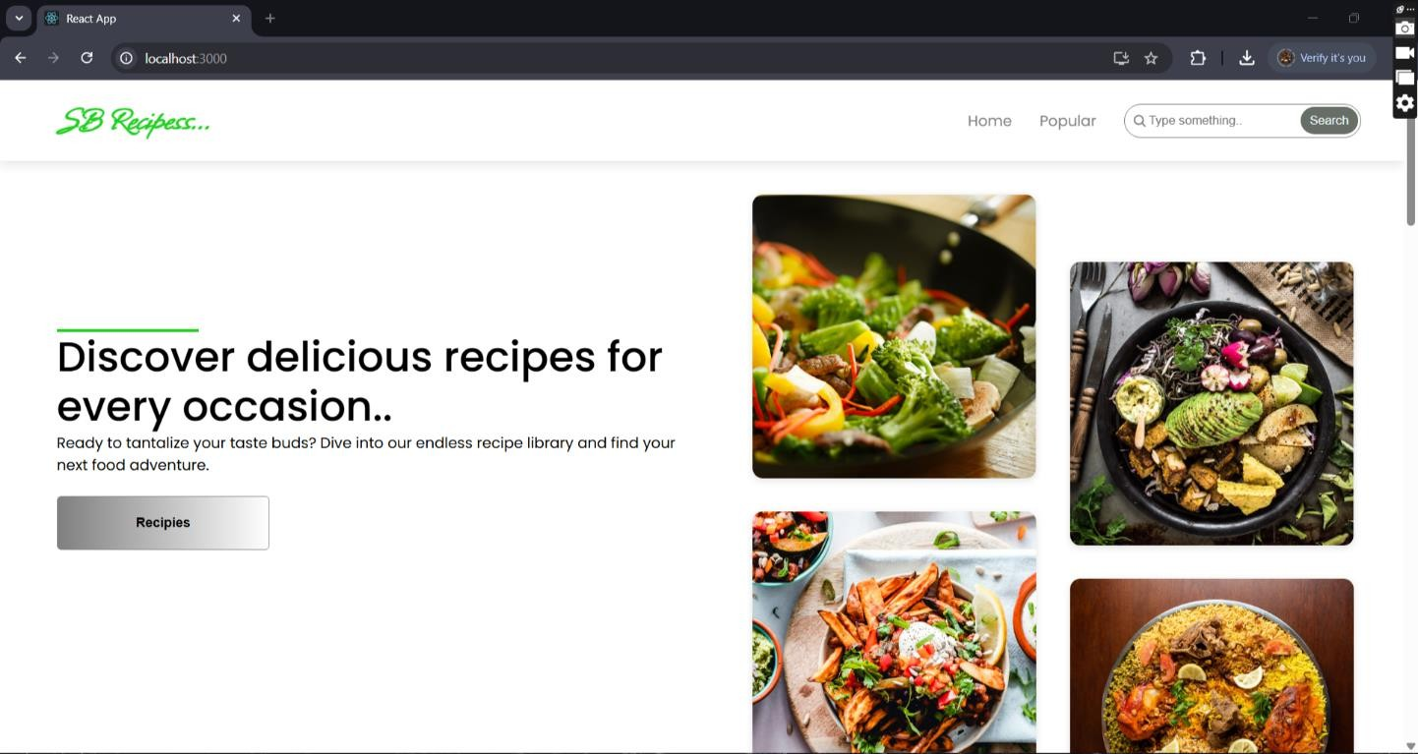

POPULAR

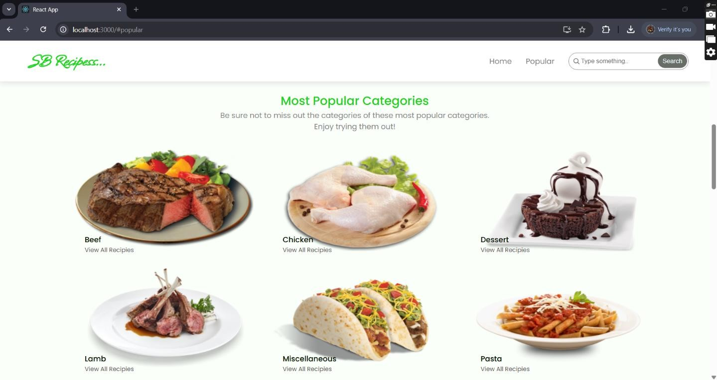

TRENDING

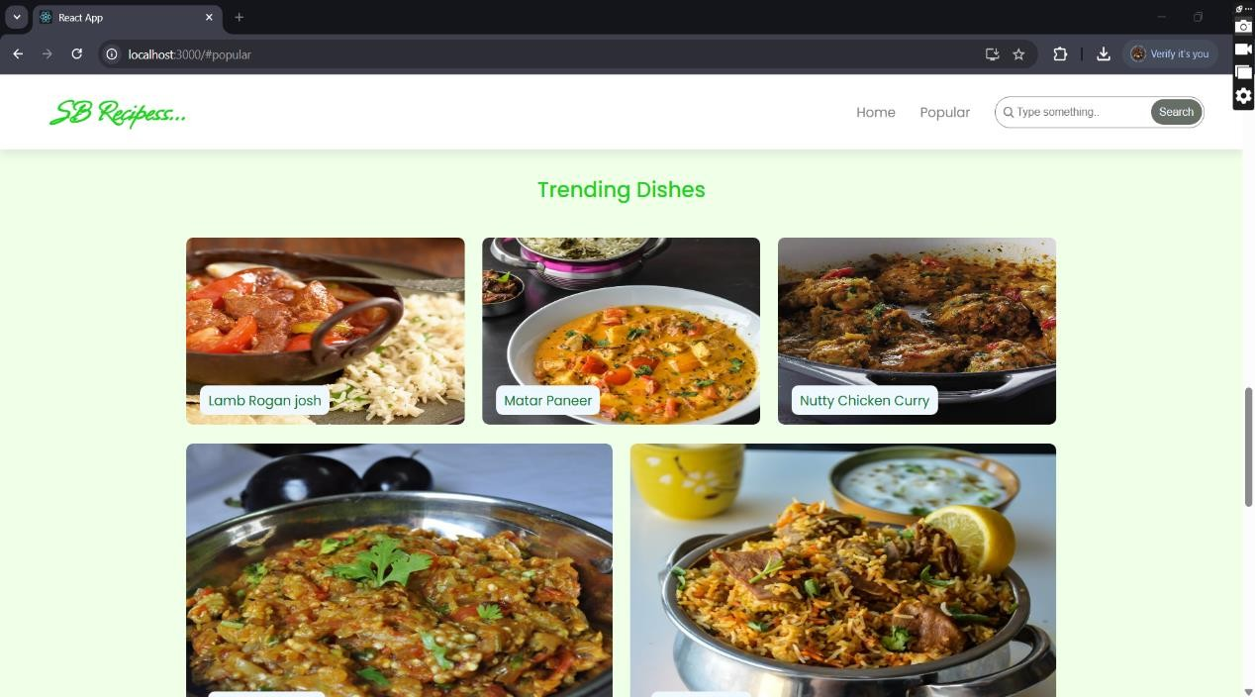RESULT & FOOTER

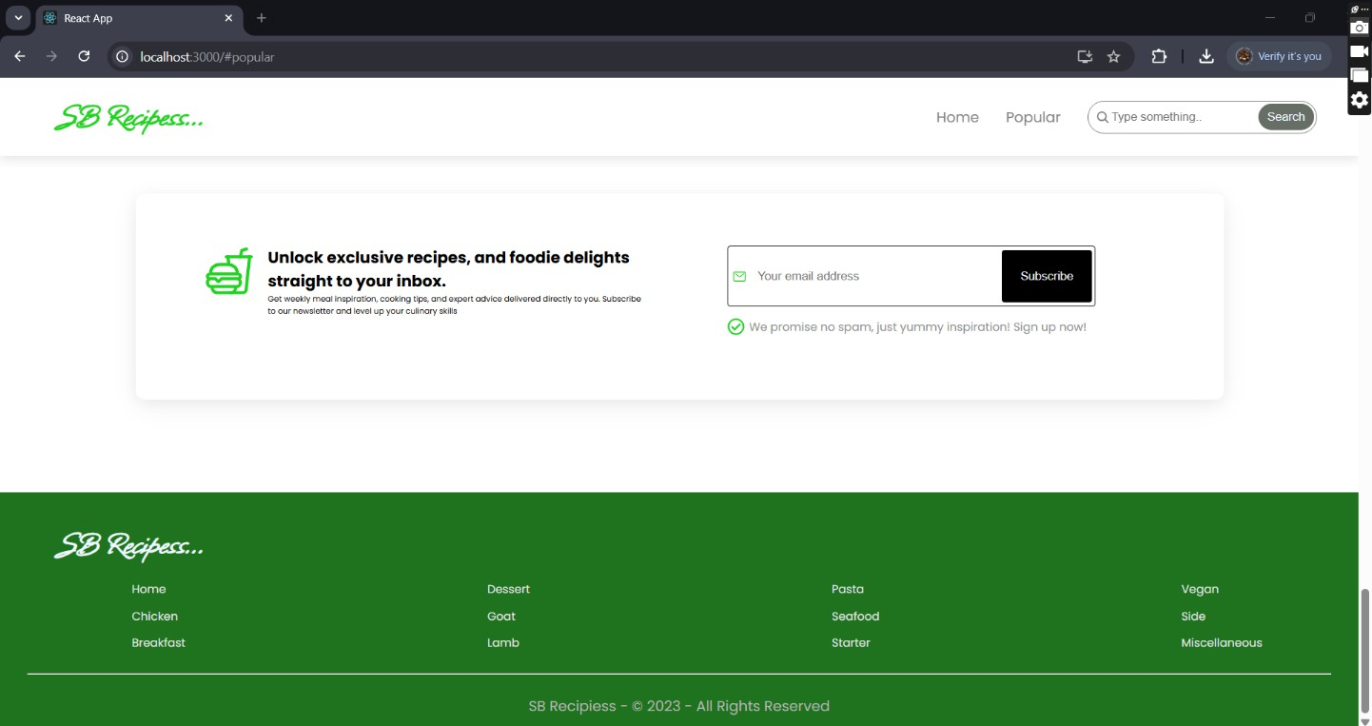

#### STYLING

##### CSS Frameworks, Libraries, or Pre-processors Used in the Project

In this project, **CSS is used for styling** the frontend, ensuring a visually appealing and responsive user interface. While no mention of **CSS pre-processors** like Sass or libraries like Styled-Components has been made, it's important to understand their possible role in improving styling efficiency.

##### CSS (Cascading Style Sheets) - The Core Styling Approach

* + The project likely uses **standard CSS** files, imported into React components for styling.
  + CSS is responsible for defining layouts, colors, fonts, and responsive designs.
  + Styles can be applied globally via a main stylesheet (e.g., App.css) or at the component level by using separate CSS files for each component.

**2** .**CSS Frameworks – Possible Enhancements** If a **CSS framework** is used, it might be one of the following:

* + **Bootstrap:** Provides ready-made, responsive components like grids, buttons, and forms. It simplifies styling without custom CSS.
  + **Tailwind CSS:** A utility-first framework that allows quick and flexible styling using predefined classes. It helps speed up development by avoiding custom CSS rules.

##### CSS Pre-processors – Sass (If Used)

* + If **Sass (Syntactically Awesome Stylesheets)** is used, it extends CSS with variables, nesting, and mixins, improving code maintainability.
  + Pre-processors help create reusable styles and reduce CSS redundancy.

##### Styled-Components – Alternative Styling in React

* + If **Styled-Components** were used, styling would be written directly inside React components using JavaScript.
  + It allows for dynamic styling based on props and state.

##### Theming and Custom Design Systems in the Project

In this project, theming or a custom design system can be implemented to maintain a **consistent look and feel** across the application. Theming allows for dynamic

styling based on user preferences, such as **light and dark mode**, while a custom design system ensures uniformity in UI elements like buttons, typography, and colors.

##### Theming in the Project (If Implemented)

* + The project could use **CSS variables (:root)** or

**React Context** to manage themes dynamically.

* + If **Tailwind CSS** or **Styled-Components** is used, themes can be toggled using utility classes or JavaScript logic.
  + Example: A **dark mode toggle** might store the user’s preference in **local storage** and update styles accordingly.

##### Custom Design System

* + A design system ensures that UI components (buttons, cards, inputs) follow a **consistent style guide**.
  + If implemented, it includes **global CSS rules** (e.g., global.css or theme.css) and **reusable components** for buttons, typography, and layouts.
  + This system improves maintainability and ensures branding consistency.

##### Possible Implementation Techniques

* + **CSS Variables (:root)** for global styles (colors, fonts, spacing).
  + **React Context API** for managing theme states globally.
  + **Tailwind CSS Configuration (tailwind.config.js)** for defining custom colors and styles.

#### TESTING

**Testing Approach for Components in the Project** Testing in a React project ensures that components function correctly and maintain stability as the application evolves. The project may use **unit, integration, and end-to-end (E2E) testing** to validate different aspects of the application.

1. **Unit Testing – Testing Individual Component Purpose:** Ensures that each component renders correctly and functions as expected in isolation.
   * **Tools Used:** Typically done using **Jest** and **React Testing Library**.
   * **Example:** Testing if the NavbarComponent renders correctly with navigation links.
   * **Command:** npm test (if Jest is configured).

###### Integration Testing – Testing Component Interactions

* **Purpose**: Verifies that multiple components **work together correctly**.
* **Example**: Checking if **clicking a recipe category updates the displayed recipes** dynamically.
* **Tools Used**: **React Testing Library** can be used to simulate **user interactions** and verify component behavior.

###### End-to-End (E2E) Testing – Testing User Flows

* **Purpose**: Ensures the **entire application** works as

expected from a user’s perspective.

* **Example**: Automating a test that:

1. **Loads the homepage**
2. **Selects a recipe category**
3. **Opens a recipe detail page**
4. **Adds a recipe to the saved list**

* **Tools Used**: **Cypress, Playwright, or Selenium** for browser-based testing.
* **Command** (for Cypress):

#### DEMO LINK

**https://drive.google.com/file/d/1guFyHmUs65BysZh6dtF-WePCrNd2MYQq/view**

#### KNOWN ISSUES

**Known Bugs and Issues in the Cookbook Project** While the project aims for a **smooth user experience**, there are a few **potential issues** that users and developers should be aware of:

###### API Limitations & Errors

* + The application fetches **recipes from an external API**, which may have a **rate limit** on free-tier plans.
  + If too many requests are made in a short time, API calls may **fail**.
  + **Solution**: Implement **caching** or reduce **API requests per session**.

###### Inconsistent Recipe Loading

* + Some recipes might not **display properly** due to missing data (e.g., missing images or ingredient lists in API responses).
  + **Solution**: Add **fallback values** for missing data in the UI.

###### Routing Issues

* + If users **refresh** a page like /category/:id, they may encounter a **404 error** due to missing backend support for **React Router**.
  + **Solution**: Use a **server-side route handler** or configure **Netlify/Vercel rewrites**.

###### Performance Bottlenecks

* + Fetching large amounts of recipe data **without pagination** can slow down the app.
  + **Solution**: Implement **lazy loading** or **pagination** for better performance.

**Future Enhancements for the Cookbook Project** To improve **functionality, user engagement, and performance**, the following **enhancements** can be implemented:

###### ⬛ OAuth Authentication

* + Implement login using **Google, Facebook, or GitHub**, allowing users to **personalize their recipe feeds**.

###### ⬛ Bookmarking & Favorite Recipes

* + Add a **"Saved Recipes"** feature so users can **store and revisit** their favorite recipes.

###### ⬛ User Reviews & Ratings

* + Allow users to **review and rate** recipes, helping others choose the best dishes.

###### ⬛ Dark Mode & UI Enhancements

* + Add **Dark Mode, infinite scrolling, and skeleton loaders** for a smoother UI/UX experience.

###### ⬛ Performance Optimization

* + Implement **caching mechanisms, lazy loading**, and

**image compression** for improved efficiency.

###### ⬛ Progressive Web App (PWA) Support

* + Allow **offline access** to saved recipes for a **seamless cooking experience**.

###### ⬛ Advanced Recipe Filters

* + Enable filtering recipes by **cuisine, ingredients, cooking time, and difficulty level**.

###### ⬛ AI-Powered Recipe Recommendations

* + Use AI to **suggest recipes based on user preferences**

and past interactions.