ARUNKUMAR.M
Mobile no: 8973932924 arunkumarmurugasan@gmail.com

OBJECTIVE |  | Seeking a position to utilize my skills and abilities in your industry upto your satisfaction level.
EDUCATION  QUALIFICATION | (2016) | B.E - Computer Science And Engineering (UG)  CGPA - 6.42  SriGuru Institute Of Technology, Coimbatore.
 | (2012) | Higher School Certificate (HSC)  Percentage - 61%  Thanthai Hans Roever Higher School, Perambalur.
 | (2010) | Secondary School Leaving Certificate (SSLC)  Percentage - 75%  Thanthai Hans Roever Higher School, Perambalur.
SOFTWARE PROFICIENCY |  | Language Known :  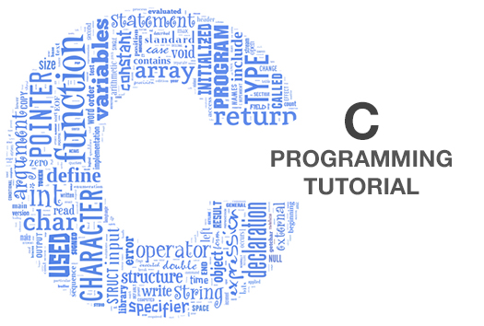, ,
Operating system :
,,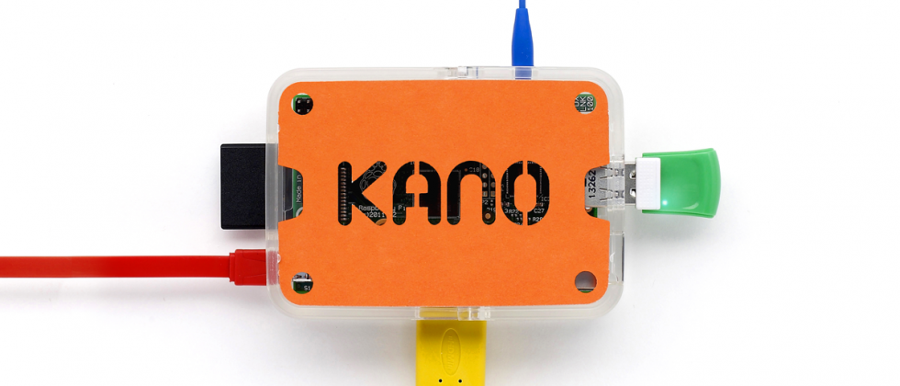
AREAS OF  INTEREST | ,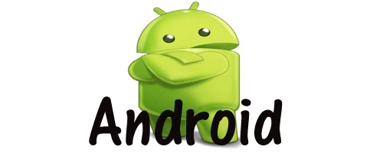,
TRAININGS |  | Attended a one day training on PHP and MySQL conducted by SriGuru Institute Of Technology On februrary 24th 2015.
PRESENTATIONS  DONE  PROJECTS  DONE  SEMINARS /  WORKSHOPS |  | Presented a paper titled “ PREVENTION OF FIRE ACCIDENTS USING WIRELESS SENSOR NETWORKS ” in a Seminar held at Erode Sengunthar college on 12th Sep 2015.
PRESENTATIONS  DONE  PROJECTS  DONE  SEMINARS /  WORKSHOPS |  | Presented a paper titled “ SMART REGISTRATION SYSTEM IN COLLEGE ”in the International Conference on “ Innovations in science and technology ” at SriGuru Institute Of Technology.  during 1st April 2016.  Done a mini Project on “ AUTOMATIC STREET LIGHT CONTROLLER ” under the guidance of R.Rajiv , Department Of Electrical and Electronics Engeeniring , SriGuru Institute Of Technology.  Done a project in raspberry pi “PROJECTOR” under the guidance of M.Sathish, Department Of Computer Science and Engeeniring , SriGuru Institute Of Technology.  Done a Project on “ SMART REGISTRATION SYSTEM IN COLLEGE ” under the guidance of V.Subha , Department Of Computer Science and Engeeniring , SriGuru Institute Of Technology.
PRESENTATIONS  DONE  PROJECTS  DONE  SEMINARS /  WORKSHOPS |  | Attended 3days workshop on “ANDROID” conducted by SriGuru Institute Of Technology from 22th March 2014 24th March 2014.
ACHIEVEMENTS |  | Done a project in raspberry pi “PROJECTOR” in SriGuru Institute Of Technology.  I have designed the certificate for the INTERNATIONAL CONFERENCE which was held in our college.  I have designed the website for the arumkumaraks.uphero.com which was held in our college.
HOBBIES |  | Drawing  Using Photoshop , Picasa, video Editing  Browsing ,video Games
PERSONAL  DETAILS |  | Father’s Name : Murugasan .K  Date of Birth : 25.05.1995  Gender : Male  Nationality : Indian  Mother Tongue : Tamil  Language Known : English ,Tamil
DECLARATION |  | I here by declare that all the details furnished above are true to my knowledge and belief.

Date:
ARUNKUMAR.M
Place: Chennai

