**PDF PROCESSING**

* **Encrypted the pdf with password:**

We select the file using the **tkinter**, used the **PyPDF2** to use the bydefault functions on the package, then we process the file and encrpt using the password

import PyPDF2  
import tkinter  
from tkinter import filedialog  
root=tkinter.Tk()  
root.withdraw()  
file_name=filedialog.askopenfilename()  
  
pdf_in_file=open(file_name,'rb')  
inputpdf=PyPDF2.PdfFileReader(pdf_in_file)  
pages_no=inputpdf.numPages  
output=PyPDF2.PdfFileWriter()  
for i in range(pages_no):  
 inputpdf=PyPDF2.PdfFileReader(pdf_in_file)  
 output.addPage(inputpdf.getPage(i))  
 output.encrypt('admin@123')  
 with open("sample2.pdf","wb")as outputStream:  
 output.write(outputStream)  
pdf_in_file.close()

* **Class, Function, Exception implementation:**
* Class **PDFProcessing:** Class is implemented for the pdf processing

class PDFProcessing:

* Function **def Encry(self):** Function is implemented for the encrypting the file with password

def Encry(self):

* Exception (Try..Except): The try block is implemented if there is any issue file we opening the file it throws error, if it has any error than except block is executed

try:  
  
 pdf_in_file = open(f_name,'rb')

except:  
 print("File open Error")

* **Selection of file using Tkinter:**

We import the tkinter package for selection of a file , by using the default functions we select the file by using the path , to be accessible for user to select the file based on the requirement

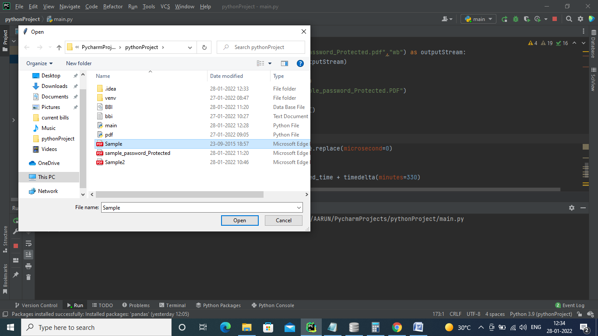

* **DateTime Stamp:**

We return the encrpyted file date ,time by using the **datetime** and **timedelta** packages

current_time = datetime.now()  
#print(current_time)  
# print(type(current_time))  
  
Modified_time = current_time.replace(microsecond=0)  
#print(Modified_time)  
  
added_current_time = Modified_time + timedelta(minutes=330)  
#print(added_current_time)  
# print(type(added_current_time))  
  
my_time_format = "%y_%m_%d_%H_%M_%S"  
converted_format_time = datetime.strftime(added_current_time, my_time_format)  
print(converted_format_time)

* **Database connection:**

We import **sqlite3** package, then we create the **DB** and **table** for stroing the file information like File_name, File_size, Time_of_encryption

connection = sqlite3.connect("BBI.db")  
query = """Create table Pdf_Processor("file_name" text, "file_size" integer,"time_of_encry" time)"""  
execution = connection.execute(query)  
connection.commit()  
connection.close()

* **Storing the file_info on Database:**  
   We insert the file_info on database based on file_name, file_size,time_encry

connection.execute("insert into Pdf_Processor values(?,?,?)", (file_name, size, converted_format_time))  
connection.commit()  
connection.close()

