Task 1: Create a directory /user/acadgild/hadoop.

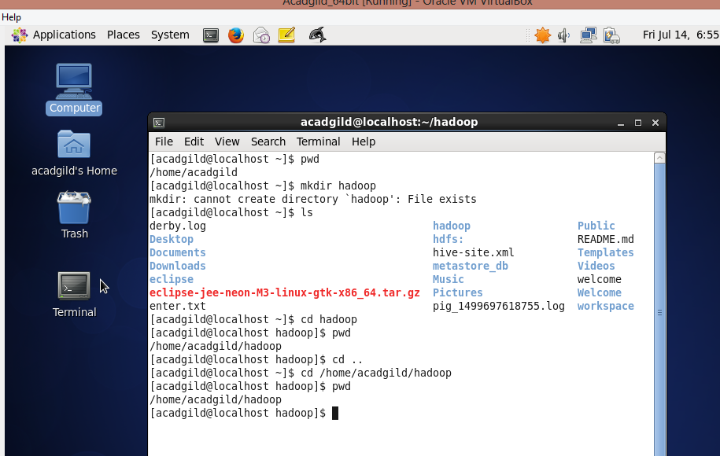

Task 2:

Create a file in HDFS under directory /user/acadgild/hadoop, with name word-count.txt.

Whatever we type on screen should get appended to the file.

Try to type (on screen) few lines from any online article or textbook.

