# ONLINE BUS TICKET BOOKING SYSTEM

Submitted By:

Name: Arun Majhi

NCC ID: 00174622

Batch No: 22 ‘C’

Computing Project

Level 5 Diploma in Computing

Softwarica College of IT & E-Commerce

May 3,2019

Submitted To: Sudeep Bajimaya

Table of Contents

ONLINE BUS TICKET BOOKING SYSTEM 1

Introduction 3

SCOPE 3

AIM 3

OBJECTIVES 3

FEATURES 3

PROJECT PLAN 5

WORK BREAKDOWN STRUCTURE 5

Fig: Time estimate table. 6

MILESTONES 6

**Analysis** 7

**Design** 7

**Implementation** 7

**Testing** 7

**Maintenance** 7

GANTT CHART 8

RISK MANAGEMENT 9

Fig: Risk impact and corresponding actions. 10

CONFIGURATION MANAGEMENT 10

Conclusion 11

# Introduction

This project is about Online Bus Ticket Booking system which is an online web-based application. This system is basically made for the customer or passenger which provide booking ticket service. The ticket reservation system is internet-based application which can be access through the net. By this customer or passenger in which all passengers can easily know about the arrival and departure time, price of ticket and also can choice which bus they want to go. Online Bus Ticket Booking system helps to consume the costumer to saving their time. I have taken Visual basic for application platform or approach to build this project.

# SCOPE

This application can be used by any travel agent to issue the tickets to the customer from this customer will able to check the timings and schedule of the buses. Other they have to go to buy bus ticket or ask for bus schedule and they need to pay cash when they buy bus tickets and sometime need to queue up for hour.

## AIM

* Customer should be able to login to the system through the first page of the application.
* Change the password after logging into the system and able to new login from the accessing the booking facility.
* To make the travelers enjoy the journey in very safe and comfort way
* To provide 24hours booking facility from anyplace to the customers.

## OBJECTIVES

* To get modified transaction and provide an electric system which helps both management and customer to process the reservation efficiently.
* To record the customer information which will serves as bases to avoid overcrowding of files.
* To find and get the information needed easily in case of conformation and for records.
* To automate the existing system of issuing tickets, at present tickets are issuing only at select outlets.
* Enable the system so that customer can book ticket at his or her place.

### FEATURES

* Admin can use the system to login, insert, delete and update the data such as about the bus transport description, timetable which will change according to the date.
* To allows customers to easily book or purchase bus tickets.
* To know and check the statistic information from the system.
* This application includes email or phone number conformation for the ticket.

#### DEVELOPMENT METHOD

Agile methodology it is the iterative approach in which the software developed incrementally to deliver software in short chunks is a flexible process to respond to changes quickly and the same is true, allowing a developer to go back to pervious tags and a carry out necessary changes so the software without much delay as compared to the convention plan driven software method.

So, I am going to use Waterfall Model because it referred as linear sequential life cycle mode.in this each phase is completely full before the next phase can begin and there is very easy to understand and use in waterfall model, phases are fully complete at a time. Works well for smaller projects where requirement are very well understood. Its stages are clearly defined, easy to arrange task and data are completely manages.

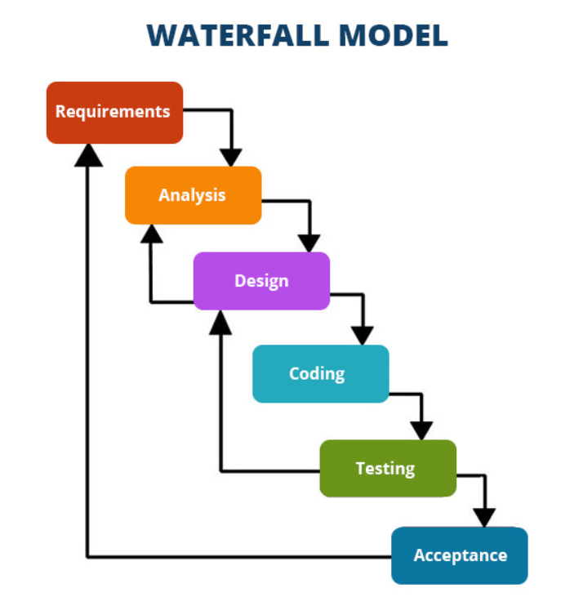

Fig: Phases of Waterfall Model.

The following phases of waterfall model are: -

* **Requirement and analysis**: the possible requirements of the system is to be developed are captures in the phase and documented in requires specification.
* **System Design**: this specification from first phase are studied in this phase and system design is prepared. System design helps in specification hardware and system requirements and also helps in defining overall system architecture.
* **Implementation/ Coding**: With inputs from system design, the system is first developed in small programs called units, which are integrated in the next phase. Each unit is developed and tested for its functionality which is referred to as unit testing.
* **Testing**: the units developed in the implementation phase are integrated into a system after testing of each unit. post integration the entire system is tested for any faults and failures.
* **Acceptance/Maintenance**: Some issues occurs which come up in the client environment. To fix those issues patches are released. Enhance the product some better version is released. Maintenance is done to deliver these changes in the customer environment.

Advantage of waterfall methodology

* It takes a sequential approach to software development where a project is divided into different phases.
* It works well when the scope of the project is known beforehand.
* It doesn’t allow partial success which increases the risk of failure.
* Testing cannot be done during the development cycle but only at the end.
* Customer availability is required only at set milestones.

# PROJECT PLAN

## WORK BREAKDOWN STRUCTURE

A work-breakdown structure (WBS) in project management and systems engineering, is a deliverable-oriented breakdown of a project into smaller components. A work breakdown structure is a key project deliverable that organizes the team's work into manageable sections.

Purpose of using WBS structure are

* Identify all task location in the outline structure of the projects.
* Assist with reporting and tracking
* Help an organization connect a task with another process or system.

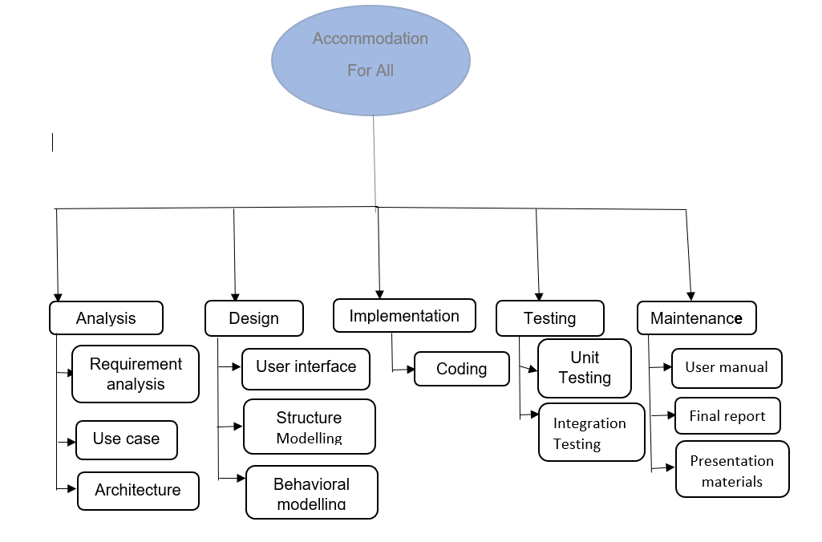

Fig: Work Breakdown structure of project.

|  |  |  |
| --- | --- | --- |
| WBS# | Task name | Days |
|  | Online Bus Ticketing Booking system. | 100 |
| 1  1.1  1.2  1.3  1.4 | **Project Management**  Risk Management  WBS  Configuration management  Proposal Submission | 20  5  5  5  5 |
| 2  2.1  2.2  2.3 | **Analysis**  Requirement analysis  Use case  Architecture | 20  8  6  6 |
| 3  3.1  3.2  3.3 | **Design**  User interface  Structure Modelling  Behavioral modelling | 15  5  5  5 |
| 4  4.1 | **Implementation**  Coding | 25  25 |
| 5  5.1  5.2 | **Testing**  Unit testing  Integration testing | 10  5  5 |
| 6  6.1  6.2  6.3 | **Maintenance**  User manual  Final report  Presentation materials | 15  5  5  5 |

## Fig: Time estimate table.

## MILESTONES

This tool is basically used in project management purpose.it add significant value in project scheduling. It helps to determine project management whether it is schedule or not.

|  |  |
| --- | --- |
| Milestones | Date |
| **Project Management**  Risk Management  WBS  Configuration management  Proposal Submission | May 3, 2019  April 27, 2019  April 29, 2019  May 1,2019  May 3,2019 |
| **Analysis** Requirement analysis  Use case  Architecture | May 27, 2019  May 4, 2019  May 11, 2019  May 27, 2019 |
| **Design** User interface  Structure Modelling  Behavioral modelling | Jun 12 ,2019  Jun 2, 2019  June 7, 2019  June 12, 2019 |
| **Implementation** Coding | July 7,2019  July 7, 2019 |
| **Testing** Unit testing  Integration testing | July 27,2019  July17, 2019  July 27,2019 |
| **Maintenance** User manual  Final report  Presentation materials | August12,2019  August 2, 2019  August 7, 2019  August 12, 2019 |

Fig 1.2- Milestone

From the above given figure, all the required date is providing to complete the project and start date of project is April,2019 and end date is August, 2019.where every task should complete according to given date.

|  |  |
| --- | --- |
| Milestones | Date |
| Project Proposal | May 3,2019 |
| Analysis report | May 27, 2019 |
| Design | June 12, 2019 |
| Coding | July 7, 2019 |
| Testing | July 27,2019 |
| Maintenance | August 12, 2019 |

Fig: Milestones of project.

### GANTT CHART

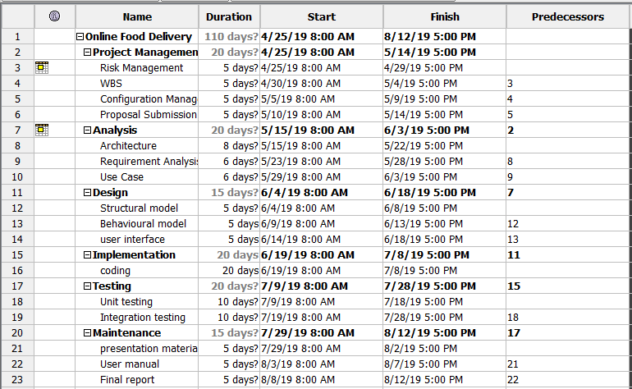

Fig: Scheduling of project

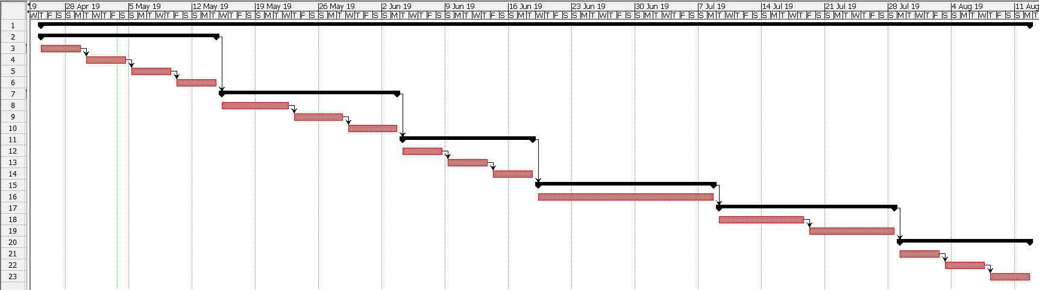

Fig: Gantt chart of project management

# RISK MANAGEMENT

It manly identifying assessing and controlling the threat. Risk can come from many sources including unnecessary threats like project failure, legal liabilities and natural disaster.

To estimate the impact of each identified risk we use

Impact = Likelihood * Consequence

|  |  |
| --- | --- |
| Likelihood | Value |
| Low | 1 |
| Medium | 2 |
| High | 3 |

Fig: Risk Likelihood and its value

|  |  |
| --- | --- |
| Consequence | value |
| Very Low | 1 |
| Low | 2 |
| Medium | 3 |
| High | 4 |
| Very High | 5 |

Fig: Risk Consequence and its value

|  |  |  |  |  |  |
| --- | --- | --- | --- | --- | --- |
| Serial No. | Risk | Likelihood | Consequence | Impact | Action to be taken |
| 1 | Hard Disk failure | 2 | 4 | 8 | Store in external hard drive, google drive and GitHub. |
| 2 | Possibility of Sickness | 1 | 3 | 3 | Maintain healthy life style |
| 3 | Natural Disaster | 1 | 5 | 5 | More focus in security policy for backup. |
| 4 | Distraction from project | 2 | 3 | 6 | Focus on project and track milestones. |
| 5 | Time Limitation | 2 | 4 | 8 | Every step should complete before moving ahead time to time. |
| 6 | Error while coding | 2 | 3 | 6 | While writing code it must be done with various precaution. |
| 7 | Unauthorized access | 3 | 4 | 12 | Large and strong password mush be used. |
| 8 | Unclear requirement | 3 | 3 | 9 | Ask correct question to client. |

# Fig: Risk impact and corresponding actions.

# CONFIGURATION MANAGEMENT

This software configuration management is used to manage and make different introduced to the products. It helps to identify the configuration, backup and individual elements.

I have made many folders for the manager system to manage each folder for each step for development process. For back up I have made a secrete folder and also for sub steps I have made sub folder. The structure of configuration is

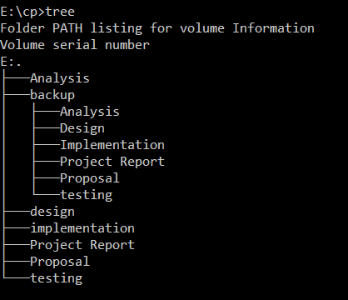

TO keep secret and for backup for file development process, I’m planning to use a GitHub or external hard drive or Google drive.

# Conclusion

The given proposal was design in focus of the upcoming generation of future modification which can be done in an easy way. Nowadays, old reservation system of Bus ticketing is slowly stopping and in present generation by the help of technology dominates human life. Also, people prefer easy, quick, Fast and

safe way for every part of life. This project is designed to meet the requirement of ticket booking system. with the platform, we are hopping to reduce time wasting, avoid misunderstanding, provide easy data flow, customer pleasure and less hard work. I hopping that will accomplish my aims, intention and clinical.