1. **##Code to retrieve all metadata for an AWS EC2 instance**

**Command:**

aws ec2 describe-instances --instance-id

**Output:**

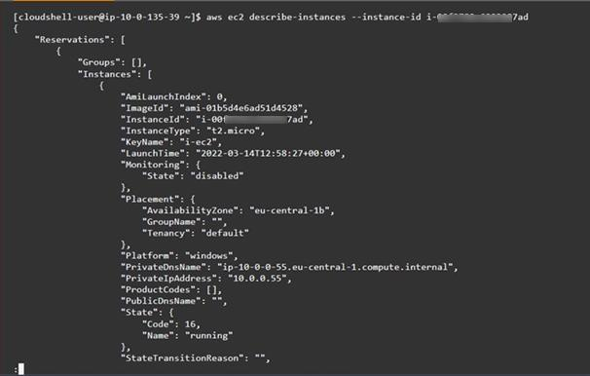

**##Bonus Question: The code allows for a particular data key to be retrieved individually in AWS EC2 instance:**

**Example filter command:**

aws ec2 describe-instances --filters "Name=tag:Name,Values=MyInstance**"**

**Output: **

**Reference used:** <https://docs.aws.amazon.com/AWSEC2/latest/UserGuide/instancedata-data-retrieval.html>

1. **##Code to retrieve all metadata for an Azure VM**

**Command:**

curl -s -H Metadata:true --noproxy "*" "http://169.254.169.254/metadata/instance?api-version=2021-02-01" | Python3 -m json.tool

**Output:**

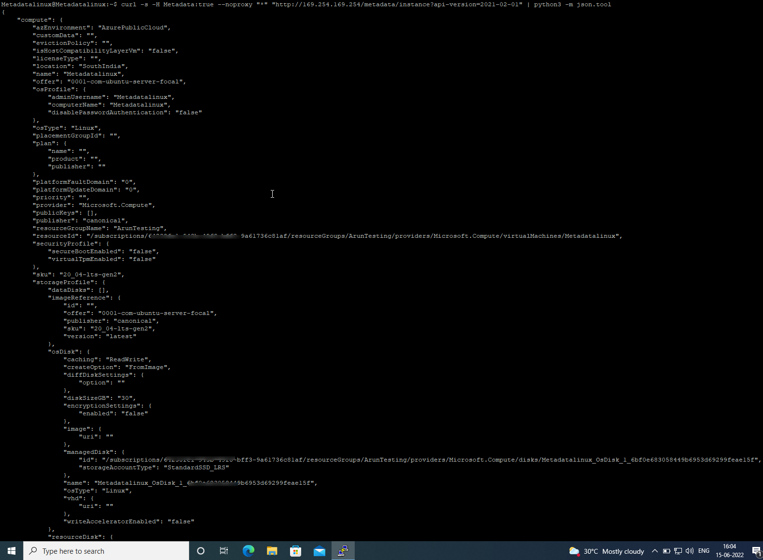

**##Bonus Question: The code allows for a particular data key to be retrieved individually in azure VM:**

**Command**:

curl -s -H Metadata:true --noproxy "*" "http://169.254.169.254/metadata/instance/network/interface/0?api-version=<version>" | python3 -m json.tool

**Referred Azure Documentation:** <https://docs.microsoft.com/en-us/azure/virtual-machines/windows/instance-metadata-service?tabs=linux>